**RESULTS BASED ON MY ANALYSIS OF THE COAL MINING DATASET**

TABLE 2:

|  |  |  |  |  |
| --- | --- | --- | --- | --- |
| The Model | MLEs of the Parameters | Log Likelihood | K-S Statistic | P-Value |
| Gamma | â = 0.85599390,  λ_cap = 2.725733e+02 | -702.4007 | 0.082138 | 0.4539 |
| Weibull | â = 0.88480740 ,  λ_cap = 2.186772e+02 | -701.7724 | 0.078444 | 0.5136 |
| APE | â = 0.00366583,  λ_cap = 9.550325e-04 | -700.6492 | 0.061673 | 0.8014 |

FIGURE 5(a):

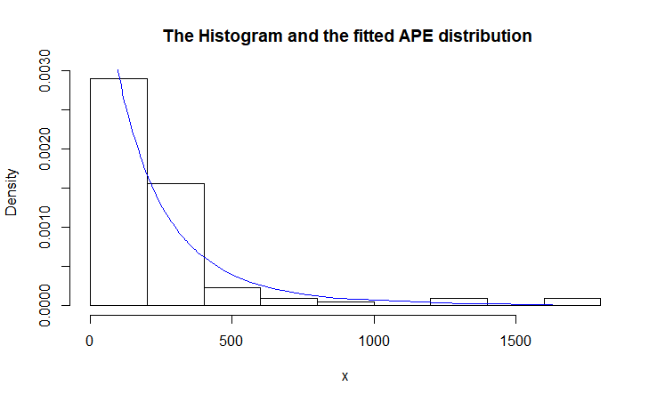

FIGURE 5(b):

