

Document: Feasibility of change in HDMI resolution on fly.

Prepared By: Nilesh Patel

Reviewed By: Mohan Sanodia

Date: 29-Aug-2016.

**Content**

1.Aim..................................................................................................................................1

2.Purpose...........................................................................................................................1

3.Internal Customer............................................................................................................1

4.Details Study/Changes/Modification................................................................................1

5.Supported Devices..........................................................................................................2

6.Scope/Not In Scope.........................................................................................................2

7.Conclusion.......................................................................................................................2

8.References......................................................................................................................2

**1. Aim**

Feasibility of changes in HDMI resolution.

1. **Purpose**

The Display resolution is set based on the supported resolution of the

monitor.

**3. Internal Customer**

Satatya Device Team/SAD Team.

**4.Details Study/Changes/Modification:**

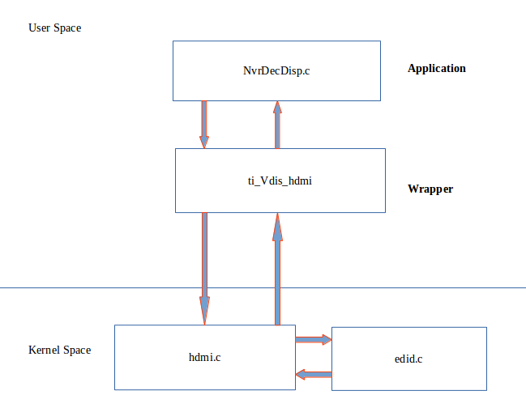

**Basic flow of connect HDMI interface from kernel to user space.**

**Feasibility:**

The HDMI driver known as ti81xxhdmi is used for HDMI monitor.

This driver can detect the max resolution supported at boot time.This Information is

Taken to User Space using IOCTL call.Based on the value the Display Resolution is

Set in for Local Client.

Ioctl:The Various Supported IOCTL call:

start();

stop();

status_get();

read_edid();

**5.Supported Devices:**

NVR08 family,NVR24P,NVR24S,HVR24P,HVR24S,HVR0408,

NVR64P.

1. **Scope:**

We are going to implement this feature on NVR24P, HVR24S, HVR08 family.

* **Not Scope:** we are not implementing of this device.( HVR24P , NVR64P)

**7.Conclusion:**

Tested feasibility and Could be implement that in future.

1. References:
   1. SVN Satatya device Code.

Test Report

|  |  |  |  |  |
| --- | --- | --- | --- | --- |
|  | NVR24P | HVR24P | HVR24S | HVR0408 |
| HDMI 1 |  |  |  |  |
| HDMI 2 |  |  | NO | NO |
| DETECTION EVENT | HDMI 1 | HDMI 2 | HDMI 1 | HDMI 1 |

NOTE:

* In NVR24P HDMI 1 is detected and its resolution set as per discussion

when HDMI connected. but HDMI 2 detection event is not coming.

* In HVR24P HDMI 1 detection event is not coming.