一、 立题依据
- 研究目的与意义
近年来，大型语言模型（LLM）持续迭代，从ChatGPT、Claude到文心一言、Deepseek，这些模型已广泛应用于教育、医疗、法律咨询等关键领域。然而，大型语言模型并非价值中立的工具 [8]，它们在训练过程中从海量文本数据中习得了隐含的价值观和文化偏见 [3，11]。如果缺乏有效评估，这些价值立场可能在实际应用中带来潜在风险 [1]。
目前，大模型价值观评估面临三重挑战：一是缺乏系统化的量化指标体系 [21]，难以比较不同模型间的价值倾向；二是跨文化评估方法不足 [16]，现有研究多基于单一文化视角；三是语言因素与对齐策略的交互机制尚不明确 [27]，制约了针对性改进措施的制定。
为此，本研究旨在建立一套系统化的“大模型价值观评价方法”。该方法以世界价值观调查（World Value Survey）为基准 [12，13]，设计大模型访谈问卷和评价流程，构建从概念界定、测量实施到分析报告的全流程评估体系。我们计划引入WVS成熟量表 [12]，在可解释的文化维度空间中，采用连续型“文化距离”指标，量化模型与人类价值图谱的契合程度 [20]。评估流程采用基线测量、跨文化一致性和语言效应检验的递进范式，确保方法在多模型、多语言环境下的稳健性与可扩展性 [23]。
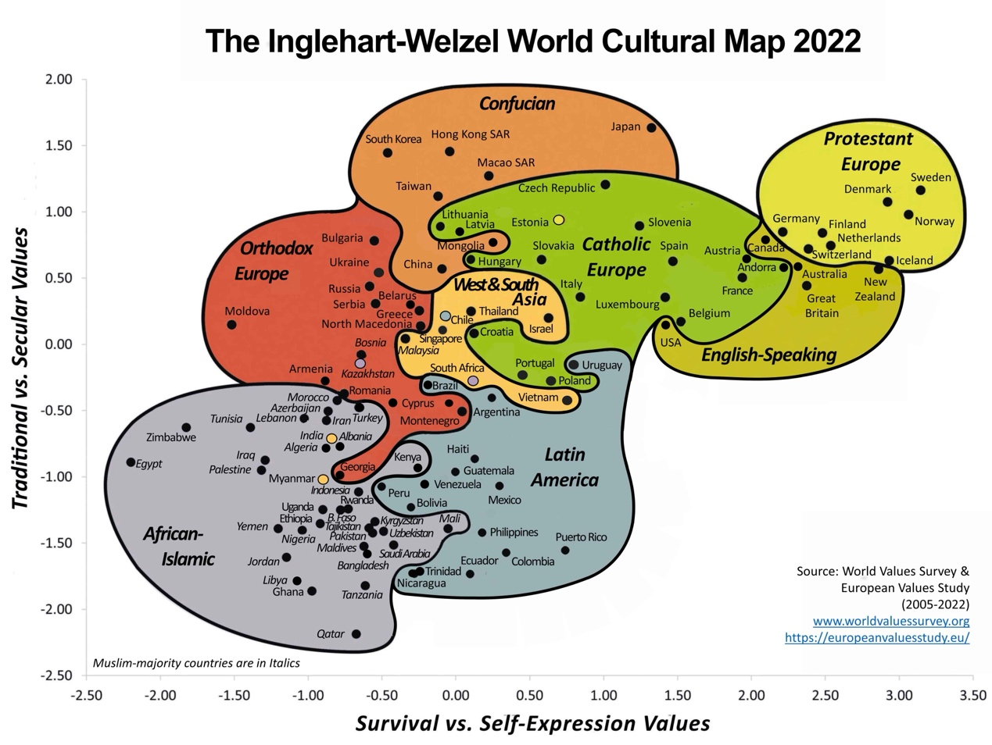
图1.The Inglehart-Welzel World Culture Map 2022
在应用层面，本评估框架可为大模型在真实场景中的价值对齐提供实践指导 [4，8]。通过将模型响应与文化语境要求对照，形成可供核查的量化证据。评估过程将完整记录模型版本、提示模板等关键参数，有助于开发团队精准调整训练数据，削弱文化偏见。这套可比较的指标体系，不仅能为跨国产品的本地化部署提供决策依据，也可为高敏感行业的风险管控提供技术支持 [5]，从而推动人工智能发展生态的形成。
- 国内外研究现状和发展趋势
随着大语言模型能力不断提升，其社会影响评估已成为全球学术界关注的焦点 [3]。国际研究正从初期的风险警示 [1]，逐步转向系统化评估框架的构建 [2]。
在基础性研究方面，Bender等人（2021）在《Stochastic Parrots》中指出 [1]，大规模训练会系统性放大语料中的社会偏见，凸显了数据治理的紧迫性。斯坦福大学CRFM团队发布的基础模型风险评估报告[3] 则系统阐述了模型能力的外溢效应，强调评估体系需超越传统的准确率指标 [22]，全面涵盖公平性、鲁棒性等社会影响维度 [10]。
在价值观测量领域，Blodgett等（2020）对自然语言处理中的偏见研究进行了批判性回顾 [9]，指出当前以刻板印象检测为主的度量方法难以支撑深层的价值判断分析。尽管CrowS-Pairs [17] 和StereoSet [18] 等基准数据集在群体偏见探测方面取得了一定进展，但对价值立场的强度测量仍显不足。学界也开发了如BBQ [19] 等更复杂的基准来衡量模型在歧义情境下的偏见。近年来，文化视角的评估研究逐渐兴起 [16]，例如Tao等（2024）对大模型文化对齐度的评估 [14]，以及Dwivedi-Yu等（2023）对语言资源与文化保真度关联的探讨 [15]，共同揭示了模型在不同文化语境中的系统性差异。
值得注意的是，评测方法正呈现标准化与跨学科融合的趋势。世界价值观调查（WVS） [13] 等长期人类价值观研究为模型评估提供了宝贵的基准数据，使模型输出与人类价值图谱的跨文化比较成为可能 [31]。在方法学层面，验证性因子分析、项目反应理论 [24，29] 等心理测量方法被引入，与自然语言处理技术形成互补；测量等值性检验 [25] 等统计方法则确保了跨语言比较的有效性。在工程实践中，自动化评估流水线和版本化管理成为保证结果可复现、过程可审计的重要支撑 [22]。
在此背景下，本研究拟将人类价值观调查数据作为统一参照系，通过构建多维指标体系，将模型在不同语言和文化语境中的表现映射到可比较的度量空间，从而连接文化理论与统计检验，实现评估过程的体系化，为全球人工智能治理提供方法论支持 [30]。
- 主要参考文献目录
[1] Bender E M, Gebru T, McMillan-Major A, et al. On the Dangers of Stochastic Parrots: Can Language Models Be Too Big?[C]. Proceedings of the 2021 ACM Conference on Fairness, Accountability, and Transparency (FAccT '21), 2021: 610–623.
[2] Bommasani R, Hudson D A, Adeli E, et al. On the Opportunities and Risks of Foundation Models[C/OL]. arXiv:2108.07258, 2021.
[3] Weidinger L, Mellor J, Rauh M, et al. Ethical and social risks of harm from Language Models[C/OL]. arXiv:2112.04359, 2021.
[4] Bai Y, Kadavath S, Woodside S, et al. Constitutional AI: Harmlessness from AI Feedback[C/OL]. arXiv:2212.08073, 2022.
[5] Perez E, Ringer N, Lukoianov P, et al. Red Teaming Language Models to Reduce Harms: Methods, Scaling Behaviors, and Lessons Learned[C/OL]. arXiv:2209.07858, 2022.
[6] Lin S, Hilton J, Evans O. TruthfulQA: Measuring How Models Mimic Human Falsehoods[C]. Proceedings of the 60th Annual Meeting of the Association for Computational Linguistics (ACL 2022), 2022: 4843–4857.
[7] Madaan A, Tandon A, Ladhak F, et al. Self-Correction in Large Language Models[C/OL]. arXiv:2305.13169, 2023.
[8] Gabriel I. Artificial Intelligence, Values, and Alignment[J]. Minds and Machines, 2020, 30(3): 411-437.
[9] Blodgett S L, Barocas S, Daumé III H, et al. Language (Technology) is Power: A Critical Survey of “Bias” in NLP[C]. Proceedings of the 58th Annual Meeting of the Association for Computational Linguistics (ACL 2020), 2020: 5454–5476.
[10] Gallegos J, Tello J, Muneera K, et al. Bias and Fairness in Large Language Models: A Survey[J]. ACM Computing Surveys, 2024, 56(6): 1-38.
[11] Schramowski P, Turan C, Rashedi Y, et al. Large pre-trained language models contain human-like biases[C]. Proceedings of the 2022 ACM Conference on Fairness, Accountability, and Transparency (FAccT '22), 2022: 624–637.
[12] Inglehart R, Welzel C. Modernization, Cultural Change, and Democracy: The Human Development Sequence[M]. Cambridge University Press, 2005.
[13] Haerpfer C, Inglehart R, Moreno A, et al. World Values Survey Wave 7 (2017-2022) Cross-National Data-Set[DB/OL]. Madrid & Vienna: JD Systems Institute, 2022.
[14] Tao S, Zhang Y, Zhang S, et al. Cultural Bias and Cultural Alignment of Large Language Models[C/OL]. arXiv:2403.01026, 2024.
[15] Dwivedi-Yu J, Chen Y, Wang Z, et al. Cultural Fidelity in Large-Language Models: An Evaluation of Online Language Resources as a Driver of Model Performance in Value Representation[C/OL]. arXiv:2312.06208, 2023.
[16] Cao P, Zhang B, Shi Z, et al. A Survey of Cultural Awareness in Language Models[C/OL]. arXiv:2407.12461, 2024.
[17] Nangia N, Vania C, Bhalerao R, et al. CrowS-Pairs: A Challenge Dataset for Measuring Social Biases in Masked Language Models[C]. Proceedings of the 2020 Conference on Empirical Methods in Natural Language Processing (EMNLP 2020), 2020: 1953–1967.
[18] Nadeem M, Bethke A, Reddy S. StereoSet: Measuring stereotypical bias in pretrained language models[C]. Proceedings of the 59th Annual Meeting of the Association for Computational Linguistics (ACL-IJCNLP 2021), 2021: 5356–5371.
[19] Parrish A, Chen M, Waseem Z, et al. BBQ: A Hand-Built Bias Benchmark for Question Answering[C]. Findings of the Association for Computational Linguistics: ACL 2022, 2022: 1636–1651.
[20] Zhao M, Li R, Liu D, et al. WorldValuesBench: A Large-Scale Benchmark Dataset for Multi-Cultural Value Awareness of Language Models[C]. Proceedings of the 2024 Joint International Conference on Computational Linguistics, Language Resources and Evaluation (LREC-COLING 2024), 2024.
[21] Chang Y, Wang X, Wang J, et al. A Survey on Evaluation of Large Language Models[C/OL]. arXiv:2307.03109, 2023.
[22] Ribeiro M T, Wu T, Guestrin C, et al. Beyond Accuracy: Behavioral Testing of NLP Models with CheckList[C]. Proceedings of the 58th Annual Meeting of the Association for Computational Linguistics (ACL 2020), 2020: 4902–4912.
[23] Talat Z, Zhao J, Sikka K, et al. You reap what you sow: On the challenges of bias evaluation under multilingual settings[C]. Proceedings of the 2022 ACM Conference on Fairness, Accountability, and Transparency (FAccT '22), 2022: 1980–1990.
[24] Lalor J P, Yu H. Item Response Theory for Natural Language Processing[C]. Proceedings of the 18th Conference of the European Chapter of the Association for Computational Linguistics: Tutorial Abstracts (EACL 2024), 2024.
[25] Measurement Invariance in Cross-Lingual NLP[C]. Proceedings of the 2022 Conference on Empirical Methods in Natural Language Processing (EMNLP 2022), 2022.
[26] Li Y, Zhang K, Du Y, et al. Role-Playing with Large Language Models[C/OL]. arXiv:2305.16367, 2023.
[27] Understanding Cross-Lingual Alignment—A Survey[C/OL]. arXiv:2404.06228, 2024.
[28] Leveraging Large Language Models for NLG Evaluation: A Survey[C/OL]. arXiv:2401.07103, 2024.
[29] Psychometric Evaluation of Large Language Model Embeddings for Personality Trait Prediction[J]. Journal of Medical Internet Research, 2024.
[30] Hendrycks D, Burns C, Kadavath S, et al. Aligning AI with Shared Human Values[C/OL]. arXiv:2008.02275, 2020.
[31] Mi Z, Zhang Z, Meng F, et al. Benchmarking Multi-National Value Alignment for Large Language Models[C/OL]. arXiv:2404.09506, 2024.

