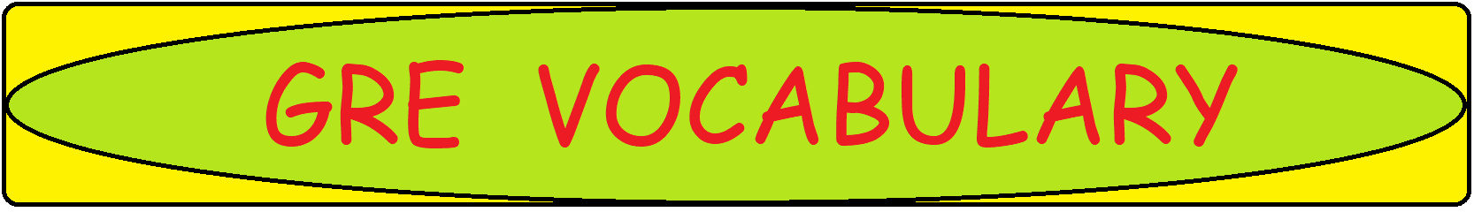

**T: Word-Meaning**

|  |  |
| --- | --- |
| **Word/Phrase** | **Meaning** |
| T |  |
| taboo | banned by social custom |
| tacit | understood or meant without being stated |
| taciturn, taciturnity | saying little |
| tact, tactful | sensitivity and skill in dealing with others |
| tad | to a small extent |
| taint | made undesirable |
| tangible | definite or real |
| tantalize | tease with the sight or promise of something they cannot have |
| tantamount to | equivalent in seriousness to |
| tasteless | lacking flavor in quality, appearance or apt behavior |
| tattered | old and torn |
| tatty | worn and shabby |
| tawdry | showy, cheap or of poor quality |
| taxing | physically or mentally demanding |
| tearaway | a wild and reckless person |
| tear into | attack verbally |
| teeter | be unable to decide between different options |
| teething troubles | short-term problems in the beginning of a project |
| temerity | excessive confidence or boldness |
| tenacious | holding on to something firmly |
| tender-hearted | soft, kind and gentle heart |
| tenebrous | dark, shadowy |
| tenit | a central principle or belief |
| tenor | the general nature of something |
| tepid | lukewarm, not enthusiastic |
| terse | using few words, abruptly |
| testy | easily irritated |
| tetchy | bad-tempered and irritable |
| thaw | become friendlier |
| thimbleful | a small quantity of something |
| thrall | state of being in another's power |
| thrifty | careful and economical with money |
| thrusting | aggressively ambitious |
| thwack | strike forcefully with a sharp blow |
| thwart | prevent from succeeding or accomplishing something |
| tiddly | slightly drunk, tiny |
| timorous | lacking in courage or confidence |
| tirade | a long speech of angry criticism |
| titch | a small person |
| tortuous | full of twists and turn, characterized by pain or suffering |
| tousle | make untidy |
| trailblazer | a person who is the first one to do something new |
| troglodyte | a person who lives in a cave |
| truant | wandering |
| truculent | quick to argue or fight |
| tumble | fall suddenly, clumsily headlong way |
| tumult | confusion or disorder |
| turgid | pompous and boring |
| turpitude | wickedness |
| twit | tease good humouredly |