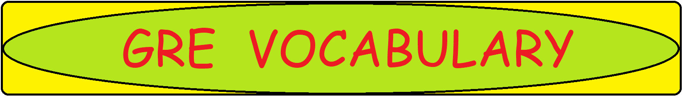

**U: Word-Meaning**

|  |  |
| --- | --- |
| **Word/Phrase** | **Meaning** |
| U |  |
| ubiquitous | present or found everywhere |
| ullage | amount by which a container falls short of being full |
| unbidden | without having been invited |
| unbridled | uncontrolled |
| uncalled | undesirable and unnecessary |
| uncanny | strange or mysterious |
| unceremonious | impolite or abrupt |
| uncivil | not polite |
| unclasp | Unfasten |
| unclench | Release |
| uncompetitive | not cheaper or better than others |
| uncongenial | not friendly or unpleasant |
| unconscionable | not right or reasonable |
| uncontentious | not causing disagreement or controversy |
| uncorroborated | not supported or confirmed by evidence |
| uncouth | lacking good manners |
| unctuous | excessive flattery or friendship |
| undaunted | not discouraged by difficulty |
| underwhelm | fail to impress or make a good impression on |
| unencumbered | not having any burden or obstacle in one's path |
| unenviable | difficult, undesirable |
| unexpergated | complete and containing all the original material |
| unfailing | without error |
| unfathomable | too strange or difficult to be understood |
| unfazed | not surprised or worried by something unexpected |
| unfeigned | genuine, sincere |
| unfettered | Uninhibited |
| unflagging | Tireless |
| unflappable | calm in a crisis |
| unflinching | not afraid or hesitant |
| unfounded | having no basis |
| ungainly | clumsy, awkward |
| ungracious | not polite, kind or pleasant |
| unheeded | noticed but ignored |
| unintelligible | impossible to understand |
| unkempt | having an untidy appearance |
| unleash | set free |
| unmoving | Still |
| unnameable | Unmentionable |
| unnerve | make someone feel nervous or frightened |
| unobtrusive | not conspicuous or attracting attention |
| unostentatious | Simple |
| unpalatable | not pleasant to taste |
| unprecedented | not done or known before |
| unpretentious | Modest |
| unravel | undo; solve |
| unrelenting | not stopping to become less severe |
| unremitting | never relaxing |
| unrequited | not returned |
| unruffled | calm and unconcerned |
| unswerving | not changing or becoming weaker |
| untenable | not able to be defended against criticism or attack |
| untoward | unexpected and usually unwanted |
| untrammelled | not restricted or hampered |
| unwinking | unwavering |
| unwonted | unusual |
| up and coming | likely to be successful |
| upbraid | scold or criticize |
| uproarious | very noisy or funny |
| urchin | a poor child dressed in rags |
| usury | practice of lending money at higher rates |
| utilitarian | useful or practical rather than attractive |
| utopian | idealistic |