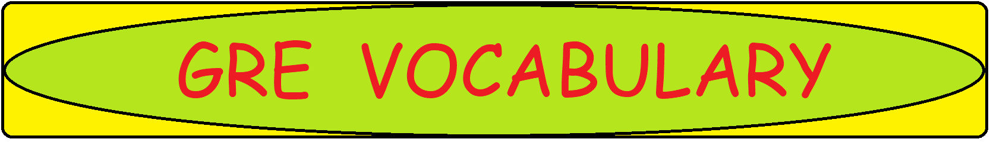

**W: Word-Meaning**

|  |  |
| --- | --- |
| **Word/Phrase** | **Meaning** |
| W |  |
| wacko | mad, insane |
| wacky | funny or amusing in a slightly odd way |
| waddle | walk with short steps and a clumsy swaying motion |
| wade through | read through |
| wade in/into | intervene in a forceful way |
| waffle | speak or write at length in a vague or trivial way |
| wag | move rapidly to and fro; a person fond of making jokes |
| waggish | humorous or playful |
| waggle | move with short, quick movements from side to side or up and down |
| waif | poor and homeless child |
| wallop | hit very hard |
| wallow | roll about side to side |
| wally | a silly or inept person |
| wan | appearing pale and sick |
| washed out | faded |
| waylay | intercept in order to attack them |
| way-out | experimental |
| wayward | self-willed and unpredictable |
| wazzock | a stupid or annoying person |
| wearisome | causing one to feel tired |
| whet | sharpen the blade of; excite or stimulate |
| whimsical | showing sudden changes in direction; being fanciful |
| whinge | complain persistently and irritably |
| whip | beat violently |
| whirr | make a low regular sound |
| whisk | move or take suddenly, quickly and lightly |
| not a whit | a small amount |
| wisecrack | a witty remark or joke |
| wrangle | long complicated dispute |
| wrest | take after resistance or effort |
| wriggle | twist and turn with quick movements |
| wringing | extremely wet |
| wry | using dry mocking humor |