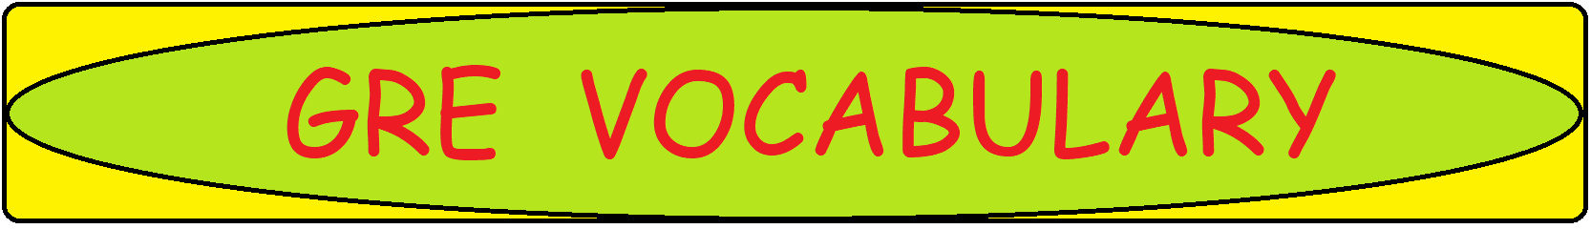

**X, Y, Z: Word-Meaning**

|  |  |
| --- | --- |
| **Word/Phrase** | **Meaning** |
| X |  |
| Xenophobia | fear of people from other countries |
| Y |  |
| Yak | a trivial or lengthy conversation |
| Yammer | talk loudly without pausing |
| Yank | a sudden hard pull |
| Yap | talk at length in an irritating way; give a sharp, shrill bark |
| Yashmak | a veil conceiving the face |
| Yaw | turn from side to side |
| Yawp | a harsh cry |
| yellow-belly | Coward |
| Yen | a longing or yearning |
| yes-man | a person who always agrees with his superiors |
| Yob | a rude and aggressive young man |
| Yoke | something that restricts freedom or is a burden; bring into close relationship |
| Yokel | an unsophisticated country person |
| Yonder | over there |
| Yore | of former times |
| Yowl | a loud, wailing cry of pain or distress |
| Z |  |
| Zany | amusingly unconventional and individual |
| Zap | destroy; a sudden burst of energy or sound |