Exact Λ-Vacuum Solutions with Curled Extra Dimensions
A step-by-step exploration from 4D to 7D, and which curled shapes survive as candidates for our universe
Harry S. Simrin · October 2026

Summary
This report collects exact solutions of Einstein's vacuum field equations with a cosmological constant, R_{μν} = Λ g_{μν}, for an expanding universe in 4 to 7 spacetime dimensions. The extra dimensions are curled up into circles, tori, and spheres. Every case was solved directly, one field equation at a time, in Mathematica notebooks that show each step; the notebooks accompany this report. Terms that may be unfamiliar are explained in the Glossary (Appendix A), which also works through a simple 5D example of a metric.
The setting is deliberately simple: vacuum (Λ only, no matter or radiation), one scale factor a(t) shared by ordinary space and the curled dimensions, and diagonal metrics. Within that setting the results are:
- Every case has exact solutions. Each comes in a standard form (GRW) and a free-gauge form (FG-GRW) that is the same geometry written in a more general radial coordinate.
- Requiring smoothness at a pinch places constraints on the solution. As r shrinks, a curled circle sometimes shrinks to zero size (a Kaluza–Klein ‘bubble of nothing’). Requiring the shrinking to occur smoothly fixes one of the solution's constants in closed form, for example χ = −p₅/2 in 6D_1 (Section 6.2).
- A curvature test eliminates whole families. Curved compact spaces (spheres) force the entire universe to be closed, with a size comparable to the curled sphere's radius, so a tiny curled sphere means a tiny universe. Flat compact spaces (circles, tori) do not, so only the circle cases survive as candidates for our universe.
- A classical connection. In 7D_1 (three circles) the exponents of the solution obey the Kasner conditions of 1921.
None of the solutions is yet a realistic model of our universe. They are a simplified starting point; Section 8 lists the next steps: a separate scale factor for the curled dimensions, and the addition of matter and radiation.

1. Introduction and how to use this report
Textbooks usually present solutions of Einstein's general relativity equations in finished form. The notebooks behind this report do the opposite: they start from a general metric, compute the Ricci tensor R_{μν}, and solve the field equations step by step, showing which assumptions are needed and why, including the dead ends. The intended reader is someone who wants to learn how to solve Einstein's equations and to gain insight into what the various solutions mean.
Technical terms are explained briefly where they first appear, and all of them are collected in the Glossary (Appendix A). This report gives common notation once (Section 3), summarizes all the results in two tables (Section 5), and explains what they mean (Sections 6–8). For any individual case, the corresponding notebook contains the full derivation.

2. The simplified starting point
Each simplification below was chosen to make exact solution possible:
- Vacuum with a cosmological constant: R_{μν} = Λ g_{μν}.
- One scale factor a(t) for all spatial directions.
- Diagonal metrics.
- Spherical symmetry in ordinary space.
- Simple compact shapes: circles (S¹), 2-spheres (S²), 3-spheres (S³), or products of these (the tori S¹×S¹ and S¹×S¹×S¹, and S²×S¹).
Each is also a limitation. Section 7.1 describes what each one leaves out.

3. Notation and conventions
Coordinates are (t, r, θ, φ) for ordinary spacetime plus angles ψ₄, ψ₅, ψ₆ for the curled dimensions. A typical metric (5D shown) is
ds² = A(t,r) dt² − a(t)² [ B(r) dr² + C(r) r² (dθ² + sin²θ dφ²) + D₄(r) p₄² dψ₄² ]
Symbol | Meaning
a(t) | scale factor, shared by all spatial directions
A | time coefficient; the field equations force A to depend on t only
B(r), C(r) | radial and angular coefficients of ordinary 3-space
D_{μ}(r), p_{μ} | coefficient and radius of the curled direction ψ_{μ}
k | curvature constant; appears in A(t) and in B
χ, ζ_{μ} | constants of integration
Λ, c | cosmological constant; speed of light

Solution types
- GRW solution (generalized Robertson–Walker): C = 1, and A(t) = c², which is the Friedmann continuity equation and determines a(t). In 4D the GRW solution is the familiar Friedmann–Lemaître–Robertson–Walker (FLRW) universe.
- FG-GRW solution (free-gauge GRW): C(r) is left free. It is the same spacetime as the GRW solution, written in the radial coordinate r√C. In practice it is obtained by replacing r with r√C and multiplying B by (2C + rC′)²/(4C).

Constraints, domains, and smoothness
- Field-equation constraints are relations forced by R_{μν} = Λ g_{μν}, such as k = 0 or Λ > 0.
- KK-bubble constraints (optional) come from requiring smoothness where a curled circle (radius p_{μ}, coefficient D_{μ}) shrinks to zero size at some r₀. Near r₀ the circle's circumference must grow like 2π times the proper distance from r₀, which requires p_{μ} |D_{μ}′(r₀)| = 2. Whether to impose this is a physical choice, so these constraints are listed separately.
- Domain restrictions on r (RCPC, ‘reduced circumference polar coordinates’, and its analogs), such as kr² < 1 in 4D, restrict the coordinate r. They are not constraints on the constants and are not listed in the tables.
- Equation form and signs. Diagonal field equations are written R_{μμ}/g_{μμ} = Λ, and off-diagonal ones R_{μν} = 0 (since g_{μν} = 0 there). The metric signature is (+, −, −, …), and the notebooks' Ricci-tensor sign convention may differ from that of some textbooks; where it does, individual terms appear with opposite signs.

4. The cases
Case | Dimensions | Curled space | Notes
4D | 4 | none | standard Λ-vacuum universe
5D | 5 | circle S¹ | KK bubble possible
6D_1 | 6 | torus T² = S¹×S¹ | k = 0 forced; KK bubble
6D_2 | 6 | sphere S² | space is a 5-sphere; closed universe
7D_1 | 7 | 3-torus S¹×S¹×S¹ | k = 0; Kasner exponents; KK bubble
7D_2 | 7 | S²×S¹ | two solutions
7D_3 | 7 | 3-sphere S³ | space is S³×S³; closed universe

5. Summary tables
The two tables below summarize every solution. Each column is one case; the upper block gives the GRW solution and the lower block the FG-GRW solution.
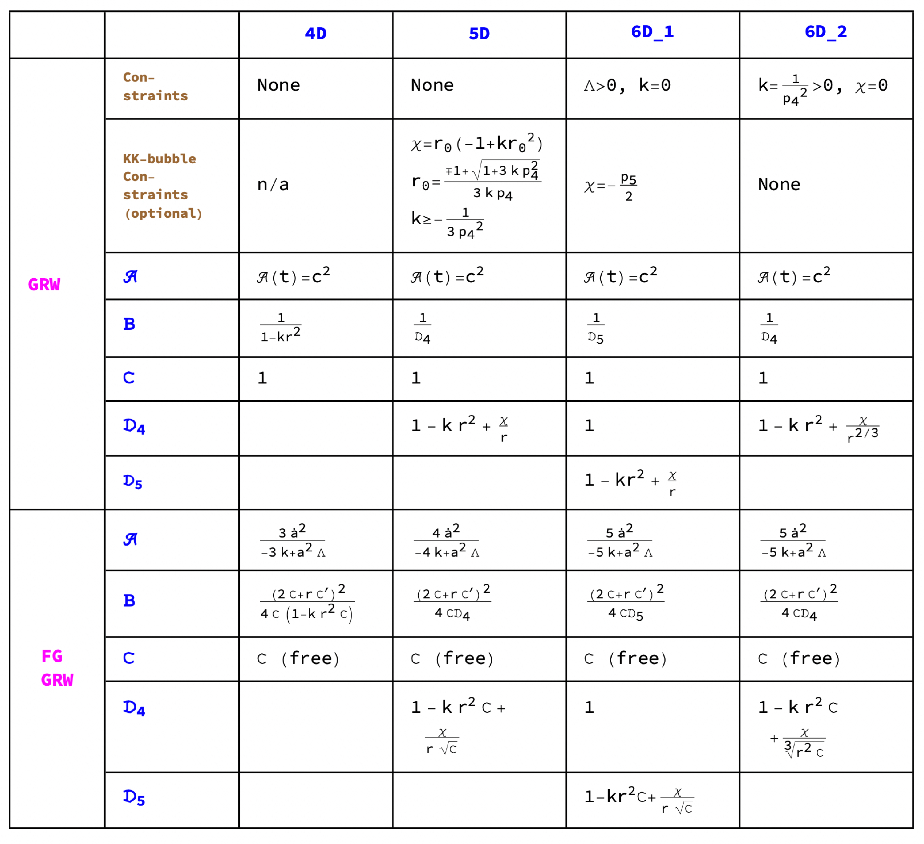
Table 1. Cases 4D through 6D_2.
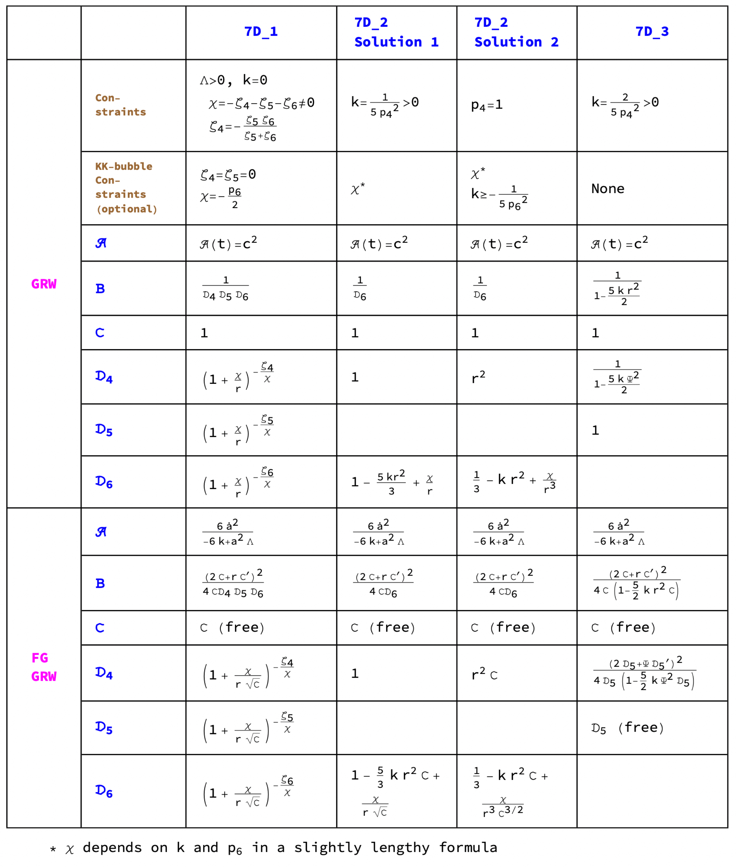
Table 2. The 7D cases.
Notes for both tables:
- The tables, like the notebooks, print A, B, C, D₄, D₅ (and D₆ in Table 2) in script, Greek and Gothic fonts; this report uses plain letters for the same functions.
- A(t) = c² is the Friedmann continuity equation; its solution is the formula for a(t).
- The two constraint rows list restrictions on parameter constants, from the field equations and from KK-bubble smoothness, respectively.
- RCPC in 4D and its analogs in higher dimensions cause domain restrictions on r. These are not listed as constraints in the tables.
- The FG-GRW solutions have the same field-equation and KK-bubble constraints as the GRW solutions.

6. What the results show

6.1 FG-GRW is a change of coordinates
In a GRW solution, ordinary 3-space has a radial part B(r) dr² and an angular part r² dΩ², where dΩ² = dθ² + sin²θ dφ² (C = 1). Now change to a new radial coordinate, again called r, related to the old one by r_{old} = r√C(r), where C is any positive function. Then
- the angular part becomes r_{old}² dΩ² = C r² dΩ², which is the FG-GRW angular part;
- dr_{old} = (2C + rC′)/(2√C) dr, so the radial part becomes B(r√C)·(2C + rC′)²/(4C) dr².
This is exactly the FG-GRW rule: replace r by r√C everywhere, and multiply B by (2C + rC′)²/(4C). So the FG-GRW solutions are not new spacetimes; they show how much freedom remains in choosing coordinates. In 7D_3 the same idea applies separately to the radial coordinate Ψ of the curled 3-sphere.

6.2 Smoothness at a pinch: closed-form constraints
Where a curled circle of radius p has its coefficient D vanish at r₀, the smoothness condition p|D′(r₀)| = 2 can be solved exactly. Using D(r₀) = 0 to eliminate χ turns the condition into a quadratic in r₀. For example, in 5D:
r₀ = (∓1 + √(1 + 3k p₄²)) / (3k p₄), χ = r₀ (k r₀² − 1), valid for k ≥ −1/(3p₄²)
In 6D_1 (k = 0) this reduces to χ = −p₅/2, and the 6D_1 notebook has plots to help visualize a smooth pinch versus a sharp conical tip.

6.3 The curvature test
Write the spatial metric as a(t)² h. The constant k enters the spatial field equations through a term (n − 1)k, where n is the number of spatial dimensions. Together they require the Ricci curvature of h — the sum of the sectional (Gaussian) curvatures of all 2-planes containing a given direction — to equal (n − 1)k in every direction. One constant therefore controls the curvature of ordinary space and the curled space alike.
- A curled sphere of radius p is curved (curvature 1/p²), so it ties k to p. In 6D_2 the whole 5-dimensional space becomes a 5-sphere of radius p₄, with k = 1/p₄²; in 7D_3 it becomes S³×S³ with k = 2/(5p₄²). By Myers' theorem the space is then finite, at most π/√k across.
- A circle has no intrinsic curvature, so curled circles and tori leave k free (5D) or allow k = 0 (6D_1, 7D_1).
The 6D_2 notebook gives this argument in more detail.

6.4 Kasner exponents in 7D_1
In 7D_1 each circle coefficient has the form D_{μ} = (1 + χ/r) raised to a power e_{μ}, and the field equations require e₄ + e₅ + e₆ = 1 and e₄² + e₅² + e₆² = 1. These are the Kasner conditions, with 1 + χ/r playing the role that time plays in Kasner's metric. Smoothness at the pinch requires the exponent of the shrinking circle to be exactly 1, so that its D_{μ} goes to zero linearly. The two Kasner conditions then force the other two exponents to be 0. So the exponents (e₄, e₅, e₆) are 1, 0, 0 in some order: only one circle shrinks, and the other two keep a constant size.

7. Candidates for our universe

7.1 What the simplifications leave out
Vacuum: no matter or radiation.
- Only Λ (dark energy) drives the expansion. For Λ > 0, a(t) is a hyperbolic cosine (k > 0), hyperbolic sine (k < 0), or exponential (k = 0): accelerating, de Sitter-like growth, with no slowing by matter. For Λ = 0 and k < 0, a(t) = ct√|k| grows linearly (the Milne universe: empty, flat spacetime described in expanding coordinates); for Λ = 0 and k = 0, a(t) is constant.
- There is no Big Bang singularity. For k > 0, a(t) never reaches zero (the universe bounces); for k ≤ 0, a = 0 at t = 0 is a coordinate effect. A genuine singularity requires matter or radiation.
- There is no radiation era or matter era, hence no cosmic microwave background and no formation of galaxies.
- Λ (dark energy) is about 70% of today's energy budget and its share is growing, so these solutions describe the far future of our universe well, and its present large-scale expansion fairly.
One scale factor.
The curled dimensions expand along with ordinary space. Section 7.3 explains why this is a serious problem for any realistic model.
Diagonal metrics.
There are no cross terms such as dt dφ or dt dψ. This leaves out rotation (a dt dφ term is what makes the Kerr black hole spin) and, in Kaluza–Klein theory, the electromagnetic field, which lives in the cross terms between ordinary spacetime and a curled circle.
Spherical symmetry and simple shapes.
Every function depends only on t and r, so everything is the same at all points of a sphere centered on the origin. In 4D space is completely uniform. In the higher-dimensional cases the χ/r terms single out the origin, much as the mass term of a Schwarzschild black hole does, so a solution can describe at most one central object, such as a KK bubble. A universe scattered with stars and galaxies would need both less symmetry and matter to make them from. The curled spaces are also limited to circles, spheres, and their products.

7.2 Cases eliminated
- Sphere cases (6D_2, 7D_2 Solution 1, 7D_3). The curvature test forces a closed universe of size comparable to the sphere's radius. A tiny curled sphere means a tiny universe.
- 7D_2 Solution 2. Its ‘curled’ 2-sphere has radius a(t)·r, which grows with r; it is not a small hidden dimension.

7.3 Cases that survive, and why they are not yet realistic
The circle cases (5D, 6D_1, 7D_1) pass the curvature test. Far from a KK bubble every D approaches 1, so these solutions look like ordinary 4D cosmology with small circles attached; 6D_1 and 7D_1 have k = 0 and Λ > 0, a flat, accelerating universe. Three problems remain:
- One scale factor: the circles expand along with space. In Kaluza–Klein theory the circle size sets physical constants such as the strength of electromagnetism, which observations show has barely changed over cosmic history.
- No matter or radiation (Section 7.1).
- KK bubbles signal instability: Witten showed that a bubble of nothing can appear spontaneously and grow, destroying the Kaluza–Klein vacuum.
Far from the bubble the circle cases are at best equivalent to 4D cosmology; they are not better approximations to our universe.

8. Next steps
The notebooks can be modified in a straightforward way to take the next steps below, and they are provided freely for anyone who wants to do so.
- Two scale factors. Give the curled dimensions their own scale factor b(t), so they can stay small or be stabilized while ordinary space expands (Kaluza–Klein cosmology).
- Add matter and radiation. This restores a hot early universe and, in higher dimensions, can help hold the curled dimensions at a fixed size.
- Off-diagonal terms. The notebooks already accept non-diagonal metrics, so cross terms can be added: dt dφ for rotation, and terms mixing ordinary spacetime with a curled circle for Kaluza–Klein electromagnetism.
- Ricci-flat compact spaces. Spaces that are compact yet have zero Ricci curvature (such as Calabi–Yau spaces in string theory) avoid the curvature test's closed-universe conclusion.

9. The notebooks
Each notebook derives one case from scratch. The notebooks are written in Mathematica (the Wolfram Language) and are ready to use: evaluated from top to bottom, each one sets up the metric, computes the Christoffel symbols and the Ricci tensor, and solves the field equations step by step, with explanatory text along the way. Each notebook is also provided as a PDF of its output, laid out in textbook style, so it can be read without Mathematica. (The free Wolfram Player can also open the notebooks.)
The notebooks (each as a Mathematica .nb file and a PDF):
- 4D — no curled dimensions; the FLRW universe
- 5D — one circle
- 6D_1 — a torus (two circles), with 6D_1 Appendix (why the assumptions are justified)
- 6D_2 — a 2-sphere
- 7D_1 — a 3-torus (three circles)
- 7D_2 — a 2-sphere times a circle
- 7D_3 — a 3-sphere
The notebooks, their PDFs, and this report are available at https://github.com/matrixbud/Lambda-Vacuum-Solutions-4D-to-7D.

Appendix A. Glossary, with a worked example
Terms are listed alphabetically. The worked example under ‘Metric and line element’ is a good place to start.
Compact space. A space that is finite and closes on itself with no edge, such as a circle, a sphere, or a torus. The curled dimensions in this report are compact.
Cosmological constant (Λ). A constant in Einstein's equations that acts like a uniform energy of empty space (‘dark energy’). A positive Λ makes the expansion of the universe accelerate.
Curled (compact) dimensions. Extra spatial directions, beyond the familiar three, that close on themselves with a small size, like the circumference of a thin tube. If small enough, they would not have been noticed in experiments.
Curvature constant (k). The constant k that appears in A(t) and in B(r). In 4D it is the curvature of ordinary space (k > 0 closed, k = 0 flat, k < 0 open). In higher dimensions it is the average curvature of the whole spatial space (see Ricci curvature).
de Sitter expansion. The accelerating expansion of a universe containing only a positive Λ; the scale factor grows like an exponential (or cosh, sinh).
Field equations (Λ-vacuum). Einstein's equations with a cosmological constant and no matter: R_{μν} = Λ g_{μν}. Here R_{μν} is the Ricci tensor, built from first and second derivatives of the metric, and g_{μν} is the metric itself. See also Solution.
Free gauge (FG). ‘Gauge’ here means a choice of coordinates. A free-gauge solution leaves a coordinate function (C(r), and in 7D_3 also D₅) free. FG-GRW solutions are the same spacetimes as GRW solutions, described with a different radial coordinate (r√C instead of r).
Friedmann continuity equation. In this report, the condition A(t) = c². Solving it gives the scale factor a(t).
GRW (generalized Robertson–Walker) solution. A metric of the form ds² = A(t) dt² − a(t)² h, where h describes space and does not depend on time. The usual FLRW universe is the 4D case.
Kaluza–Klein (KK) theory. The 1920s idea (Kaluza, Klein) that a fifth, curled dimension could unify gravity and electromagnetism; the cross terms between ordinary spacetime and the circle behave like the electromagnetic potential.
Kasner metric. A 1921 vacuum solution, ds² = dt² − t^{2p₁} dx² − t^{2p₂} dy² − t^{2p₃} dz², in which three directions expand at different rates. Its exponents must satisfy p₁ + p₂ + p₃ = 1 and p₁² + p₂² + p₃² = 1. The same conditions appear in 7D_1 for the curled circles, with 1 + χ/r in place of t.
KK bubble (‘bubble of nothing’). A place where a curled circle shrinks to zero size, so that space ends smoothly there, like the tip of a rounded cap. Witten (1982) found the first example.
Λ-vacuum. Empty space (no matter or radiation) with a cosmological constant Λ. Its field equations are R_{μν} = Λ g_{μν}; see Field equations and Solution.
Line element. See Metric.
Metric and line element (worked 5D example). The metric is the rule for turning small coordinate changes into physical distances and times. It is usually written as a line element, ds², the squared separation between two nearby points. Here is the 5D GRW solution from this report, with coordinates t, r, θ, φ, and an angle ψ₄ around a curled circle of radius p₄:
ds² = c² dt² − a(t)² [ dr²/D₄(r) + r² (dθ² + sin²θ dφ²) + D₄(r) p₄² dψ₄² ], D₄(r) = 1 − k r² + χ/r
- c² dt²: the time part (here A = c²).
- a(t)²: the scale factor squared; it multiplies every spatial term, so all spatial distances grow together as a(t) grows.
- dr²/D₄: the radial part (B = 1/D₄). Unless D₄ = 1, a step dr in the coordinate is not the same as a step in physical distance.
- r²(dθ² + sin²θ dφ²): an ordinary sphere of radius a(t) r around the origin (C = 1).
- D₄ p₄² dψ₄²: the curled circle. As ψ₄ goes once around (0 to 2π), the physical circumference is 2π a(t) p₄ √D₄, so the circle's size depends on r.
With k = χ = 0 this is flat space plus a circle of fixed size p₄, expanding as a(t). With χ < 0, D₄ reaches zero at some r₀ and the circle shrinks to a point there: a KK bubble.
Pinch. The radius r₀ where a curled circle shrinks to zero size. The geometry there is either smooth (a rounded cap) or has a conical point; requiring smoothness fixes a constant (see 6.2).
Proper distance. Physical distance measured with the metric, as opposed to a difference in coordinates.
RCPC (reduced circumference polar coordinates). A radial coordinate r chosen so that a sphere at radius r has circumference 2πr. In a closed space r can only reach a maximum value (for 4D with k > 0, r < 1/√k), at the ‘equator’; this restricts the range of r but is not a constraint on any constant.
Ricci curvature (in a direction). The sum of the sectional curvatures of all 2-planes that contain that direction; for a diagonal metric it is R_{ii}/h_{ii}. The field equations require it to be the same in every direction (Section 6.3).
Robertson–Walker (FLRW) metric. The standard metric of a universe that is the same everywhere and in every direction, expanding with a scale factor a(t) (Friedmann, Lemaître, Robertson, Walker).
Scale factor a(t). The function of time that multiplies all spatial distances. A growing a(t) means an expanding universe. If the curled dimensions are to grow differently, they need a second scale factor, b(t) (Section 8).
Sectional (Gaussian) curvature. The curvature of a 2-dimensional slice of space: 1/p² for a sphere of radius p, 0 for a plane or cylinder, negative for a saddle. It can be measured from inside, for example by comparing a small circle's circumference with 2π times its radius.
Simple compact shapes. The curled spaces used here: circles (S¹), 2-spheres (S²), 3-spheres (S³), and products such as the torus S¹×S¹ and S²×S¹.
Solution (of the field equations). A metric that satisfies every one of the field equations R_{μν} = Λ g_{μν}. In practice, solving a case means finding formulas for the metric functions listed in Section 3 (A, B, C, and the D_{μ}) such that all the equations hold, together with any conditions on the constants (such as k = 0) that the equations require. The scale factor a(t) then follows from the Friedmann continuity equation.
Spatial metric (h). The part of the metric that describes distances within space at one instant, with the scale factor removed: the full spatial part of ds² is a(t)² h. In the 5D example above, h = dr²/D₄ + r²(dθ² + sin²θ dφ²) + D₄ p₄² dψ₄². The curvature test (Section 6.3) is a statement about h.
Torus. A product of circles: T² = S¹×S¹ (the surface of a donut, but flat), T³ = S¹×S¹×S¹.

References
- A. Friedmann, “Über die Krümmung des Raumes,” Z. Phys. 10, 377 (1922).
- H. P. Robertson, “Kinematics and world-structure,” Astrophys. J. 82, 284 (1935).
- A. G. Walker, “On Milne's theory of world-structure,” Proc. London Math. Soc. 42, 90 (1937).
- T. Kaluza, “Zum Unitätsproblem der Physik,” Sitzungsber. Preuss. Akad. Wiss. 966 (1921).
- O. Klein, “Quantentheorie und fünfdimensionale Relativitätstheorie,” Z. Phys. 37, 895 (1926).
- E. Kasner, “Geometrical theorems on Einstein's cosmological equations,” Am. J. Math. 43, 217 (1921).
- S. B. Myers, “Riemannian manifolds with positive mean curvature,” Duke Math. J. 8, 401 (1941).
- E. Witten, “Instability of the Kaluza–Klein vacuum,” Nucl. Phys. B195, 481 (1982).
- A. Chodos and S. Detweiler, “Where has the fifth dimension gone?,” Phys. Rev. D 21, 2167 (1980).
- J. Foster and J. D. Nightingale, A Short Course in General Relativity, 3rd ed., Springer (2006).

