High Level Design (HLD)

Ezshop – Ecommerce Website

Sameer Swankar

**Table of Content**

Abstract ………………………………………………………………………………………… 3

Introduction ………………………………………………………………………………….. 4

1. Why this High-Level Document? ……………………………………………. 4

2. Scope …………………………….………………………………………………………. 4

General Description ………………………………………………………………………. 5

1. Product Perspective ……………………………………………………….………. 5

2. Problem Statement ………………………………………………………..………. 5

3. Problem Solution ……………………………………………………………………. 5

4. Further Improvements ……………………………………………………………. 5

5. Data Required ……………………………………………………...…………………. 5

6. Tools Used ………………………………………………………………………………. 5

7. Constraints …………………………………………………………………..…………. 6

8. Assumptions ……………………………………………………………………………. 6

Design Details ……………………………………………………………..…………………. 7

1. Process Workflow ………………………………………………………..…………. 7

2. Error Handling ………………………………………………………………..………. 8

Performance …………………………………………………………………………….……. 9

1. Reusability ……………………………………………………………..………………. 9

2. Application compatibility ………………………………………..………………. 9

3. Resources Utilization ………………………………………………………….……. 9

4. Deployment ……………………………………………………………………..…..…. 9

Conclusion ………………………………………………………………………….……..……. 10

Reference ………………………………………………………………………………..………. 11

**Abstract**

Online shopping is a form of electronic commerce where the buyer is directly online to the seller's computer usually via the internet. There is no intermediary service. The sale and purchase transaction is completed electronically and interactively in real-time such as Amazon.com for new products. If an intermediary is present, then the sale and purchase transaction is called electronic commerce such as online shopping.

**Introduction**

**1. Why this High-Level Design Document?**

The purpose of this High-Level Design (HLD) Document is to add the necessary detail to the current project description to represent a suitable model for coding. This document is also intended to help detect contradictions prior to coding and can be used as a reference manual for how the modules interact at a high level.

The HLD will:

* Present all the design aspects and define them in detail
* Describe the user interface being implemented
* Describe the hardware and software interfaces
* Describe the performance requirements
* Include design features and the architecture of the project

**2. Scope**

The HLD documentation presents the structure of the system, such as the database architecture, application architecture (layers), application flow (Navigation), and technology architecture. The HLD uses non-technical to mildly technical terms which should be understandable to the administrators of the system.

**General Description**

**1. Product Perspective**

E-Commerce  is a process of  buying, selling, transferring, or exchanging products,  services, and/or information online. E-Commerce  website is a platform to enable  E-Commerce. Online shopping is a form of electronic commerce where the buyer is directly online to the seller's computer usually via the internet.

**2. Problem Statement**

To provide the customer with various goods just by sitting in front of a computer.

**3. Problem Solution**

Develop the web application to that will a chance of introducing their products not only in a single place but throughout the world using online classifieds. This system allows the user to interact directly just by sitting in front of the computer. Consumers have a chance of comparing the product and purchase the desired one.

**4. Further Improvement**

The project can be extended by using optimised product imagery and

enabling customers to easily find what they need.

**5. Data Required**

Information about the products such as their price, description, manufacturer.

**6. Tools Used**

* Front end development is done using React JS.
* Backend development using Node JS and Express JS.
* MongoDB is used for database.
* GitHub is used as version control system.

**7. Constraints**

Adding the cart feature in the website which is dynamic to individual user where the products can added and removed with their respective quantity and price. To create an extremely user-friendly user interface that improves the consumer experience. user verification to make user authentication more secure

**8. Assumptions**

The main goal is to provide the customer with various goods just by sitting in front of a computer .He can get the goods easily without moving from place to place. It is assumed that the customer knows what he wants and the product requested is available on the website.

**Design Details**

**1. Process Workflow**

Below is the process flow diagram.

Three Tier Architecture: (MVC – Model View Controller)

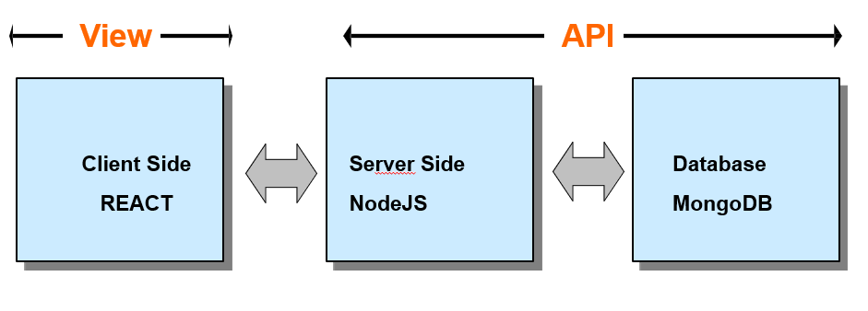

Model–view–controller is a software architectural pattern commonly used for developing user interfaces that divide the related program logic into three interconnected elements.

**2. Error Handling**

I faced many errors while working on backend api because there are lots of exceptions while handling the data and any problem can result in the failure in fetching data. Using the exception handling this issue was solved and the edge cases such as if cart is empty and product unavailability is handled.

**Performance**

**1. Reusability**

This website is used using React JS for frontend where every part of website is divided into components. Each component such as navbar, slider and many are reusable

**2. Application compatibility**

This web application is compatible with all most commonly used browsers such as Google Chrome, Mozilla Firefox , MS Edge, etc.

**3. Resource utilization**

When any product is searched in the search box, then all the products matching the query are displayed which includes product information. Each product info is of size 800 bytes.

**4. Deployment**

The code is deployed in GitHub.

**Conclusion**

E-commerce is continuously progressing and is becoming more and more important to businesses as technology continues to advance and is something that should be taken advantage of and implemented. This website helps in buying and selling products through internet.

**References**

1. <https://www.dotnettricks.com/learn/react/mern-stack-crud-operations-example>
2. <https://www.mongodb.com/>
3. <https://reactjs.org/>
4. <https://reactjsexample.com/e-commerce-website-using-the-mern-stack/>