Traveling Assistant

|  |  |
| --- | --- |
| Mehedi Hasan Khondoker |  |
| *Department of Computer Science and Engineering* |  |
| *Daffodil International University* |  |
|  |  |
|  |  |

***Abstract* - In this era ,We want all things easy by the side of**

**our hand.When we decided to go for a tour ,We want details about the places.User can register and login.**

I. Introduction

In this website people will find the place to visit Hotel. 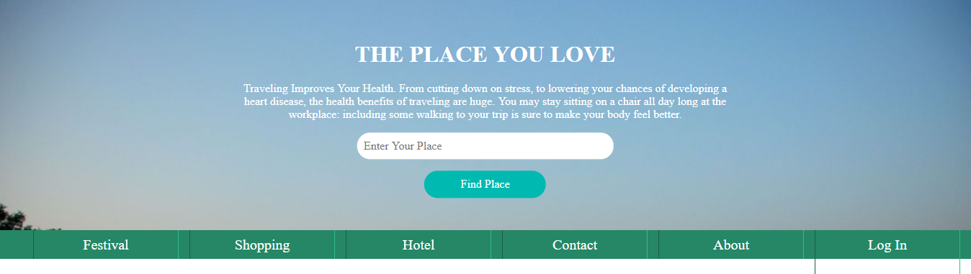

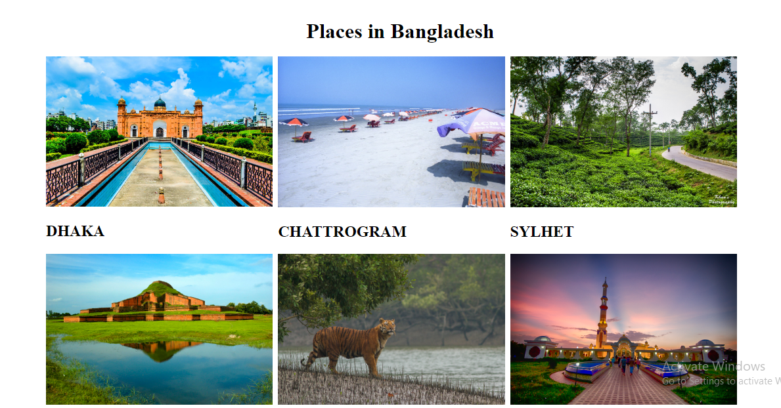



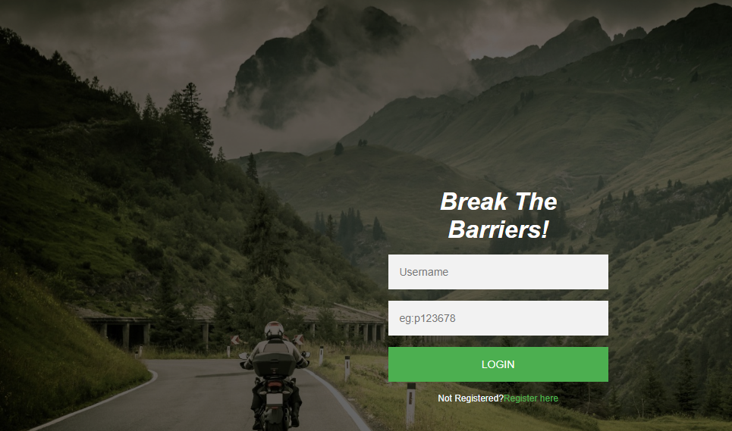

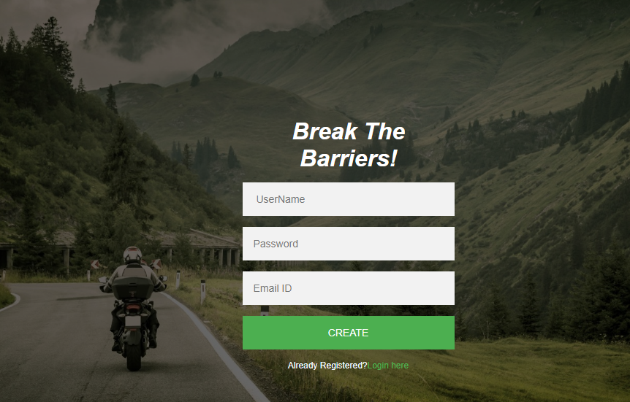

This every easy to find places and register as user.