Montecarlo simulation for semiconductors

Group:

Mattia Siviero s278053  
Marta Vona s269099

# Part 1

Write a Matlab program to compute the acoustic deformation potential scattering rate in GaAs according to the inelastic expression (3.59); plot the absorption and emission scattering rates as a function of energy, for different values of the temperature (e.g., T = 300K and T = 77K). Compare the results with the elastic approximation (3.54), see Fig. 3.6.

## Introduction

Phonons are quanta of lattice vibration, so they are associated to the displacements of ions from their equilibrium position. The phonon dispersion relation (momentum-energy relation) has as many branches as the number of atoms constituting the crystal basis. If all the atoms associated to a lattice site vibrate in phase the corresponding phonon is an acoustic phonon, so called because acoustic vibrations are in the frequencies covered by this branch and the branch itself is linearized around k = 0 to derive a linear dispersion relation for lower frequencies (where the linear coefficient is a velocity: the speed of sound). If the vibrations of atoms associated to a site are out of phase the phonon has higher energy and is defined as an optical phonon due to the possibility of being excited by EM radiation and emitting such radiations in ionic compounds like GaAs.

Phonons interact with electrons. Carrier-phonon interactions represent the scattering of said carriers by the ion lattice.

The scattering by phonons is either nonpolar or polar depending on the absence or presence of long range electric (dipole) field that can interact with electrons

## Deformation potential scattering by acoustic phonons (intravalley)

It is a nonpolar interaction due to the fact that the displacement of the ions from their equilibrium position cause a displacement of the ionic potential. In principle both acoustic and optical phonons contribute to this interaction, but here we consider only deformation potential scattering by longitudinal (eq = q/q) acoustic waves.

The inelastic acoustic scattering rate for a nonparabolic valley is

 

Where the expression in blue corresponds to absorption and the one in red corresponds to emission.

|  |  |
| --- | --- |
|  |  |
|  |  |

And

 is the Bose-Einstein distribution

While the integration limits are

 

The integrals are approximated by expanding the Bose-einstein distribution in terms of the variable

 with a Laurent series expansion



Where B2m are Bernoulli numbers

And using the asymptotic limit e**. z**for large z.

### Derivation of the integrals

For the integrals the Matlab symbolic toolbox has been used to determine an approximation up to the 12th order. The following expressions have been determined

|  |
| --- |
|  |
|  |
|  |
|  |

The full expression seen above has been used and the following plots have been determined:

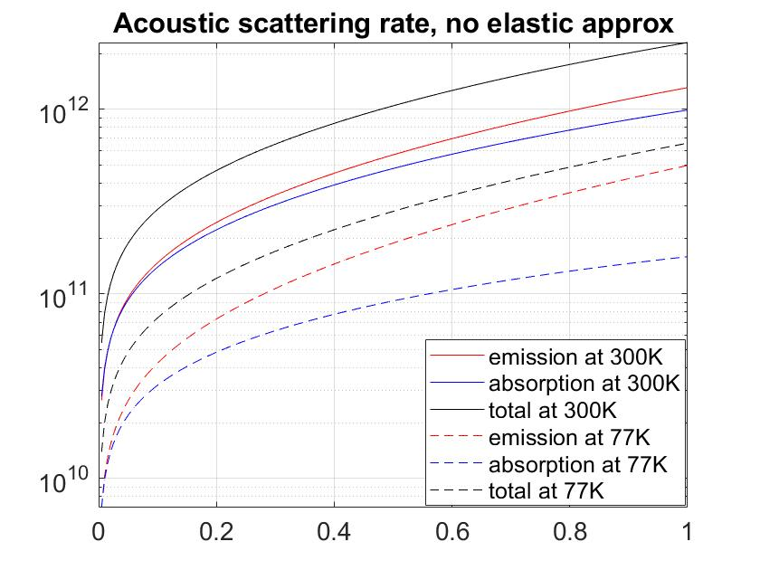

In this first plot all contributions are highlighted

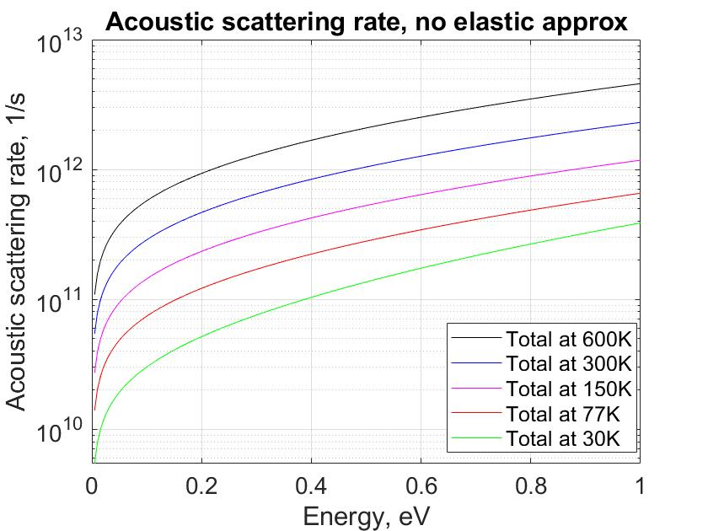

Here the full scattering rate is compared for various temperatures showing the esponential increase of the scattering rate one expects with the growing population of the phonon states, which diverges for growing T (z -> 0)

Another very clear observation is that, since the emission rate is proportional to NQ +1 and the absoption is proportional to NQ, as long as the temperature is low enough so that NQ is lower or comparable to 1 the ratio NQ/(NQ + 1) will be significantly smaller than 1, thus the spread between emission and absorption rate will be high

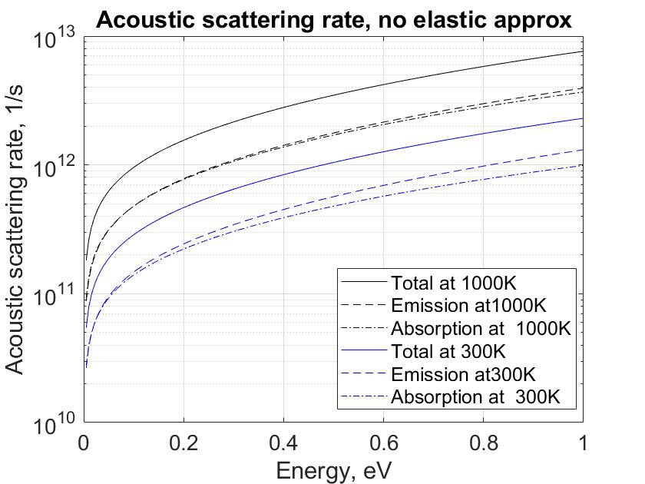

This difference will get small only close to the melting point, where spontaneous emission starts becoming negligible over the total scattering processes.

The elastic approximation assumes a negligible energy for the scattering phonon. This is not anymore valid if higher momentum phonons, carrying significant energies, are involved. The approximation thus fails for higher electron energies where transitions involve higher momentum variations.