Jet Bridge Air Speed Reconstruction
  - Interpolation and support vector regression with experimental and CFD comparisons
MMA3001 Numerical Methods and Machine Learning | Matthew Brasacchio | 33858659
27 October 2026 | https://github.com/matt-b-0/jetbridge-ml-cfd

Abstract
Sparse ventilation measurements leave much of a jet bridge cross-section unobserved. This investigation compares a retained-sensor mean, nearest neighbour, linear interpolation, thin-plate radial basis function interpolation and support vector regression using 36 FAA/NRC replicate-average datasets from one apparatus. Nested held-location evaluation gives mean supported-region RMSE of 0.04959 m/s for RBF and 0.05774 m/s for SVR. RBF improves on the mean baseline by 26.7%, but its average advantage over SVR is concentrated at the 58 ft station. Separate OpenFOAM virtual-sensor studies show that boundary coverage affects whole-plane reconstruction. The isothermal CFD has positive bias against the matched experiment, so agreement with CFD cannot establish physical accuracy. Controlled timing shows that all methods are practical for these small arrays. The recommended use is exploratory spatial reconstruction with an explicit support mask; the evidence does not establish suitability for ventilation compliance or disease-risk assessment.

1 Engineering question and intended use
The engineering question is how accurately a limited sensor array can reconstruct scalar air speed within a bridge cross-section, and whether SVR offers useful improvement over simpler interpolation. A ventilation engineer could use such a reconstruction to identify regions that warrant additional measurements. The reconstruction is accompanied by experimentally evaluated predictive errors and an explicit indication of regions outside the training sensor hull. These measures identify important limitations, although they do not provide calibrated uncertainty at every predicted location.
Three comparisons are kept separate. Held-location experimental tests assess prediction of measured speed. Virtual sensors sampled from CFD assess reconstruction of a numerical field with known spatial coverage. Matching CFD to an experimental run assesses whether that numerical field represents the apparatus. The same error metric can be used in each comparison, but its reference and engineering meaning differ.

Scope and contribution
The primary study concerns the approximately isothermal empty bridge. Thermal calculations are a diagnostic extension and are excluded from trusted reference fields and ML training. The project contributes reproducible spatial evaluation, comparison with simple baselines, a controlled sensor-layout experiment, and quantitative checks on numerical sensitivity. It does not resolve airflow direction from hot-sphere speed measurements or simulate passenger exposure.
The report develops the data and methods, interprets experimental and CFD results, and evaluates robustness and cost. Ten main pages are followed by references and four supporting appendices. Experimental processing, interpolation, machine learning and CFD interfaces remain separate modules in the repository [4].

2 Experimental data geometry and data contract
The S01-A-HN subset contains 36 replicate-average files and 504 sensor means at nine stations from 10 to 58 ft. Thirty files use 12 positions; six at 58 ft use 24 positions assembled sequentially from A/B measurements. Replicates share one apparatus. Station measurements are not simultaneous and supplied flow varies [1,2].
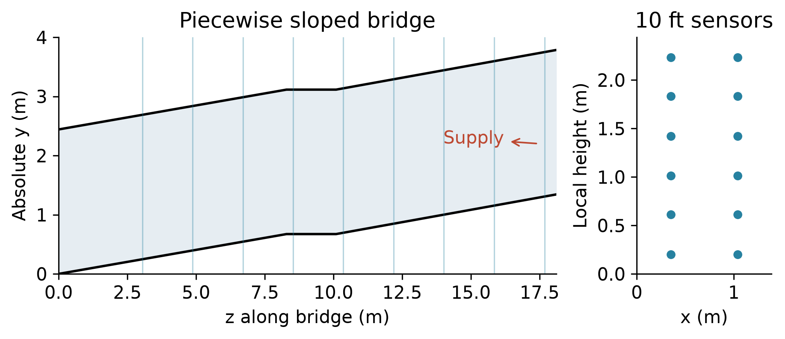
Figure 1. Source laboratory geometry and the matched 10 ft array. The sloped floor must be included when converting local sensor heights to absolute laboratory height.
Table 1. Accepted data formats units and handling of unsupported data
Input or output | Contract and unsupported cases
Experimental input | FAA 03-Averages BLOCK .txt; unique coplanar absolute x, y, z in metres; scalar speed in m/s; replicate ID retained.
Boundary and audit input | HVAC and raw sensor CSV, with source time windows and units checked; supplied L/s divided by 1000 gives m³/s.
CFD input | Exported CSV coordinates in metres and U components / speed in m/s; numerical reference kept separate.
Prediction output | CSV scalar speed in m/s plus hull membership, source/run identifiers and held-location residuals where observed.
Invalid observations | −9999 speed becomes missing and is excluded; duplicate/invalid coordinates, negative/infinite source speeds or nonplanar arrays are rejected.
Unsupported queries | Linear returns NaN outside the training hull; nearest, RBF and SVR extrapolate and are flagged. Negative predictions are not silently clipped.

The retained frame uses x across width, y above the laboratory floor and z along the bridge. Feet convert with 0.3048; inches with 0.0254. A local height needs the floor offset; published absolute metre coordinates must not receive it again. Width is 1.388618 m, clear height 2.441448 m and length 18.10512 m. Four defining sections and all block vertices were audited; the documented 0.127 mm upper-ceiling difference remains.
The full 12-point hull covers 41.3% of physical cross-sectional area and the 24-point hull 49.7%; outer-held-location hulls cover 37.1–41.3% and 48.0–49.7%, respectively. These area fractions are not the 71.43% of withheld targets supported in evaluation. Hot-sphere speed is not signed axial velocity, and HVAC supply is not an exact flux identity for each experimental plane.

3 Models and spatial evaluation
Every model receives the same retained sensor coordinates and measured scalar speeds within a run. Predictions are assessed at withheld locations. The mean baseline predicts the mean retained speed. Nearest neighbour gives a simple local reference; linear interpolation uses the triangulation and returns no value outside its training convex hull. The hull is the polygon enclosing retained coordinates, not a confidence region.

Why RBF and SVR
Thin-plate RBF uses the kernel φ(r) = r² ln(r), a degree-one polynomial term and zero smoothing. It tests exact, globally smooth interpolation between sparse measurements. Zero smoothing is deliberate as an interpolation baseline, but it also passes measurement noise through the sensors. Smooth appearance therefore does not imply robustness. The geometry-based perturbation analysis on page 8 examines this limitation directly [6].
SVR uses the radial kernel K(a,b) = exp(−γ‖a−b‖²). The penalty C controls the cost of deviations beyond the epsilon tube, γ controls spatial variation and epsilon sets an insensitive error scale. Training-only coordinate standardisation makes width and height comparable. This is the unit topic of support vector regression applied to a small spatial regression problem; it allows a regularised alternative to exact interpolation [5].
Gaussian process regression was a plausible alternative in the initial scope. SVR was selected as a bounded comparison aligned with the taught topic and the implemented evaluation workflow. At 11 or 23 retained sensors, computational cost is not a convincing reason to exclude GPR. GPR was not tested, so this study makes no ranking against it. Its predictive intervals would require explicit kernel and noise assumptions and a calibration check [7].
Table 2. Predeclared SVR search grid
SVR parameter | Training search values
C | 0.1, 1, 10
gamma | 0.1, 1
epsilon in m/s | 0.002, 0.01

The small grid is not established as sufficient: C = 0.1 is selected in 243/504 folds (48.2%), so stronger regularisation may be requested. Gamma and epsilon each have only two endpoint candidates. An exploratory extension adds C = 0.01 using the same nested splits; Appendix C reports its separate results. It does not justify claiming globally optimal SVR settings.

Nested validation and common support
Each file contains one averaged speed at each unique sensor position. Separate files are not pooled. The outer leave-one-location-out split trains on 11 and tests on 1 point for 12-point layouts, or trains on 23 and tests on 1 for 24-point layouts. Inner three-fold tuning groups unique locations, with training-only scaling. There are no multiple observations to group at a position in these averaged fits; grouping protects location separation in the reusable implementation.
All five methods are compared on the same 360 targets supported by linear interpolation, or 71.43% of 504 observations. The remaining 144 targets are evaluated separately for methods that extrapolate. Reported RMSE, MAE and bias are calculated within each run and then averaged equally over runs. Bias is prediction minus observation. These are internal spatial generalisation estimates for one apparatus and configuration, not external physical validation.

4 What the experimental models reconstruct
The matched 10 ft replicate provides a concrete view of the reconstruction. Full-array refits in panels B and C are illustrative fitted surfaces; panel D contains actual outer held-location errors. There is no continuously measured experimental truth between sensors. Black hull boundaries and hatching distinguish extrapolation. The annotation reports physical area coverage; unhatched colour is still a fitted estimate, not calibrated local certainty.
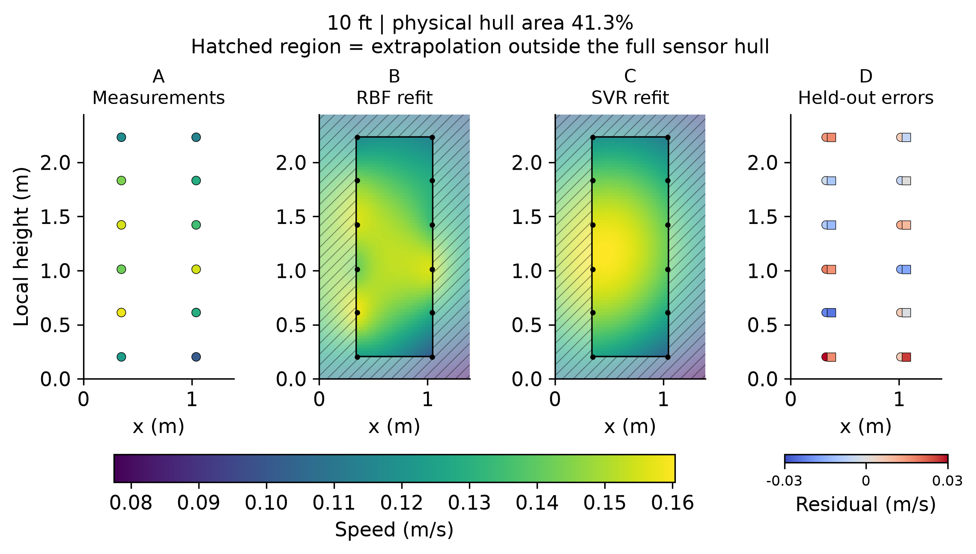
Figure 2. S01-A-10-HN-1 measurements and full-array refits on a common speed scale. Hatching marks extrapolation; only 41.3% of physical area lies within the full-array hull. Panel D shows prediction-minus-observation residuals from location withholding, with circles for RBF and squares for SVR; small horizontal offsets distinguish methods. The refits do not generate the reported cross-validation scores.
Both models place higher speeds around the middle heights and lower speeds near the sampled top and bottom. RBF retains more local variation between the two sensor columns; SVR smooths these lobes. On the plotted grid, RBF spans 0.0826–0.1581 m/s and SVR 0.0775–0.1604 m/s; neither predicts negative speed in this example. Their boundary predictions differ without measurements there to establish which is correct. Exact agreement at retained RBF sensors is a fitting property, not a prediction test.
Across all common supported experimental targets, RBF RMSE is 0.04959 m/s, linear 0.05524, SVR 0.05774, the mean 0.06765 and nearest 0.07129. Full MAE/bias and extrapolation tables are in Appendix D. RBF improves on the mean by 26.7% and on SVR by 14.1%, using each comparator as denominator.
The 360 evaluated target speeds have median 0.1765 m/s and interquartile range 0.1380–0.4223 m/s. RBF RMSE is about 28.1% of that median; this scale ratio is not mean percentage error, nor a calibrated local error bar. Substantial prediction error remains despite a favourable relative ranking.
No acceptance threshold has been specified. These results support approximate pattern screening and planning measurements, not precise minimum-speed guarantees, ventilation compliance or disease-risk assessment. An engineer should mark extrapolation, inspect held-location residuals, and add sensors in weakly supported regions before relying on local differences. A mean baseline is reasonable where spatial detail is unnecessary.

5 Variation between stations
Paired differences compare RBF and SVR within each run using identical supported targets. RBF wins in 21 of 36 runs and SVR in 15. These counts are descriptive: the files share apparatus, layouts and operating conditions and are not 36 independent facilities or geometries. The equal-run mean RBF-minus-SVR RMSE is −0.008151 m/s, whereas the median is only −0.000575 m/s. The much smaller median shows that a few strong advantages influence the overall average.
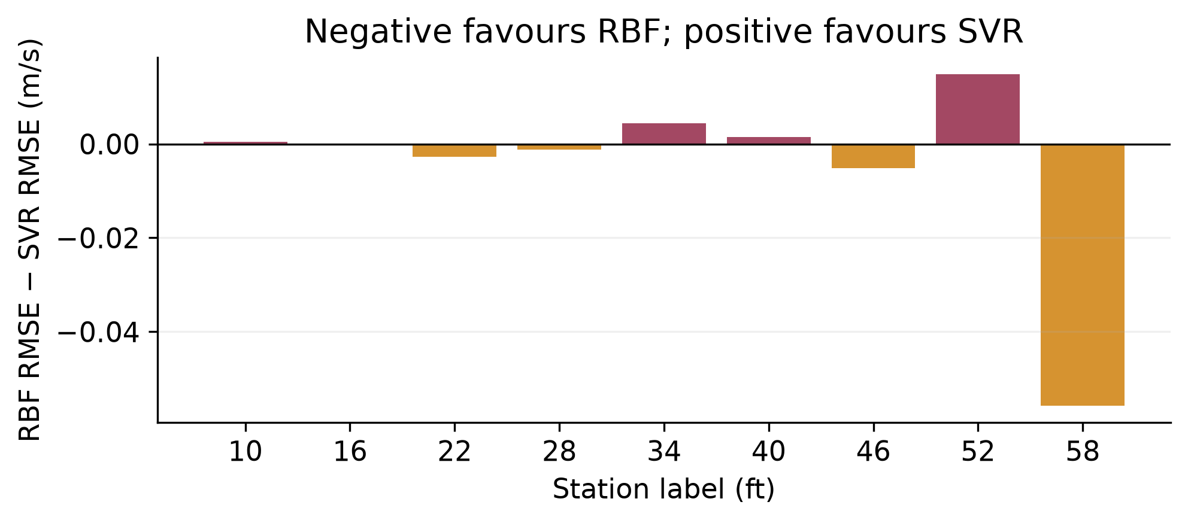
Figure 3. Mean paired RBF-minus-SVR RMSE at each station. Negative values favour RBF. The 58 ft station is also the only station with the 24-point layout; station and sensor density are confounded.
Table 3. Paired experimental comparisons by source layout
Group | Runs | Mean RBF minus SVR RMSE
12-point layouts | 30 | +0.001385 m/s
24-point layouts at 58 ft | 6 | −0.055829 m/s
All runs equally weighted | 36 | −0.008151 m/s

The 12-point group slightly favours SVR on average, while the 24-point group strongly favours RBF. Giving each station equal weight reduces the overall RBF advantage to 0.004884 m/s. This sensitivity to aggregation is scientifically meaningful: an overall score depends on which operating locations the dataset represents.
It would be incorrect to infer that adding sensors causes RBF to improve by the observed amount. The denser layout occurs only at 58 ft and uses sequential A/B acquisition. Position, local flow structure, operating conditions and density change together. A hypothesis that the denser array resolves a more complex field is plausible, but this dataset cannot isolate that mechanism. The controlled CFD layout study addresses geometry of sampling without removing the experimental confounding.
The 58 ft results are retained because removing an inconvenient station would distort the defined study population. Conversely, allowing that station to determine a universal recommendation would overstate generality. The defensible conclusion is conditional: RBF is the strongest aggregate interpolation baseline, while the implemented SVR is competitive on the more common 12-point layouts. Broader claims require an independent layout or operating-condition test. Figure 9 in Appendix D shows the decisive 58 ft example: SVR smooths a high-speed row, while RBF retains more variation but predicts unphysical negative speed outside the hull. Neither relative advantage nor visual fit establishes adequate pointwise accuracy.

6 CFD model assumptions and credibility
The matched S01-A-10-HN-1 case is a simplified sealed bridge. The chosen steady k–epsilon RANS model provides an inexpensive engineering baseline for a mean turbulent flow, but its applicability to this low-speed apparatus has not been independently established. Full-face inlet/outlet boundaries omit the real perforated diffuser and exhaust plenum.
Table 4. Isothermal CFD specification verified against the case dictionaries
Parameter | Actual baseline dictionary or check
Solver and fluid | OpenCFD v2412 patch 260127; simpleFoam; steady incompressible isothermal RANS; ν = 1.5 × 10⁻⁵ m²/s.
Inlet and outlet | Inlet flowRateInletVelocity Q = 0.533865517 m³/s toward −z; inlet p zeroGradient. Outlet p fixedValue 0 m²/s² gauge; U pressureInletOutletVelocity.
Walls | No-slip, impermeable. kqRWallFunction, epsilonWallFunction and nutkWallFunction; no wall inflation layers.
Turbulence boundaries | Fixed inlet k = 9.29896 × 10⁻⁵ m²/s² and epsilon = 1.18900 × 10⁻⁶ m²/s³; outlet inletOutlet with same reverse-flow values. Assumed intensity 5%, length 7% of hydraulic diameter; not measured.
Schemes and relaxation | Bounded upwind convection for U, k and epsilon; corrected linear Laplacian; pressure relaxation 0.3, equation relaxation 0.6; one nonorthogonal corrector.
SIMPLE stopping criteria | Initial residual screens p < 10⁻⁴, U < 10⁻⁵, k and epsilon < 10⁻⁵. Converged at 237. Linear-solver tolerances are separate from these stopping criteria.

At iteration 237 the configured SIMPLE residual screens are satisfied, with reported global continuity error 4.00 × 10⁻¹¹. Final sensors and patch fluxes were postprocessed at the saved field; complete residual values are retained in the repository [4]. These checks establish numerical consistency with the equations and stopping criteria, not correct physical boundary assumptions.
The prescribed volumetric flow establishes the inlet mass-flow condition, and continuity checks consistency of the computed solution. Neither guarantees a correct local speed profile. The idealised full-face supply can differ materially from the real diffuser even when its net flow is correct. Wall treatment, omitted leakage and the steady turbulence assumption add separate modelling uncertainty.
Saved-field y-plus postprocessing gives wall minimum 10.0, maximum 27.1 and patch average 18.7. This is neither viscous-sublayer resolution nor comfortably high log-layer placement; wall treatment needs reassessment [8]. It is a model limitation, not proof of the cause of disagreement. Coarse/baseline/fine meshes contain 17,664 / 141,312 / 476,928 cells and all pass checkMesh. Baseline-to-fine sensor RMSE is 0.001423 m/s and dense-section relative L2 difference 4.54%; mesh independence is not established.
Cell-point sampling at 12 matched sensors gives RMSE 0.03977 m/s, bias +0.03667 m/s and r = 0.489. Appendix D shows observed temporal variability: SD is 0.0119–0.0287 m/s, not standard error or a confidence interval. The bias is 20.8% of the evaluated-target median 0.1765 m/s, a scale comparison across different populations. Coordinate-choice sampling RMSE is only 0.000293 m/s. Neither a conserved field nor a good surrogate removes physical CFD bias.

7 Spatial CFD errors and the original discrepancy
The 28 ft numerical example uses 24 hybrid virtual sensors and disjoint candidate/reference grids. It tests reconstruction of the saved CFD field, not experimental truth. The larger panels expose where a plausible reconstruction misses local structure.
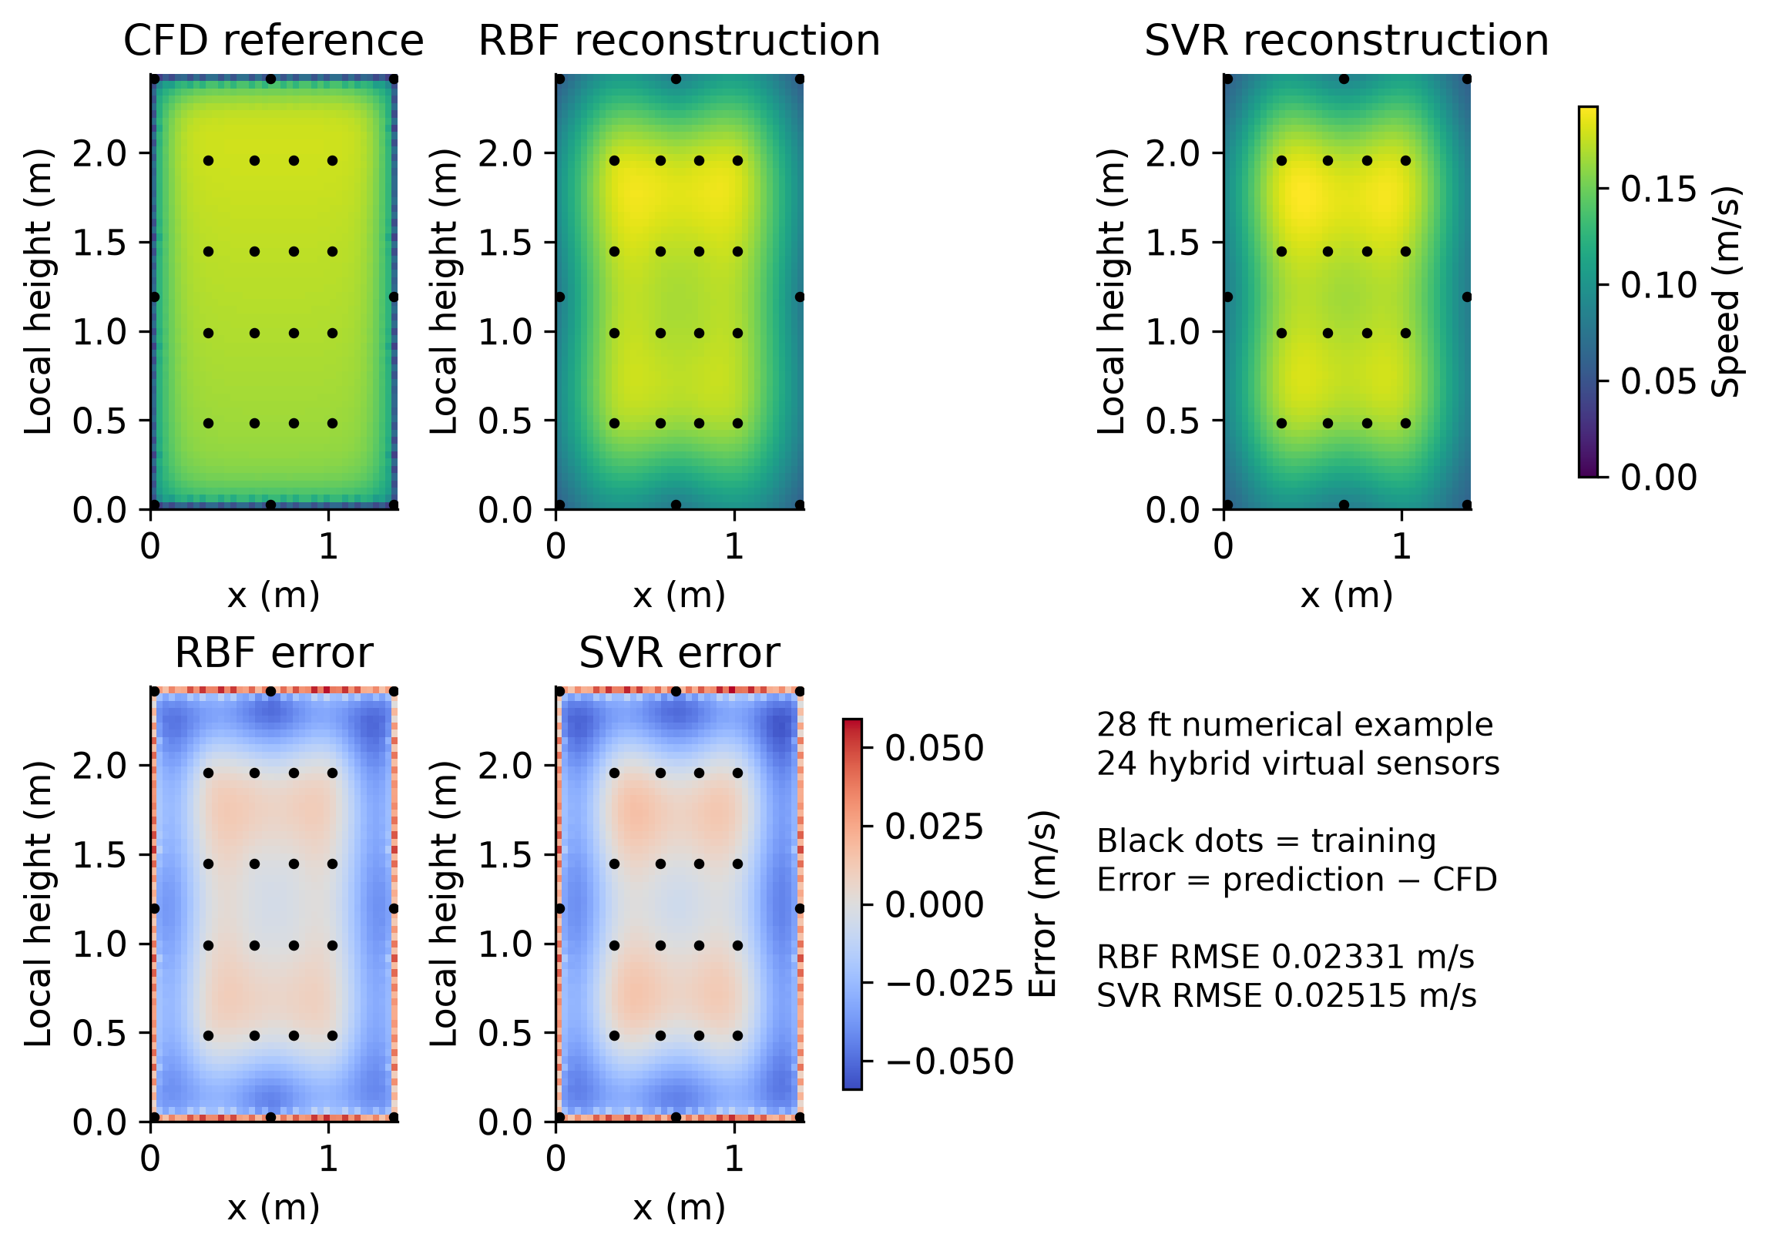
Figure 4. CFD reference and RBF/SVR reconstructions above; signed full-section errors below. Shared scales support comparison, and black dots mark training samples. Neither smoothness nor net-flow consistency establishes agreement with the physical apparatus.
Both methods recover the broad high-speed core but smooth its near-wall gradient. Underprediction bands just inside the walls coexist with overprediction in the outermost sampled band. Whole-plane RMSE is 0.02331 m/s for RBF and 0.02515 for SVR; maximum absolute errors reach 0.05750 and 0.05904 m/s. These maps explain why boundary coverage and the intended prediction domain matter.
Across planes, 24-sensor hybrid placement reduces baseline RBF error from 0.03388 to 0.02658 m/s and SVR from 0.03365 to 0.02844 m/s versus interior placement. An average benefit persists at 80% supply flow with refitted models, but not at every plane. This is exploratory layout transfer with new sensor values, not frozen-model generalisation.
The motivating high-upstream/low-downstream experimental discrepancy remains unresolved. A matched 10 ft audit cannot establish a station trend; different HVAC flows and sequential windows make an unmatched error curve misleading. Resolving it requires station-specific matched boundary/window cases, repeatability context and directional measurements if net flux is inferred. Diffuser, leakage and turbulence explanations remain hypotheses.

8 Sensitivity and observed measurement variation
For fixed geometry, linear-in-values interpolation has û(q) = Σwᵢ(q)uᵢ. A bounded input perturbation |δuᵢ| ≤ ε implies |δû(q)| ≤ εΣ|wᵢ(q)|. On the standardised full 12-sensor geometry, the maximum RBF gain is 1.468 inside and 2.829 outside the hull; nearest and supported linear interpolation have gain 1. Rounding alone at ±0.0005 m/s would give small bounds of 0.000734 and 0.001415 m/s. It does not represent dominant experimental variation.
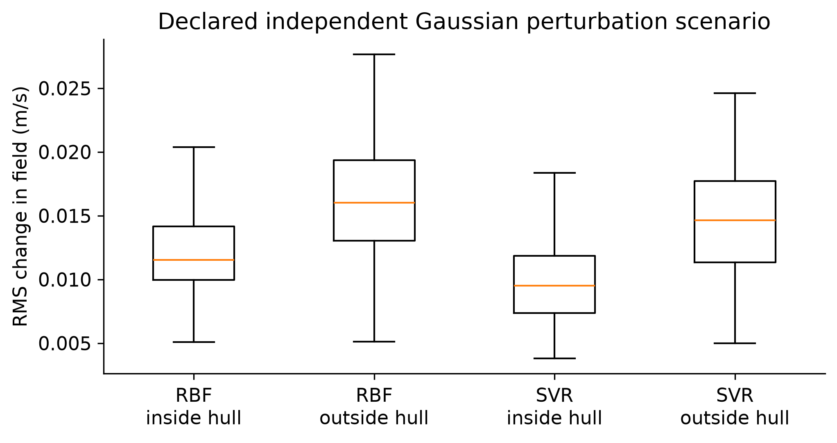
Figure 5. Two hundred common perturbation draws applied to both models at the matched 10 ft geometry. Box centres are medians, boxes are Q1–Q3 and whiskers extend to points within 1.5 IQR. This is a sensitivity scenario based on observed between-run variation, not a predictive uncertainty interval.
Six 10 ft replicate-average datasets give location-wise sample SDs of 0.00576–0.03346 m/s. Each draw adds centred independent Gaussian perturbations with these SDs to the matched replicate speeds, refits both methods and evaluates RMS change over a fixed section grid. The SVR parameters selected on the full original 12-point dataset are frozen (C = 1, gamma = 0.1, epsilon = 0.002), so changes reflect response to data perturbation rather than retuning. RBF retains zero smoothing.
Median RMS change is 0.01153 m/s inside and 0.01602 outside for RBF, versus 0.00952 and 0.01463 m/s for SVR. Corresponding interquartile intervals are 0.00997–0.01417, 0.01305–0.01935, 0.00736–0.01184 and 0.01134–0.01771 m/s. In this constructed scenario SVR changes slightly less, while both methods are more sensitive outside the hull. This does not establish a general robustness ranking.
Between-run variation also contains operating changes: the six files do not hold supplied flow exactly constant. It is labelled observed variation rather than pure instrument uncertainty or controlled repeatability. The independent Gaussian perturbations omit spatial/time correlation and physical co-variation. Real flow variations may move neighbouring sensors together; correlated perturbations could change the comparison. This is a specified sensitivity scenario, not realistic sensor noise established from calibration. No perturbed result changes the original held-location scores.
Zero smoothing preserves local measured features but also input variation. SVR regularisation trades some fit for reduced response in this scenario. A future smoothing comparison should tune only within inner folds and use documented uncertainty or matched-repeat data. Appendix B retains the reduced diffusion verification as a separate taught-method exercise; it cannot diagnose nonlinear CFD convergence.

9 Computational cost variability and reproducibility
The controlled benchmark withholds the first source location in each of 36 files, leaving n = 11 or 23 training sensors. All methods receive identical retained data, one held-out query and a 2,400-point grid. A warm-up precedes 20 repetitions with shuffled method order, one numerical thread and file I/O excluded. Fitting includes required preprocessing; prediction includes query transformation.
Table 5. Timing medians and within-run repetition variability at eleven retained sensors
Method | Fit n = 11 sensors  ms median [Q1–Q3] | Predict 2400 points n = 11  ms median [Q1–Q3]
Mean | 0.014 [0.013–0.016] | 0.0022 [0.0021–0.0025]
Nearest | 0.38 [0.36–0.47] | 0.44 [0.41–0.50]
Linear | 0.49 [0.45–0.60] | 0.20 [0.18–0.23]
RBF | 0.42 [0.38–0.50] | 0.45 [0.42–0.51]
SVR | 0.95 [0.87–1.18] | 0.71 [0.67–0.78]

Q1, median and Q3 are calculated across repetitions within each run, then each statistic is summarised by its median across runs. These are typical repetition quartiles, not confidence intervals or pooled cross-run quartiles. The n = 23 results are in Appendix C. At n = 23, median fit/dense-prediction costs are 0.43/0.74 ms for RBF and 0.93/1.31 ms for SVR. Linear may return NaN outside its hull; faster computation is not equivalent coverage.
The separate 12-candidate, three-fold SVR search plus final fit takes median 47.2 ms at n = 11 and 52.4 ms at n = 23 over three repetitions per file. All selected settings reproduce the saved nested-fold choices. A deployment that retunes each new array must include this cost; a deployment with frozen parameters does not. Search dominates SVR fitting, yet approximately 0.05 s is still practical for this offline task. Current accuracy and coverage provide stronger selection grounds than runtime.
The recorded system is WSL2 on an Intel i7-1165G7 at 2.80 GHz, using NumPy 2.5.4, SciPy 1.18.1 and scikit-learn 1.9.1. Scheduling contributes variation, especially for very short mean timings. The 11-to-23 comparison does not establish large-data scaling. Dense global RBF has quadratic matrix storage and approximately cubic direct-solve work; SVR cost depends on support vectors and the optimisation problem. Tracemalloc records omit some native/process memory and are not a total-RAM comparison.

Evidence that can be reproduced
The repository separates experimental processing, interpolation, ML and CFD interfaces. Scripts save hashes, split audits, search records and benchmark repetitions. The report extension adds source, selected input evidence, figure data and a test report; 82 tests pass. Generated HTML/API documentation is included. The required FAA/NRC subset and archived CFD samples are bundled with hashes and attribution. The run_all.py live profile regenerates figures and runs the baseline CFD case; full fields are regenerated rather than committed. The accompanying submission audit distinguishes local reproducibility from public availability; the final-review audit records the published revision separately from the document packaging commit. Project code is published under the MIT licence; external FAA/NRC data retain CC BY 4.0 attribution.

10 Engineering conclusions and remaining work

What the evidence supports
The central finding is that reconstruction quality depends substantially on measurement coverage and geometry; a more flexible regression method does not consistently compensate for sparse sampling. RBF is the strongest aggregate supported-region baseline and improves on the mean by 26.7%, but its advantage over SVR is concentrated at the 58 ft layout. The common 12-point datasets slightly favour SVR. This is a conditional result for one apparatus, not a universal model ranking.
The spatial plots explain why the distinction matters. Both models produce a plausible smooth experimental core, but more than half the physical section lies outside the full measured hull. In the CFD example, broad core agreement coexists with near-wall error bands. Numerical reconstruction can therefore look convincing while missing regions important to a ventilation decision. Neither model supplies calibrated uncertainty at every location.

Practical recommendation
Use RBF and SVR as paired exploratory reconstructions, show measured points and the sensor hull, and report held-location errors in m/s. Use disagreement and weak coverage to plan further measurements, rather than to certify local airflow. Select the simplest method that meets a predeclared engineering tolerance on independent matched observations. With this workload, including SVR search cost does not make computation a limiting factor.
The next priorities are a predeclared layout test that balances interior and boundary coverage; a matched-condition CFD comparison across stations; and a near-wall/turbulence assessment informed by the observed y-plus range. Inlet diffuser and leakage evidence should accompany that assessment. Reducing a surrogate’s error against CFD cannot remove CFD’s physical bias, and matching net flow does not ensure the correct spatial speed distribution.

Thermal extension
The cold-supply extension uses an unmeasured wall-temperature surrogate and remains unconverged. Bounded temperature and relative flux imbalance 1.23 × 10⁻⁶ coexist with failed residual and probe-stationarity screens. SIMPLE iteration is not physical time. These diagnostic fields remain excluded from trusted training/reference data; Appendix A records the details.

AI Use and Individual Learning
This project developed from my previous experience investigating CFD simulations of the jet bridge and identifying discrepancies between experimental airflow measurements and numerical predictions. I established the engineering objectives and directed the investigation towards comparing numerical interpolation and machine learning methods, with OpenFOAM providing an additional reference for evaluating spatial reconstruction.
I used ChatGPT to assist with initial project planning and Codex extensively to support Python implementation, debugging, automated testing, visualisation and report development. My focus was on understanding the numerical methods, assessing their suitability and critically interpreting the results rather than relying solely on generated outputs.
Throughout the project, issues involving coordinate conversion, sensor measurement windows and CFD convergence highlighted the importance of verification. In particular, investigating the disagreement between experimental measurements and mass-conserving CFD predictions reinforced my understanding that numerical convergence does not establish physical accuracy.
The project strengthened my understanding of interpolation, regression, numerical validation and computational modelling. AI accelerated the development process, while the engineering objectives, interpretation of limitations and final conclusions remained central to my contribution.

References
[1] Lebbin, P., Laengert, S., Howell, S. and Jeans, L. (2026). Communicable Disease Transmission in Air Travel: Jet Bridge Ventilation. DOT/FAA/AM-25/28. Federal Aviation Administration, July. Supplied report dot_92576_DS1.pdf.
[2] FAA/NRC (2026). Jet bridge ventilation dataset, JetBridge_2026. https://doi.org/10.21949/qqdx-gh59. Experimental records, replicate means, HVAC records and data dictionary.
[3] MMA3001 teaching team (2026). Numerical Methods and Machine Learning Project Brief. Supplied assessment document. The main report has a ten-page maximum excluding references and appendices.
[4] Jet bridge project repository (2026). jetbridge-ml-cfd. https://github.com/matt-b-0/jetbridge-ml-cfd. Implementation and evidence commit 513e94da8281fd98604d0e702ff7493127115e2a, generated 27 October 2026. Repository availability and clean-clone checks are recorded in the final-review audit. See docs/assumptions.md, docs/ai_usage_log.md and saved result manifests. The final submitted clone must include the recorded implementation revision and its external-data regeneration instructions.
[5] scikit-learn developers (2026). SVR API reference. https://scikit-learn.org/stable/modules/generated/sklearn.svm.SVR.html. Accessed 25 October 2026.
[6] SciPy developers (2026). RBFInterpolator API reference. https://docs.scipy.org/doc/scipy/reference/generated/scipy.interpolate.RBFInterpolator.html. Accessed 25 October 2026.
[7] scikit-learn developers (2026). Gaussian processes user guide. https://scikit-learn.org/stable/modules/gaussian_process.html. Accessed 25 October 2026.
[8] OpenCFD. nutkWallFunction and yPlus documentation. https://doc.openfoam.com/2312/tools/processing/boundary-conditions/rtm/derived/wall/nutkWallFunction/ and https://doc.openfoam.com/2212/tools/post-processing/function-objects/field/yPlus/. Accessed 25 October 2026. Installed v2412 dictionaries and saved-field output supply the case-specific values.

Data and code provenance
Selected raw records are bundled in Git; full OpenFOAM fields are regenerated. Derived report figures and benchmark tables are generated from the existing saved analysis. Experimental metrics use equal-run aggregation on common support. CFD layouts, the three-dimensional surrogate and noise-gain diagnostics use different evaluation designs, identified in their captions and accompanying text. No thermal field is included as trusted training data.

Appendix A Thermal diagnostic results
These results document an unsuccessful numerical extension. They must not be interpreted as a validated thermal ventilation prediction. The original buoyant run diverged with maximum speed above 62,000 m/s. The subsequent restart saved a field at iteration 967 even though its log reached 1000; continuation starts from the saved field and ends at 1967. Relaxation and initialisation differ from the zero-gravity control, preventing attribution of field differences solely to converged buoyancy.
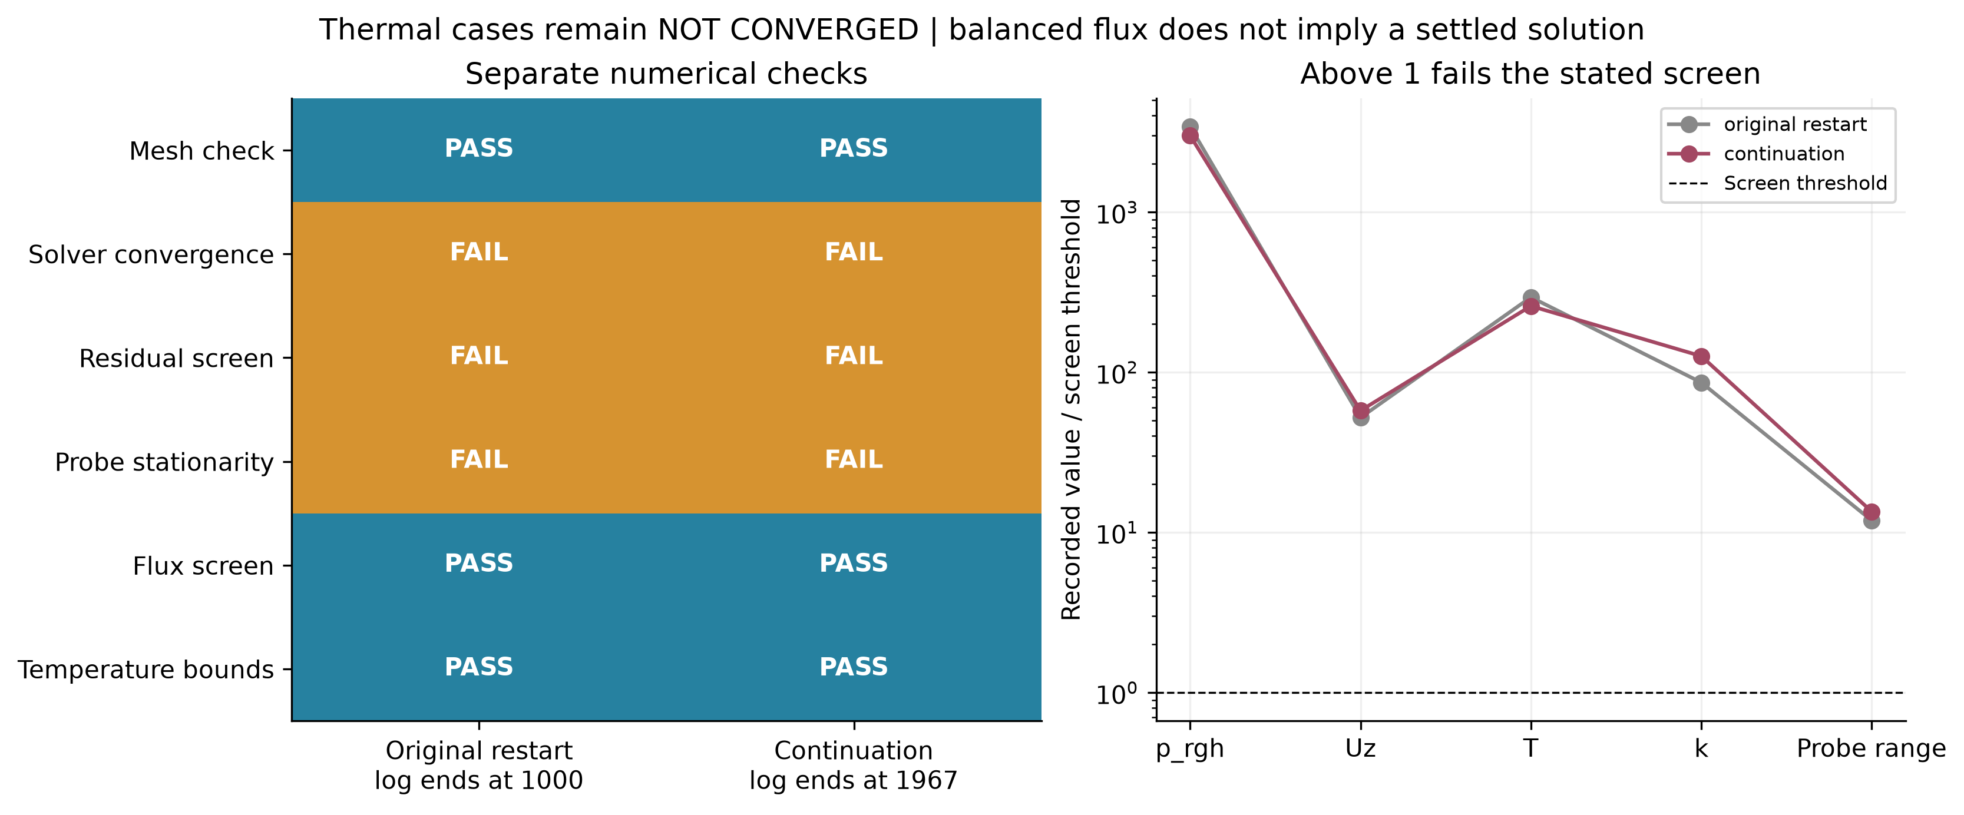
Figure 6. Thermal residual, stationarity and conservation screens. Ratios above one fail the stated diagnostic threshold. Low flux imbalance does not override failed residual and stationarity checks.
Maximum speed in the continuation is about 5.10 m/s. Bounded temperature reflects only one aspect of numerical behaviour. A useful next experiment would predefine boundary assumptions, initialisation, relaxation and stopping criteria, then change one factor at a time. A transient formulation would require its own time-step and temporal-accuracy assessment; switching formulation is not evidence of success.

Appendix B Reduced diffusion stability study
A separate one-dimensional diffusion problem provides a known analytical reference for finite-difference verification. It connects finite differences, ODE stability, implicit solution and relaxation to the unit syllabus. It does not diagnose the steady nonlinear OpenFOAM failure or establish a physical CFL limit for SIMPLE.
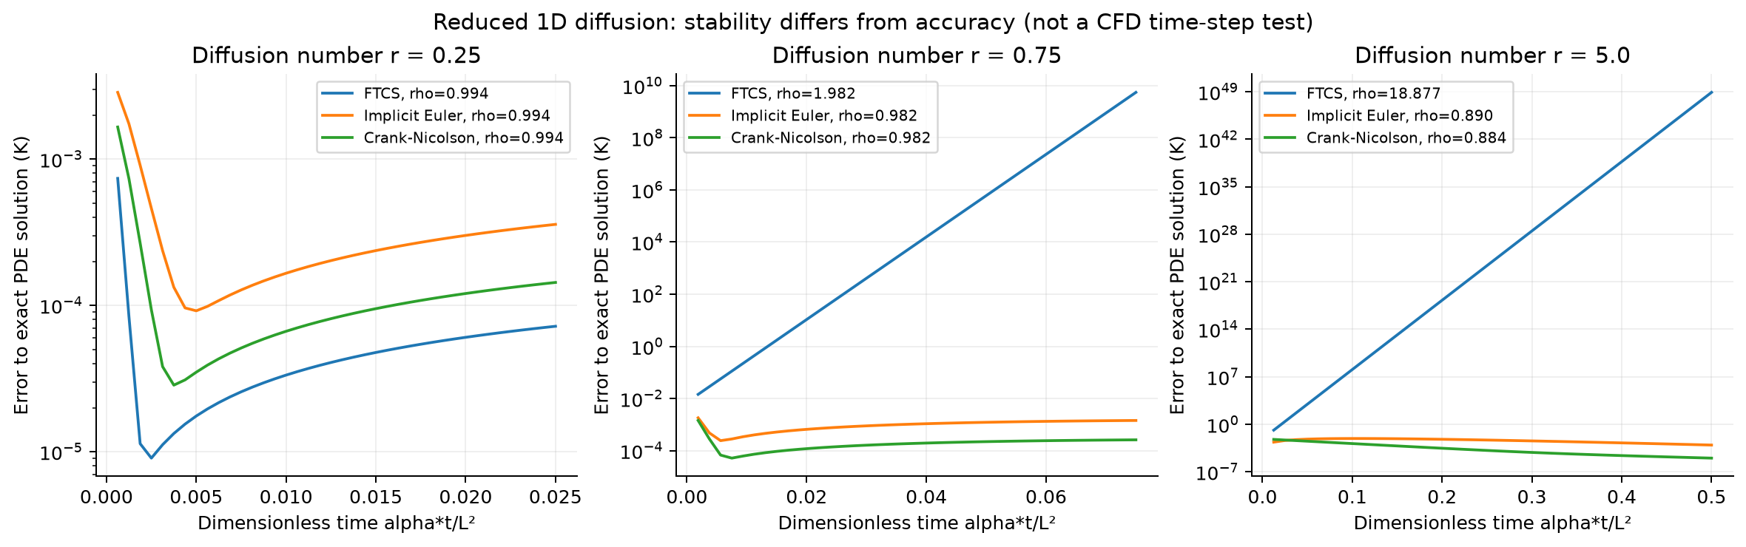
Figure 7. Reduced diffusion verification using FTCS, backward Euler and Crank–Nicolson. Stability and accuracy are separate properties; an implicit stable scheme can still have substantial time-discretisation error.
For diffusion coefficient α, the dimensionless step is r = αΔt/Δx². Standard one-dimensional FTCS requires r ≤ 1/2 for stability. Backward Euler and Crank–Nicolson allow larger steps in the linear diffusion problem, but large steps can reduce accuracy; Crank–Nicolson can retain oscillatory high-frequency modes. Refinement and analytical comparison are therefore necessary alongside a stability condition.
Weighted-Jacobi relaxation and temporal refinement are retained in the reproducible study. Their role is to test numerical mechanisms against a known solution. The main report instead prioritises sensitivity on the actual sensor geometry, which bears directly on interpolation robustness. This separation prevents a successful simplified test from being presented as validation of a more complex CFD calculation.

Appendix C Parameter selection and timing details
Across 504 outer folds, C reaches the lower endpoint in 243 cases (48.2%) and the upper endpoint in 65 (12.9%). The remaining 196 select C = 1. Every selected gamma and epsilon is necessarily an endpoint because each has only two candidates. These counts do not establish where an unconstrained optimum lies; extension beyond the grid is warranted before claiming sufficient optimisation. The median within-fold spread between best and worst candidate inner RMSE is 0.01585 m/s.
Table 6. Frequency of each training-only SVR choice over all outer folds
C | gamma | epsilon m/s | Selected folds
0.1 | 0.1 | 0.002 | 86
0.1 | 0.1 | 0.01 | 45
0.1 | 1 | 0.002 | 51
0.1 | 1 | 0.01 | 61
1 | 0.1 | 0.002 | 52
1 | 0.1 | 0.01 | 79
1 | 1 | 0.002 | 34
1 | 1 | 0.01 | 31
10 | 0.1 | 0.002 | 28
10 | 0.1 | 0.01 | 26
10 | 1 | 0.002 | 0
10 | 1 | 0.01 | 11

An outer 12-point array leaves 11 positions; its inner fits use only 7–8 points and validate on 3–4. At 24 points, inner fits use 15–16 and validate on 7–8. Different small subsets can favour different settings. This is a limitation of hyperparameter selection, not evidence that nested validation was unnecessary. No new setting is chosen using outer test scores in this revision.
Table 7. Timing medians and within-run repetition variability at twenty-three retained sensors
Method | Fit n = 23 sensors  ms median [Q1–Q3] | Predict 2400 points n = 23  ms median [Q1–Q3]
Mean | 0.014 [0.013–0.016] | 0.0021 [0.0019–0.0024]
Nearest | 0.38 [0.36–0.46] | 0.53 [0.50–0.58]
Linear | 0.56 [0.50–0.64] | 0.21 [0.19–0.24]
RBF | 0.43 [0.40–0.51] | 0.74 [0.69–0.86]
SVR | 0.93 [0.88–1.03] | 1.31 [1.27–1.45]

The reported intervals summarise repeated computation, not variation in physical measurements. CPU scheduling, cache effects and library implementation affect these millisecond workloads. Full raw timings, the search-cost records and manifests are retained with the reproducibility evidence.

Appendix C Exploratory lower C sensitivity
The original lower C boundary was selected in 48.2% of outer folds. Adding C = 0.01 directly tests the request for stronger regularisation without changing gamma or epsilon. The expanded grid has 16 candidates; every outer target is withheld before three-fold inner selection, using the same separate-run and training-only scaling rules. The original grid and its primary results remain unchanged.
Table 8. Separate post-hoc sensitivity to adding C = 0.01 with otherwise identical nested evaluation
Evaluation | Original SVR RMSE m/s | Expanded SVR RMSE m/s
Common supported targets | 0.05774 | 0.05884
Outside-hull targets | 0.07999 | 0.07929
12-point files supported | 0.01955 | 0.01943
24-point files supported | 0.24869 | 0.25586

The expanded search selects C = 0.01 in 143 of 504 folds (28.4%), C = 0.1 in 111, C = 1 in 187 and C = 10 in 63. Selection at the new lower edge still prevents a claim of a fully bounded optimum. Greater regularisation is sometimes preferred by the inner folds, but aggregate supported-region prediction does not improve. The tiny improvement in the 12-point group coexists with a worse 24-point result.
This extension was motivated after inspection of the primary results. Although each outer target remains excluded from its own tuning, the broader research decision is post-hoc. It is an exploratory sensitivity analysis, not an untouched confirmatory test or a reason to choose a new final model from the outer scores. It shows why lower-bound frequency alone does not establish that expanding the search will improve generalisation.
The original computational timing table measures the 12-candidate search. It must not be relabelled as the cost of this 16-candidate extension, which was not subjected to the same repeated timing experiment. Search/split records and the new leakage regression test are retained with the implementation.

Appendix D Accuracy and matched measurement variation
Table 9. Equal-run experimental errors on the 360 common supported targets
Method | RMSE m/s | MAE m/s | Bias m/s
Mean | 0.06765 | 0.05568 | −0.00936
Nearest | 0.07129 | 0.05929 | +0.00126
Linear | 0.05524 | 0.04342 | −0.00980
RBF | 0.04959 | 0.04039 | −0.00116
SVR | 0.05774 | 0.04974 | −0.00770

Outside-hull equal-run RMSE is 0.07789 m/s for the mean, 0.09041 for nearest, 0.06726 for RBF and 0.07999 for SVR. Linear is unsupported. Low aggregate bias can conceal large individual errors; bias and RMSE are not interchangeable.
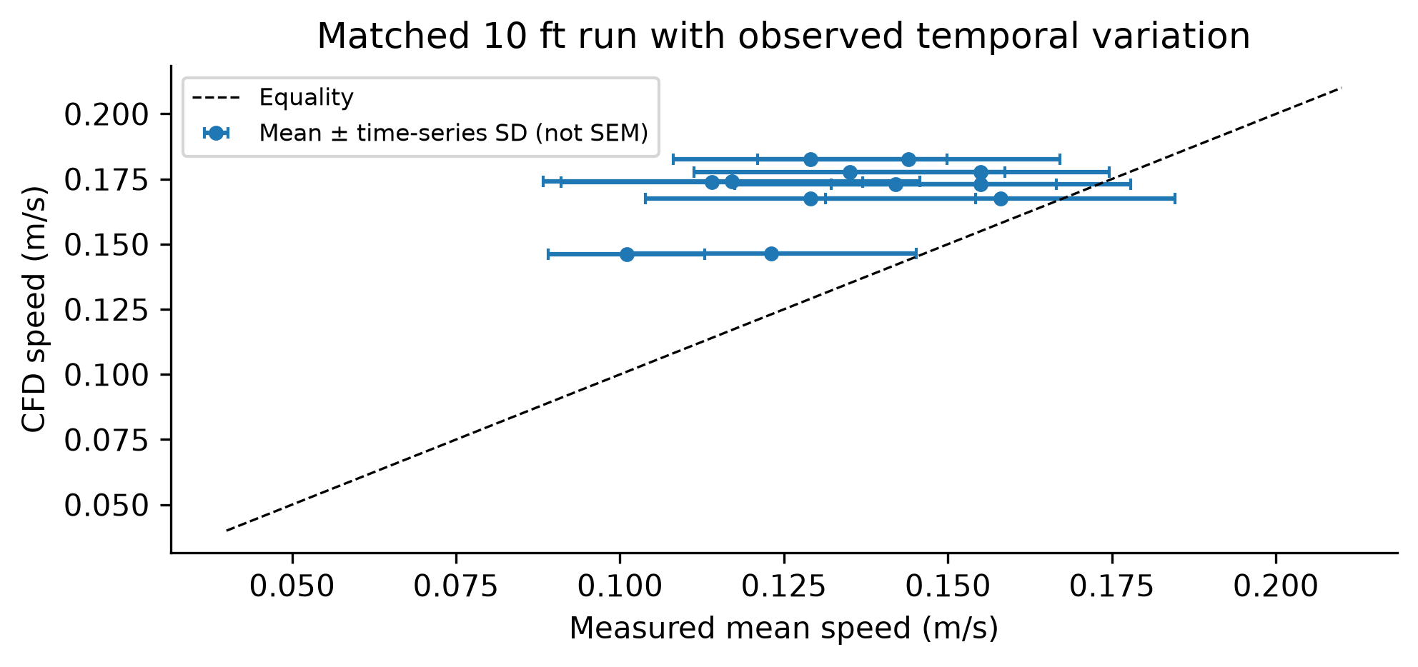
Figure 8. Matched cell-point CFD speed against twelve experimental means with horizontal ±1 temporal SD bars from the raw record. Bars describe fluctuating readings, not uncertainty of the mean, and no independence-based standard-error reduction is applied.
CFD is above every matched mean. Some temporal SD bars overlap equality and others do not, but this plot supplies no confidence-level test of model agreement. Samples are time-correlated, sensor calibration uncertainty is not quantified, and one plane cannot distinguish turbulence, diffuser, leakage or boundary effects. The 58 valid HVAC readings and 882 valid raw speed samples per sensor support window auditing; they do not supply 882 independent physical replications.

Appendix D The decisive 58 ft example
This is the first 58 ft replicate, not a best-case selection. It uses 24 sequential A/B sensor positions and illustrates the station where the aggregate RBF advantage is concentrated. Full-array fits and held-location residuals remain distinct. Only 49.7% of the physical section lies inside the full measured hull; hatching marks the rest.
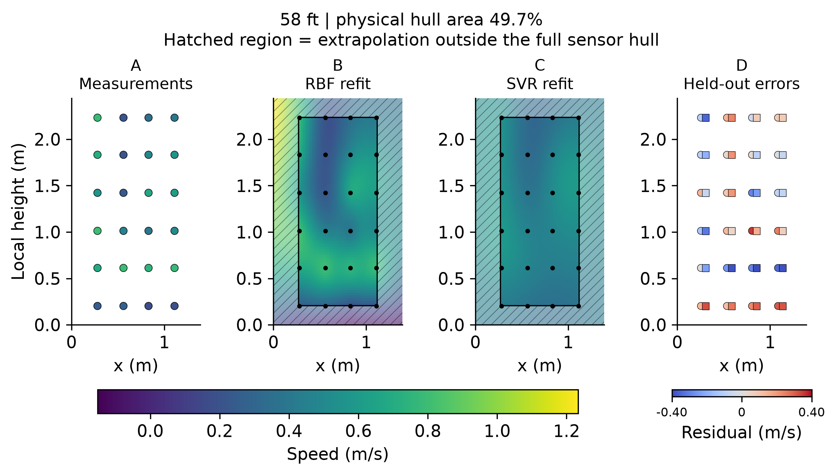
Figure 9. S01-A-58-HN-1 measurements, RBF/SVR full-array refits and genuine held-location residuals. Circles are RBF and squares SVR, with small horizontal offsets. All speed panels share a scale including unphysical RBF extrapolation; hatching must not be interpreted as validated area.
Measured speeds span 0.172–0.805 m/s and vary strongly between nearby heights and columns. The full-array SVR fit (C = 0.1, gamma = 1, epsilon = 0.01) smooths these contrasts, spanning about 0.307–0.599 m/s. RBF retains more variation, but its full-grid range −0.152 to 1.234 m/s overshoots the observations. Its negative speed occurs outside the hull and is physically inadmissible; no clipping is applied to conceal it.
Held-location supported RMSE is 0.18893 m/s for RBF and 0.23342 for SVR in this example. At x = 0.83 m and local height 0.613 m, SVR predicts 0.346 m/s for an observed 0.747 m/s. At x = 1.11 m at the same height, it predicts 0.389 for 0.780 m/s. These underpredictions are consistent with smoothing the high-speed row. RBF also misses it and has a maximum supported absolute error of 0.356 m/s; its relative advantage does not imply adequate pointwise accuracy.
The measured contrast could reflect local flow structure or sequential/operating variation; the sparse data do not resolve that cause. Neither the fitted surface nor this representative residual map establishes continuous experimental truth. The appropriate conclusion concerns conditional model behaviour and support, not a universally superior physical reconstruction.

