Jet Bridge Air Speed Reconstruction
  - Numerical interpolation and support vector regression with OpenFOAM evaluation
MMA3001 Numerical Methods and Machine Learning | [Student name] | [Student ID]
Report date 25 October 2026 | Repository https://github.com/matt-b-0/jetbridge-ml-cfd

Abstract
Sparse ventilation measurements do not resolve a complete cross-sectional air-speed field. This project compares a retained-sensor mean, nearest-neighbour interpolation, linear interpolation, thin-plate radial basis function interpolation and support vector regression using FAA/NRC jet-bridge measurements. An outer held-location evaluation across 36 runs and 504 sensor means keeps SVR parameter selection inside the training data. On common supported targets, mean per-run RMSE is 0.04959 m/s for RBF and 0.05774 m/s for SVR. The overall difference is concentrated at the 58 ft station, where a 24-point layout is used; the 12-point layouts slightly favour SVR on average. Separate CFD virtual-sensor experiments examine spatial coverage, mesh sensitivity and a controlled flow change. Isothermal solves converge, but experimental agreement remains imperfect. A buoyant thermal continuation fails residual and stationarity screens despite low inlet/outlet imbalance. The results support careful spatial evaluation and credible simple baselines rather than a claim that one method is universally superior.
[AUTHOR TASK Rewrite the abstract in your own words after checking all final numbers. State your own engineering conclusion in one sentence.]

1 Engineering problem and objectives
The laboratory jet bridge provides a controlled ventilation geometry relevant to passenger boarding. The intended computational output is a spatial reconstruction of scalar air speed from a limited number of measurements, with an explicit statement of where predictions are supported by retained sensors. This is not a disease-transmission or passenger-risk model. The FAA/NRC report supplies the experimental context and released measurements [1,2].
The research question is: how do interpolation and SVR compare when reconstructing sparse jet-bridge air-speed measurements, and what does CFD reveal about errors caused by sensor placement? The project tests local predictive error separately from numerical field reconstruction and supplied-flow consistency.

Scope and report structure
The core is the approximately isothermal empty-bridge dataset and its numerical reference field. Pages 2–4 define data, methods and CFD checks; pages 5–7 compare predictions and spatial sampling; pages 8–9 address thermal and numerical stability, reproducibility and AI use; page 10 draws conclusions and lists references. Thermal results remain a bounded extension rather than training data.
[AUTHOR TASK Add a brief practical example of how a ventilation engineer could use the reconstruction, and explain why the chosen scope is achievable.]

2 Experimental data and coordinate definitions
The S01-A-HN subset contains 36 replicate-average files and 504 sensor means at nine nominal stations from 10 to 58 ft. Most planes use 12 positions; the 58 ft planes use 24 positions assembled from sequential A/B half-layout measurements. Each replicate is fitted separately. Measurements at different stations must not be presented as a simultaneous three-dimensional flow field [1,2].
Input or output | Format and units | Treatment
Sensor position | x y z in metres | Use published absolute coordinates
Measured air speed | Scalar magnitude in m/s | Compare with CFD magnitude |U|
HVAC supply Q.FS | L/s converted to m³/s | Supply is not net flux at every plane
Raw sensor records | Asynchronous timestamps and local inches | Retain probe times and nominal frame
Missing observations | Sentinel −9999 | Treat as missing and exclude explicitly
Predictions and errors | m/s with coverage flags | Separate hull support from extrapolation

The coordinate frame is x across width, y above the laboratory floor and z along the bridge. Local height is h = y − yfloor(z). The floor is piecewise linear through (z,y) = (0,0), (8.2931,0.6731), (10.0965,0.6731), (18.10512,1.343025) m. Width is 1.388618 m and nominal clear height is 2.441448 m.
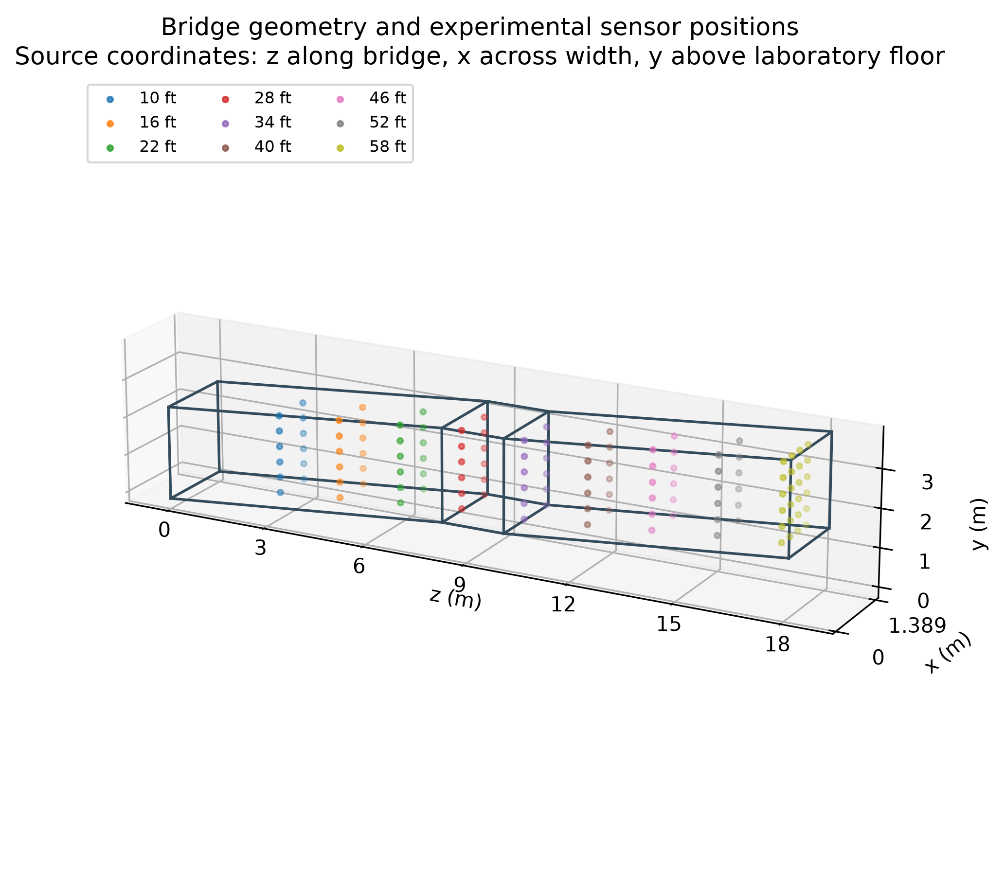
Figure 1. CFD geometry and published experimental sensor positions. Axis meanings follow the source; no second floor offset is added to absolute y.
A nominal station conversion uses 0.3048 m/ft, but the published average-file coordinates are retained for sampling, such as z = 3.05 m rather than replacing it with 3.048 m. The final source-template ceiling differs from the constant-height case by 0.127 mm; this discrepancy is recorded and retained.
[AUTHOR TASK Explain why preserving coordinate meaning matters more than silently rounding every station label. Cite the source boundary template in the final data description.]

3 Reconstruction methods and evaluation design
Method | Definition and reason for inclusion
Retained-sensor mean | Arithmetic mean of outer training speeds; no spatial fitting or tuning.
Nearest neighbour | Copy the closest retained value; simple local reference.
Linear interpolation | Piecewise linear interpolation within the training convex hull; no extrapolation.
Thin-plate RBF | Thin-plate spline with degree 1 polynomial and zero smoothing; smooth fixed baseline.
SVR | RBF-kernel support vector regression with training-only scaling and parameter selection.

For each outer fold, one entire sensor location is withheld. The remaining locations form the training set. A three-fold grouped-location inner evaluation selects C from {0.1,1,10}, gamma from {0.1,1} and epsilon from {0.002,0.01} m/s. The selected model is fitted on all outer training observations and predicts the withheld sensor. No other replicate is pooled into that fit. StandardScaler is fitted on training data only and its transformed coordinates are shared with the interpolation baselines [4].
For the RBF kernel, K(x,x′) = exp(−gamma ||x−x′||²). C controls the penalty on errors, epsilon sets the insensitive band and gamma controls spatial influence after scaling. The finite grid evaluates a defined tuning procedure; it does not establish that all other SVR configurations are inferior.
RMSE = sqrt[mean((prediction − observation)²)], MAE = mean(|prediction − observation|), and bias = mean(prediction − observation). Pearson r is descriptive and cannot substitute for agreement. The common-hull comparison uses 360 supported targets; 144 outside-hull targets are scored separately. Runs and stations share one physical apparatus, so no IID-sensor significance claim is made.
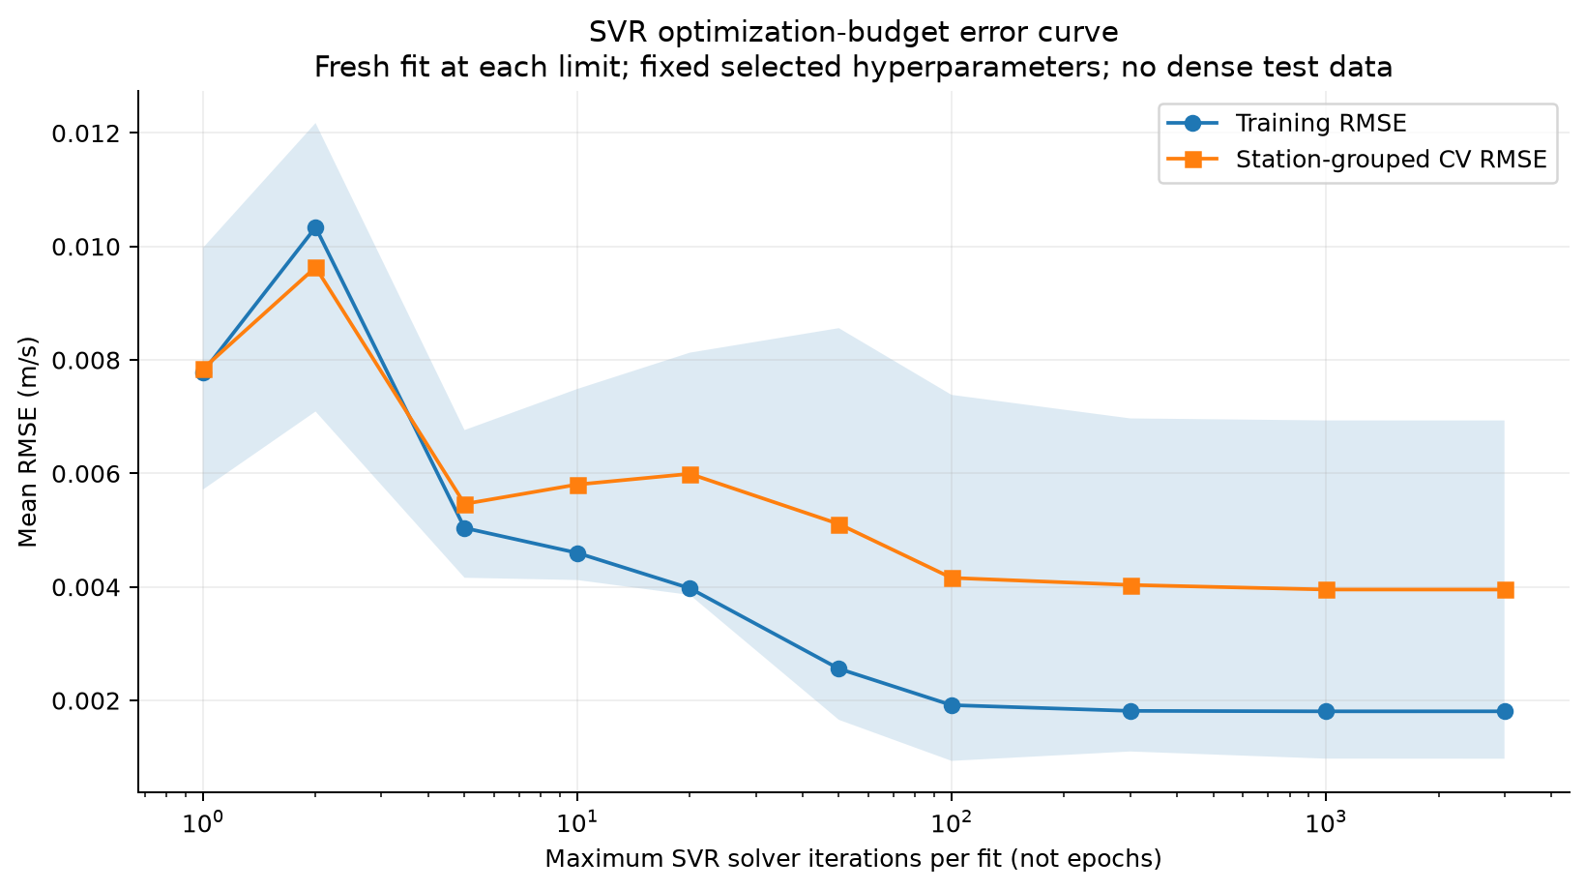
Figure 2. SVR optimisation-budget diagnostic from the separate CFD surrogate study. Each budget is a fresh fit using training-station cross-validation; the horizontal axis is solver iterations, not neural-network epochs. The shaded band is station variability.
[AUTHOR TASK Explain standardisation, the role of the inner loop and why a test target must not affect parameter choice. Add the relevant course and library references [5].]

4 CFD implementation and numerical verification
The isothermal reference uses steady incompressible simpleFoam with k-epsilon RANS, a full-face inlet at z = 18.10512 m, a pressure outlet at z = 0 and sealed no-slip walls. The prescribed supply is 0.533865517 m³/s. The real diffuser, wall leakage and detailed plenum are omitted. The Boussinesq extension is kept separate. OpenCFD v2412 is used; required writeFields compatibility entries are included in the tracked starter case [4].
Mesh or case | Cells | Converged iteration | Interpretation
Coarse | 17664 | 115 | Same isothermal physics
Baseline | 141312 | 237 | Original numerical reference
Fine | 476928 | 380 | Sensitivity comparison only
Synthetic 80% flow | 141312 | 237 | Fixed-layout transfer case

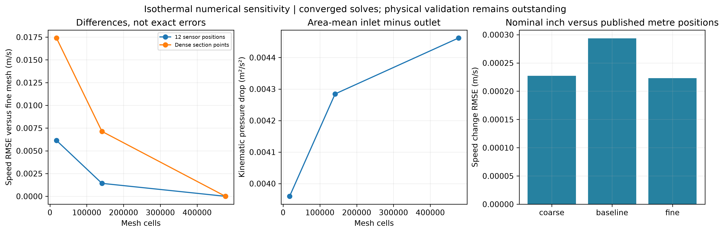
Figure 3. Isothermal mesh and coordinate sensitivity. Pressure is kinematic pressure in m²/s², not Pa. The fine mesh is a numerical comparison, not exact truth; unequal refinement ratios do not establish a GCI or mesh independence.
Baseline-to-fine speed differences are 0.001423 m/s RMSE at the 12 matched sensors and 0.007135 m/s over 9,600 section points, with relative L2 difference about 4.54%. Nominal-inch versus published-metre positions change baseline sensor speeds by 0.000293 m/s RMSE, much smaller than the approximately 0.04 m/s matched CFD–measurement discrepancy.
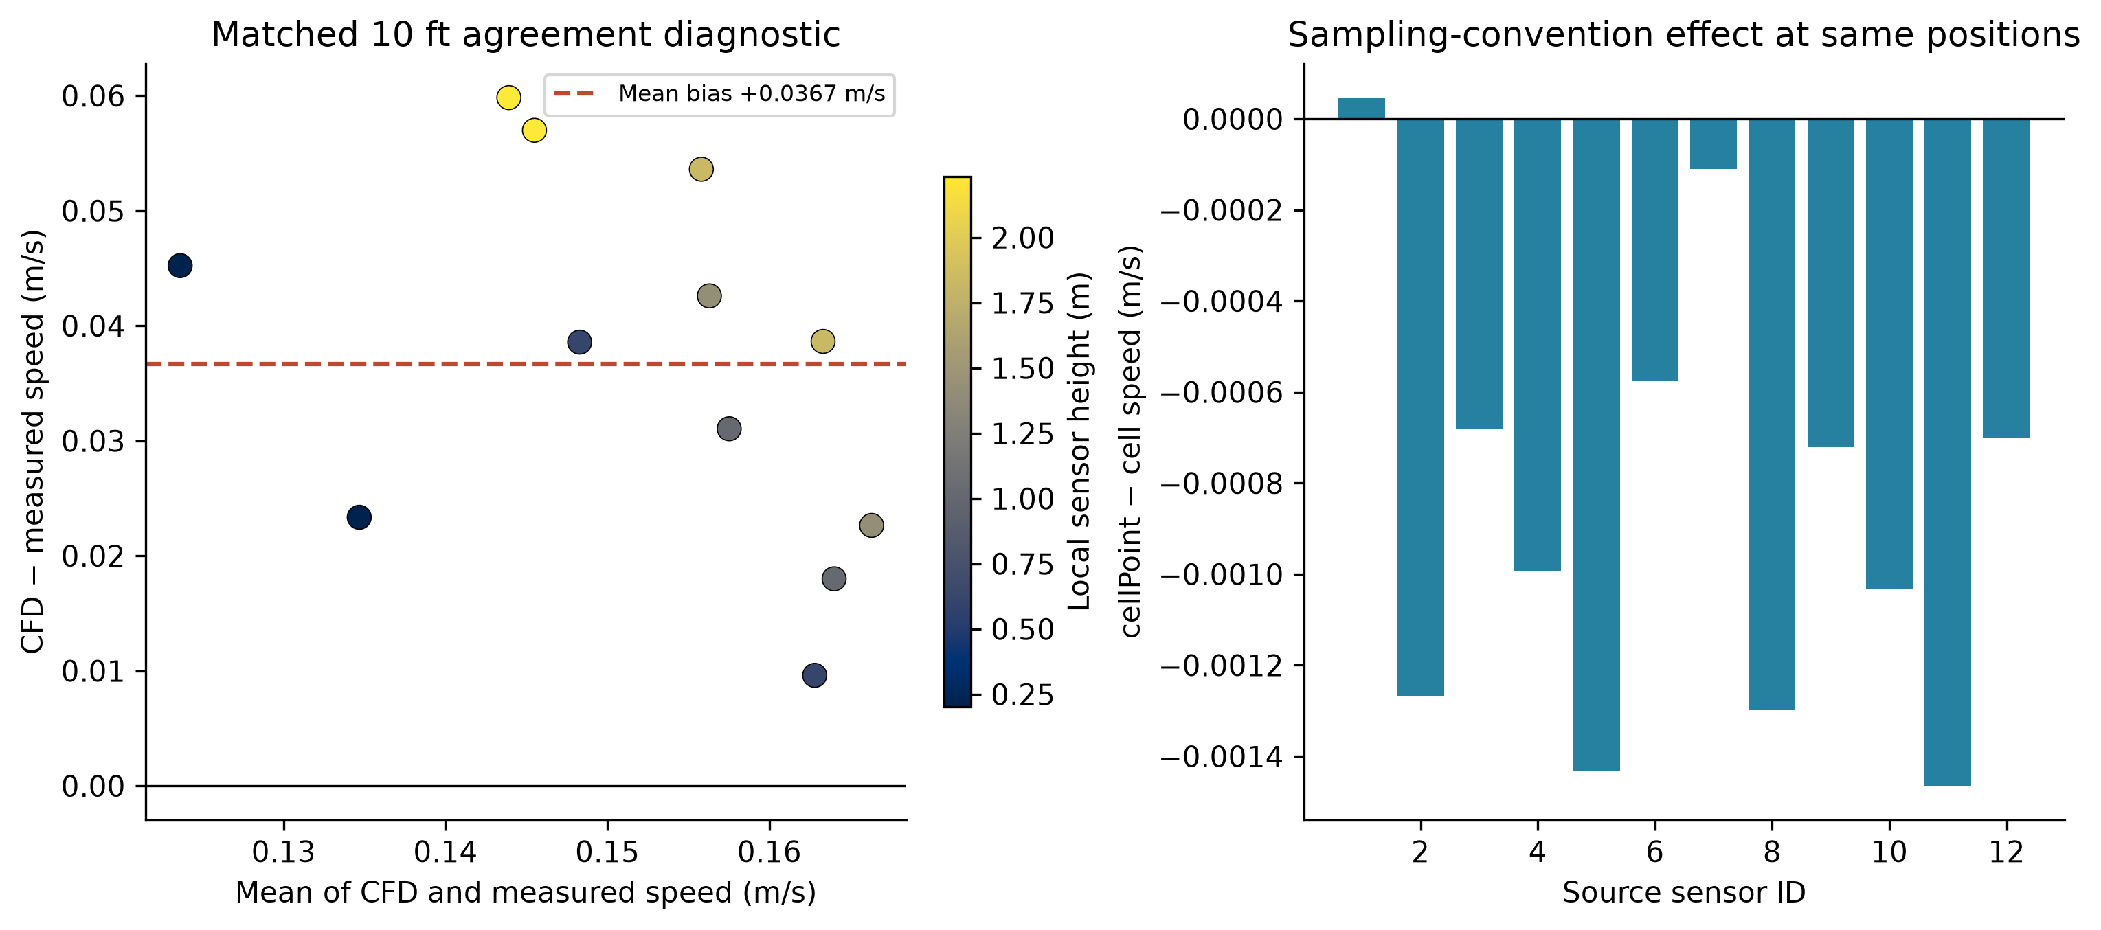
Figure 4. Matched S01-A-10-HN-1 agreement and the cell versus cellPoint sampling effect. A positive difference means CFD overpredicts speed. The twelve spatial points do not justify normal-theory limits of agreement.
Raw sensor means reproduce the published three-decimal averages within rounding. The stable and entire measurement intervals are identical for this run, and 58 valid HVAC readings reproduce the imposed supply mean. Nevertheless, cellPoint speed RMSE is 0.039769 m/s with bias +0.036674 m/s. Other runs have supply means from about 433 to 535 L/s and are not all matched by this single solution.
[AUTHOR TASK Discuss unresolved wall treatment and y-plus, boundary simplifications and physical validation. Do not claim that conservation proves agreement with the laboratory system.]

5 Experimental prediction results
The following table compares the five methods on identical supported experimental targets. Each value is an equal-run mean, not a pooled sensor RMSE. The mean baseline is fitted using retained sensors only. Results are nested cross-validation estimates for one configuration and apparatus, not an untouched external test [4].
Method | RMSE m/s | MAE m/s | Bias m/s
Mean | .067648 | .055683 | −.009355
Nearest | .071293 | .059292 | +.001263
Linear | .055241 | .043424 | −.009798
RBF | .049590 | .040388 | −.001164
SVR | .057741 | .049735 | −.007704

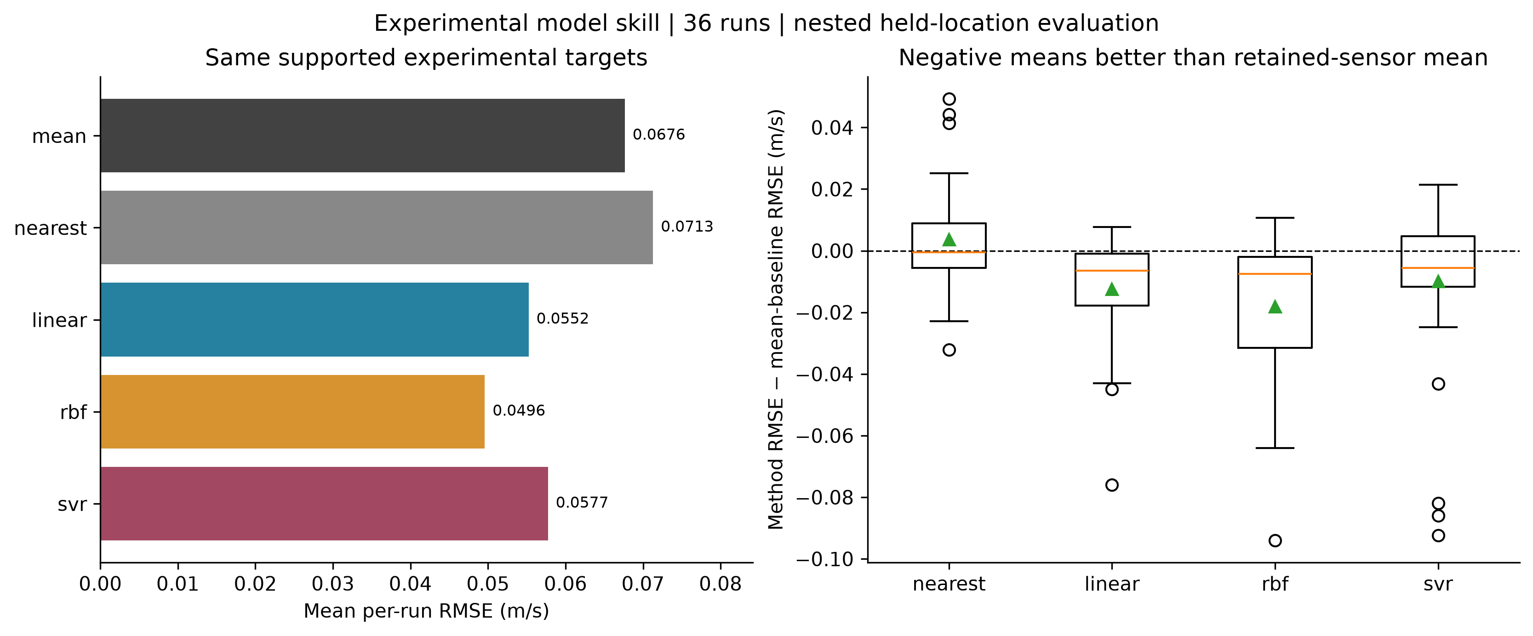
Figure 5. Model skill on common supported locations and paired differences against the mean baseline. Boxes show the interquartile range; the line is the median and the triangle is the mean. These descriptive distributions are not confidence intervals.
RBF has the lowest overall supported-region RMSE, while nearest neighbour is worse than the mean baseline on average. RBF beats the mean in 29 of 36 runs and SVR in 24. This shows why a simple reference is needed before attributing value to a more complex reconstruction. The ranking does not imply that RBF wins at every station.
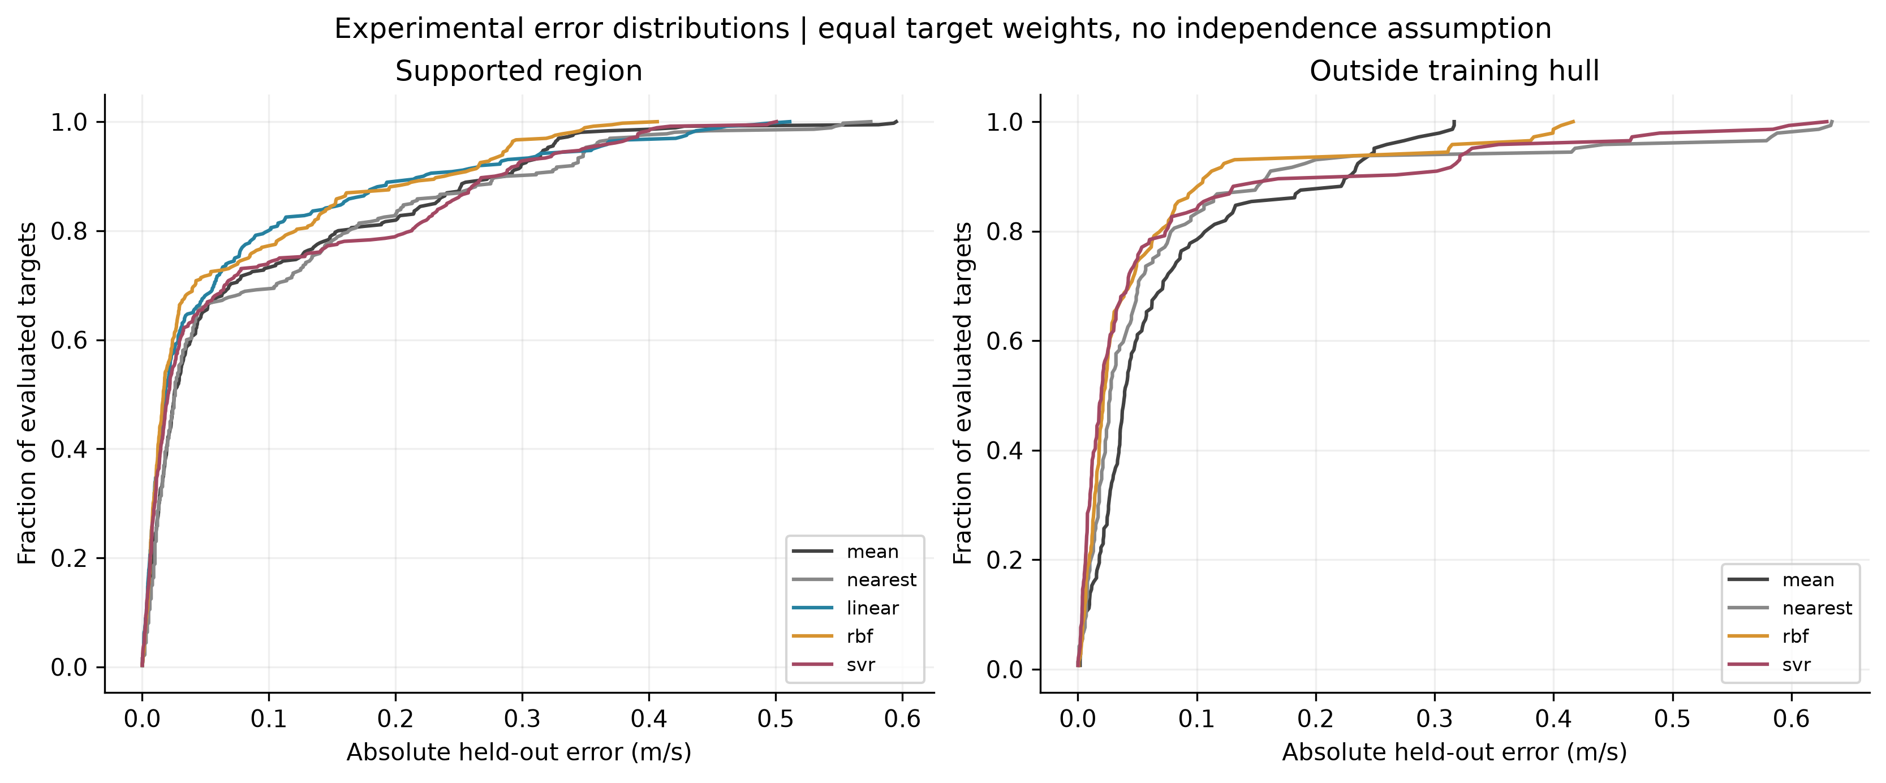
Figure 6. Absolute experimental prediction errors inside and outside the training hull. This plot gives each target equal weight, so 24-point runs contribute more points than 12-point runs. Linear provides no outside-hull predictions.
Outside-hull mean per-run RMSE is 0.07789 m/s for the mean, 0.09041 for nearest, 0.06726 for RBF and 0.07999 for SVR. Missing linear predictions remain unsupported rather than being filled and treated as valid extrapolation.
[AUTHOR TASK Explain the engineering meaning of an error in m/s relative to the observed speeds, and identify a case where model simplicity would justify choosing the mean or linear baseline.]

6 Paired comparisons and interpretation
Paired comparison subtracts SVR RMSE from RBF RMSE within each run. Negative values favour RBF. RBF wins 21 of 36 runs and SVR wins 15. The equal-run mean difference is −0.008151 m/s but the median is only −0.000575 m/s, indicating that the average advantage is not uniform across the dataset.
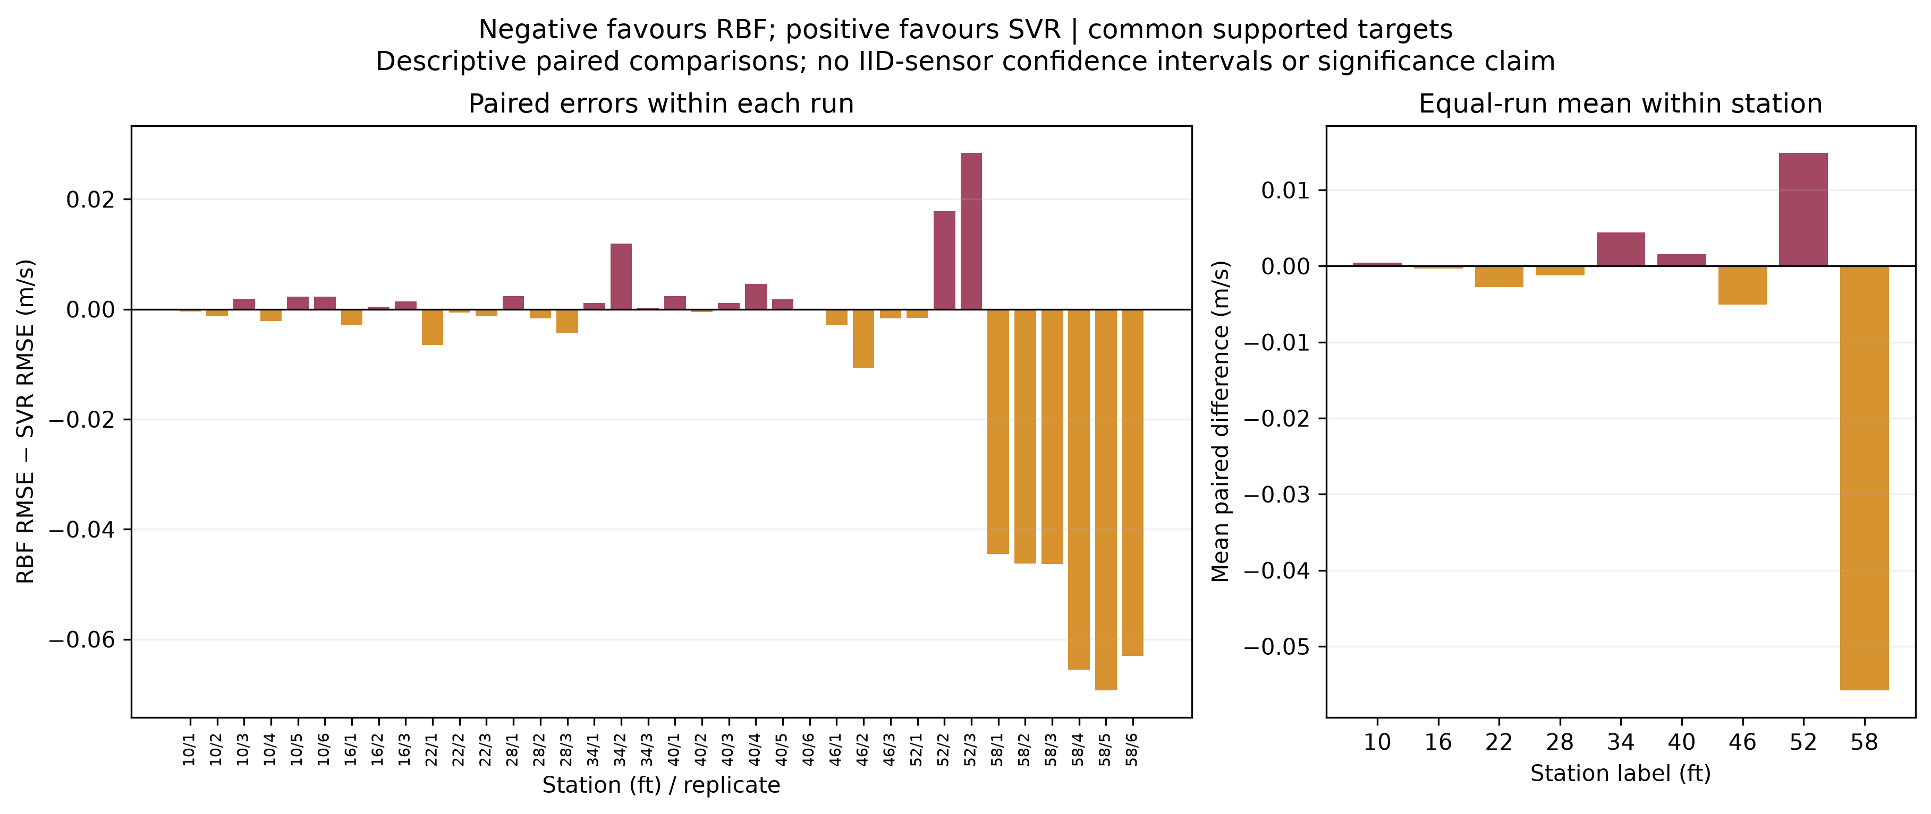
Figure 7. RBF-minus-SVR error by run and station on common supported targets. Differences are descriptive; repeated measurements of one apparatus are not independent physical replications.
The 30 runs with 12-point layouts slightly favour SVR on average: mean RBF-minus-SVR error is +0.001385 m/s. The six 24-point runs favour RBF much more strongly, with mean difference −0.055829 m/s. However, the 24-point layouts occur only at 58 ft. Sensor density, position along the bridge, sequential acquisition and local flow structure cannot be separated by this comparison.
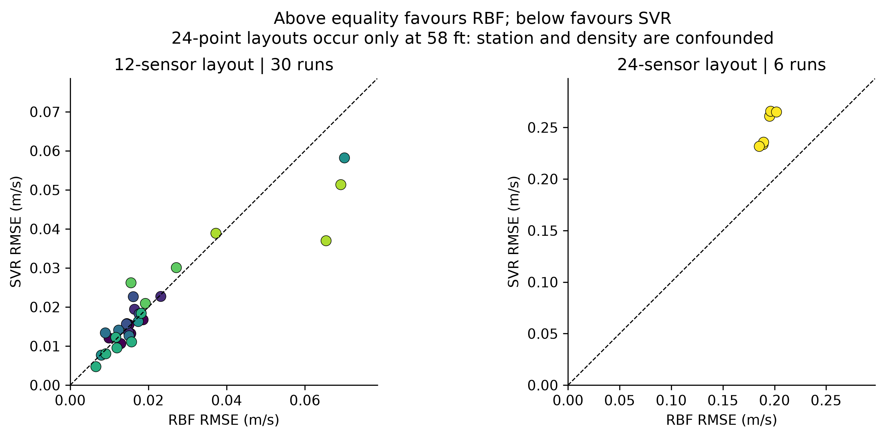
Figure 8. Paired model RMSE split by source layout size. Points above equality favour RBF. The groups were inspected after evaluation and do not identify a causal effect of density.
The defensible interpretation is that the selected methods have different strengths under the available layouts and conditions. Choosing a method should account for error, support, robustness, implementation complexity and the intended prediction region, rather than using the smallest dataset-wide mean as the only criterion.
[AUTHOR TASK Describe why you would not remove the 58 ft runs merely because they influence the average. State which comparisons you consider most useful for the stated engineering objective.]

7 CFD virtual sensors and spatial sampling
CFD is used as a dense numerical reference for a separate reconstruction task. The earlier three-dimensional surrogate used 72 virtual sensors at 10, 22, 34, 46 and 58 ft and tested 9,600 points on the withheld 16, 28, 40 and 52 ft planes. SVR and RBF were nearly tied inside their shared support, with mean plane RMSE about 0.00291 and 0.00293 m/s. This did not imply equivalent performance on experimental measurements.
A separate within-plane study compares 6, 12, 24 and 48 sensors. Training labels come from 32 × 48 candidate grids, while evaluation uses disjoint 40 × 60 grids. Interior, boundary-heavy and hybrid layouts are chosen geometrically. All layouts are scored on a fixed common core as well as on full sections. Linear full-section coverage is incomplete and must not be ranked as though every point were predicted.
Layout at 24 sensors | RBF full-section RMSE | SVR full-section RMSE
Interior | 0.033883 m/s | 0.033648 m/s
Boundary heavy | 0.048397 m/s | 0.056783 m/s
Hybrid | 0.026579 m/s | 0.028435 m/s

Moving a sparse array to the walls can remove too much interior information. The 24-point hybrid improves the overall numerical reconstruction, but a 48-point hybrid is not consistently better. These arrays are independently placed rather than nested additions; sensor count and arrangement both change. The placement study is exploratory and used a previously inspected numerical field.
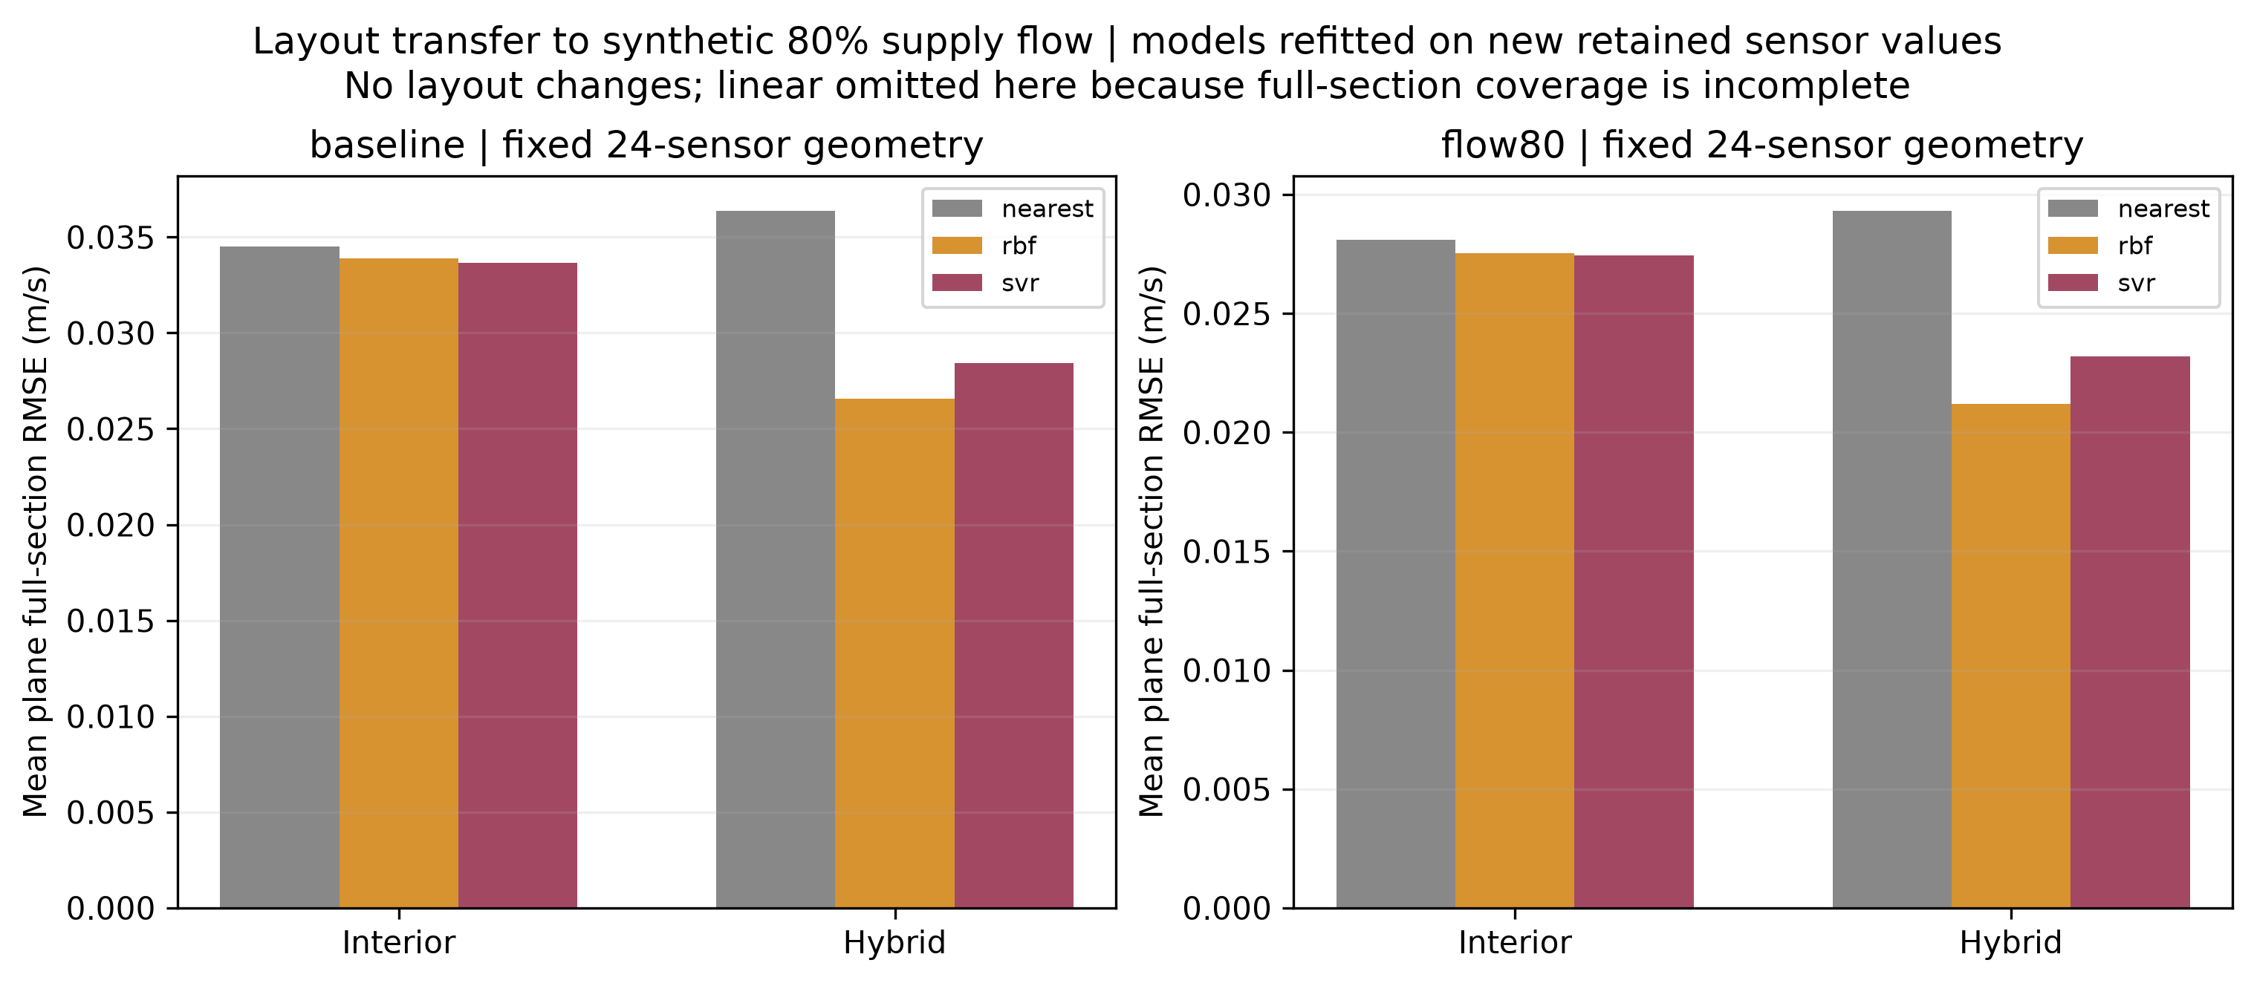
Figure 9. The predefined 24-point interior and hybrid layouts evaluated at baseline and synthetic 80% supply flow. Models are refitted on new retained values; the geometry is unchanged. This is layout transfer, not generalisation of a frozen surrogate.
At 80% flow, RBF full-section mean plane RMSE falls from 0.027537 m/s for interior sensors to 0.021193 m/s for the hybrid. Corresponding SVR values are 0.027427 and 0.023186 m/s. The effect is not favourable on every individual plane. This controlled numerical comparison cannot establish transfer to other geometries, thermal regimes or independently measured experiments.
[AUTHOR TASK Explain the trade-off between interior coverage and boundary coverage. Distinguish the 3D station-withholding experiment from the 2D sensor-layout study, and avoid comparing their error values as one task.]

8 Thermal extension and convergence limits
The cold-supply extension uses measured means of 21.289 °C at supply and 24.375 °C in the laboratory, with supply 0.531761 m³/s. Walls are fixed at laboratory air temperature as an unmeasured wall-temperature surrogate. A zero-gravity control with identical thermal boundaries converges at iteration 733; the buoyant results do not establish a converged thermal solution.
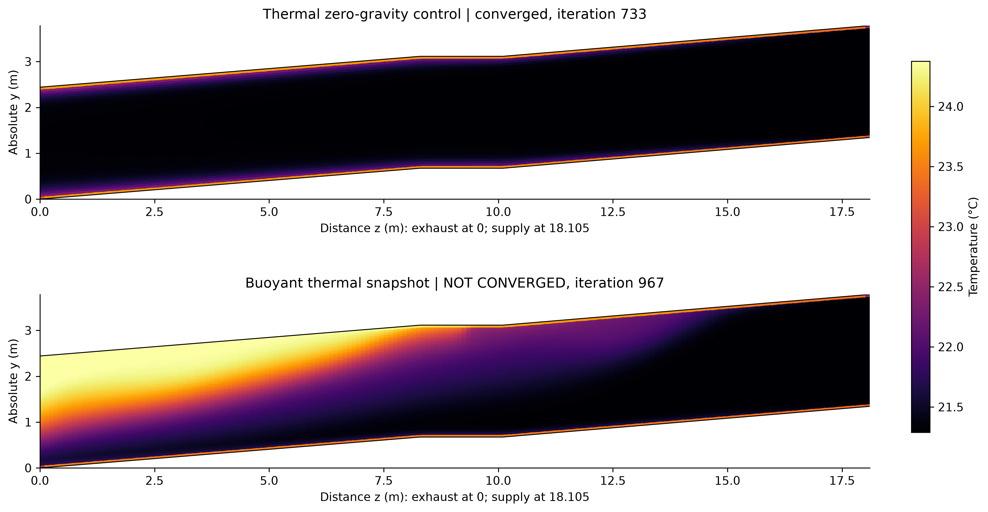
Figure 10. Mid-width temperature fields for the converged zero-gravity control and the NOT CONVERGED buoyant snapshot at saved iteration 967. The visible layering is provisional and must not be described as validated stratification.
A bounded continuation restarts from saved 967 with unchanged physics, schemes and relaxation. It reaches saved iteration 1967 but fails the configured residual criteria and a declared 0.01 K probe-range screen over the last 100 iterations. The maximum probe temperature range is 0.1350 K and maximum speed reaches 5.10 m/s. The relative inlet/outlet imbalance is only 1.23 × 10⁻⁶, showing that close flux balance is insufficient.
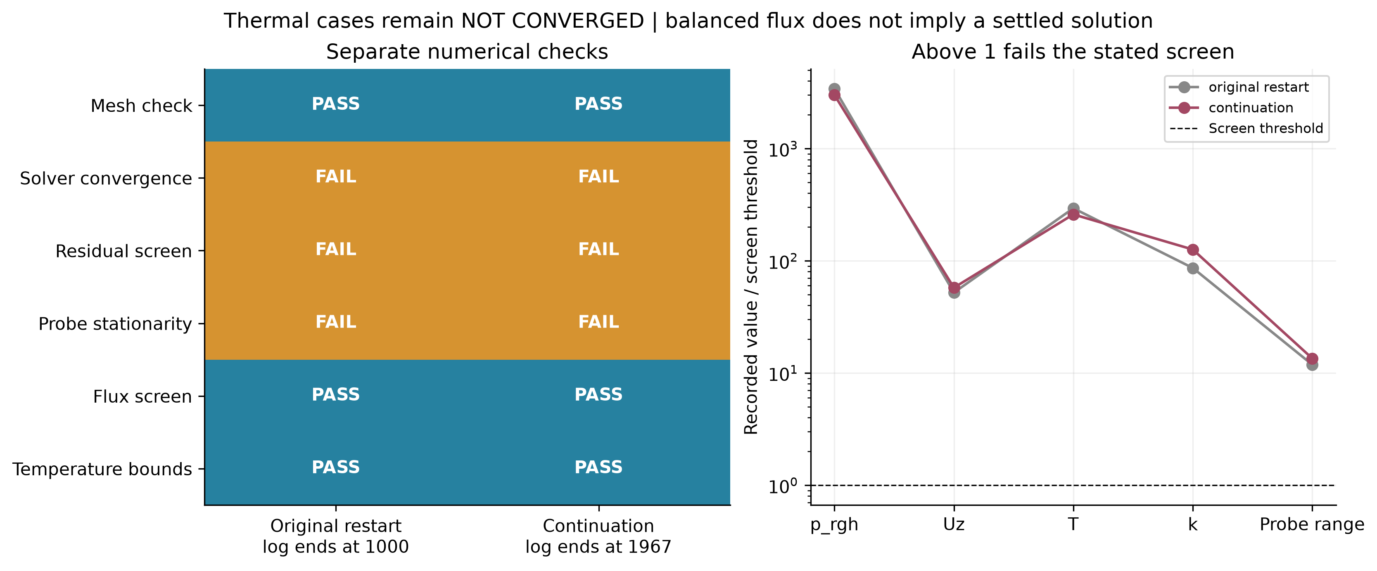
Figure 11. Separate numerical screens for the buoyant restart and continuation. The original log ends at 1000 but its last saved field is 967. Ratios above one fail the stated diagnostic threshold; these are not physical validation metrics.
SIMPLE iteration is not physical time. Initial conditions and relaxation also differ from the zero-gravity control, so a difference in fields cannot yet be attributed solely to converged buoyancy. The initial divergent field, snapshot 967 and continuation 1967 remain excluded from ML training and trusted reference data.
[AUTHOR TASK Explain what was learned from this unsuccessful extension. Propose a bounded next investigation, such as controlled numerical settings or a carefully checked transient formulation, without claiming that it has already solved the problem.]

9 Numerical stability reproducibility and AI use

Reduced numerical verification
A separate one-dimensional diffusion problem links the project to the unit treatment of finite differences, ODE stability and implicit methods [5]. FTCS, backward Euler and Crank–Nicolson are compared against a known analytical solution. The diffusion number is r = alpha Δt / Δx²; the standard one-dimensional FTCS stability condition is r ≤ 1/2. Backward Euler and Crank–Nicolson can be stable at larger r, but stability alone does not ensure small error or strong damping of high-frequency modes.
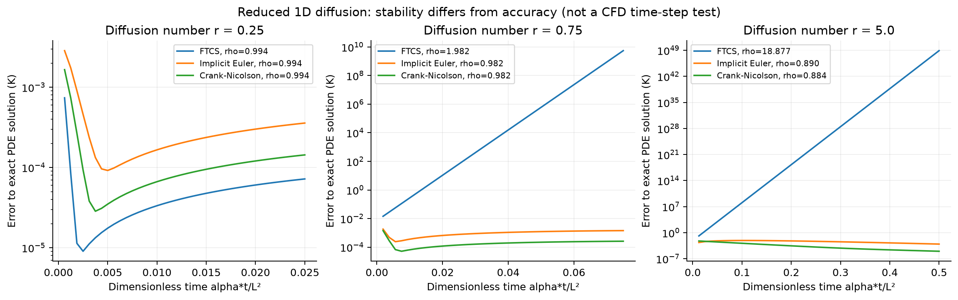
Figure 12. Reduced diffusion verification with explicit and implicit schemes. This synthetic test explains numerical mechanisms; it does not diagnose the nonlinear steady CFD failure or supply a physical CFL limit for SIMPLE.
The study also examines temporal refinement, weighted-Jacobi relaxation and interpolation noise amplification on the actual sensor geometry. The full-plane thin-plate RBF worst-case noise gain is about 2.55 in the recorded sensitivity test. Such a bound measures amplification of assumed perturbations, not instrument uncertainty or prediction accuracy. Reduced linear relaxation is not identical to OpenFOAM equation relaxation.

Reproducibility and performance
The repository separates data processing, interpolation, ML, validation and CFD interfaces. A one-command runner saves logs, parameter searches, split audits, hashes, versions and a result summary. Sixty-seven local tests pass, and hosted checks pass on Python 3.10 and 3.12. Raw data and large CFD fields remain external; selected derived plots are committed [4].
The available timing records do not support a fair overall runtime ranking: some combine fitting and prediction while SVR records only prediction separately from search. A controlled end-to-end timing comparison remains a useful next check. Report the hardware, repetitions and separate tuning, fitting and prediction costs before drawing performance conclusions.

AI use and individual learning
AI assistance supported parsing, workflow and plotting code, numerical checks, documentation and this report scaffold. Verification included unit tests, coordinate/source audits, repeated outputs, mesh checks, solver logs and hosted CI. Errors found during development included a probe-window bug and coordinate-dependent geometric tie selection; these were corrected and recorded in the AI-use log [4].
[AUTHOR TASK Write 120–160 words in your own voice: which AI tools you used, approximate contribution, why they were useful, what you independently checked, what you rejected or corrected, and which engineering decisions you personally own. Do not imply that automated tests alone establish physical validity.]

10 Discussion conclusions and references
The numerical and experimental comparisons answer different questions. Small error against a CFD field demonstrates reconstruction of that numerical field, whereas held-location experimental errors assess prediction of measured scalar speed. Neither one alone establishes that CFD reproduces all physical ventilation mechanisms. The matched 10 ft audit supports the input flow and averaging window but leaves substantial positive CFD bias unexplained.

Limitations and next investigations
Priorities are a fair end-to-end timing experiment; wall-treatment and y-plus assessment; boundary, diffuser and leakage evidence for physical CFD comparisons; and a new controlled thermal robustness investigation if thermal modelling remains in scope. The source-ceiling discrepancy remains documented. Three meshes provide sensitivity evidence, not mesh independence. Station and density are confounded in the experimental layout comparison. Broader transfer would require independently specified operating cases and evaluation criteria.
[AUTHOR TASK Select two or three limitations most important to your engineering conclusion. Separate checks completed here from work you recommend. Confirm teaching-team scope approval, an appropriate repository licence, generated HTML documentation and the required final repository clone before submission [3].]

Conclusions
Under the tested procedure, RBF is a strong baseline and has the lowest overall supported experimental RMSE, but its advantage over SVR is concentrated at the 58 ft layout. Balanced spatial coverage can improve numerical field reconstruction, including under a controlled flow perturbation. Mesh and coordinate checks quantify numerical sensitivity, while the thermal extension shows why bounded temperature and balanced flux do not establish convergence. The principal outcome is a reproducible, coverage-aware comparison with explicit limits on physical interpretation.
[AUTHOR TASK Replace this paragraph with your own final conclusion. State what the evidence supports, what remains unresolved and what method you would recommend for the intended use.]

References
[1] Lebbin, P., Laengert, S., Howell, S. and Jeans, L. (2026). Communicable Disease Transmission in Air Travel: Jet Bridge Ventilation. DOT/FAA/AM-25/28, Federal Aviation Administration, July. Supplied report dot_92576_DS1.pdf.
[2] FAA/NRC (2026). Associated jet bridge ventilation dataset, JetBridge_2026. DOI: https://doi.org/10.21949/qqdx-gh59. Raw records, replicate means, HVAC files, periods and data dictionary.
[3] MMA3001 teaching team (2026). Numerical Methods and Machine Learning Project Brief. Supplied assessment document, especially pages 4–8. References and appendices are excluded from the 10-page maximum.
[4] [Student author] (2026). jetbridge-ml-cfd. https://github.com/matt-b-0/jetbridge-ml-cfd. Record the final submitted commit and access date. Methods, test evidence, figures, assumptions and AI-use log.
[5] [Complete the references to the course notes and the exact scikit-learn, SciPy and OpenFOAM documentation used. Verify bibliographic details and access dates before submission.]

