Jet Bridge Air Speed Reconstruction
  - Interpolation and support vector regression with experimental and CFD comparisons
MMA3001 Numerical Methods and Machine Learning | [Student name] | [Student ID]
25 October 2026 | https://github.com/matt-b-0/jetbridge-ml-cfd

Abstract
Sparse ventilation measurements leave much of a jet bridge cross-section unobserved. This investigation compares a retained-sensor mean, nearest neighbour, linear interpolation, thin-plate radial basis function interpolation and support vector regression using 36 FAA/NRC experimental runs. Nested held-location evaluation gives mean supported-region RMSE of 0.04959 m/s for RBF and 0.05774 m/s for SVR. RBF improves on the mean baseline by 26.7%, but its average advantage over SVR is concentrated at the 58 ft station. Separate OpenFOAM virtual-sensor studies show that boundary coverage affects whole-plane reconstruction. The isothermal CFD has positive bias against the matched experiment, so agreement with CFD cannot establish physical accuracy. Controlled timing shows that all methods are practical for these small arrays. The recommended use is exploratory spatial reconstruction with an explicit support mask; the evidence does not establish suitability for ventilation compliance or disease-risk assessment.

1 Engineering question and intended use
The engineering question is how accurately a limited sensor array can reconstruct scalar air speed within a bridge cross-section, and whether SVR offers useful improvement over simpler interpolation. A ventilation engineer could use such a reconstruction to identify regions that warrant additional measurements. This requires both a local error estimate and a clear indication of where the model extrapolates. A smooth contour alone provides neither.
Three comparisons are kept separate. Held-location experimental tests assess prediction of measured speed. Virtual sensors sampled from CFD assess reconstruction of a numerical field with known spatial coverage. Matching CFD to an experimental run assesses whether that numerical field represents the apparatus. The same error metric can be used in each comparison, but its reference and engineering meaning differ.

Scope and contribution
The primary study concerns the approximately isothermal empty bridge. Thermal calculations are a diagnostic extension and are excluded from trusted reference fields and ML training. The project contributes reproducible spatial evaluation, comparison with simple baselines, a controlled sensor-layout experiment, and quantitative checks on numerical sensitivity. It does not resolve airflow direction from hot-sphere speed measurements or simulate passenger exposure.
The report develops the data and methods, interprets experimental and CFD results, and evaluates robustness and cost. Ten main pages are followed by references and two diagnostic appendices. Experimental processing, interpolation, machine learning and CFD interfaces remain separate modules in the repository [4].

2 Experimental data and geometry
The S01-A-HN subset comprises 36 replicate-average files and 504 sensor means at nine nominal stations from 10 to 58 ft. Thirty runs use 12 positions; six runs at 58 ft use 24 positions assembled from sequential A/B measurements. Each replicate is fitted separately. Different stations were measured under different supplied-flow conditions and must not be assembled as a simultaneous measured three-dimensional field [1,2].
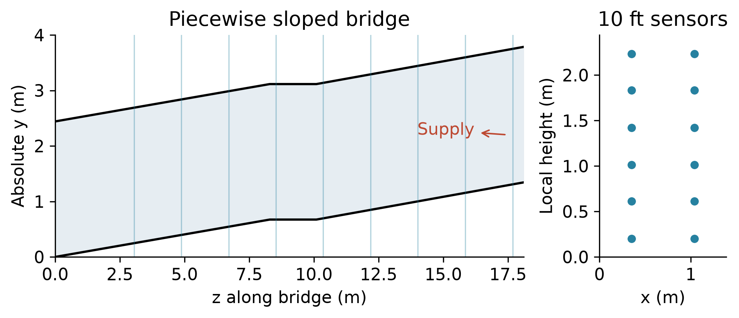
Figure 1. Bridge profile in the source laboratory frame and the matched 10 ft sensor cross-section. The floor rises along the bridge; the vertical sensor position must include the local floor elevation.
The source frame is retained: x is width, y is height above the laboratory floor and z is distance along the bridge. Station conversion uses z = 0.3048 × distance in feet; thus 10 ft is 3.048 m and 58 ft is 17.6784 m. Nominal local heights in inches require multiplication by 0.0254 and addition of the local floor height. Published absolute metre coordinates must not receive that floor offset again.
Quantity | Value or definition
Bridge width and length | 1.388618 m and 18.10512 m
Floor profile z / y in metres | 0 / 0; 8.2931 / 0.6731; 10.0965 / 0.6731; 18.10512 / 1.343025
Clear ceiling height | 2.441448 m
Source ceiling discrepancy | 0.000127 m in the upper ceiling coordinate; retained and documented

Coordinate audits compare all block vertices and the four defining cross-sections. Nominal inch positions differ from published rounded coordinates by at most 2.85 mm across width, 2.00 mm along the bridge and 3.65 mm in height. Their effect on matched CFD sampling is quantified on page 6 rather than assumed negligible.
SWEMA hot-sphere observations are speed magnitudes. They cannot be integrated as exact signed normal volume flux. HVAC Q.FS is supplied volumetric flow, which need not equal flow through every plane of a leaky physical bridge. Missing sentinels are excluded, acquisition windows are checked, and raw files are preserved. These distinctions prevent a numerical flow constraint from being mistaken for an experimental identity.

3 Models and spatial evaluation
Every model receives the same retained sensor coordinates and measured scalar speeds within a run. Predictions are assessed at withheld locations. The mean baseline predicts the mean retained speed. Nearest neighbour gives a simple local reference; linear interpolation uses the triangulation and returns no value outside its training convex hull. The hull is the polygon enclosing retained coordinates, not a confidence region.

Why RBF and SVR
Thin-plate RBF uses the kernel φ(r) = r² ln(r), a degree-one polynomial term and zero smoothing. It tests exact, globally smooth interpolation between sparse measurements. Zero smoothing is deliberate as an interpolation baseline, but it also passes measurement noise through the sensors. Smooth appearance therefore does not imply robustness. The geometry-based perturbation analysis on page 8 examines this limitation directly [6].
SVR uses the radial kernel K(a,b) = exp(−γ‖a−b‖²). The penalty C controls the cost of deviations beyond the epsilon tube, γ controls spatial variation and epsilon sets an insensitive error scale. Training-only coordinate standardisation makes width and height comparable. This is the unit topic of support vector regression applied to a small spatial regression problem; it allows a regularised alternative to exact interpolation [5].
Gaussian process regression was a plausible alternative in the initial scope. SVR was selected as a bounded comparison aligned with the taught topic and the implemented evaluation workflow. At 11 or 23 retained sensors, computational cost is not a convincing reason to exclude GPR. GPR was not tested, so this study makes no ranking against it. Its predictive intervals would require explicit kernel and noise assumptions and a calibration check [7].
SVR parameter | Training search values
C | 0.1, 1, 10
gamma | 0.1, 1
epsilon in m/s | 0.002, 0.01

Nested validation and common support
The outer loop withholds each sensor location. Any repeated observations at that location stay together. SVR selects among 12 parameter combinations using three grouped inner folds containing only outer training data, then refits before outer prediction. Scaling is fitted within training data. This prevents the held-out target from selecting model complexity.
All five methods are compared on the same 360 targets supported by linear interpolation, or 71.43% of 504 observations. The remaining 144 targets are evaluated separately for methods that extrapolate. Reported RMSE, MAE and bias are calculated within each run and then averaged equally over runs. Bias is prediction minus observation. These are internal spatial generalisation estimates for one apparatus and configuration, not external physical validation.

4 Experimental accuracy and engineering meaning
RBF gives the lowest average error on common supported targets. The improvement over the mean demonstrates useful spatial information beyond a single representative speed; nearest neighbour does not improve on that baseline. However, the ranking must be interpreted with error magnitude and station dependence.
Method | RMSE m/s | MAE m/s | Bias m/s
Mean | 0.06765 | 0.05568 | −0.00936
Nearest | 0.07129 | 0.05929 | +0.00126
Linear | 0.05524 | 0.04342 | −0.00980
RBF | 0.04959 | 0.04039 | −0.00116
SVR | 0.05774 | 0.04974 | −0.00770

What the improvement does and does not mean
The RBF RMSE is 26.7% lower than the mean baseline and 14.1% lower than SVR, using each comparator as the denominator. Relative to an illustrative characteristic speed of 0.15 m/s, an RMSE of 0.04959 m/s is about 33.1%; the SVR value is about 38.5%. These ratios give scale, not a measured mean percentage error, because 0.15 m/s is not every target speed. The absolute errors remain substantial for distinguishing modest local speed differences.
No engineering acceptance threshold or instrument uncertainty budget has been specified. Consequently, the lowest RMSE cannot certify sufficient accuracy for compliance, minimum-airflow guarantees or infection-risk decisions. The present evidence better supports approximate pattern screening and planning additional sensors. A use requiring precise pointwise speeds would need tighter error criteria, repeated independent measurements and a model that meets those criteria under the intended operating conditions.
Small aggregate RBF bias does not mean every prediction is accurate. Positive and negative errors can cancel, while RMSE remains appreciable. MAE is lower than RMSE for every method, consistent with some larger errors contributing disproportionately to the squared-error score. A claim of uniformly accurate reconstruction would require examining where those errors occur.

Extrapolation is a separate decision
Method | Outside-hull RMSE m/s
Mean | 0.07789
Nearest | 0.09041
Linear | Unsupported
RBF | 0.06726
SVR | 0.07999

RBF remains best on average outside the hull, but its error increases and linear makes no prediction. Filling linear gaps with another method would change the method being assessed. Practical contour plots should retain a support mask and mark extrapolated regions. Where spatial detail is unnecessary, the mean may be preferable because it is transparent and inexpensive; where support is adequate, linear interpolation is a useful low-complexity spatial comparator. The intended decision determines whether extra flexibility is justified.

5 Variation between stations
Paired differences compare RBF and SVR within each run using identical supported targets. RBF wins in 21 of 36 runs and SVR in 15. The equal-run mean RBF-minus-SVR RMSE is −0.008151 m/s, whereas the median is only −0.000575 m/s. The much smaller median shows that a few strong advantages influence the overall average.
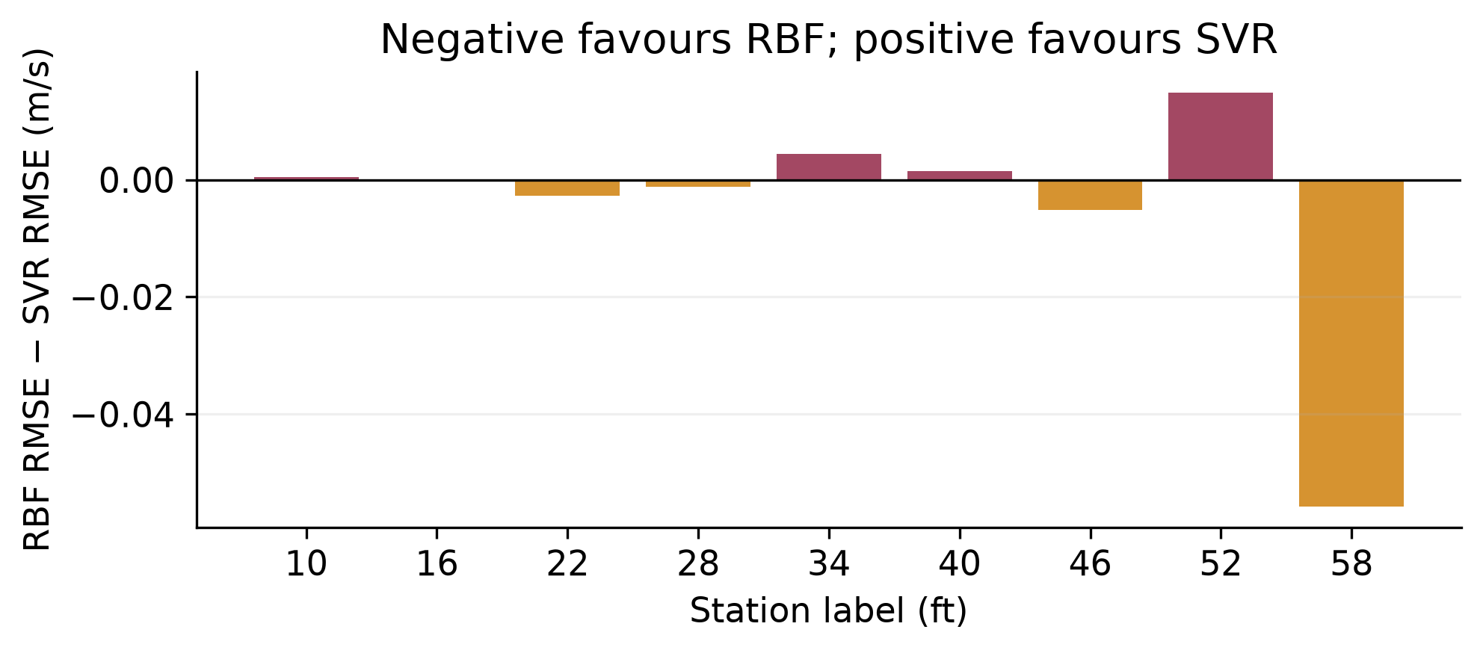
Figure 2. Mean paired RBF-minus-SVR RMSE at each station. Negative values favour RBF. The 58 ft station is also the only station with the 24-point layout; station and sensor density are confounded.
Group | Runs | Mean RBF minus SVR RMSE
12-point layouts | 30 | +0.001385 m/s
24-point layouts at 58 ft | 6 | −0.055829 m/s
All runs equally weighted | 36 | −0.008151 m/s

The 12-point group slightly favours SVR on average, while the 24-point group strongly favours RBF. Giving each station equal weight reduces the overall RBF advantage to 0.004884 m/s. This sensitivity to aggregation is scientifically meaningful: an overall score depends on which operating locations the dataset represents.
It would be incorrect to infer that adding sensors causes RBF to improve by the observed amount. The denser layout occurs only at 58 ft and uses sequential A/B acquisition. Position, local flow structure, operating conditions and density change together. A hypothesis that the denser array resolves a more complex field is plausible, but this dataset cannot isolate that mechanism. The controlled CFD layout study addresses geometry of sampling without removing the experimental confounding.
The 58 ft results are retained because removing an inconvenient station would distort the defined study population. Conversely, allowing that station to determine a universal recommendation would overstate generality. The defensible conclusion is conditional: RBF is the strongest aggregate interpolation baseline, while the implemented SVR is competitive on the more common 12-point layouts. Broader claims require an independent layout or operating-condition test.

6 CFD credibility against the matched experiment
The isothermal S01-A-10-HN-1 case uses matched HVAC supplied flow Q = 0.533866 m³/s, obtained from 58 valid readings in the checked experimental window. Twelve experimental sensor means are compared with sampled CFD speed. Raw means reproduce published rounded means within 0.000494 m/s. These checks support data matching; they do not establish physical accuracy.
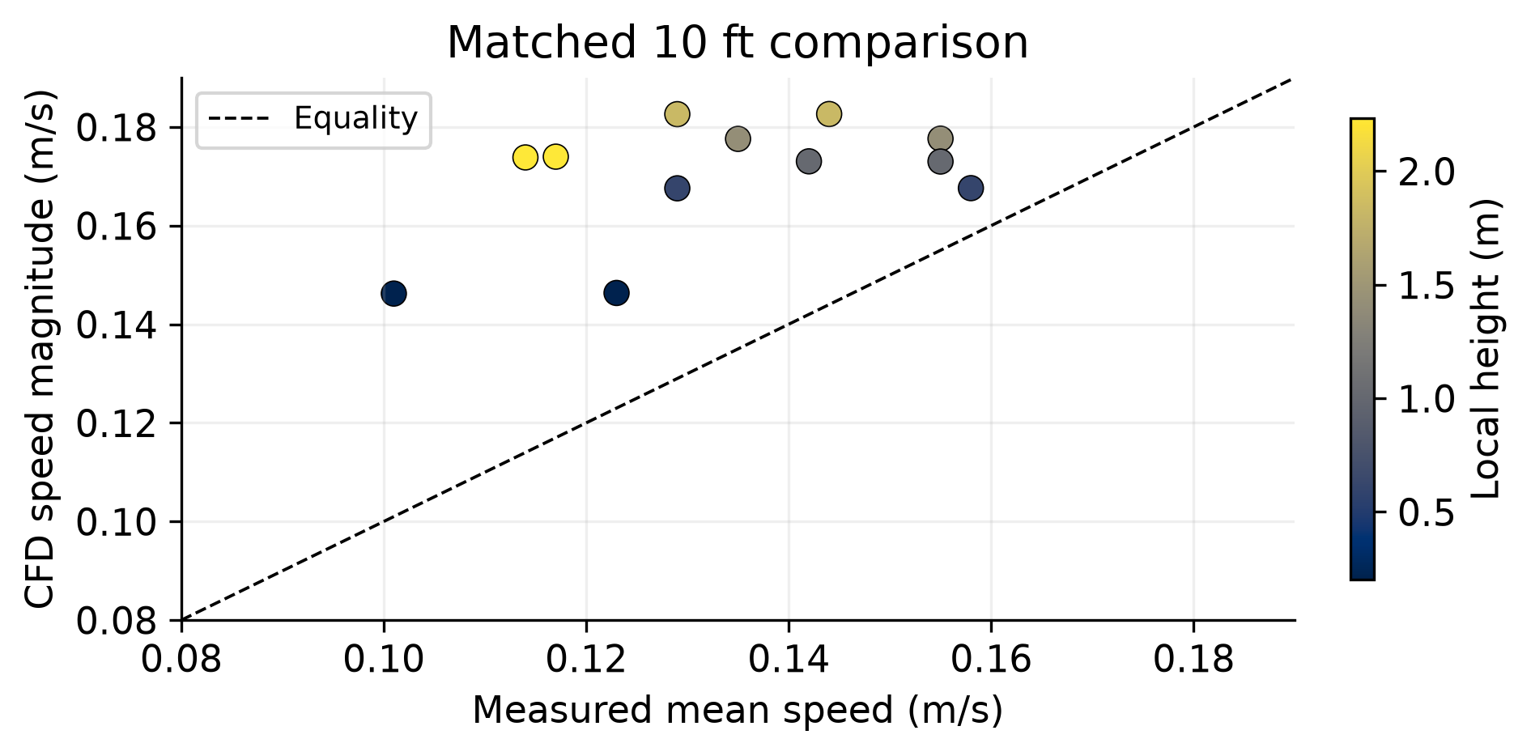
Figure 3. Matched 10 ft experimental and CFD scalar speeds. Point colour identifies height. The equality line indicates agreement; the systematic positive offset remains after input and coordinate checks.
Cell-point sampling gives RMSE 0.03977 m/s, mean bias +0.03667 m/s and correlation r = 0.489. Cell sampling gives RMSE 0.04047 m/s and bias +0.03753 m/s. Correlation measures association rather than agreement: it can coexist with systematic overprediction. Error has descriptive correlation 0.618 with height across only 12 points, which motivates further investigation but does not identify a cause.
Mesh | Cells | Converged iteration
Coarse | 17,664 | 115
Baseline | 141,312 | 237
Fine | 476,928 | 380

All three meshes pass checkMesh. Baseline-to-fine sensor RMSE is 0.001423 m/s; dense-section relative L2 difference is 4.54%. Unequal refinement ratios and remaining field differences prevent a mesh-independence claim. Switching between nominal and published coordinates changes sampled speed by RMSE 0.000293 m/s, with maximum change 0.000769 m/s. These effects are smaller than the matched discrepancy and do not explain it.
The +0.03667 m/s bias is about 24.4% of the illustrative 0.15 m/s scale. It is of similar order to experimental reconstruction errors, but bias and RMSE from different comparisons cannot be subtracted to form an error budget. A surrogate can reproduce CFD very accurately while inheriting its physical bias. Wall treatment, diffuser conditions, leakage and apparatus boundary evidence remain priorities; none has been established as the cause.

7 CFD sampling and the limits of transfer
Virtual sensors make the sampling question testable because the entire numerical section can be queried. Each layout is fitted on selected CFD samples and evaluated on a disjoint 40 × 60 reference grid. Candidate layouts use a separate 32 × 48 grid. The tested 6, 12, 24 and 48 sensor layouts include interior, boundary-heavy and hybrid placement; increasing count also changes placement, so the sequence is not a pure nested density experiment.
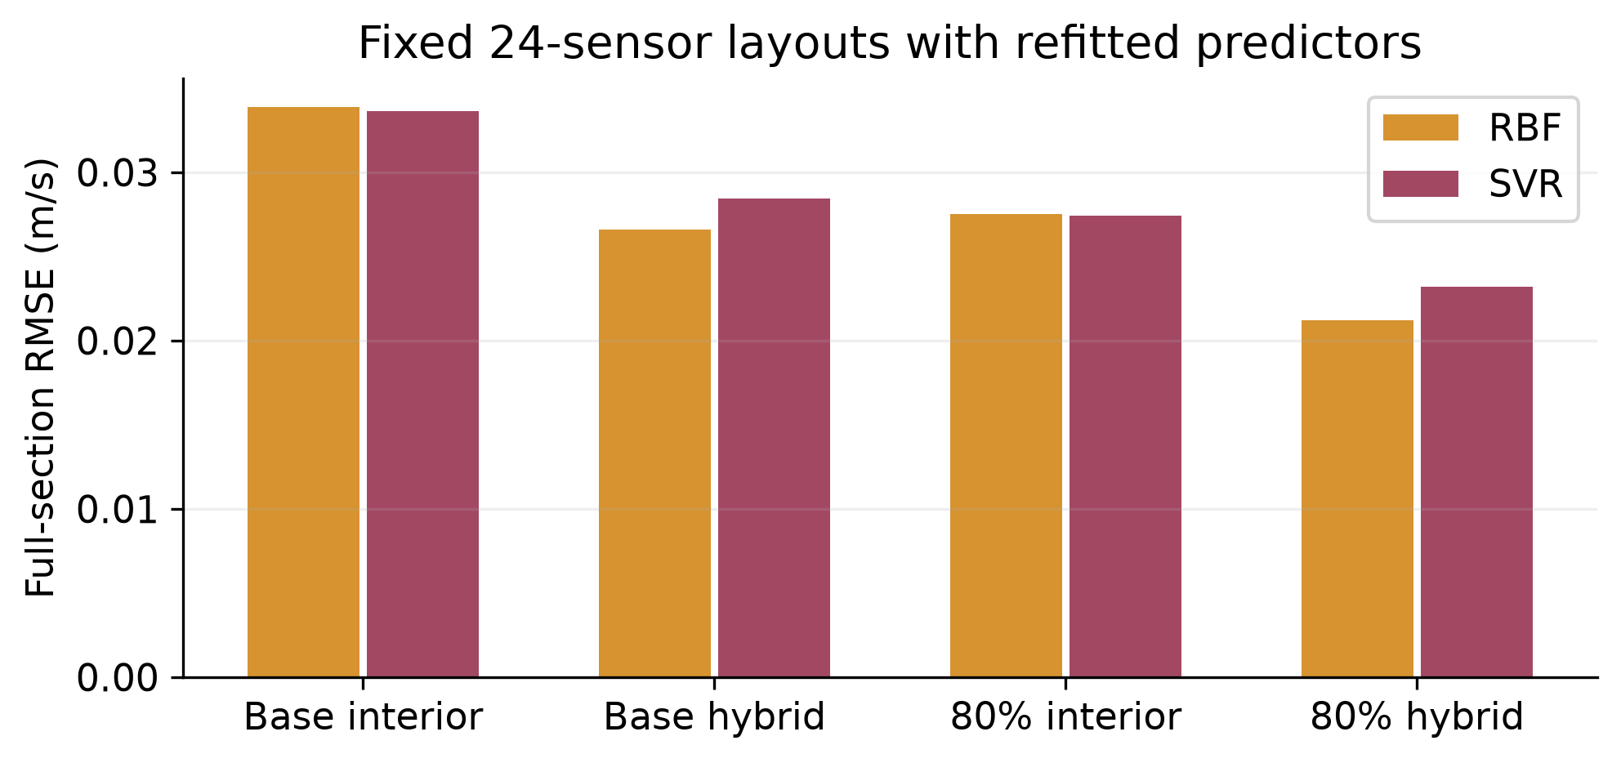
Figure 4. Whole-plane error for 24-sensor interior and hybrid layouts. The flow80 case supplies 80% of baseline flow and refits the models at the same sensor positions. Lower error is better; this tests layout transfer with new data, not a frozen model predicting a new operating condition.
At 24 sensors in the baseline case, hybrid placement reduces full-plane RBF RMSE from 0.03388 to 0.02658 m/s and SVR from 0.03365 to 0.02844 m/s. Boundary-heavy placement performs worse, with RBF 0.04840 and SVR 0.05678 m/s. Boundary coverage helps only if interior structure is also represented. The exploratory hybrid design was introduced after inspecting boundary-heavy performance, so it is a promising design result rather than an untouched final test.
At 80% supplied flow, the same positions with refitted models give RBF errors 0.02754 and 0.02119 m/s for interior and hybrid layouts, and SVR errors 0.02743 and 0.02319 m/s. The average improvement persists, but not at every plane: the 52 ft plane can worsen. A layout recommendation therefore needs inspection of local failures as well as average performance.

Why small surrogate error can mislead
A separate three-dimensional surrogate uses 72 CFD samples from five training stations and tests four withheld planes. On 4,400 commonly supported test points, SVR and RBF RMSE are approximately 0.002914 and 0.002927 m/s. Across all 9,600 points, errors rise to 0.03259 and 0.03238 m/s. Only 45.8% of the dense test points share the supported comparison. These values belong to a different design from the two-dimensional layout study and should not be mixed into one ranking.
The result links interpolation, extrapolation and training-data selection: a model may capture the interior numerical field while missing boundary regions that dominate full-plane error. Denser sampling is useful when it covers relevant gradients, but neither density nor a smooth kernel guarantees adequate domain coverage. The engineering recommendation is to allocate sensors across the interior and boundary regions, then assess the intended whole-plane output explicitly.

8 Sensitivity to measurement perturbations
The directly relevant stability question is whether small perturbations in measured speeds produce disproportionately large changes in reconstructed fields. For a fixed linear interpolator, prediction is a weighted sum û(q) = Σwᵢ(q)uᵢ. If each input perturbation satisfies |δuᵢ| ≤ ε, then |δû(q)| ≤ ε Σ|wᵢ(q)|. The sum of absolute weights is a worst-case gain; it is not a statistical uncertainty interval.
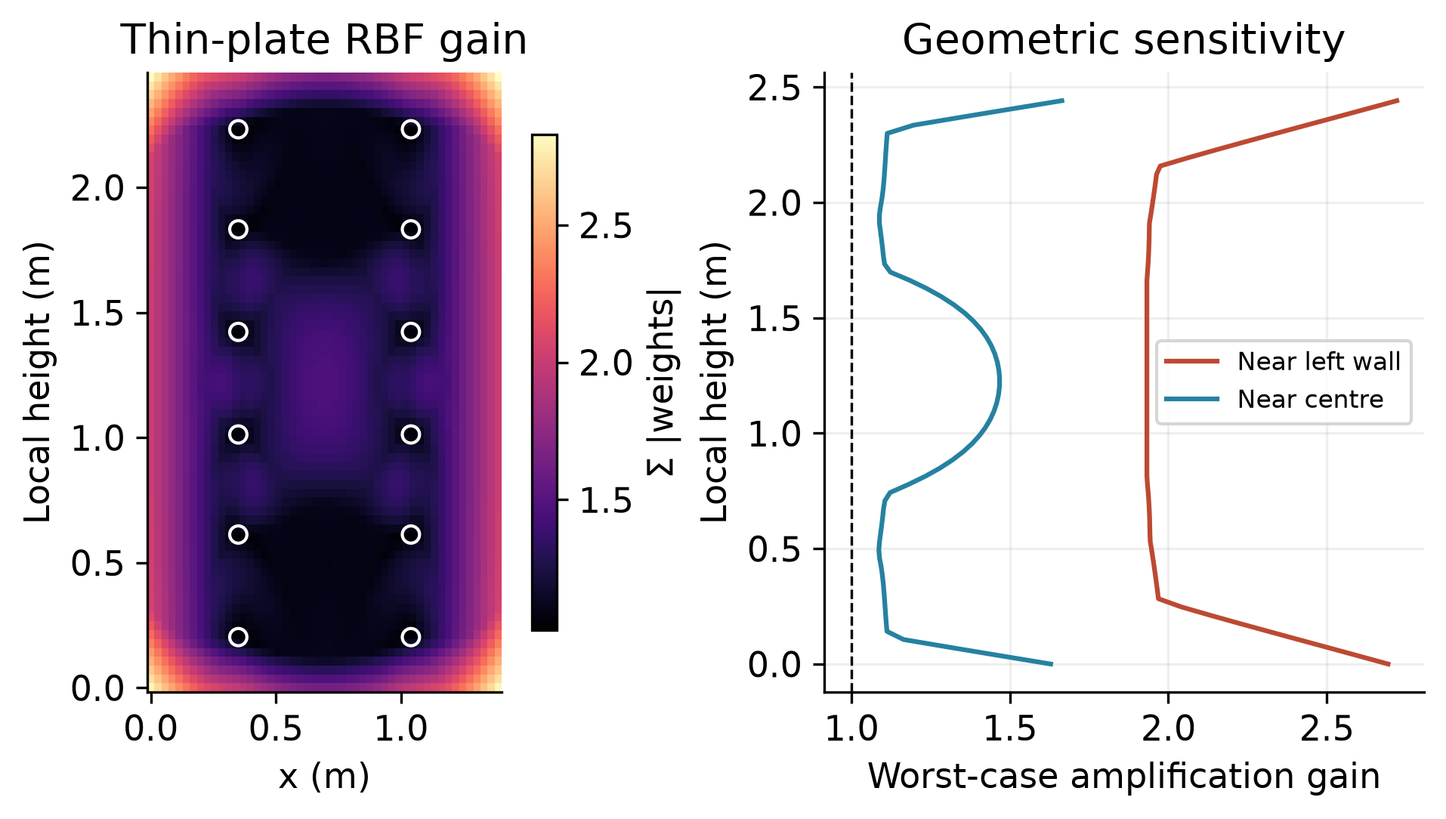
Figure 5. Noise amplification on the full 12-sensor matched geometry using standardised coordinates. The RBF map and profiles show increasing gain beyond the sensor hull. Values depend on the geometry and scaling; they are distinct from held-location prediction scores.
Basis-vector calculations on a 50 × 70 section grid give maximum thin-plate RBF gain 1.468 inside the hull and 2.829 outside. Nearest neighbour has gain 1; linear interpolation has gain 1 where supported and no outside prediction. The full 12-point geometry is used here, whereas outer validation retains 11 points. This diagnostic therefore explains a mechanism without replacing the cross-validation errors.
For illustration, rounding a speed to the nearest 0.001 m/s bounds rounding alone by 0.0005 m/s per sensor. Multiplying by the calculated gains gives maximum bounds of about 0.000734 m/s inside and 0.001415 m/s outside for this grid and geometry. These are not instrument uncertainty estimates and do not include experimental variability. The small rounding bound cannot justify dismissing other sources of measurement error.
Zero smoothing makes RBF interpolate observed values exactly. That is useful for a clean baseline, but it can preserve noise and increase extrapolation sensitivity through negative weights. SVR can tolerate residual deviations through epsilon and regularisation, although no equivalent SVR perturbation experiment is reported here. It would be unsupported to claim that SVR is demonstrably more noise-stable from its formulation alone.
A next study could choose RBF smoothing within the existing inner validation loop and test perturbations tied to documented instrument uncertainty. This would directly address the bias–variance trade-off without tuning against outer test outcomes. The reduced diffusion study is retained in Appendix B to demonstrate taught finite-difference stability, but it is not used to explain the nonlinear CFD failure.

9 Computational cost and reproducibility
A controlled benchmark replaces the earlier incompatible timing records. The first source location is withheld in each of 36 runs, giving 11 or 23 retained sensors. Every method receives the same retained data, one held-out query and a 2,400-point query grid. One warm-up precedes 20 repetitions; method order is shuffled, numerical thread pools are limited to one, and file I/O is excluded. The table gives medians across repetitions within each run and then across runs of the same size.
Method | Fit 11 / 23 ms | Predict 2400 at 11 / 23 ms
Mean | 0.014 / 0.014 | 0.002 / 0.002
Nearest | 0.382 / 0.376 | 0.436 / 0.531
Linear | 0.493 / 0.557 | 0.198 / 0.212
RBF | 0.419 / 0.430 | 0.452 / 0.741
SVR | 0.954 / 0.928 | 0.709 / 1.307

Fitting includes each method’s required preprocessing, and prediction includes coordinate transformation. SVR uses the previously selected training-fold parameters. Its 12-candidate, three-fold search plus final fit is timed separately with three repetitions per run: median 47.2 ms for 11 sensors and 52.4 ms for 23. The selected parameters reproduce the saved nested-fold choices. These costs must not be hidden inside, or omitted from, an overall deployment comparison.
The benchmark ran under WSL2 on an Intel Core i7-1165G7 at 2.80 GHz with NumPy 2.5.4, SciPy 1.18.1 and scikit-learn 1.9.1. Very short timings depend on scheduling and hardware; extra decimal places would overstate precision. Linear prediction can be unsupported outside its hull, so its speed does not imply equal spatial coverage.

Practical interpretation and scaling
All methods fit and predict these small fields in milliseconds; even the SVR search completes in roughly 0.05 s. Runtime therefore does not justify choosing a less accurate model for this workload. Accuracy, support and transparency are the stronger selection criteria. Repeated online updates or much larger sensor sets could change that decision, but were not benchmarked.
Dense global RBF systems require quadratic matrix storage and approximately cubic direct-solve work as sensor count grows. Nearest-neighbour indexing has a different cost structure; SVR cost depends on the data and support vectors. The 11-to-23 sensor comparison cannot establish large-data scaling. Tracemalloc records were also retained for fit plus dense prediction, but they omit some native-library and process memory. They are diagnostic allocation measurements, not a total-RAM ranking.

Reproducing the extension
The controlled_performance and revision_figures modules save input hashes, versions, parameter checks, raw timings and figure data in separate derived-output folders. The existing workflow retains split audits, raw-data separation and numerical checks [4]. The new benchmark changes the cost assessment without changing the reported predictive scores or CFD physics. Tests check numerical behaviour; they cannot establish physical validation.

10 Engineering conclusions and remaining work

Recommended use of the models
RBF is the preferred aggregate interpolation baseline for supported experimental locations, with a 26.7% RMSE reduction relative to the mean. SVR remains competitive on the 12-point layouts and offers a regularised comparator rather than a universal improvement. The station dependence prevents a single unconditional winner. For exploratory mapping, predictions should display their support mask and be accompanied by errors in m/s; decisions requiring precise local ventilation levels need additional evidence.
The CFD experiments strengthen the case for balanced sensor placement and expose the cost of extrapolation. They do not prove agreement with the apparatus. The matched CFD bias is too large to ignore when interpreting a surrogate’s small numerical error. Improving reconstruction of a biased reference cannot correct missing or inaccurate physics.

Thermal extension and numerical judgement
A thermal case introduces inlet air at 21.289 °C into a bridge with laboratory and prescribed wall temperature 24.375 °C, using Q = 0.531761 m³/s. The wall temperature is an unmeasured surrogate and differs from the intended adiabatic A/AC interpretation. A zero-gravity control converges at iteration 733, but the initial buoyant solve diverges. A lower-relaxation restart and continuation remain unconverged; they are diagnostic fields only.
At continuation iteration 1967, temperatures remain between 294.439 and 297.525 K, but pressure residual is 0.0300 against a 10⁻⁵ screen and temperature residual is 0.000259 against 10⁻⁶. The last-100-iteration probe range is 0.135 K against 0.01 K. Relative flux imbalance is only 1.23 × 10⁻⁶. Thus bounded temperature and conservation alone do not establish convergence. SIMPLE iterations are not physical time, and these fields remain excluded from training and quantitative reference comparisons. Appendix A retains the diagnostics.

Priority investigations
First, inspect wall treatment and y-plus, diffuser conditions and leakage evidence to address the physical CFD discrepancy. Second, test a predeclared sensor layout or independent operating case, including an acceptance criterion for the intended use. Third, if thermal modelling remains in scope, isolate numerical settings and boundary assumptions in a controlled robustness study before using thermal fields as references. Additional ML models are a lower priority than these credibility checks.

AI use and individual learning
AI assistance supported parsing, workflow and plotting code, numerical checks, documentation and this report scaffold. Verification included unit tests, coordinate/source audits, repeated outputs, mesh checks, solver logs and hosted CI. Errors found during development included a probe-window bug and coordinate-dependent geometric tie selection; these were corrected and recorded in the AI-use log [4].

References
[1] Lebbin, P., Laengert, S., Howell, S. and Jeans, L. (2026). Communicable Disease Transmission in Air Travel: Jet Bridge Ventilation. DOT/FAA/AM-25/28. Federal Aviation Administration, July. Supplied report dot_92576_DS1.pdf.
[2] FAA/NRC (2026). Jet bridge ventilation dataset, JetBridge_2026. https://doi.org/10.21949/qqdx-gh59. Experimental records, replicate means, HVAC records and data dictionary.
[3] MMA3001 teaching team (2026). Numerical Methods and Machine Learning Project Brief. Supplied assessment document. The main report has a ten-page maximum excluding references and appendices.
[4] Jet bridge project repository (2026). jetbridge-ml-cfd. https://github.com/matt-b-0/jetbridge-ml-cfd. Existing code snapshot 3cb9b93 with local report-revision extensions generated 25 October 2026. See docs/assumptions.md, docs/ai_usage_log.md and saved result manifests. Record the final submitted commit when preparing submission.
[5] scikit-learn developers (2026). SVR API reference. https://scikit-learn.org/stable/modules/generated/sklearn.svm.SVR.html. Accessed 25 October 2026.
[6] SciPy developers (2026). RBFInterpolator API reference. https://docs.scipy.org/doc/scipy/reference/generated/scipy.interpolate.RBFInterpolator.html. Accessed 25 October 2026.
[7] scikit-learn developers (2026). Gaussian processes user guide. https://scikit-learn.org/stable/modules/gaussian_process.html. Accessed 25 October 2026.

Data and code provenance
Experimental raw files and large OpenFOAM fields remain external to Git. Derived report figures and benchmark tables are generated from the existing saved analysis. Experimental metrics use equal-run aggregation on common support. CFD layouts, the three-dimensional surrogate and noise-gain diagnostics use different evaluation designs, identified in their captions and accompanying text. No thermal field is included as trusted training data.

Appendix A Thermal diagnostic results
These figures document an unsuccessful numerical extension. They must not be interpreted as a validated thermal ventilation prediction. The original buoyant run diverged with maximum speed above 62,000 m/s. The subsequent restart saved a field at iteration 967 even though its log reached 1000; continuation starts from the saved field and ends at 1967. Relaxation and initialisation differ from the zero-gravity control, preventing attribution of field differences solely to converged buoyancy.
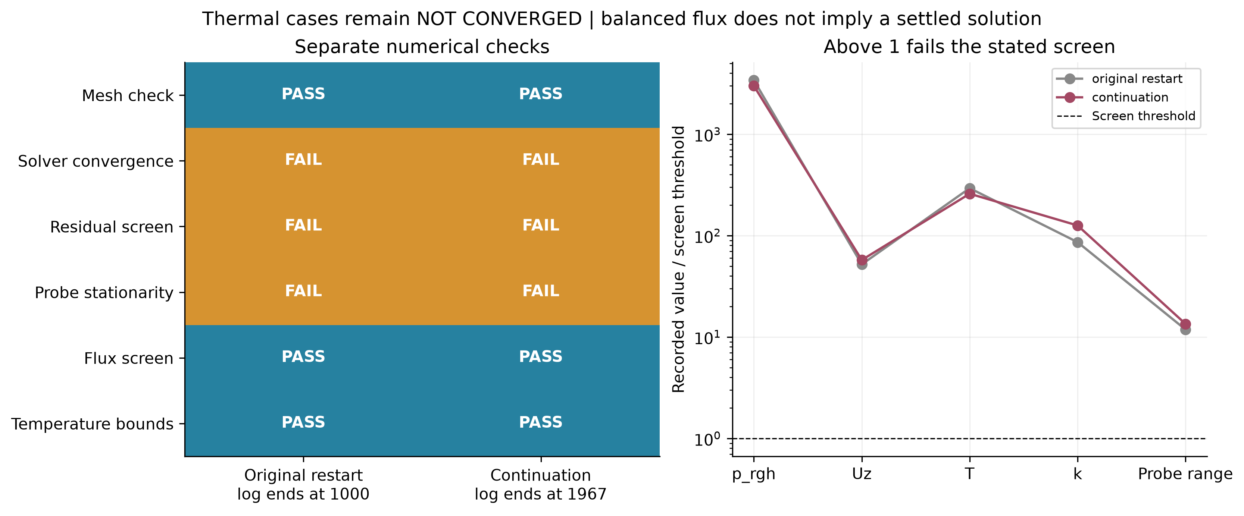
Figure 6. Thermal residual, stationarity and conservation screens. Ratios above one fail the stated diagnostic threshold. Low flux imbalance does not override failed residual and stationarity checks.
Maximum speed in the continuation is about 5.10 m/s. Bounded temperature reflects only one aspect of numerical behaviour. A useful next experiment would predefine boundary assumptions, initialisation, relaxation and stopping criteria, then change one factor at a time. A transient formulation would require its own time-step and temporal-accuracy assessment; switching formulation is not evidence of success.

Appendix B Reduced diffusion stability study
A separate one-dimensional diffusion problem provides a known analytical reference for finite-difference verification. It connects finite differences, ODE stability, implicit solution and relaxation to the unit syllabus. It does not diagnose the steady nonlinear OpenFOAM failure or establish a physical CFL limit for SIMPLE.
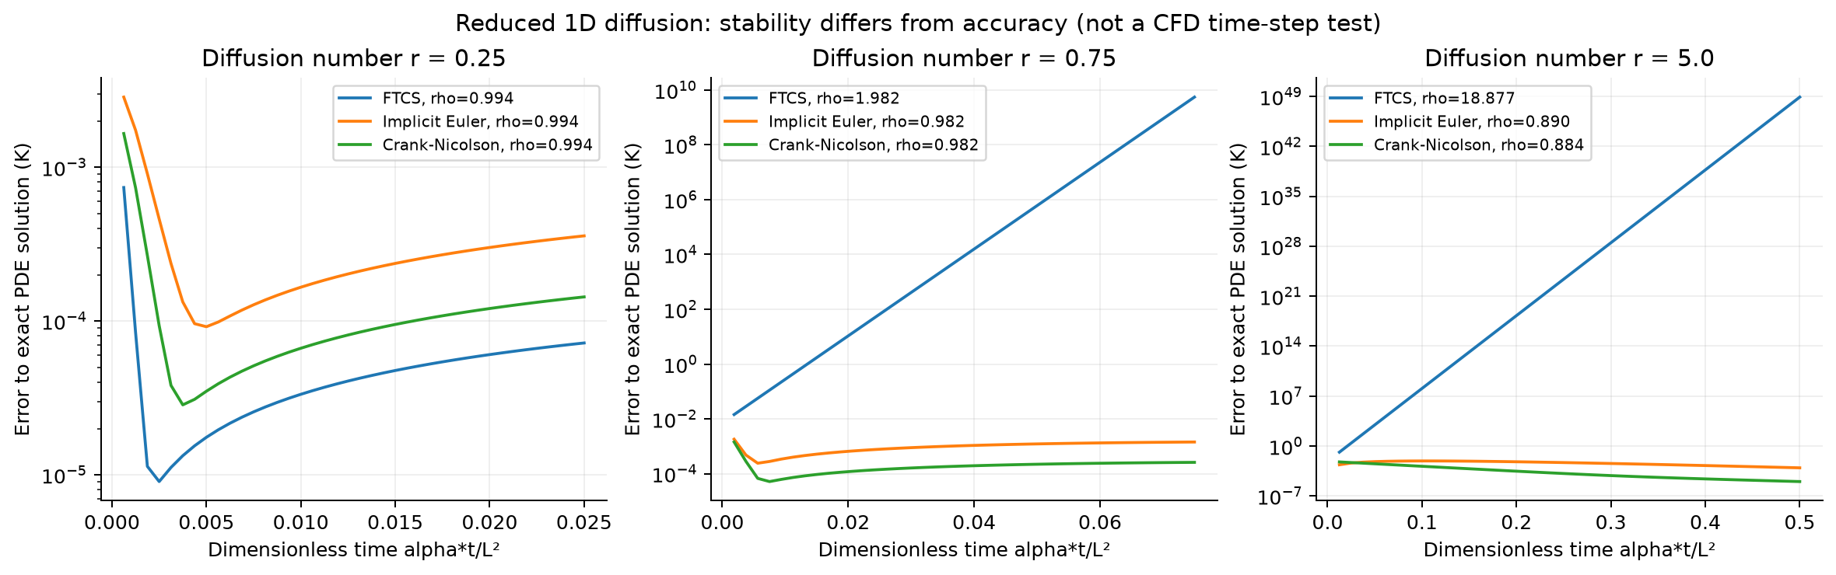
Figure 7. Reduced diffusion verification using FTCS, backward Euler and Crank–Nicolson. Stability and accuracy are separate properties; an implicit stable scheme can still have substantial time-discretisation error.
For diffusion coefficient α, the dimensionless step is r = αΔt/Δx². Standard one-dimensional FTCS requires r ≤ 1/2 for stability. Backward Euler and Crank–Nicolson allow larger steps in the linear diffusion problem, but large steps can reduce accuracy; Crank–Nicolson can retain oscillatory high-frequency modes. Refinement and analytical comparison are therefore necessary alongside a stability condition.
Weighted-Jacobi relaxation and temporal refinement are retained in the reproducible study. Their role is to test numerical mechanisms against a known solution. The main report instead prioritises sensitivity on the actual sensor geometry, which bears directly on interpolation robustness. This separation prevents a successful simplified test from being presented as validation of a more complex CFD calculation.

