The goal would be to find a long term partner for software development. In this document I have created two exercises. If you pass the test, we carry on the collaboration. The information will be retrieved via SOAP (XML) or similar. Once you start the exercises, I will provide you an username, password and the link to the webservices.

The software provides two modules. (HelpDesk and Workorders)

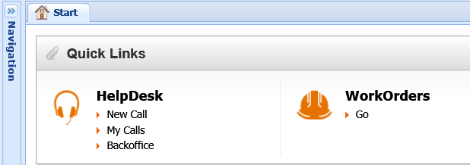

**Exercise 1**

**Book a call in the software via webservices. See below how it’s done manually in the software.**

1. Click New Call

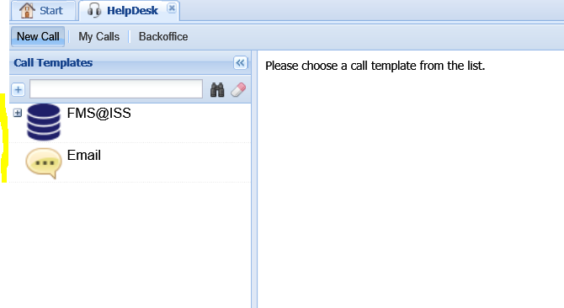

1. Choose an emailtemplate. In my case I chose Email
2. Fill out the questions
3. Book call

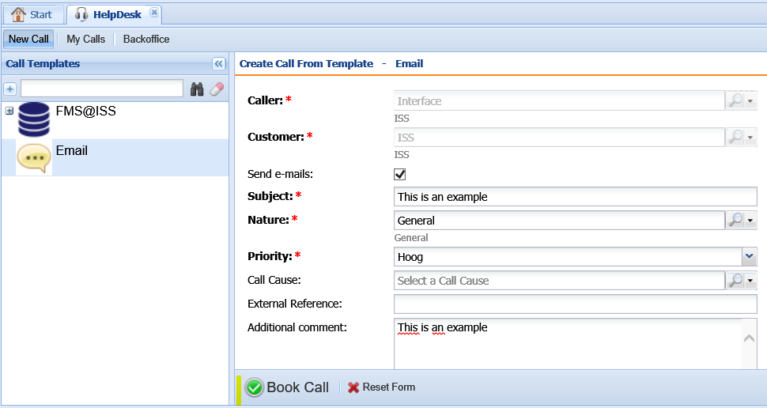

**Exercise 2**

**Book a workorder in the software via webservices. See below how it’s done manually in the software.**

1. Click Add

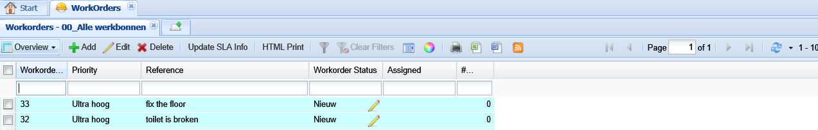

1. Select a workorder type and click next

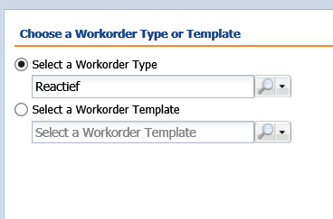

1. Fill out the mandatory fields (bold) and click next

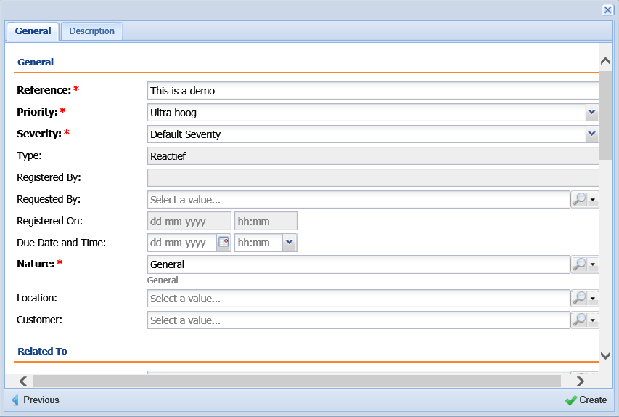

1. Workorders has been created

