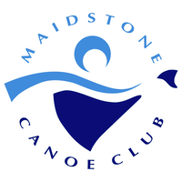Issue: 1

Date : 28 January 2023

# Leading on the Medway between Allington and East Farleigh in different conditions

This document is intended to apply to Group Leaders

The Medway in normal conditions (i.e. flow slower than walking pace) is considered as Very Sheltered Water under British Canoeing guidelines. When the flow is high, this may increase to Moderate Water.

https://www.britishcanoeingawarding.org.uk/download/331/

**Who can lead?**

|  |  |  |
| --- | --- | --- |
|  | **Flow normal**  **(slower than walking pace)** | **Flow high**  **(faster than walking pace)** |
| **Daylight** | PAA – max group 5  PI – max group 8  PSL – max group 8  Coach – as per British Canoeing remits | PI / PSL provided they have been approved by the Committee and CDG  As competent in these conditions.  Each group must contain some paddlers with experience on moving water.  Coach – as per British Canoeing remits |
| **Dark** | PI – max group 8  PSL – max group 8  All group members must be Explore level or above and be able to self-rescue in the craft they are using.  Coach – as per British Canoeing remits | Each group must contain some paddlers with experience on moving water.  Coach – as per British Canoeing remits |

These are max group sizes only. It is expected that group leaders will take their own experience plus that of their group members into account when planning a trip, and to conduct further dynamic risk assessments both before and during the paddle.

Note: this table talks about led groups only, rather than peer paddles or solo paddlers.