**Documenting country-specific contraception codes and reasons for discontinuation**

1. As mentioned in the email, we need to find codes for variables vcal_2 and vcal_2 not accounted for in the DHS Recode Manuals. Below are the standard codes from [Recode Manual VII](https://dhsprogram.com/pubs/pdf/DHSG4/Recode7_DHS_10Sep2018_DHSG4.pdf):

Codes for vcal_1 (reproductive events and methods of contraception)

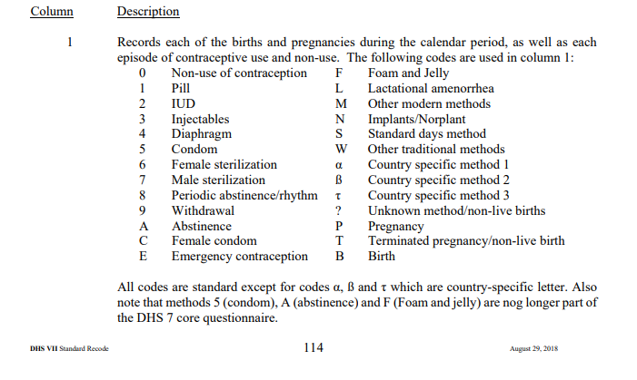

Codes for vcal_2 (reasons for discontinuation of use of contraceptive methods)

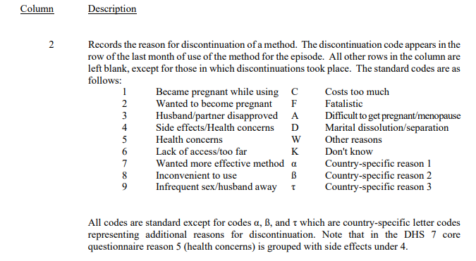

2. Some country-specific codes are known; they are documented in the country_specific_codes.txt. You can open the file with Notepad ++ for convenience. Below is an example of some information the file contains:

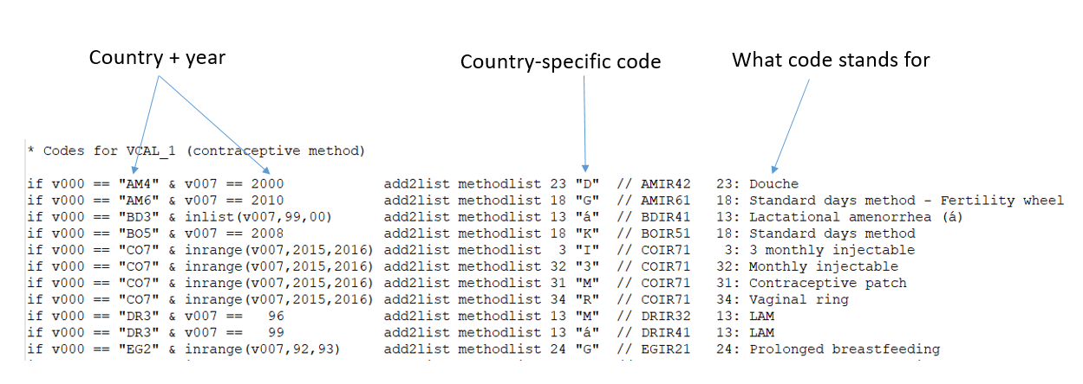

**We need to collect country-specific codes for samples not accounted for the in the country_specific_codes.txt. So if a sample is listed in that document (such as Egypt 2000, for example), you can skip that sample.**

3. To find out if a sample has a country-specific code, we will need to check **two documents** because there appears to be no consistency in where the country-specific codes are reported. They can be found either in sample-specific Final reports or in Individual Recodes Documentation.

4. First, check Individual Recode documentation. To find out if a sample has a country-specific code, download an Individual Recode data from the DHS website. You need to be a registered user of DHS to request the data. Below is an example for Guatemala 2015.

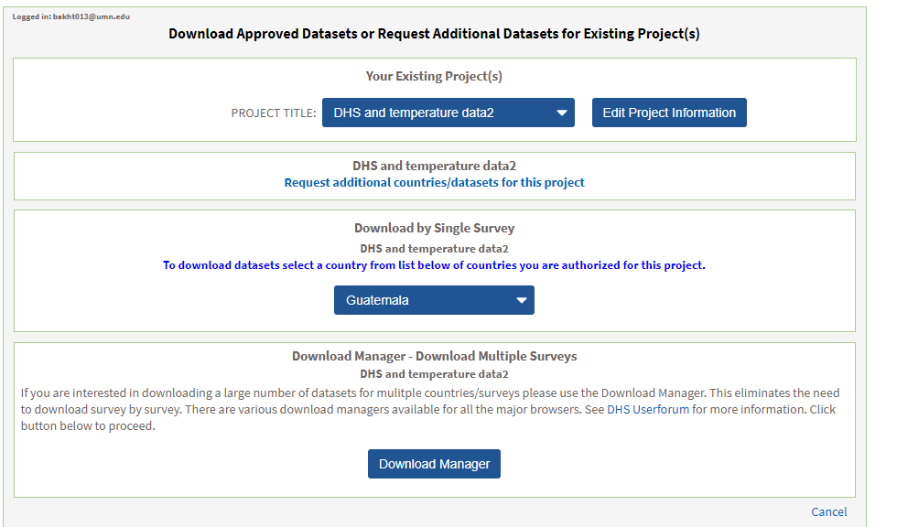

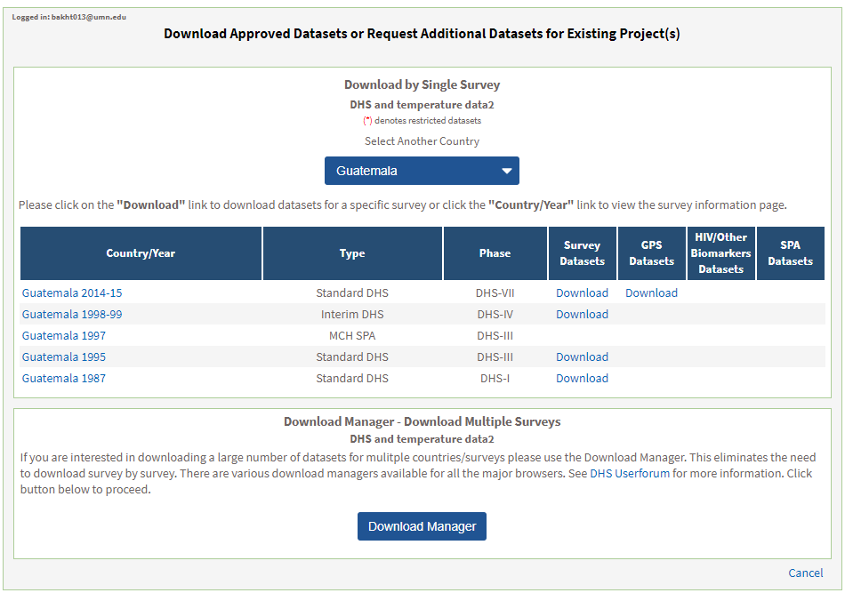

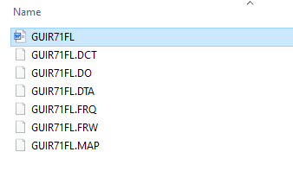

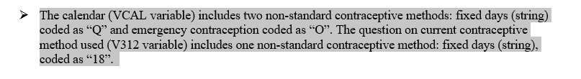

Click the selected Individual Recode file to download it.

Click on the Individual Recode file to download it. We don’t need to data itself but we need the word file that comes with the download.

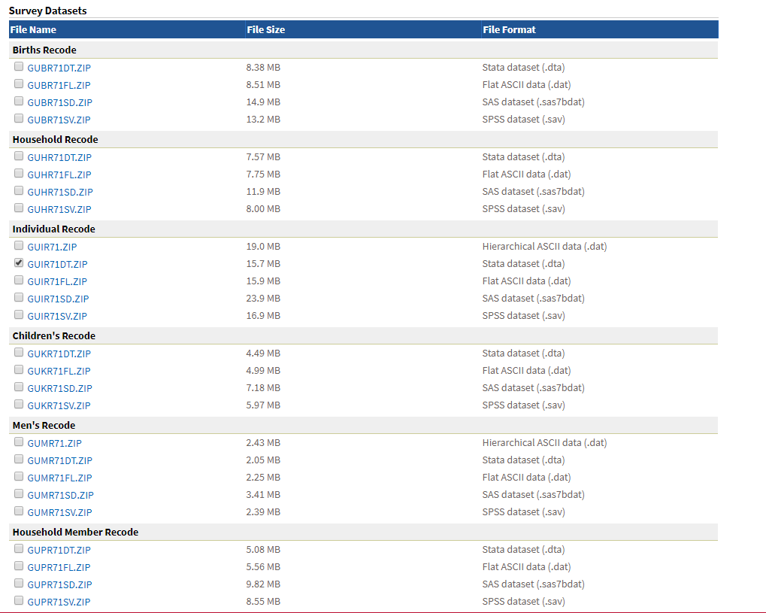

Once the downloaded is complete, navigate to the zipped folder and open a Word document inside it.

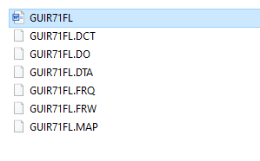

The document contains a lot of technical detail about the sample, but we only need information related to calendar data (vcal). Screen the document to find mentions of calendar data and calendar variables related to contraception and reasons for discontinuation. We are not interested in standard variables for methods of contraception, so ignore those codes unless they explicitly mention calendar data (for example, in the highlighted figure below we don’t need to document code 18 for variable V312 because it is not a calendar variable). If the document is too long, you can search for (Ctrl + F) specific words such as “calendar” or “vcal”.

Make sure to screen the document for the two variables: vcal_1 (contraceptive methods) and vcal_2 (reasons for discontinuation).

The document for Guatemala 2015 contains the following statement on page 22 regarding VCAL, which is exactly what we’re after.

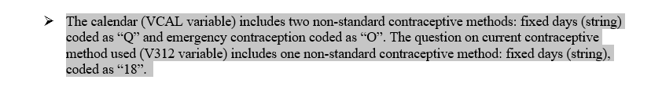

5. Document sample, code, and what codes stand for in the Excel spreadsheet. There are two sheets in the spreadsheet – one for vcal_1 and once for vcal_2.

For comparison, open Guatemala 2015 DHS Final report (<https://dhsprogram.com/pubs/pdf/FR318/FR318.pdf>) and scroll to page 693. You will see there is no code Q or O for the methods column (see below), which is why we need to check both Individual Recode documentation and Final Reports.

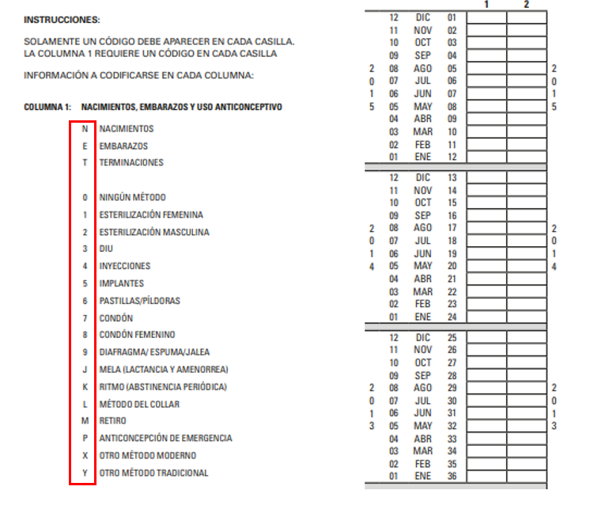

6. To check county-specific calendar variables codes in the Final Report, open a Final Report for the sample. A final report can either be found in the X:\source_materials\COUNTRY\documents\Archived or downloaded from the internet (because not all final reports are in the archived folders). It’s pretty easy to find online – just google “country year DHS final report” (e.g., Egypt 2000 DHS final report).

For example, Egypt 2000 Final report can be found here: X:\source_materials\egypt_2000\documents\Archived (the final report starts with “FR” - **FR_Egypt_2000_117.pdf**. Open that document, scroll to the very last page, and you will see all the codes for vcal_1 and vcal_2. The part on calendar variables is usually located at the end of the Final Reports but sometimes you’ll need to scroll a bit through the last 10-20 pages to find the calendar section. It will always look similar to this:

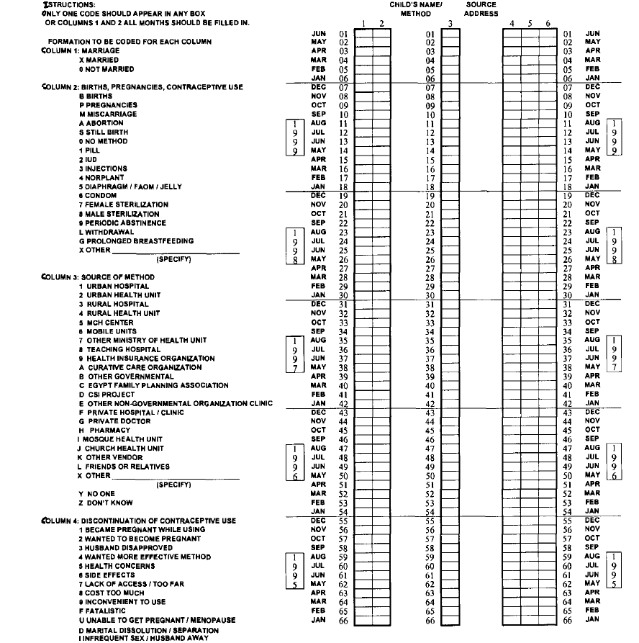

7. To find out if a sample has a country-specific code, compare the codes for column: birth, pregnancies, and contraceptive use to the codes from the DHS Recode Manual (at the very start of this document).

Again, make sure to check the final report for two variables: vcal_1 (contraceptive methods) and vcal_2 (reasons for discontinuation).

See example:

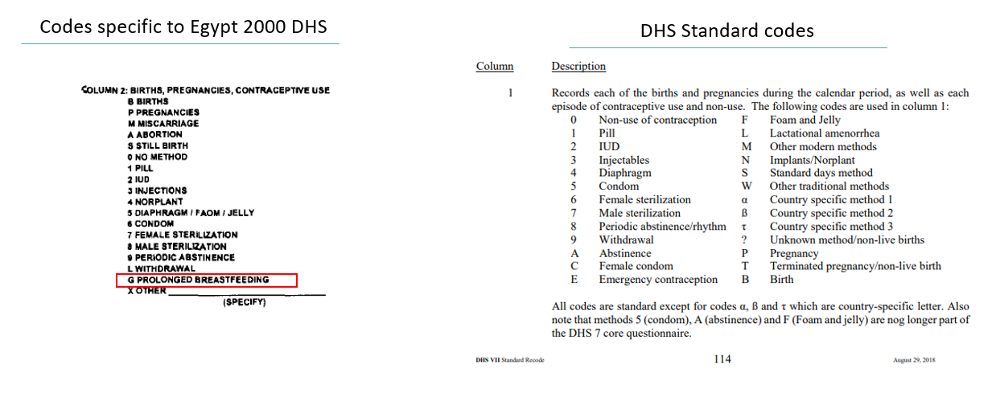

8. You can see that G – prolonged breastfeeding – is not found among the DHS standard codes. Document that code in the Excel spreadsheet.

9. If you checked a sample and did not find any country-specific calendar codes, put NA in the columns of the excel spreadsheet.