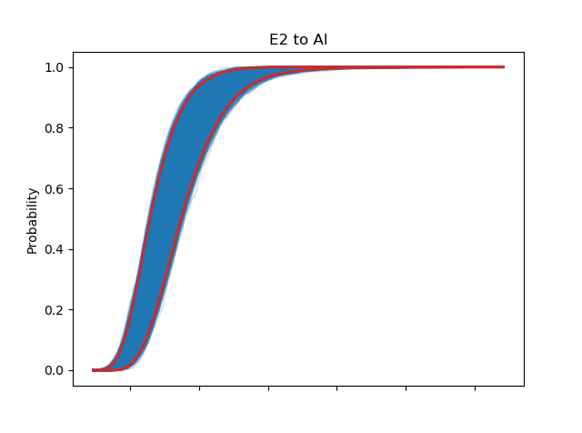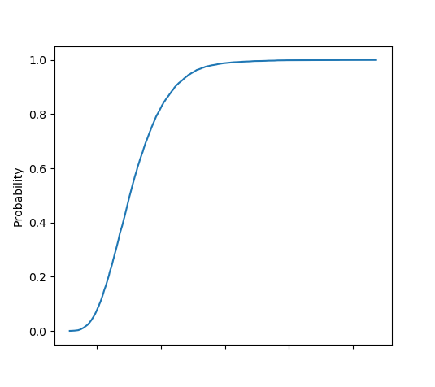

**Outer loop (Epistemic), $i=1, …, N$**

Sample values for $E_{1}, E_{2},E_{3}$

**Inner loop (Aleatory)**

Sample values for

Visualization

Download .png file

Tabset Panel: control panel (data source, visualization options, etc.)