Bike Hire System: User Guide

# Overview

The Bike Hire System’s user-interface consists of 4 main tabbed panes: Hire, Customer, Bike and Invoice. A further 2 tabbed panes reside within each main tabbed pane. The table below shows how to navigate to the relevant section for each action.

|  |  |  |
| --- | --- | --- |
| **Main Tab** | **Sub Tab** | **Action** |
| Hire | Create | Create a new hire |
| Hire | View | View all hires |
| Hire | View | Return a hired bike |
| Hire | View | View hire statistics |
| Customer | Create | Create a new customer |
| Customer | View | View all customers |
| Bike | Create | Create a new Bike |
| Bike | View | View all bikes |
| Bike | View | Repair a damaged bike |
| Bike | View | View bike statistics |
| Invoice | Out | View all invoices (out) |
| Invoice | In | View all invoices (in) |

Table 1: The tab/sub tabs where each action resides.

# System Usage Instructions

This section features screenshots of the system in use. Where applicable, instructions or additional information is provided in the screenshot’s caption.

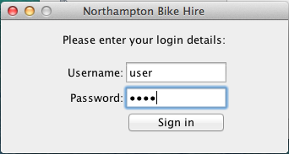

Figure 1: GUI - Login Frame

The login window is displayed when the application is first opened. It is used to control access to the system. The username (“user”) and password (“pass”) are hardcoded. An error message will be displayed if the credentials entered are incorrect.

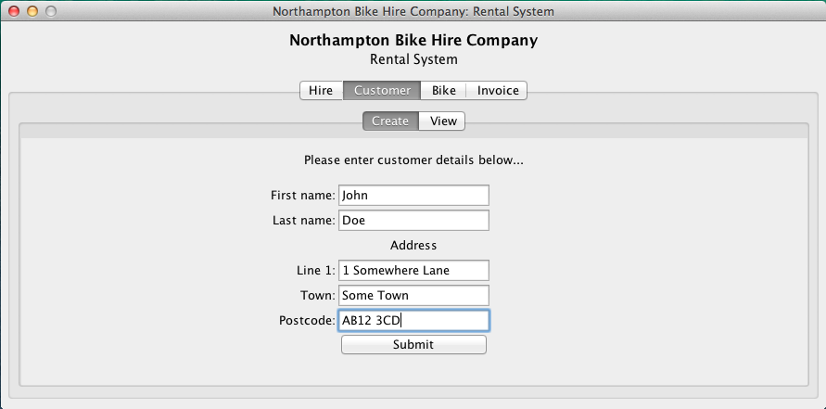

Figure 2: GUI - Create Customer Panel

All fields must be completed in order to create a new customer. If one or more fields are incomplete, an error message will be displayed when the user clicks submit. The GUI displays a confirmation message when a new customer is successfully created.

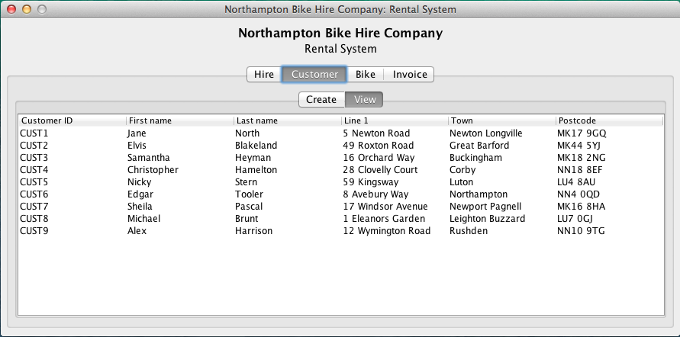

Figure 3: GUI - Customer View Panel

The user can view all customer details from within the Customer->View tab.

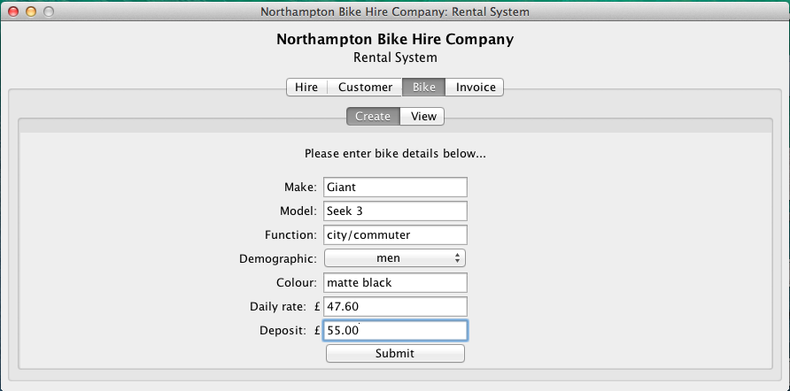

Figure 4: GUI - Create Bike Panel

All fields must be completed in order to create a new bike. If one or more fields are incomplete, an error message will be displayed when the user clicks submit. Furthermore, the value entered in the Daily rate and Deposit fields must be greater than 0 and in numeric format. The GUI displays a confirmation message when a new bike is successfully created.

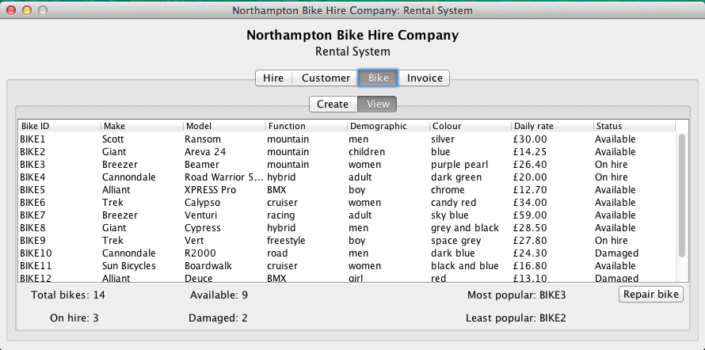

Figure 5: GUI - Bike View Panel

The user can view all bike details from within the Bike->View tab. Statistics are also displayed at the bottom of the panel, including total amount of: all bikes, available bikes, bikes on hire and damaged bikes. The most and least popular bikes can also be seen. To repair a bike, click on the Repair bike button located at the bottom right of the panel. An input dialog box will prompt for the damaged bike’s ID (as shown in Figure 6: GUI - Repair Bike).

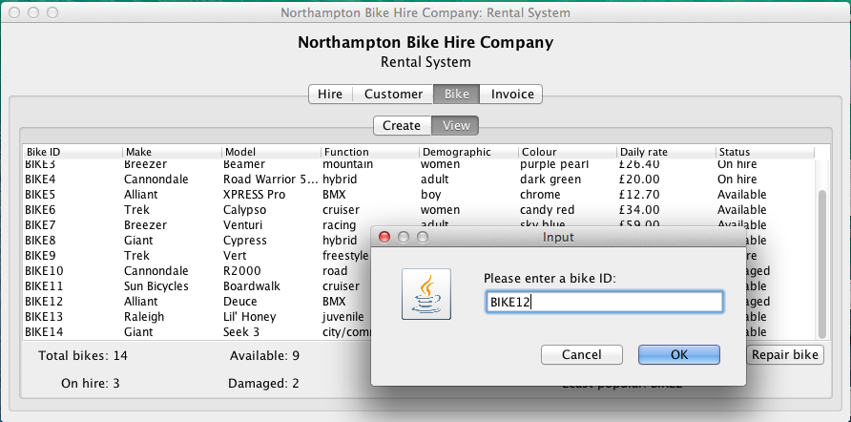

Figure 6: GUI - Repair Bike

To repair a bike, click on the Repair bike button located at the bottom right of the panel. An input dialog box will prompt for the damaged bike’s ID. An error message will be displayed if the bike ID entered is not recognised or the bike is not currently damaged. The GUI displays a confirmation message when a bike is repaired.

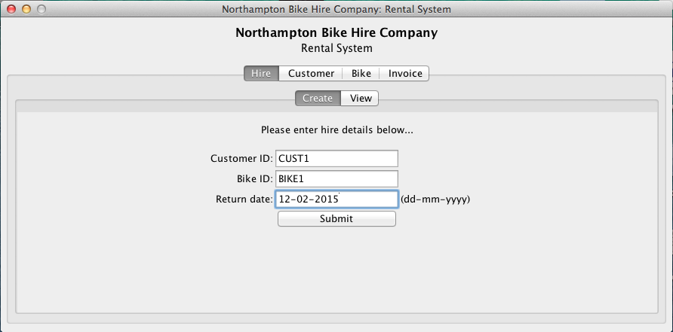

Figure 7: GUI - Create Hire Panel

All fields must be completed in order to create a new hire. The system will display an error message when the Submit button is clicked if:

* One or more fields are incomplete
* The Customer ID entered is not recognized
* The Bike ID entered is not recognized
* The format of the return date is not recognisable as a date
* The return date is before the current date

If all fields are complete and valid, the GUI will display the invoice for the newly created hire, (as shown in Figure 8: GUI - Confirm Payment Window). If the user clicks yes, the hire and invoice will be added to the system. If the user clicks no the hire and invoice will be discarded.

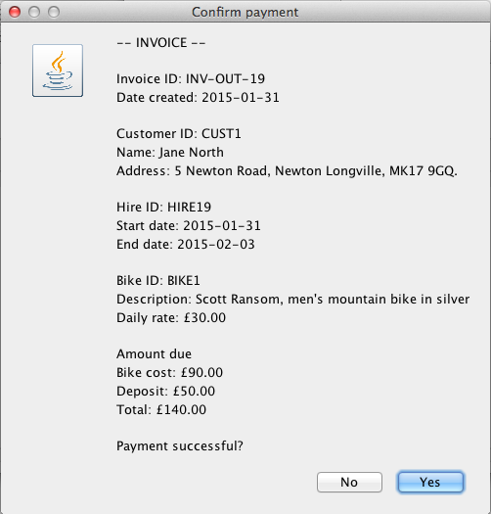

Figure 8: GUI - Confirm Payment Window

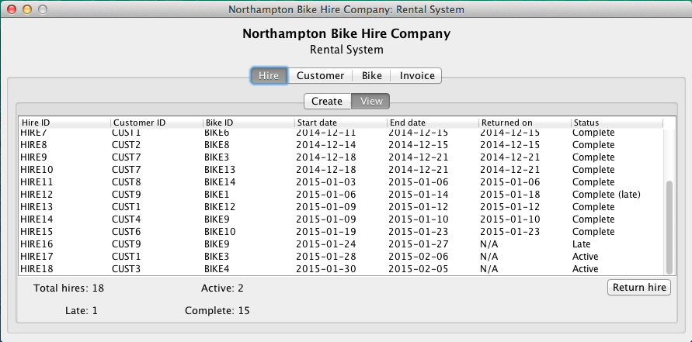

Figure 9: GUI - View Hire Panel

The user can view all hire details from within the Hire->View tab. Statistics are also displayed at the bottom of the panel, including total amount of: all hires, active hires, late hires and completed hires. To return a hire, click on the Return hire button located at the bottom right of the panel. An input dialog box will prompt for the hire’s ID (as shown in Figure 10: GUI - Return Hire).

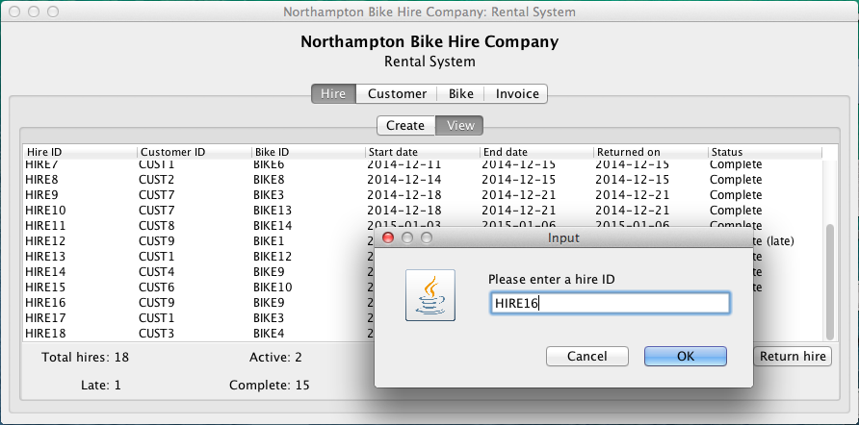

Figure 10: GUI - Return Hire

Hires can be returned by clicking on the Return hire button located at the bottom right of the panel. An input dialog box will prompt for the hire’s ID. An error message will be displayed if the hire ID entered is not recognised or the hire is not currently suitable for return. If the hire ID is recognised and suitable for return, the GUI will display a window asking if the bike is damaged (as shown in Figure 11: GUI - Damage Check), after which the invoice for the returned hire will be displayed (as shown in Figure 12: GUI - Invoice in).

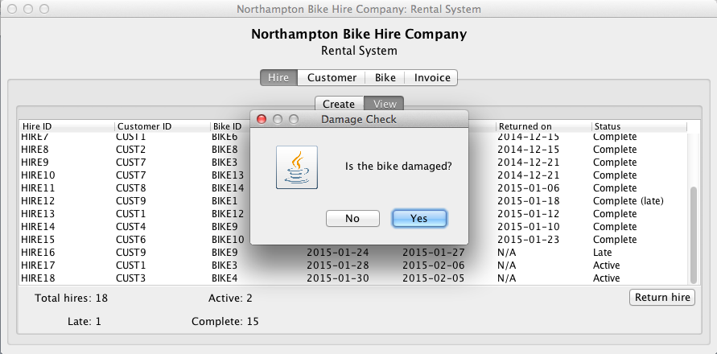

Figure 11: GUI - Damage Check

If the bike is damaged, the customer’s deposit is not refunded.

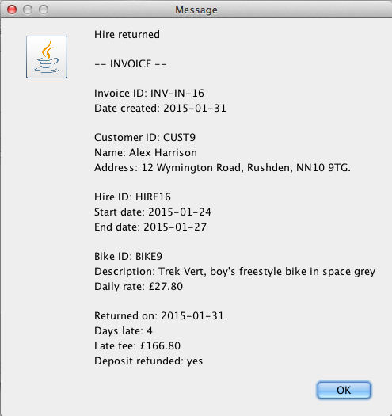

Figure 12: GUI - Invoice in

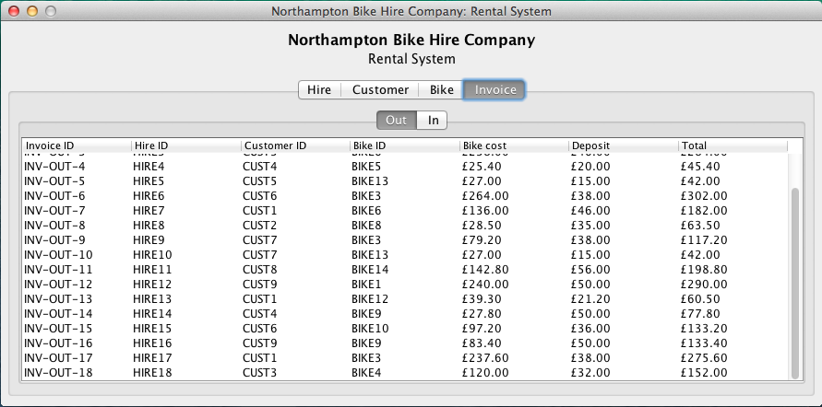

Figure 13: GUI - View Invoices Out

The user can view all invoices generated at time of bike hire from within the Invoice->Out tab.

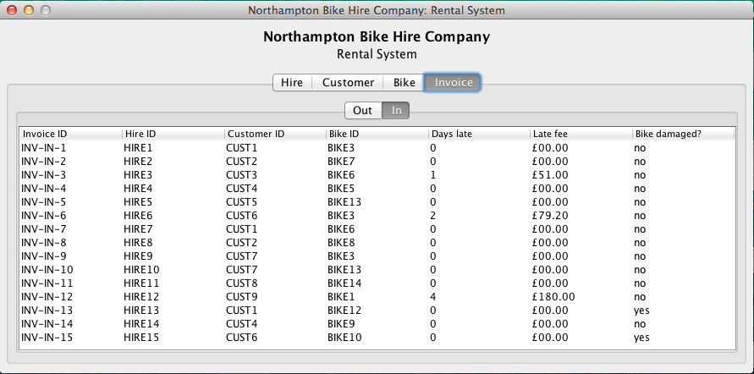

Figure 14: GUI - View Invoices In

The user can view all invoices generated at time of bike return from within the Invoice->In tab.