Canals, cooling and cities: a national-scale assessment of the cooling effects of urban canals

Authors

Tomkins, M.D.,

Mcdonald, H.,

Huck, J.J.,

Tippett, J.,

Chambers, J.

Abstract
Max. 150 words

Keywords: climate change adaptation, urban heat island, urban canals, urban cooling, blue green infrastructure

INTRODUCTION
Anthropogenic climate change is one of the principal threats facing humanity (1). While climate change impacts vary in form and intensity across the globe (2), urban areas are particularly vulnerable due to the high and growing concentration of human assets and activities (3, 4), comprising ~4.5 billion individuals in 2022 (5). Impacts associated with rising average temperatures, as well as an increase in the frequency and intensity of extreme weather events, such as heatwaves (6), also have a disproportional impact in urban areas due to the urban heat island (UHI), in which cities are typically warmer than surrounding rural areas (7, 8). In combination, these trends have important consequences for morbidity and mortality (9).

While urgent global-scale climate action is ultimately required to target the underlying drivers of climate change (1), adaptation strategies enacted at the local-scale, such as modifications to urban design, have the potential to mitigate against severe climate change impacts (10). Expansion of green space, such as tree planting or the creation of parks or green roofs, is one commonly studied example, and has been shown to depress urban temperatures by ~0.94°C during the day (11). By comparison, the effects of blue space (such as canals) on urban temperatures have received comparatively little attention (12), with uncertainty regarding the magnitude of urban cooling (13, 14).

In this study, we model the thermal effects of blue infrastructure on the surrounding environment, performing a national-scale analysis of Great Britain and Ireland, where an extensive urban canal network (Fig. 1) reflects the legacy of the Industrial Revolution (15). Our model quantifies the energy balance of urban canals (16), incorporating radiative, evaporative, and conductive–convective exchanges (17) and returns modelled water (wT) temperatures and concrete temperatures (cT) at 15-minute intervals for 2022, where fluctuations in energy balance associated with wT and cT are used as a baseline for estimating potential air temperature change (ΔT). Crucially, our model also incorporates atmospheric shading by nearby buildings, which can play a key role in water energy balance (18). This approach allows us to assess the cooling potential of urban waterways in the context of new temperature extremes (19), the degree to which this potential is modified by urban form (20), and the implications of our study for urban heat mitigation.

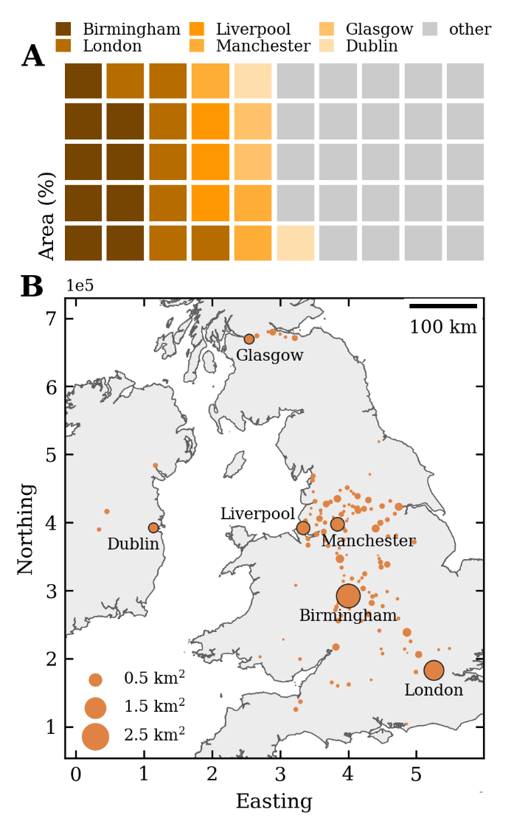
Fig. 1 Urban canal distribution for Great Britain and Ireland.

(A) Waffle chart and (B) spatial distribution of canal areas (km²) for 129 sub-regions of Great Britain and Ireland. The urban areas with the most extensive canal networks are highlighted, including Birmingham, London, Liverpool, Manchester, Glasgow, and Dublin, which account for ~52% of the total canal area. Map projection: British National Grid.

RESULTS

Figure 2 shows a typical model output for one contiguous feature of the urban canal network. In total, 2,358 features were modelled, using minimum and maximum size thresholds of 500 m² and 20,000 m², respectively.

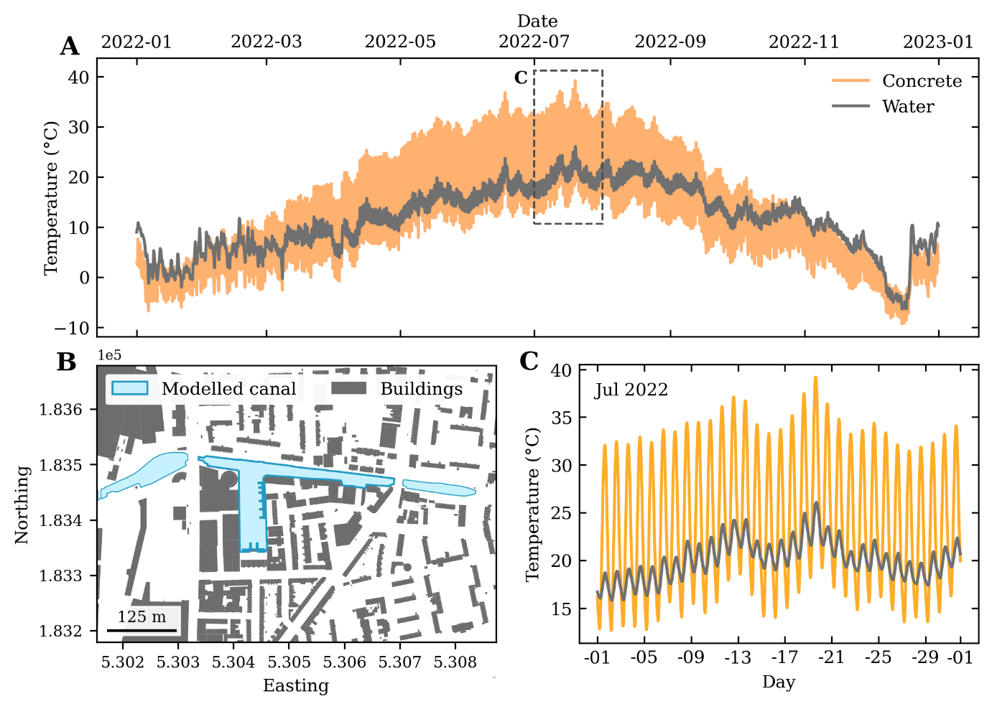

Fig. 2 Model output for a feature of the Regent’s Canal, London, UK.

(A) Modelled water (wT) and concrete temperatures (cT) for 2022 (15-minute intervals) for a feature of the Regent’s Canal, London, UK. (B) The modelled canal and nearby buildings geometries. ΔT values are calculated based on a shape-normalised 100-m wide, 10-m tall corridor around the canal. Map projection: British National Grid. (C) Modelled wT and cT for July 2022, illustrating the daily fluctuations in temperature, and the differing heat capacities of the two modelled materials.

Model validation

To validate our outputs, modelled wT was compared to measured wT at six locations, with data provided by the Canal and River Trust (Fig. 3). Overall, model performance is very good, with residuals commonly in the range ±1 − 2°C and Spearman’s rank correlation coefficients of 0.57 – 0.79 (p < 0.01). Although there is some pattern to the residuals (e.g., Fig. 3J) as well as evidence of under- (e.g., Fig. 3H) and over-prediction (e.g., Fig. 3E), the models capture both seasonal variability and shorter-term fluctuations in wT, even though they are forced using weather and shading inputs alone. While additional energy fluxes could be incorporated into a future model, such as bed heat exchange, longitudinal advective heat flux or modifications during freeze-up (21), as well as additional site-specific information (e.g., shading by vegetation, bank materials, building albedo, wind tunnel effects), this would require a step change in model complexity for only a marginal improvement in model performance.

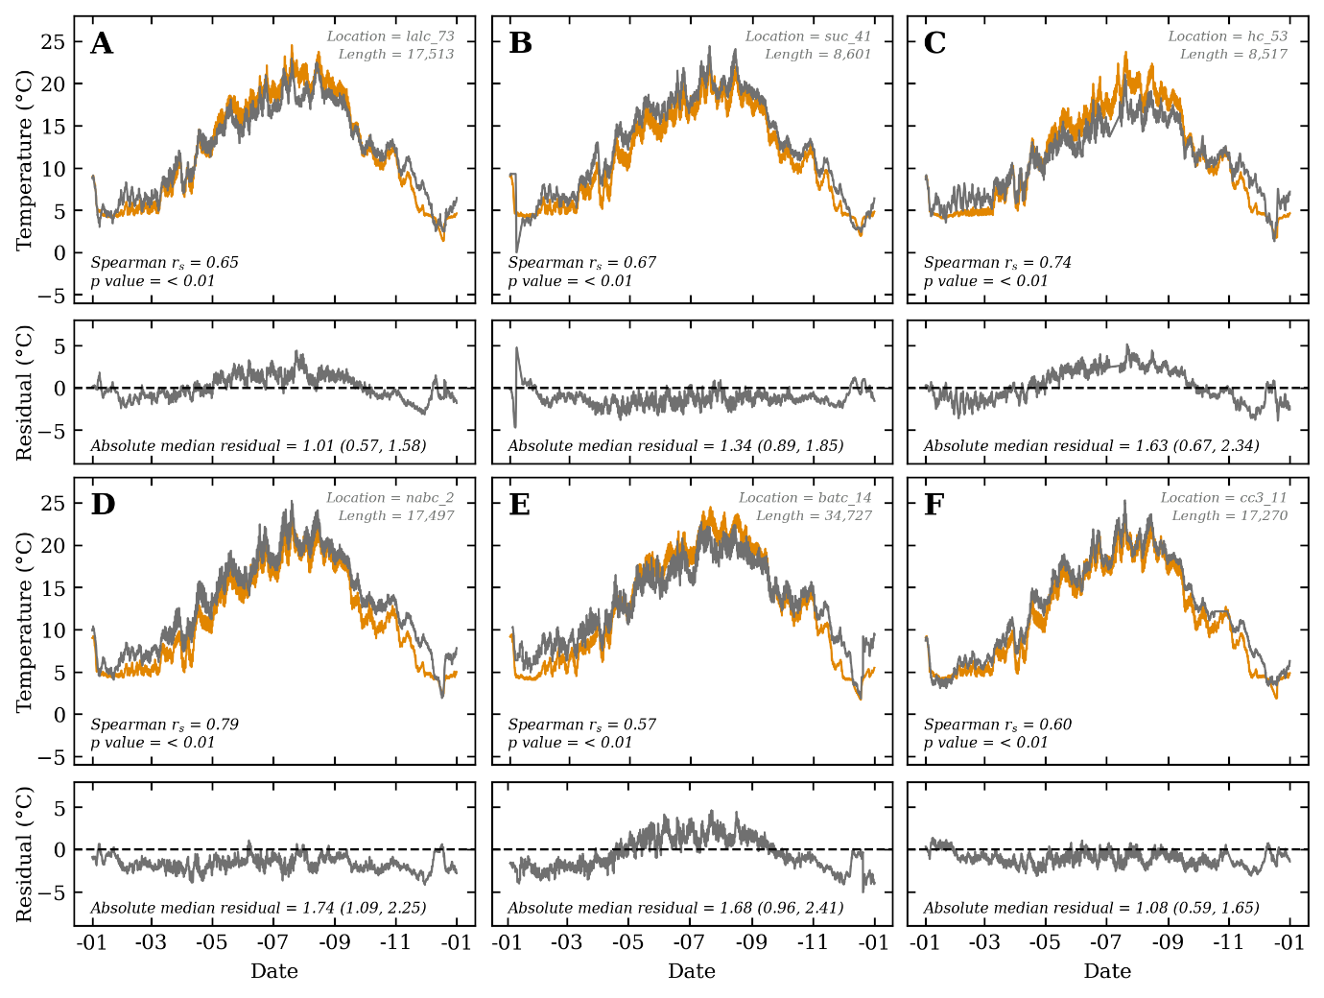

Fig. 3 Comparison of measured vs. modelled wT

Comparison of modelled wT at 40 – 60 cm depth within the water column (orange lines) with measured wT for the same depth (grey lines), plus residuals (absolute median, p25, p75). Measured data were provided by the Canal and River Trust and were available for the Leeds and Liverpool Canal (A), the Shropshire Union Canal (B), the Huddersfield Canal (C), the Nottingham and Beeston Canal (D), the Bridgwater and Taunton Canal (E), and the Coventry Canal (F). Spearman’s rank correlation coefficient (r_{s}, p value) was calculated based on stationary time series, produced using the differences between consecutive observations. The measurement interval varied across the sites, ranging from every five minutes (E) to hourly (C), which is reflected in varying array lengths used for calculation of Spearman’s r_{s} (length = 8,517 – 34,727).

Effects on air temperature
To predict the potential change in air temperature in the surrounding environment when the canal is present (ΔPT), compared to a concrete baseline, we utilise the following equation:
$$∆PT=\frac{Q}{mc}$$

where Q is heat transfer (J), m is the mass of the surrounding air, and c is the specific heat of the material (J⋅kg⁻¹⋅K⁻¹). The coefficient m is calculated using a shape-normalised 100-m wide, 10-m tall corridor around the canal (see Supplementary Information), which is consistent with prior studies which have shown temperature effects within c. 30 – 40 m of water bodies (20, 22), or potentially up to c. 60 m (23).
However, it should be noted that prediction of ΔPT is based solely on the modelled energy exchange from the water or concrete to the surrounding air in a non-spatial model, and does not take into account energy flows within the urban boundary and canopy layers (24), as well as the degree to which these flows are modified by weather, such as changing wind (25), or by urban structure, such as canyon effects (26). These factors could act to enhance, diminish, or influence the spatial distribution of any ΔPT effects.

Based on the above approach, and when shading effects are included, urban canals exert a median (p25, p75) annual daytime ΔPT of −1.06°C (−1.50, −0.68) within a shape-normalised 100-m wide, 10-m tall corridor around the canal, with a corresponding nighttime ΔPT of 0.70°C (0.44, 1.02). This diurnal pattern is consistent with prior work (27, 28) and reflects the thermal inertia of water (10).

Thermal effects vary markedly across the year, however (Table 1), with the median monthly daytime ΔT ranging from a minimum of −0.52°C in November to a maximum of −1.60°C in April (Fig. 4). This trend is consistent with field measurements from Sheffield, UK, in 2010 (20), which show maximum cooling on the riverbank during the spring. Although somewhat reduced in the summer months, ΔT remains high, ranging from −0.97°C in August to −1.25°C in June. While nighttime ΔT warming also follows a seasonal pattern, the timing of maximum ΔT is delayed until the summer months (July: 1.46°C; 0.92, 2.13), in line with changing water temperature (Fig. 2A), with reduced warming in spring, and no clear effect in winter.

The magnitude of ΔT also varies over much shorter timescales, reflecting the interplay of current and prior weather, as well as antecedent water temperatures. 2022 was the warmest year on record in the UK, in series stretching back to 1884 (29) and 1659 (30), with the summer period marked by extreme heatwaves on 15–17 June, 17–19 July and 9–15 August. Of these, the 17–19 July heatwave resulted in the UK’s highest ever recorded temperature, at 40.3°C (31). Each heatwave is marked by an increase in median daytime ΔT from the canal cooling effect, reaching −2.22°C (−3.08, −1.45), −2.24°C (−3.17, −1.44) and −1.85°C (−2.60, −1.19), respectively. It should be noted, however, that daytime cooling is partially offset by nighttime warming of 1.17°C (0.75, 1.71), 1.08°C (0.66, 1.65), and 1.34°C (0.84, 1.93) for the June, July, and August heatwaves, respectively.

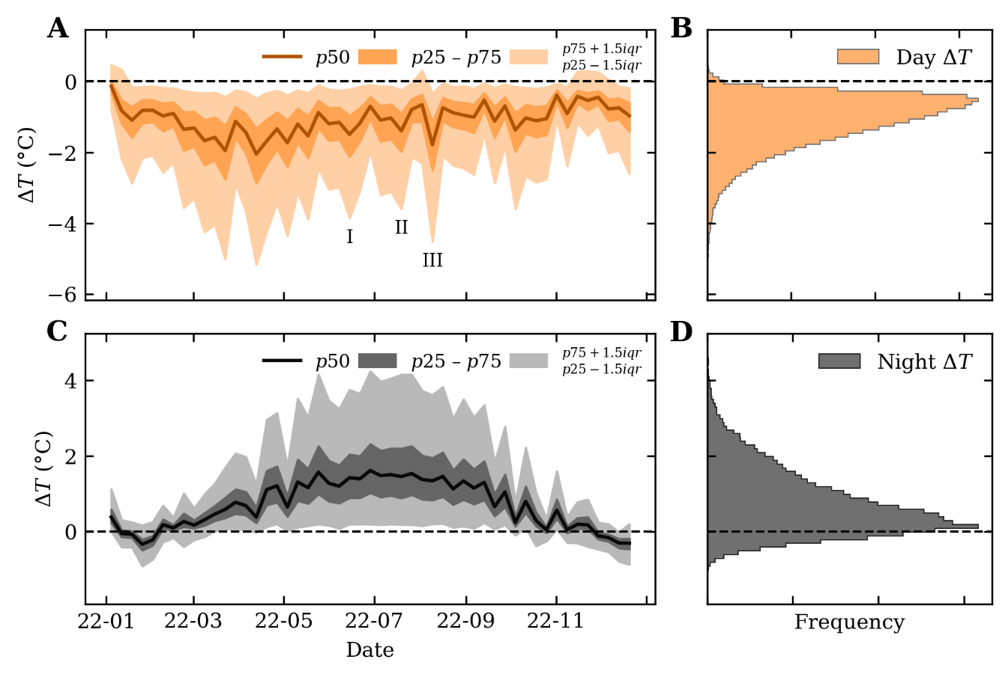
Fig. 4 Weekly-averaged time-series of median daytime and nighttime ΔT

Time-series and histograms of median weekly air temperature change (ΔT) for daytime (A – B, 10:00 – 15:45) and nighttime periods (C – D, 22:00 – 03:45), including the effects of building shading. Designated summer heatwaves, defined as three or more consecutive days where daily maximum temperatures meet or exceed a heatwave temperature threshold (32), occurred on 15–17 June (I), 17–19 July (II) and 9–15 August (III).

Effects of shading
Shading by buildings, vegetation or topography can have a large impact on land surface temperature (33) and the energy balance of water (18) and concrete (34). To investigate the degree to which urban form modifies ΔPT, we focused on a subset of the canal features with significant daytime shading (median annual shading ≥ 20%, n = 305) and re-ran models including and excluding shading effects. To isolate the effects of shading on water energy balance alone, unshaded concrete was utilised as the reference material (Fig. 5).

When shading effects are excluded, the subset canals exert a median annual daytime ΔPT of −0.81°C (−0.53, −1.14) and nighttime ΔPT of 0.55°C (0.85, 0.37). These values are slightly lower than those derived from the full feature set, which reflects the size and location of the subset canals, being (on average) smaller (reduced ΔPT effect) and in more developed urban areas, and therefore more susceptible to high shading. When shading effects are included in water energy balance, and ΔPT is calculated based on comparison with unshaded concrete, there is a significant reduction in daytime ΔPT to −0.26°C (−0.05, −0.51) and nighttime ΔPT to 0.26°C (0.45, 0.14). This is equivalent to a ~70% reduction in daytime cooling and a ~50% reduction in nighttime warming under high shading scenarios.

It is worth noting, however, that concrete energy balance is also influenced by shading (34), which has implications for the designation of the reference material used for determining ΔPT. When the reference material is allowed to vary (Fig. 5) then ΔPT values are near identical, at −1.06°C (−1.50, −0.68) when shading effects are included in both water and concrete energy balance, and −1.04°C (−1.47, −0.66) when shading effects are excluded from both (n = 2,356). These values illustrate the importance of the urban reference site or material (13), as shading either has a high magnitude effect on ΔPT (c. 0.55°C, fixed reference material) or a negligible effect (c. 0.02°C, variable reference material).

If unshaded concrete is retained as the reference material, then the effects of shading also vary seasonally, having the greatest impact on daytime ΔPT during February and March (−0.68°C, −0.82°C) and September and October (−0.72°C, −0.77°C), and a comparatively minor effect during June (−0.18°C) and July (−0.25°C). The effects of shading on daytime ΔPT during heatwaves is consistent with the monthly trends (Table S2). The effect of shading on nighttime ΔPT is more stable across the year, ranging from 0.12°C (January) to 0.37°C (August and September).
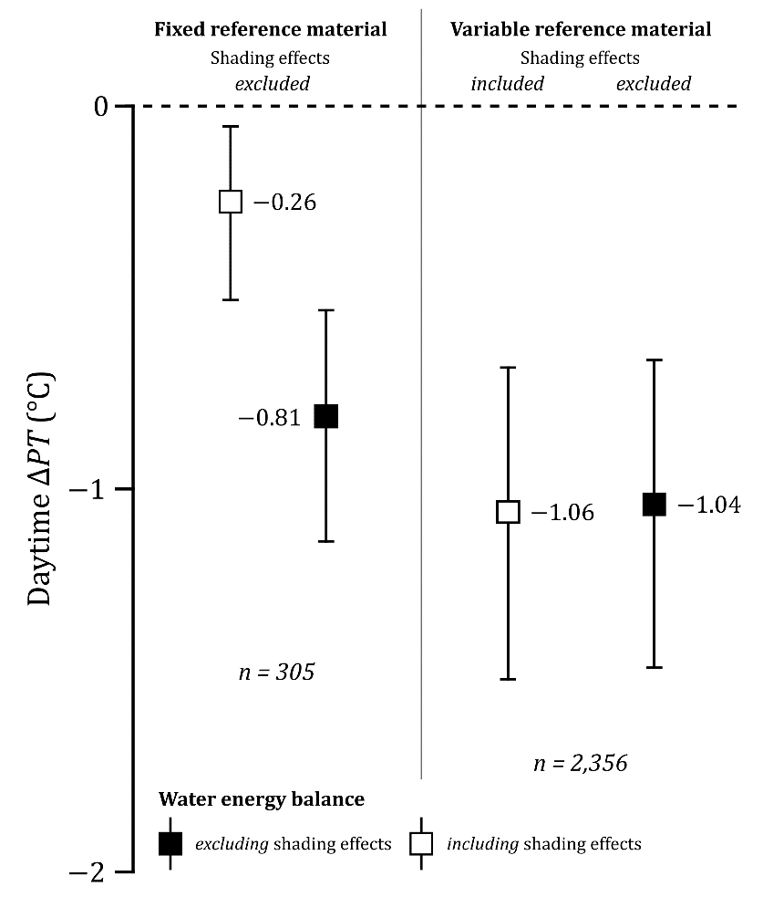

Fig. 5 Effects of shading on ΔPT, using fixed and variable reference materials

Forest plot of median (p25, p75) annual daytime ΔPT (°C) values, excluding (black symbols) and including (white symbols) the effects of shading on water energy balance. ΔPT values are presented for the full feature set (n = 2,356) and the subset of highly shaded features (n = 305), and for a fixed reference material (shading effects excluded from concrete energy balance) and a variable reference material (shading effects included or excluded from both water and concrete energy balance).

DISCUSSION

Cooling potential of urban canals
Our models indicate that urban canals in Great Britain and Ireland provide a daytime median cooling effect of ~1°C across the year within a shape-normalised 100-m wide, 10-m tall corridor around the canal, with more pronounced cooling during spring (~1.5 – 1.6°C) and, importantly, during heatwaves (~1.8 – 2.2°C). These results show that canals can contribute to urban cooling during warmer periods of the year. It should be acknowledged, however, that the effects of urban canals are not exclusively positive (i.e., ΔT cooling), with median annual nighttime warming of ~0.7°C, which is enhanced during the summer months and remains high during heatwaves (1.1 – 1.3°C). This pattern is consistent with prior work (24, 27, 28) and has implications for nighttime heat stress (41, 42).

Rising urban temperatures have important consequences for population health (35), particularly for vulnerable groups (36), and this is likely to be exacerbated by even small changes in temperature (37, 38). In turn, partially offsetting temperature extremes, in the order of ~1 – 2°C during the daytime, would have benefits for population mortality and morbidity, and could contribute to a reduction in heat-related deaths, which averaged ~800 per annum in England and Wales across 2000 – 2019 (39).

Alongside these physiological benefits, there is also an array of potential secondary benefits associated with the cooling effects of canals. These include the psychological benefits of accessing urban blue space (40), encouragement of active travel (REF) and potential energy savings (REF). As rising temperatures are a key driver of air conditioning uptake and use in domestic and commercial settings (REF), particularly during heatwaves (REF), cooling by canals could reduce energy demand and enable carbon savings (REF). These benefits are of particular importance for Great Britain and Ireland, where ~5.7 million individuals live within 1 km of the urban canal network (~15-minute walking distance; ~5.4 million in Great Britain, ~280,000 in Ireland; see Supplementary Information) and where there were ~785 million unique visits to urban canals across the Canal and River Trust network between April 2022 and March 2023. Future work utilising our model could assess variability in ΔT in other locations and could be readily adapted to other urban water bodies i.e., rivers, including an advective heat flux component.

Comparison with prior work
Prior studies of the effects of urban blue space on temperature have utilised a range of methods (e.g., on-site measurement, modelling, remote sensing) and are typically characterised by analysis of a small number of locations, infrequent or short-term temporal sampling, and/or variability in the designation of urban reference sites (13). This complicates comparison with the ΔT values reported above, which are based on a national-scale approach, while retaining temporal breadth (annual) and resolution (15-minute model intervals). It should be noted, however, that our calculation of ΔT is based solely on energy transfer from the water–concrete to the surrounding air in a non-spatial model, and ignores energy flows within the urban boundary and canopy layers (24), as well as the degree to which these flows are modified by weather, such as changing wind (25), or by urban structure, such as canyon effects (26).

From a meta-analysis in 2013 on the effects of a broad range of blue spaces (13), the most appropriate comparison is with small ponds (excluding fountains), which exerted median daytime ΔT cooling of ~1.6°C during the warmer months in the northern hemisphere (14), albeit based upon a small number of studies (n=3). On-site measurement of a small urban river in Sheffield, UK, in 2010 (20), showed a similar level of ΔT cooling during warmer periods in May (1.01 – 1.15°C) and June (0.25 – 0.59°C) at distances 30 – 70 m from the river centre line, and ~1.5°C at the river bank (May), albeit with less pronounced effects during periods of reduced ambient air temperature. More recent modelling of canals in the Netherlands has estimated a much smaller daytime ΔT cooling effect, at just 0.0 – 0.6°C at street level (14). This difference may partly arise from study design, as our work utilises concrete as the reference value for calculating ΔT, which we regard as a reasonable assumption for an urban environment. By comparison, we would anticipate reduced ΔT when the reference sites includes greenspace (14).

In summary, although there is uncertainty regarding the magnitude of ΔT in different environments, stemming from differences in study design and methods e.g., remote sensing vs. on-site measurement (13, 24), as well as differences in blue space characteristics e.g., size and shape (43), our analysis indicates that urban canals and similar water bodies can have a pronounced effect on daytime ΔT, and therefore should be considered an integral part of climate-responsive design.

Impacts of urban form
Urban form on the river bank has been shown to have a marked effect on ΔPT, for example due to the presence of vegetated banks or hard engineering materials (20), or the degree of ventilation (14). In our work, we have assessed the effects of shading by proximal buildings, which have a consistent cooling effect on water and concrete temperatures (see Figure S1). However, determining the effects of shading on ΔPT is more complex, as this is dependent on the designation of the reference material (Fig. 5) and the influence of shading on both water and concrete energy balance (18, 34).

Overall, shading does effect both con

shading can act to reduce ΔT by ~0.5°C across the year for both materials, albeit with marked short-term fluctuations due to wind effects (Fig. 6). Overall, increasing shading for an existing blue space e.g., high-rise construction on the canal banks, would act to reduce ΔT.

When considered in aggregate, and when utilising concrete as the reference material, shading has a negligible effect across the year (~0.03°C). However, in absolute terms, and when considering water and concrete energy balance in isolation, shading can act to reduce ΔT by ~0.5°C across the year for both materials, albeit with marked short-term fluctuations due to wind effects (Fig. 6). Overall, increasing shading for an existing blue space e.g., high-rise construction on the canal banks, would act to reduce ΔT.

It should be noted, however, that our analysis is focused solely on the effects of canals on ΔT i.e., the degree to which they cool or warm the surrounding area, rather than considering the environment in its totality. For example, while shading by buildings might reduce the effectiveness of canals at offsetting air temperature extremes, shading will reduce air temperatures in isolation by modifying incoming solar radiation at the pedestrian level, thereby reducing thermal stress (44). Similarly, while higher water temperatures due to the absence of shading (Fig. 5B) may enhance ΔT cooling, this could have negative ecological effects (45–47). Finally, the form of shading is likely important, as shading via green space, compared to via the built environment, would likely be associated with a much wider range of benefits (10–12).

MATERIALS AND METHODS

Materials

The model utilises hourly meteorological data provided by OpenWeather (REF), interpolated at 15-minute intervals for model stability. Modelled parameters include air temperature (K), humidity (%), cloud cover (%), wind speed (m/s) and air pressure (mbar).

For Great Britain, canal characteristics (geometries, depths) were provided by the Ordnance Survey (OS) and the Canal and River Trust (CRT). Canal geometries were filtered to urban areas based on the UK Centre for Ecology & Hydrology (UKCEH) 2021 Land Cover Map (48) and were pre-processed to produce contiguous canal features (e.g., Fig. 2B). Building characteristics (geometries, heights) were obtained from the OS MasterMap Topography layer.

For Ireland, canal characteristics and building geometries were obtained from OpenStreetMap (49). Canal geometries were filtered to urban areas based on either the UKCEH 2021 Land Cover Map for Northern Ireland (48) or the CORINE 2018 Land Cover Map for the Republic of Ireland (REF). Building heights for Ireland were derived from modelling by Keany et al. (50).

Model simulations
An initial model spin-up was performed for each canal feature to generate starting wT, cT and corresponding energy values (2022–01–01 00:00:00; Fig. S1). This produced a starting surface wT of ~8.9°C, which is consistent with empirical measurements by the CRT for the same datetime (9.0 ± 0.5°C, mean ± sd; Table S1).

Once complete, the model iterates at 15-minute intervals, and produces new wT, cT and energy values for each layer of the water column, which is modelled based on a given canal depth, subdivided into 0.2 m layers. Values are modelled based on radiative, evaporative, and conductive–convective exchanges (17), incorporating the meteorological data described above. To assess the influence of urban form on cooling potential, the model was run including and excluding building shading. For the former, the shading proportion of the canal was modelled based on the Python packages PySolar (REF) and pybdshadow (REF), which return the solar azimuth-altitude and building shadow geometries respectively.

At each model step, ΔT was calculated based on the energy change in the air surrounding the canal, where ΔT represents the difference between the air temperature when the canal is present (wT) compared to a concrete baseline (cT). ΔT is calculated for a shape-normalised 100-m wide, 10-m high corridor around the canal.

Time-series analysis
To assess changing ΔT through time, we extracted values corresponding to the core periods of daytime (10:00 – 15:45) and nighttime (22:00 – 03:45). Annual and monthly statistics were calculated.

Acknowledgments
Funding, data, and support for this project was provided by the Canal and River Trust (CRT), with the current national scale up generously supported thanks to funds raised by players of People’s Postcode Lottery. The paper is dedicated to the late Professor Walter Menzies, who inspired the project in the first place. This project was developed following a pilot project supported by the CRT, and special thanks are extended to David Baldacchino for his input and to Dr. Olutayo Adebowale of Cirkadia for her role in project management.

We would like to thank the Ordnance Survey for providing the OS MasterMap Topography layer for Great Britain, Eoghan Keany and co-authors (Met Éireann) for providing their building height model for Ireland, and Dr. Kirsty Watkinson for assistance running our models on the Geography department server.

References
1. K. Calvin, D. Dasgupta, G. Krinner, A. Mukherji, P. W. Thorne, C. Trisos, J. Romero, P. Aldunce, K. Barrett, G. Blanco, W. W. L. Cheung, S. Connors, F. Denton, A. Diongue-Niang, D. Dodman, M. Garschagen, O. Geden, B. Hayward, C. Jones, F. Jotzo, T. Krug, R. Lasco, Y.-Y. Lee, V. Masson-Delmotte, M. Meinshausen, K. Mintenbeck, A. Mokssit, F. E. L. Otto, M. Pathak, A. Pirani, E. Poloczanska, H.-O. Pörtner, A. Revi, D. C. Roberts, J. Roy, A. C. Ruane, J. Skea, P. R. Shukla, R. Slade, A. Slangen, Y. Sokona, A. A. Sörensson, M. Tignor, D. Van Vuuren, Y.-M. Wei, H. Winkler, P. Zhai, Z. Zommers, J.-C. Hourcade, F. X. Johnson, S. Pachauri, N. P. Simpson, C. Singh, A. Thomas, E. Totin, P. Arias, M. Bustamante, I. Elgizouli, G. Flato, M. Howden, C. Méndez-Vallejo, J. J. Pereira, R. Pichs-Madruga, S. K. Rose, Y. Saheb, R. Sánchez Rodríguez, D. Ürge-Vorsatz, C. Xiao, N. Yassaa, A. Alegría, K. Armour, B. Bednar-Friedl, K. Blok, G. Cissé, F. Dentener, S. Eriksen, E. Fischer, G. Garner, C. Guivarch, M. Haasnoot, G. Hansen, M. Hauser, E. Hawkins, T. Hermans, R. Kopp, N. Leprince-Ringuet, J. Lewis, D. Ley, C. Ludden, L. Niamir, Z. Nicholls, S. Some, S. Szopa, B. Trewin, K.-I. Van Der Wijst, G. Winter, M. Witting, A. Birt, M. Ha, J. Romero, J. Kim, E. F. Haites, Y. Jung, R. Stavins, A. Birt, M. Ha, D. J. A. Orendain, L. Ignon, S. Park, Y. Park, A. Reisinger, D. Cammaramo, A. Fischlin, J. S. Fuglestvedt, G. Hansen, C. Ludden, V. Masson-Delmotte, J. B. R. Matthews, K. Mintenbeck, A. Pirani, E. Poloczanska, N. Leprince-Ringuet, C. Péan, “IPCC, 2023: Climate Change 2023: Synthesis Report. Contribution of Working Groups I, II and III to the Sixth Assessment Report of the Intergovernmental Panel on Climate Change [Core Writing Team, H. Lee and J. Romero (eds.)]. IPCC, Geneva, Switzerland.” (Intergovernmental Panel on Climate Change (IPCC), 2023); https://doi.org/10.59327/IPCC/AR6-9789291691647.
2. S. Zhou, B. Yu, Y. Zhang, Global concurrent climate extremes exacerbated by anthropogenic climate change. Sci. Adv. 9, eabo1638 (2023).
3. E. Kalnay, M. Cai, Impact of urbanization and land-use change on climate. Nature 423, 528–531 (2003).
4. N. B. Grimm, S. H. Faeth, N. E. Golubiewski, C. L. Redman, J. Wu, X. Bai, J. M. Briggs, Global Change and the Ecology of Cities. Science 319, 756–760 (2008).
5. Total and urban population – UNCTAD Handbook of Statistics 2023. https://hbs.unctad.org/total-and-urban-population/.
6. S. E. Perkins, L. V. Alexander, J. R. Nairn, Increasing frequency, intensity and duration of observed global heatwaves and warm spells. Geophys. Res. Lett. 39 (2012).
7. S. Grimmond, Urbanization and Global Environmental Change: Local Effects of Urban Warming. Geogr. J. 173, 83–88 (2007).
8. A. J. Arnfield, Two decades of urban climate research: a review of turbulence, exchanges of energy and water, and the urban heat island. Int. J. Climatol. 23, 1–26 (2003).
9. G. B. Anderson, M. L. Bell, Heat waves in the United States: mortality risk during heat waves and effect modification by heat wave characteristics in 43 U.S. communities. Environ. Health Perspect. 119, 210–218 (2011).
10. K. R. Gunawardena, M. J. Wells, T. Kershaw, Utilising green and bluespace to mitigate urban heat island intensity. Sci. Total Environ. 584–585, 1040–1055 (2017).
11. D. E. Bowler, L. Buyung-Ali, T. M. Knight, A. S. Pullin, Urban greening to cool towns and cities: A systematic review of the empirical evidence. Landsc. Urban Plan. 97, 147–155 (2010).
12. C. J. Veerkamp, A. M. Schipper, K. Hedlund, T. Lazarova, A. Nordin, H. I. Hanson, A review of studies assessing ecosystem services provided by urban green and blue infrastructure. Ecosyst. Serv. 52, 101367 (2021).
13. S. Völker, H. Baumeister, T. Claßen, C. Hornberg, T. Kistemann, Evidence for the temperature-mitigating capacity of urban blue space – a health geographic perspective. ERDKUNDE 67, 355–371 (2013).
14. C. Jacobs, L. Klok, M. Bruse, J. Cortesão, S. Lenzholzer, J. Kluck, Are urban water bodies really cooling? Urban Clim. 32, 100607 (2020).
15. G. Turnbull, Canals, coal and regional growth during the industrial revolution. Econ. Hist. Rev. 40, 537–560 (1987).
16. B. W. Webb, Y. Zhang, Spatial and Seasonal Variability in the Components of the River Heat Budget. Hydrol. Process. 11, 79–101 (1997).
17. D. M. Hannah, G. Garner, River water temperature in the United Kingdom: Changes over the 20th century and possible changes over the 21st century. Prog. Phys. Geogr. Earth Environ. 39, 68–92 (2015).
18. G. Kalny, G. Laaha, A. Melcher, H. Trimmel, P. Weihs, H. P. Rauch, The influence of riparian vegetation shading on water temperature during low flow conditions in a medium sized river. Knowl. Manag. Aquat. Ecosyst., 5 (2017).
19. S. C. Chapman, N. W. Watkins, D. A. Stainforth, Warming Trends in Summer Heatwaves. Geophys. Res. Lett. 46, 1634–1640 (2019).
20. E. A. Hathway, S. Sharples, The interaction of rivers and urban form in mitigating the Urban Heat Island effect: A UK case study. Build. Environ. 58, 14–22 (2012).
21. M. Toffolon, L. Cortese, D. Bouffard, SELF v1.0: a minimal physical model for predicting time of freeze-up in lakes. Geosci. Model Dev. 14, 7527–7543 (2021).
22. C. Y. Park, D. K. Lee, T. Asawa, A. Murakami, H. G. Kim, M. K. Lee, H. S. Lee, Influence of urban form on the cooling effect of a small urban river. Landsc. Urban Plan. 183, 26–35 (2019).
23. D. Kim, J.-G. Cha, E.-H. Jung, A Study on the Impact of Urban River Refurbishment to the Thermal Environment of Surrounding Residential Area. J. Environ. Prot. 5, 454–465 (2014).
24. P. Ampatzidis, T. Kershaw, A review of the impact of blue space on the urban microclimate. Sci. Total Environ. 730, 139068 (2020).
25. T. Foken, “Specifics of the Near-Surface Turbulence” in Micrometeorology, T. Foken, Ed. (Springer, Berlin, Heidelberg, 2017; https://doi.org/10.1007/978-3-642-25440-6_3), pp. 83–142.
26. M. Nunez, T. R. Oke, The Energy Balance of an Urban Canyon. J. Appl. Meteorol. Climatol. 16, 11–19 (1977).
27. N. E. Theeuwes, A. Solcerová, G. J. Steeneveld, Modeling the influence of open water surfaces on the summertime temperature and thermal comfort in the city. J. Geophys. Res. Atmospheres 118, 8881–8896 (2013).
28. L. Yao, D. J. Sailor, X. Zhang, J. Wang, L. Zhao, X. Yang, Diurnal pattern and driving mechanisms of the thermal effects of an urban pond. Sustain. Cities Soc. 91, 104407 (2023).
29. M. Kendon, M. McCarthy, S. Jevrejeva, A. Matthews, J. Williams, T. Sparks, F. West, State of the UK Climate 2022. Int. J. Climatol. 43, 1–83 (2023).
30. G. Manley, Central England temperatures: Monthly means 1659 to 1973. Q. J. R. Meteorol. Soc. 100, 389–405 (1974).
31. A. Witze, Earth boiled in 2023 — will it happen again in 2024? Nature 625, 637–639 (2024).
32. M. McCarthy, L. Armstrong, N. Armstrong, A new heatwave definition for the UK. Weather 74, 382–387 (2019).
33. X. Peng, W. Wu, Y. Zheng, J. Sun, T. Hu, P. Wang, Correlation analysis of land surface temperature and topographic elements in Hangzhou, China. Sci. Rep. 10, 10451 (2020).
34. D. Armson, P. Stringer, A. R. Ennos, The effect of tree shade and grass on surface and globe temperatures in an urban area. Urban For. Urban Green. 11, 245–255 (2012).
35. K. L. Ebi, A. Capon, P. Berry, C. Broderick, R. de Dear, G. Havenith, Y. Honda, R. S. Kovats, W. Ma, A. Malik, N. B. Morris, L. Nybo, S. I. Seneviratne, J. Vanos, O. Jay, Hot weather and heat extremes: health risks. The Lancet 398, 698–708 (2021).
36. G. P. Kenny, J. Yardley, C. Brown, R. J. Sigal, O. Jay, Heat stress in older individuals and patients with common chronic diseases. CMAJ Can. Med. Assoc. J. 182, 1053–1060 (2010).
37. S. K. Maloney, C. F. Forbes, What effect will a few degrees of climate change have on human heat balance? Implications for human activity. Int. J. Biometeorol. 55, 147–160 (2011).
38. S. Russo, J. Sillmann, S. Sippel, M. J. Barcikowska, C. Ghisetti, M. Smid, B. O’Neill, Half a degree and rapid socioeconomic development matter for heatwave risk. Nat. Commun. 10, 136 (2019).
39. A. Gasparrini, P. Masselot, M. Scortichini, R. Schneider, M. N. Mistry, F. Sera, H. L. Macintyre, R. Phalkey, A. M. Vicedo-Cabrera, Small-area assessment of temperature-related mortality risks in England and Wales: a case time series analysis. Lancet Planet. Health 6, e557–e564 (2022).
40. D. Kolokotsa, A. Α. Lilli, M. A. Lilli, N. P. Nikolaidis, On the impact of nature-based solutions on citizens’ health & well being. Energy Build. 229, 110527 (2020).
41. P. Murage, S. Hajat, R. S. Kovats, Effect of night-time temperatures on cause and age-specific mortality in London. Environ. Epidemiol. Phila. Pa 1, e005 (2017).
42. L. Yao, D. J. Sailor, X. Yang, G. Xu, L. Zhao, Are water bodies effective for urban heat mitigation? Evidence from field studies of urban lakes in two humid subtropical cities. Build. Environ. 245, 110860 (2023).
43. P. Ampatzidis, C. Cintolesi, T. Kershaw, Impact of Blue Space Geometry on Urban Heat Island Mitigation. Climate 11, 28 (2023).
44. A. Middel, N. Selover, B. Hagen, N. Chhetri, Impact of shade on outdoor thermal comfort—a seasonal field study in Tempe, Arizona. Int. J. Biometeorol. 60, 1849–1861 (2016).
45. P. S. Murdoch, J. S. Baron, T. L. Miller, Potential Effects of Climate Change on Surface-Water Quality in North America1. JAWRA J. Am. Water Resour. Assoc. 36, 347–366 (2000).
46. D. Caissie, The thermal regime of rivers: a review. Freshw. Biol. 51, 1389–1406 (2006).
47. M. T. H. van Vliet, W. H. P. Franssen, J. R. Yearsley, F. Ludwig, I. Haddeland, D. P. Lettenmaier, P. Kabat, Global river discharge and water temperature under climate change. Glob. Environ. Change 23, 450–464 (2013).
48. C. G. Marston, A. W. O’Neil, R. D. Morton, C. M. Wood, C. S. Rowland, LCM2021 – the UK Land Cover Map 2021. Earth Syst. Sci. Data 15, 4631–4649 (2023).
49. OpenStreetMap contributors, Planet dump retrieved from https://planet.osm.org (2023).
50. E. Keany, G. Bessardon, E. Gleeson, “Using machine learning to produce a cost-effective national building height map of Ireland to categorise local climate zones” in Advances in Science and Research (Copernicus GmbH, 2022; https://asr.copernicus.org/articles/19/13/2022/)vol. 19, pp. 13–27.

