SUPPLEMENTARY
Model design
Water temperatures are modelled incorporating evaporative, sensible (conductive and convective) and radiative (sunlight and thermal) heat fluxes between the water and the outside environment.

Evaporation
The rate of evaporation (E_{v}) is calculated utilising equations from Webb and Zhang (1997), Lawrence (2005) and The Engineering Toolbox (2004):
$$E_{v}=0.165∙\left(0.8+0.864∙U\right)∙(E_{w}-E_{a})$$
where U is wind speed at a height of c. 2 m above the surface, E_{w} is saturated vapour pressure at surface water temperature, and E_{a} is vapour pressure at air temperature, calculated as follows:
$$E_{w}=\frac{e^{(77.3450 + 0.0057 ∙ T_{w} - 7235 / T_{w})}}{{T_{w}}^{8.2}}$$
$$E_{a}=E_{o}∙e^{\left(\frac{L}{R_{v}}\right)∙\left(\frac{1}{T_{o}}-\frac{1}{T_{dp}} \right)}$$
where T_{w} is surface water temperature, E_{o} is baseline pressure at triple point (0.611 kPa), L is the latent heat of vaporisation, R_{v} is the gas constant for water vapour, T_{o} is the triple point of water, and T_{dp} is the dew point temperature, calculated using the Magnus Formula.
These formulas allow the evaporation and condensation rate of the water to be calculated, and the energy gain or loss of the canal and the surrounding area (assuming a 50:50 distribution).

Sensible Heat
Sensible heat losses from the water to the air can be calculated using the evaporation losses by the Bowen Ratio which relates evaporative and sensible losses:
$$Q_{h} = Q_{e}∙B$$
where Q_{h} is sensible heat losses, Q_{e} is evaporative losses, and B is the Bowen Ratio, calculated following Webb and Zhang (1997):
$$B =\frac{0.61∙P∙\left(Tw-Ta\right) / (E_{w}-E_{a})}{1000}$$
where P is air pressure and T_{a} is air temperature.

Internal Conductive and Convective
To calculate the transfer of heat between depths within the water column, the conduction and convection are accounted for using standard equations. These equations hold true for water with negligible flow rates (i.e., for canals), but at higher rates enhanced mixing would change conduction and convention values, while energy transfer due to advection would also need to be incorporated:
Conduction (W/m): Kc*A*(T1-T2)/d
- Kc: Conduction Coefficient
- A: Surface Area
- T1: Upper Temperature
- T2: Lower Temperature
- d: distance
Convection: hc*A*(T1-T2)
- hc: Convection Coefficient
- A: Surface Area
- T1: Upper Temperature
- T2: Lower Temperature

Note: Convection is assumed to be zero when the higher temperature water is above the lower temperature water.

The Engineering ToolBox (2004). Moist Air - Water Vapor and Saturation Pressure. [online] Available at: https://www.engineeringtoolbox.com/water-vapor-saturation-pressure-air-d_689.html [Accessed 18-04-2024].

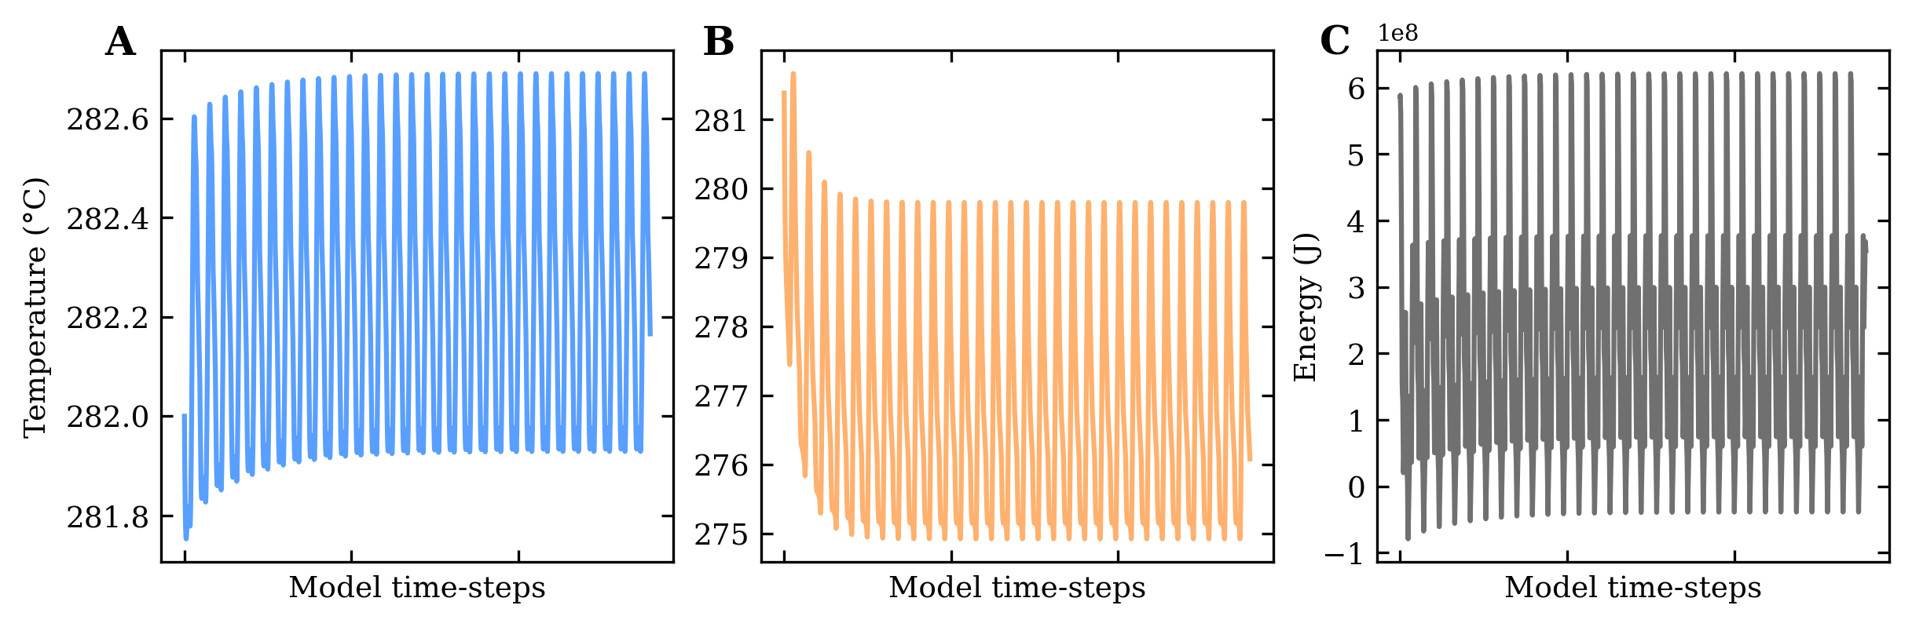
Fig. S1 Results of a 30-day model spin-up for a feature of the Regent’s Canal, London, UK.

(A) Modelled surface water temperatures (wT; °C), (B) surface concrete temperatures (cT; °C) and (C) surface water energy values (wJ; J) for a feature of the Regent’s Canal, London, UK. Model spin-up utilises weather data from 15-12-2021, approximately two weeks prior to the model start date (01-01-2022). This is iterated for 30-days at 15-minute intervals (2,790 model steps) to ensure equilibrium is reached.
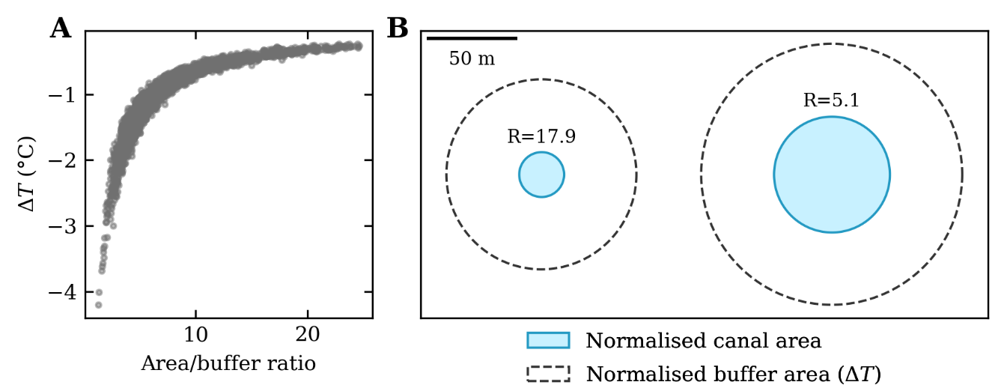
Fig. S2 Effects of canal area on modelled air temperatures.

(A) Plot of water temperatures (wT; °C) against the canal area–buffer area ratio. (B) Plot of normalised canal areas and normalised buffer areas. For each canal, we use a shape-normalised 100-m wide corridor (50 m buffer) for calculating air temperature change (ΔT). As a result, larger canals (e.g., right example, 5000 m²) are associated with larger cooling effects (A), as the canal area–buffer area ratio is reduced (R=5.1), relative to smaller canals (e.g., left example, 750 m², R=17.9).

