Notes
“Overall, the results indicate that high levels of vegetation next to the river increase the cooling on the bank, that opening up the streets to the river increases the propagation of cooling, and that the surface nature of the surrounding materials can have a more significant effect on the air temperatures than the presence of the river.”

Crucially, our model incorporates the effects of shading by proximal buildings. When shading is excluded, and averaged over a year, canals cool the surrounding area during the daytime by 1.0 ± 0.7°C (mean ± sd). When shading is included, this falls to 0.6 ± 0.5°C (mean ± sd). While these national average falls showcase the critical role that shading plays in affecting the cooling potential of the canal, these mask starker differences in heavily urbanised areas, such as London, Manchester and Birmingham. For some areas of these canals, incorporating shading decreases the cooling potential to 0.1 ± 0.5°C.

Overall, our work highlights the critical role that canals play in ameliorating the effects of UHI, but also their vulnerability to inappropriate development along their margins. In order to maximise the cooling benefits of canals and minimise the increase morbidity and mortality risks, policy will be needed.

(ΔT)

One common example is expansion of green infrastructure (GI), such as

which has been shown to have

0.94 degrees C cooler in the day

parks, tree-planting, green roofing, is one commonly studied example (13),

(e.g.,) is commonly

Green infrastructure

Urban greening is perhaps the most commonly studied

Things to consider:
- Do we incorporate all the heat fluxes?
- How is our work distinguished from earlier papers?
- Should we include Ireland?
- Decide on terminology, canal / waterway?

Key paper:

https://www.webofscience.cosm/wos/woscc/full-record/WOS:000309332800002

They found it was most in spring!
This is good, but they basically have our results (but 10 years ago)

Scale is unique
Temporal precision
Shading directly

https://www.tandfonline.com/doi/abs/10.1080/00221680009498315?journalCode=tjhr20

Future work, if we could incorporate river flow, we could model all rivers and water bodies

Talk about heatwaves: July 2022 (temperature record)

Talk about greenspaces…

Context: how important is 1 deg of cooling?

Magnitude of effects? i.e., distance from canal?
How can this be used?

At the extreme, this could be expanding blue infrastructure in cities, which has been done effectively in some places (Singapore?)

More practically, it is about how we manage existing blue infrastructure.

Our analysis highlights the fact that canals can partially offset temperature extremes, but this is highly dependent on urban form.

Inapproprioate development is squandering that… high-rises

Appropriate development (no high-rises on south bank) is better. Greenspace would also be good – although the degree to which these add is unclear…

Ultimately, we want to use our resources effectively, rather than actively diminishing their cooling potential…

the reduction in energy delivered to the air by water (due to shading) is larger than the corresponding reduction in energy delivered by concrete, ΔT will be reduced

When the reduction in energy delivered to the air due to shading is larger for water than concrete

  - When it’s windy, evaporative cooling is greatly enhanced when water temperature is high (i.e., the unshaded model).
  - When it’s still, evaporative cooling is only slightly enhanced when water temperature is high.
  - In summary, the key difference in our model is changing water temperature (and related energy fluxes).

and even stronger correlations between wind and the underlying energy fluxes, including evaporative cooling,

- As a result, fluctuations in ΔT due to shading (sometimes positive, sometimes negative, are primarily driven by fluctuations in the energy delivered to the air from the water (and not from concrete).

Key interpretation
- Focusing on the energy flux associated with water alone, includfg shading effects reduces and reduces nighttime ΔT warming by 0.27°C (0.19, 0.39).
- Focusing on the energy flux associated with concrete alone, including shading effects reduces
- As the degree of shading increases, the magnitude of the ΔT difference also increases (Fig. 5A).
- Shading also has a predictable effect on surface wT (Fig. 5B) and cT (Fig. 5C).
- However, the effects of shading on net ΔT, incorporating energy fluxes associated with both wT and cT, are negligible for the studied features, with an annual median daytime ΔT change of only 0.03°C (0.016, 0.053). Ultimately, this is a more complex question i.e., “What is the impact of shading vs. not shading on the differences between cooling/heating from a canal and concrete equivalent”.
- When wind speeds are low, incorporating shading is more likely to have a warming effect, compared to the models excluding shading.
- When wind speeds are high, incorporating shading is more likely to have a cooling effect, compared to the models excluding shading.

Key interpretations (12/05/2024)
- Strong relationship between wind speed and difference in ΔT due to shading. When wind speeds are low, incorporating shading is more likely to have a relative warming effect, compared to the models excluding shading. When wind speeds are high, incorporating shading is more likely to have a relative cooling effect, compared to the models excluding shading.
- Have to struggled to identify why this is though i.e., what are the fluxes associated with this?
- However, we can now say that this largely driven by fluctuations in water energy balance as this is correlated with wind speed (R² = 0.47). By comparison, there is no correlation with concrete energy balance (R² = 0.02). As a result, fluctuations in ΔT due to shading (sometimes positive, sometimes negative, are primarily driven by fluctuations in the energy delivered to the air from the water (and not from concrete).
- The influence of wind on water energy balance controls the ratio between WEB and CEB.
- On windy days, the energy delivered to the air is reduced (-80,000 J) – on still days the energy delivered to the air is enhanced (-220,000 J).
- The individual fluxes in WEB also show a relationship with wind e.g., evaporative cooling (R2 = 0.72), sensible heat (R2 = 0.87) and thermal emissions (R2 = 0.28).
- The key thing to remember though is that it is not difference in wind which is explaining the changes (because both the unshaded and shaded models are driven by the same weather data), but is the temperature dependence of processes which are influenced by wind e.g.,
  - When it’s windy, evaporative cooling is greatly enhanced when water temperature is high (i.e., the unshaded model).
  - When it’s still, evaporative cooling is only slightly enhanced when water temperature is high.
  - In summary, the key difference in our model is changing water temperature (and related energy fluxes).
“The result of this would be that I would expect hotter water to cool down more through evaporative cooling (which is wind dependent and will increase with stronger winds), which we do have when things are unshaded compared to shaded. Important for us to know if this happens in the model.”

MUST CITE: Evidence for the temperature-mitigating capacity of urban blue space - a health geographic perspective

MUST ENGAGE WITH: Are urban water bodies really cooling?
MUST ENGAGE WITH WEBB & ZHANG 1997

Engage with: https://doi.org/10.1016/j.scitotenv.2019.133742

---------------------------- ORIGINAL TEXT ----------------------------

When shading effects are excluded, urban canals exert a median (p25, p75) annual daytime cooling effect of −1.04°C (−1.47, −0.66) within a shape-normalised 100-m wide, 10-m tall corridor around the canal, with a corresponding nighttime warming effect of 0.74°C (0.47, 1.06). Thermal effects vary markedly across the year, however (Table 1), with the average monthly cooling ranging from a minimum of −0.47°C in November to a maximum of −1.58°C in April. Although somewhat reduced in the summer months, cooling effects remain high, ranging from −0.95°C in August to −1.22°C in June. This trend is consistent with field measurements from Sheffield, UK, in 2010 (19), which show maximum cooling on the riverbank during the spring.

The magnitude of daytime cooling also varies over much shorter timescales (Fig. 4), reflecting the interplay of current and prior weather, as well as antecedent water temperatures. 2022 was the warmest year on record in the UK, in series stretching back to 1884 (23) and 1659 (24), with the summer period marked by extreme heatwaves on 15–17 June, 17–19 July and 9–15 August. Of these, the 17–19 July heatwave resulted in the UK’s highest ever recorded temperature, at 40.3°C (25). Each heatwave is marked by an increase in median ΔT, reaching −2.21°C, −2.22°C and −1.85°C, respectively.

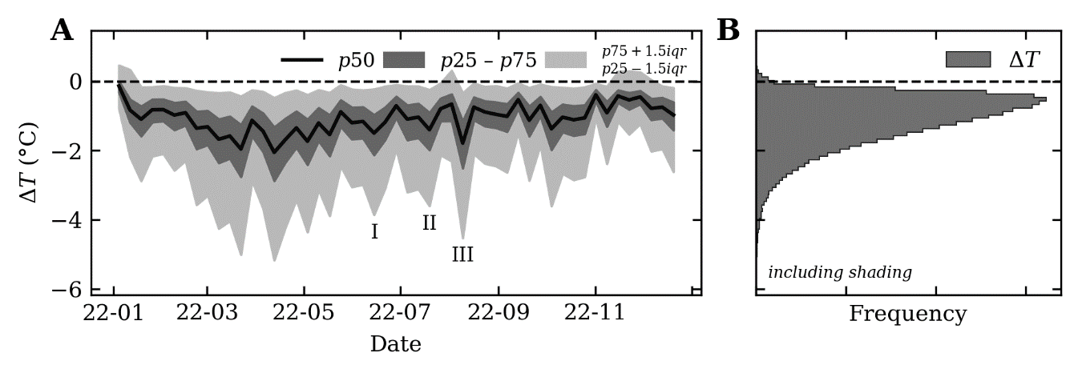
Fig. 4 Weekly-averaged time-series of median ΔT, including shading effects.

(A) Time-series and (B) histogram of median modelled air temperature change (ΔT), including the effects of building shading. Designated summer heatwaves, defined as three or more consecutive days where daily maximum temperatures meet or exceed a heatwave temperature threshold (26), occurred on 15–17 June (I), 17–19 July (II) and 9–15 August (III).
While shading can have a large impact on land surface temperature (27) and water energy balance (28), our models indicate that shading by buildings has only a minor effect on ΔT, when considered in aggregate. For example, when shading effects are included, the median annual daytime cooling effect across the entire canal network is −1.06°C (−1.50, −0.68), which is almost identical to the model output when shading effects are excluded. The magnitude and seasonality of monthly cooling is also very similar (Table 1). In part, this reflects the fact most urban canals in the UK and Ireland are not extensively shaded (see Supplementary Information Fig. S1).

However, aggregated statistics mask important variability day-to-day and between different modelled canal features. Importantly, incorporating shading can both increase and decrease ΔT i.e., an enhanced or diminished cooling effect when shading is present, particularly for highly shaded canals in the main urbanised areas (Fig. 1B). Figure 3 illustrates this…

STUCK HERE

Key shading result:

- The model is working correctly, as modelled wT and cT are consistency lower or equal when shading effects are including, depending on the degree of shading (Fig. 5).

- However, the implications for ΔT are more complex, because this is dependent on the ratio of the rate of change in wT compared to the rate of change in cT (rather than the absolute value).

- Incorporating shading can both increase and decrease the magnitude of cooling, generally within the range of ± 0.5°C.

- The magnitude and direction of this effect is strongly controlled by wind speed While this is independent of the degree of shading, this effect is most pronounced during the warmer months (May – September, R² = 0.6 – 0.9).

- This is likely because of the importance of wind to the rate of evaporation, and in turn, the magnitude of evaporative cooling. When wind speeds are high, this leads to a surprising result, in that:

  - evaporative cooling is enhanced for unshaded canals (↑ solar input) = lower rate of warming
  - evaporative cooling is reduced for shaded canals (↓ solar input) = higher rate of warming

- By comparison, energy change to concrete follows the expected pattern, in that:

  - for unshaded concrete, cT is higher, so the rate of warming is higher.
  - for shaded concrete, cT is lower, so the rate of warming is lower.

- In turn, during windy periods, we have:

  - Unshaded canals warming slowly and unshaded concrete warming quickly.
  - Shaded canals warming quickly and shaded concrete warming slowly.

- By comparison, when wind speeds are low, then evaporative cooling becomes less important, and we see a similar trend for wT (including vs. excluding shading). By comparison, the unshaded concrete still warms at a lower rate when shaded (and vice. Versa), which explains

HOWEVER, much more complicated…

e.g., warming on March 31st 2022

Cooling during the heatwaves though (often!)

Wind plays a role!

Low wind speed + high temperature are most important…

Similar pattern (wind + temperature, irrespective of degree of shading between May, June, July, August, September)

Shading regression results

There is a consistent negative correlation between wind speed and median ΔT (r)

R2 is related (generally) to shading proportion. Not all canals with high R2 are highly shaded, but canals that are highly shaded are generally high (ish) R2.

Slope is related to shading proportion. Much higher slope for those with low shading (makes sense! Small difference = steep slope), but lower slopes for those with higher shading. Once shading prop > 0.2, slope is generally < -40

18: ‘Weather data provided by OpenWeather’ (https://openweathermap.org/)
19: Ordnance Survey MasterMap Topography Layer (https://www.ordnancesurvey.co.uk/products/os-mastermap-topography-layer)
20: Canal and Rivers Trust (https://canalrivertrust.org.uk/)
21: Marston, C.; Rowland, C.S.; O’Neil, A.W.; Morton, R.D. (2022). Land Cover Map 2021 (land parcels, GB). NERC EDS Environmental Information Data Centre. https://doi.org/10.5285/398dd41e-3c08-47f5-811f-da990007643f
22: Pysolar
23: pybdshadow

https://www.cape.ac.uk/wp-content/uploads/2023/05/GBI-Rapid-Evidence-Assessment.pdf

changing ratio of concrete and water energy balance as a function of wind. There is no correlation between wind speed and the total energy delivered to the air by concrete (R² = 0.02), but there is a stronger correlation with the energy delivered to the air by water (R² = 0.47).

Need to engage with https://doi.org/10.3390/cli11020028

Urban heat mitigation
Debates around the potential benefits of urban water bodies often concerns the construction and design of new water bodies (14), considering factors such as size and shape (43). This is less of an issue in Great Britain, and to a lesser extent in Ireland, where there already exists an extensive urban canal network (Fig. 1). The key question to consider, therefore, is how can the climatological benefits of existing blue spaces be maximised?

- Don’t remove canals
- Maintenance (dredging)
- Size (larger is better)
- Shape (not considered, non-spatial model)

This requires consideration of the characteristics of the water body, and the surrounding environment. For the former, our analysis indicates that canals should not be actively removed i.e., infilling with concrete, as observed in some locations. The maintenance of water bodies is also an important issue and future work is needed to assess the contrasting effects of sediment build-up and dredging on ΔT, which decrease and increase water depth respectively. For the surrounding environment,

The key thing here is to consider relative and absolute cooling. If focused on relative cooling (i.e., concrete ΔT vs water ΔT), then shading has no effect i.e., the overall effect of shading the canal is almost identical to the overall effect of shading concrete (0.03°C; 0.016, 0.053). However, in absolute terms, shading does reduce ΔT during the day by ~0.5°C e.g., if we shaded the canal.

HERE's what I said in the introduction…

This approach allows us to assess the cooling potential of urban waterways in the context of new temperature extremes (19), the degree to which this potential is modified by urban form (20), and the implications of our study for urban heat mitigation.

As a result, existing canal infrastructure should be preserved and maintained and steps taken to maximise the benefits of urban canals.

- In this work, we assessed the role that building shading can play in this, but our results do not have a clear implication for planning / regulation i.e., the presence of shading does not have a simple effect on T, in that it can be enhance and diminish urban cooling.
- This linked to wind speed i.e., when wind speeds are low, the presence of shading is more likely to lead to diminished cooling.
- It should be noted that our analysis is based on the existing canal / building setting, and there are likely scenarios where shading would be worse i.e., certain orientations, heights etc.
- However, other steps are likely important e.g., development of greenspaces in tandem with blue which have been explored in field studies but could be explored in a spatial model (rather than non-spatial here).
- Link to heatwaves
- Health
- Urban heat island
- Global importance
- Focus on canals – what about rivers?

Effects of shading
To isolate the effects of shading, and the degree to which urban form modifies ΔT, we focused on a subset of the canal features with significant daytime shading (median annual shading ≥ 20%, n=305) and re-ran models excluding shading effects. To aid interpretation, we first consider changes in wT and cT in insolation, and then assess the net change in ΔT associated with both wT and cT.

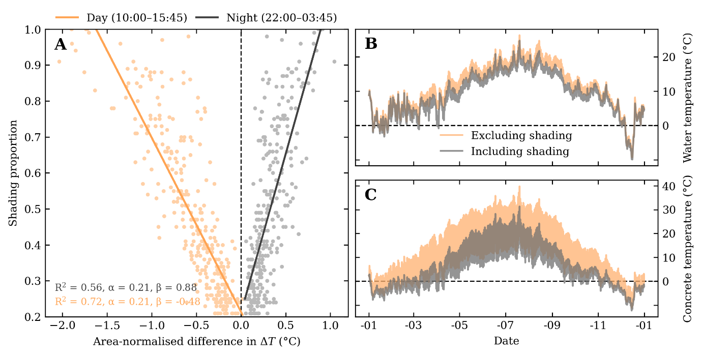
Fig. 5 Shading effects on surface temperature (wT, cT) and air temperature (ΔT)

(A) Scatter plot of the area-normalised difference in median annual ΔT associated with changing water temperature alone, for daytime (10:00 – 15:45) and nighttime periods (22:00 – 03:45). Data presented for a subset of highly shaded features (median annual daytime shading ≥ 20%). An example of the effects of shading on wT and cT are shown in (B) and (C) respectively, for a feature of the Regent’s Canal, London, UK.

Based on the above approach, shading effects act to reduce median daytime ΔT cooling from water alone by 0.49°C (0.74, 0.27), while also reducing nighttime ΔT warming by 0.27°C (0.19, 0.39). The magnitude of this effect is linked to the degree of shading (Fig. 5A; R² = 0.56 – 0.72), with highly shaded canals exhibiting the largest reductions in ΔT. When considered in isolation, these data provide strong evidence for modification of water energy balance (18) by building shading (Fig. 5B) with implications for ΔT. However, concrete energy balance is also influenced by shading (34) and exhibits a similar overall pattern when studied in isolation (Fig. 5C), with a reduction in median daytime ΔT cooling by 0.52°C (0.84, 0.31) and a reduction in nighttime ΔT warming by 0.15°C (0.10, 0.27). In combination, the net effect of incorporating shading is negligible for the studied features, with a change in annual median daytime ΔT of only 0.03°C (0.016, 0.053).

However, aggregated annual statistics can mask important day-to-day and feature-to-feature variability in ΔT due to shading. Importantly, incorporating shading can both increase and decrease ΔT i.e., an enhanced or diminished air temperature effect. This pattern is illustrated for one representative feature of the Regent’s Canal, London, UK (Fig. 6A), but is common for highly shaded canals in the main urbanised areas (Fig. 1B).

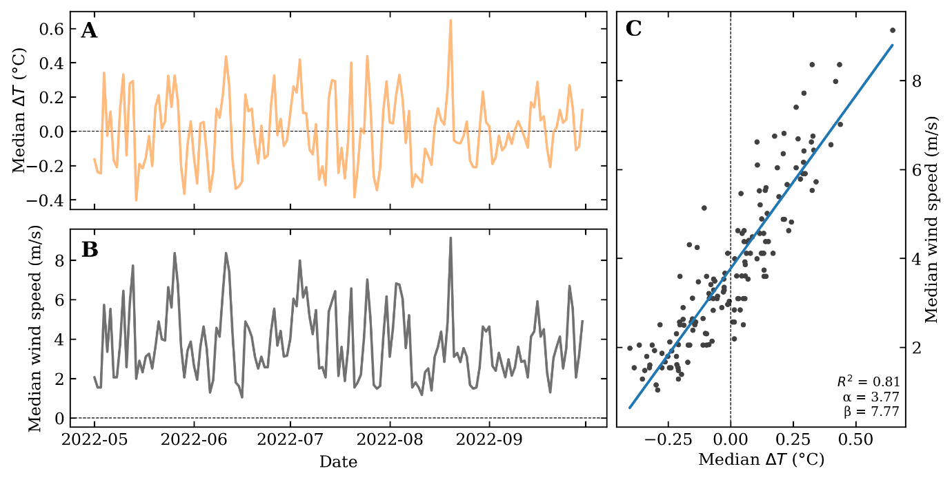

Fig. 6 Effects of shading and wind speed on air temperature (ΔT) for a feature of the Regent’s Canal, London, UK.

(A) Time-series of daily daytime median ΔT as a function of shading (positive values equate to a cooling effect when shading effects are included, negative values equate to a warming effect when shading effects are included). (B) Time-series of daily median wind speed (m/s) for May to September (inclusive). (C) Scatter plot of the previously described time-series, showcasing the strong, positive correlation (R² = 0.81, β = 7.77, p < 0.01) between ΔT difference and wind speed.
The fluctuation in daytime ΔT due to shading, as illustrated in Fig. 6A, is typically within the range ± 0.5°C and appears strongly correlated with wind speed during the summer period (May – September inclusive; Fig. 6B, 6C; R² = 0.81, p < 0.01). This pattern is consistent across the highly shaded canals, with a median R² of 0.79 (0.70, 0.85). In general, when wind speeds are high, incorporating shading is more likely to have a relative cooling effect during the daytime (−ΔT), compared to the models excluding shading. The reverse is true when wind speeds are low, as incorporating shading is more likely to have a relative warming effect (+ΔT). These fluctuations in ΔT are largely driven by the sensitivity of water energy balance to wind speed.

It is important to note, however, that fluctuations in wind speed alone do not explain the differences in ΔT between the models excluding and including shading, as fundamentally both sets of models are forced using the same input weather data. Instead, the temperature dependence of the energy fluxes is critical, as changing water temperature is the key effect of shading (Fig. 5B). One example of this is evaporative cooling by water (16), which exhibits a strong correlation with wind speed (R² = 0.72). When wind speeds are high, there is a high magnitude reduction in evaporative cooling when there is a switch from higher wT (unshaded model) to lower wT (shaded model). By comparison, the reduction is evaporative cooling is much smaller for the same switch in wT when wind speeds are low. A similar pattern is evident for sensible heat (R² = 0.87), and to a lesser extent, thermal emissions (R² = 0.28). By comparison, concrete energy balance appears less sensitive to changing wind speed, and it is this differing sensitivity which acts as a key control on short-term fluctuations in ΔT.

