Brick Breaker

Matthew Yuen

ICS4U Proposal

Submitted to Mr. Heffernan

March 8, 2017

**Introduction**

Brick Breaker is an adaptation on the classic arcade game Arkanoid that falls under the genre Breakout clone. Games in this genre have similar mechanics in which the player controls a “bat” or a “paddle” which hits a ball to towards objects or another player’s paddle depending on the game; in Brick Breaker, there will be a wall of bricks. The objective of the game is, as the name suggests, to smash a wall of bricks by deflecting a bouncing ball with a paddle. This adaptation of the game will have two different game modes: single player and multiplayer (two players only). In single player, the player will have the option to choose between five different levels which are increasingly more difficult; one is the easiest level and five is the hardest level. In multiplayer, the player can challenge and play against another player on a different computer. They will have the option to choose between three levels. A variety of power-ups are hidden behind bricks which will fall down when the brick is broken. In the game, the player will start with three lives. Once the player loses all three lives, they lose the game.

**Menu**

When entering the game, the menu screen will pop up. The Brick Breaker logo will be located at the center of the top of the screen. There will be three buttons located directly under the logo in the following order: Play, Instructions, and Settings. The player can select any of these three options by using the mouse to navigate and left clicking to select an option. At the top left corner of the menu screens, there will be an arrow which returns to the previous screen if clicked (unless on the very first menu screen).

**Play**

The Play button will lead the player to another screen with two buttons which are Single Player or Multiplayer. If the player selects Single Player, they will be brought to another screen where they can select the level (1 - 5) that they want to play. If the player selects Multiplayer, they will be sent to another screen which will provide instructions on how to set up the multiplayer aspect with another computer.

**Instructions**

The Instructions button will bring the player to a guide of the basic rules, controls, and objectives of the game. Here, the power-ups will be described.

**Settings**

In Settings, the player will be able to customize some of the aesthetics of the game including the paddle design and colour, sound, etc.

**Gameplay and Controls**

After clicking through the menu options and either choosing a level in single player or multiplayer, the game will begin. The paddle will be shown at the bottom of the screen. This is the only thing that the player will control while playing the game. The paddle can only move horizontally and is controlled by the left and right arrow keys on the keyboard. The goal is to move the paddle and place it in the path of the falling ball in order to bounce the ball into the bricks above at the top of the screen. The only other control is the space bar which is used when the gun power-up is active. Pressing the space bar will allow the user to use the gun.

**Game Mechanics**

* The size of the screen will be 750x1000 pixels.
* The paddle, which is flat and rectangular, will only move horizontally.
* The player will control the paddle using the left and right arrow keys, and the spacebar if the gun power-up is active.
* If the ball hits the paddle, wall, ceiling, or brick, it will bounce off of it.
* The player starts with three lives. If the ball hits the bottom of the screen (the player fails to bounce the ball off of the paddle), the player loses a life. This is the only way that the player can lose a life. If no lives are left, the player loses the game.
* If the player loses the game, a message will be displayed at the center of the screen. The game will then give the option to play again or return to the main menu. If the player wins, a message will be displayed and the game will go on to the next level.
* There are three different types of bricks, all of which are different shades of red. The lightest shade only needs to be hit by the ball once in order to break and disappear. The shade darker than that will need to be hit twice, and the darkest shade will need to be hit three times.
* If the ball hits a brick, the brick will disappear (if the lightest shade of red) or will be weakened (changes from darker shade to lighter shade) depending on which type of brick it is.
* There are metal blocks, the same size as the bricks, that can not be destroyed. They will stay in place throughout the game, acting as an obstacle.
* Power-ups are hidden behind bricks. If the brick is broken, the power-up will fall. The player must catch the power-up with the paddle in order to activate it. Some power-ups will give the player an advantage, and others will give the player a disadvantage.
* Only one power-up can be active at a time. If a power-up is activated while another is already in effect, the newly activated power-up will override the effects of the previous one. The only exception is that a power-up can not take a way any lives that you’ve gained from previous power-ups.

**Power-ups**

Power-ups will be hidden behind bricks. Their locations and the type of power-up are randomized each time the player starts a game. Power ups will be revealed when the brick at it’s location is completely broken. The number of power ups in each level differs. The higher, more difficult levels will have more power ups. There may not necessarily be one of each type of power up listed below in each level.

|  |  |  |
| --- | --- | --- |
| Power-ups | Effect | Duration |
| Life | Gives you an extra life. | N/A |
| Catch | Enables you to catch and hold the ball. While the ball is caught on the paddle, you can move around. You will be able to launch the ball by pressing the spacebar. | 10 seconds |
| Gun | Gives you three bullets that destroy bricks. The effect of a bullet hitting a brick is the same as if the ball hit the brick. It takes the same number of bullets to break a brick of the darkest shade of red as the ball. You can shoot by pressing the spacebar. The bullet will shoot from the middle of the paddle. | Ends after the third bullet is shot |
| Long | Makes your paddle longer in the horizontal direction. | 10 seconds |
| Slow | Slows down the ball. | 10 seconds |
| Wrap | Allows you to move the paddle beyond the edge of the screen. If the paddle is moved to the left edge of the screen, it will come out on the right side of the screen. | 10 seconds |
| Flip | This changes the direction of your paddle. The left arrow key now makes the paddle move right, and the right arrow key now makes the paddle move left. | 10 seconds |

**In-game Interface**

* The number of lives will be displayed on the right side of the screen.
* Active power-ups will also be displayed on the right of the screen (except the life power-up which will simply just add another life to where the lives are shown). When there are three seconds left in the power-up’s duration, the power-up symbol will flash. If the gun power-up is active, the number of bullets left will be displayed.
* The score will be displayed at the top center of the screen.
* 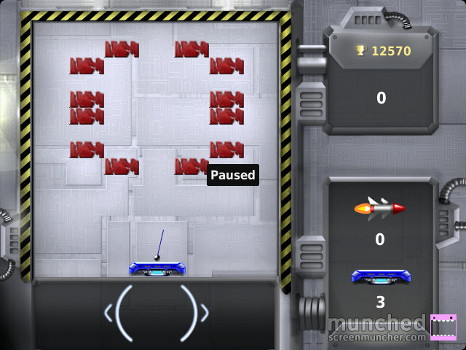A pause button will be located at the top right of the screen.

The layout will be similar to this, but not exactly the same.

**Multiplayer**

The multiplayer game mode will be slightly different than the single player. The game will be similar to pong in that there will be two paddles at either side of the screen (left and right side). The paddle on the right will be controlled by the host of the game, and the paddle on the left by the guest. The paddles are vertically oriented and can be moved up and down. There will be blocks in the middle of the screen separating the two paddles. Each side will start with a ball. They will be essentially playing the single player game mode horizontally instead of vertically. If any of the two balls touch the left or right edge of the screen (if the player on that side fails to deflect the ball), then the game ends and the player on the same side of the screen loses. Players on have one life each. Aside from this, the same rules and game mechanics as the single player mode will apply. Power-ups will be the same except instead of falling down vertically, they will move horizontally towards either side of the screen depending on which player breaks the brick.

Notes:

* 10 points for weakening a brick
* 25 points for breaking a brick
* 50 points for getting a power up
* Map ideas: <https://darmandr.wordpress.com/2013/12/12/simple-brick-breaker/>

