NX-421 Miniproject 1 – Report
Group T | Variant 3: K-means
Marbach Valentin, Schaffhauser Kilian, Martignoni Matteo
This project seeks to analyse fMRI data from a language task, taken from the Human Connectome Project (HCP) which was adapted from an experiment run by Binder and colleagues (Binder et al., 2011)[1], by mapping language and semantic processing against mathematical processing with a hypothesis-driven Generalised Linear Model (GLM; Part 1) followed by a data-driven Multi-voxel Pattern Analysis (MVPA; Part 2). The experiment alternates auditory story and math blocks, totalling a 3.8min run. The dataset contains a T1-weighted anatomical image, a task fMRI (LR run) and the event onset times.

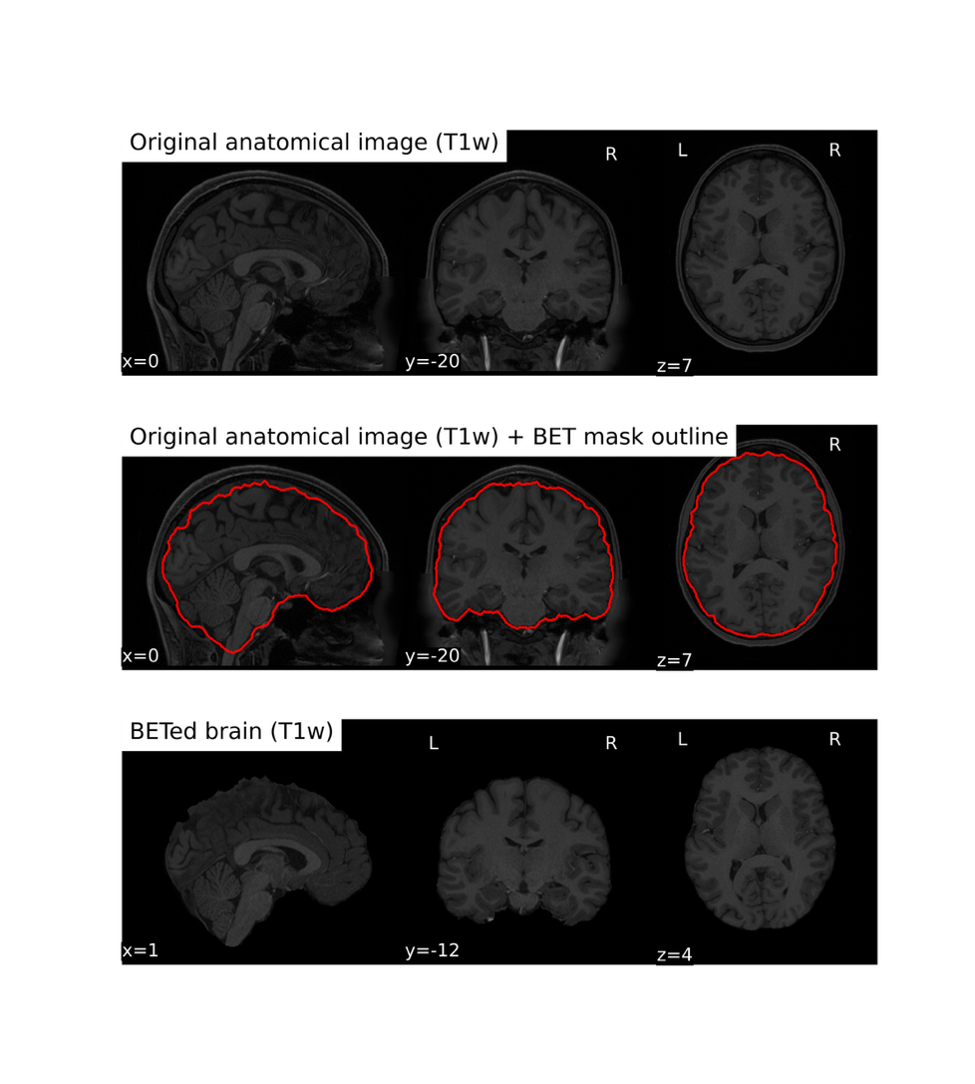
1. Preprocessing and GLM
Figure 1 T1w with BET mask overlay on sagittal, coronal and axial slices. The extracted brain is shown in the second subplot.

1.1 Structural preprocessing
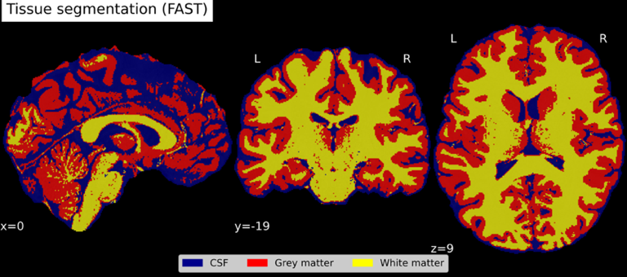
Skull-stripping: Purpose: remove skull, scalp and neck, which carry no brain signal and disturb segmentation and registration. We used FSL Brain Extraction Tool (BET) with robust centre estimation and a fractional intensity threshold of 0.3. A stricter threshold of 0.5 (Annex 1) removes some brain tissue, so we kept the conservative 0.3 at the cost of a little remaining non-brain tissue (e.g., orbit/sinus region).
Figure 2 Tissue segmentation. Segmented tissues are overlaid on the BETed brain.
Segmentation. Purpose: separate tissues to check the anatomy and to provide tissue masks (e.g., grey matter, where the BOLD signal originates). We used FSL FAST to obtain grey matter, white matter and CSF (volumes: CSF 229 mL, GM 654 mL, WM 496 mL; Fig. 2).
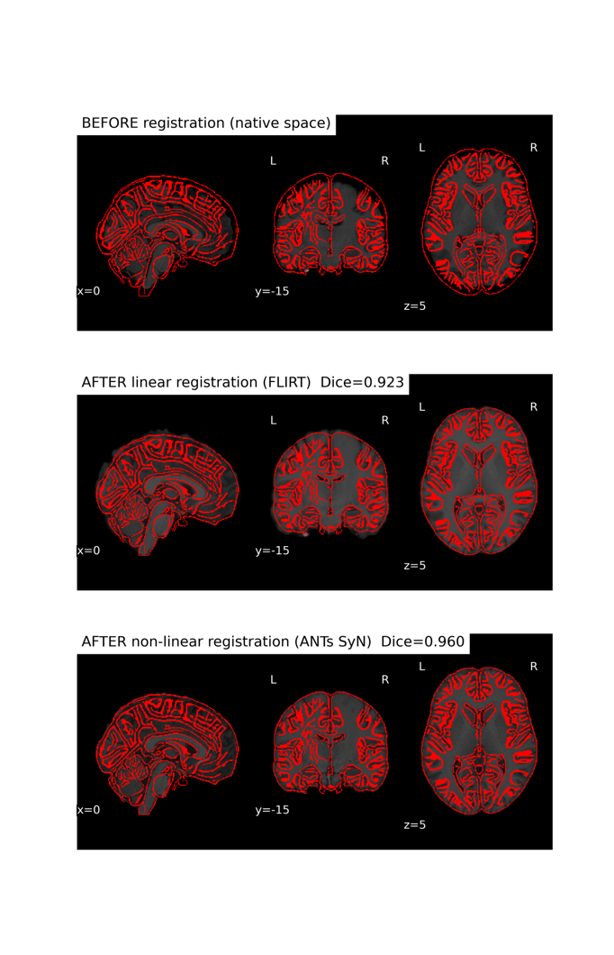
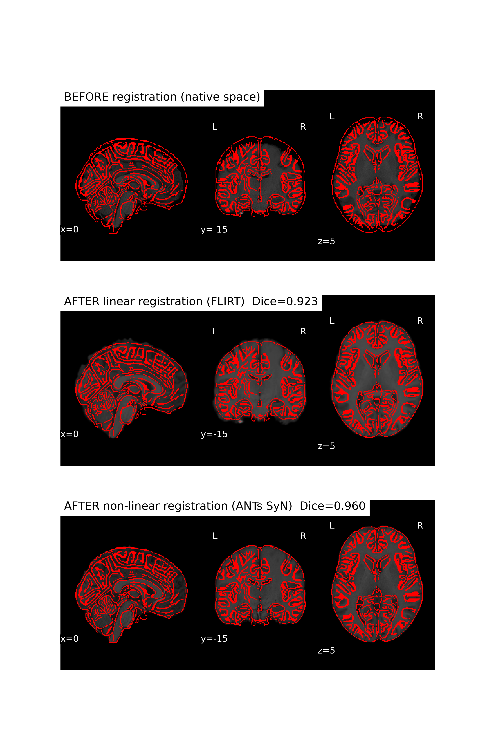
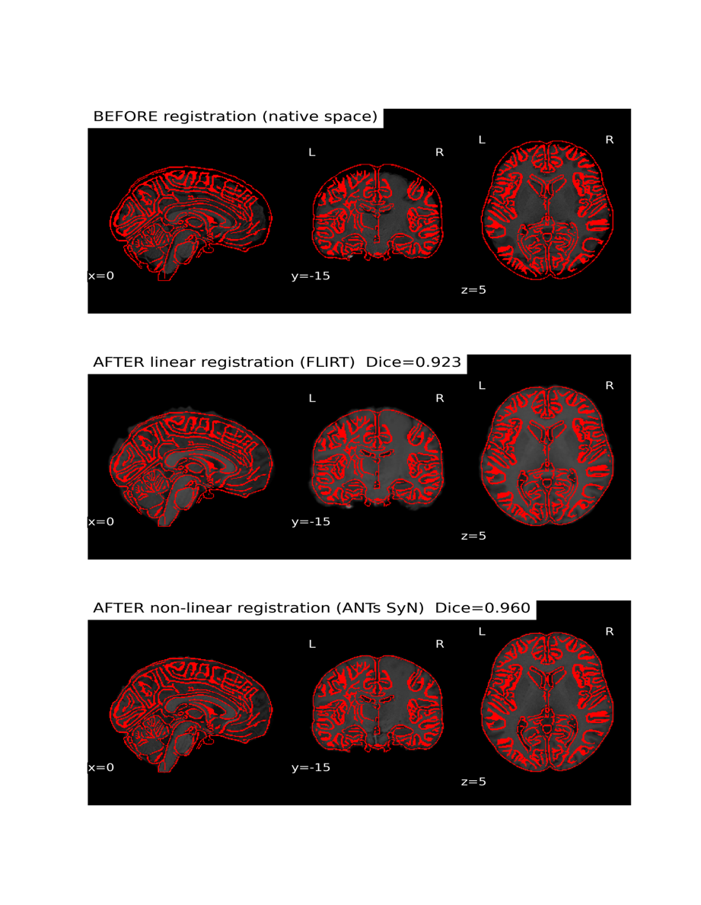
Registration to MNI. Purpose: bring the data into a common, standard space so that activations can be compared with atlases and literature coordinates. We compared two transformations (Fig. 3). FLIRT, affine with 12 DOF. The scale factors (1.08/1.12/1.18) show that the subject's brain is smaller than the template, which a rigid 6-DOF transform could not absorb. The correlation with the MNI template is 0.796. ANTs SyN non-linear. It gives the best match (correlation 0.854), notably at the ventricles and sulci. We kept it, because the HCP fMRI is itself non-linearly normalised to MNI, so the T1 must match it equally well. The same transform was applied to the segmentation to yield the grey matter mask in MNI space, used for the GLM.
Figure 3 Brain before registration, in its native space, after FLIRT, and after SyN. The MNI outline is superimposed in red.

1.2 Functional preprocessing
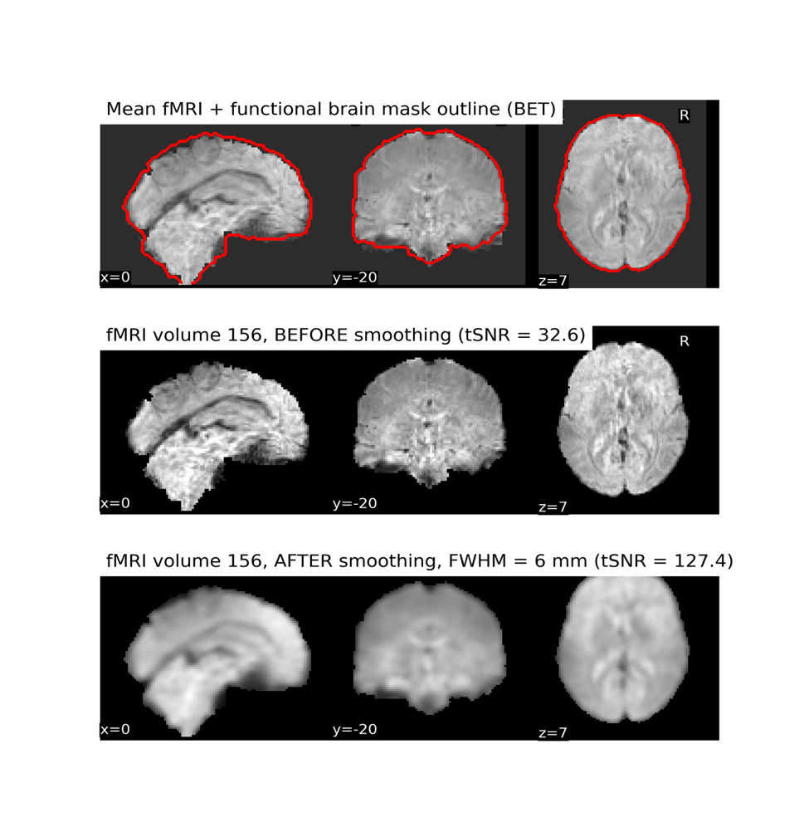
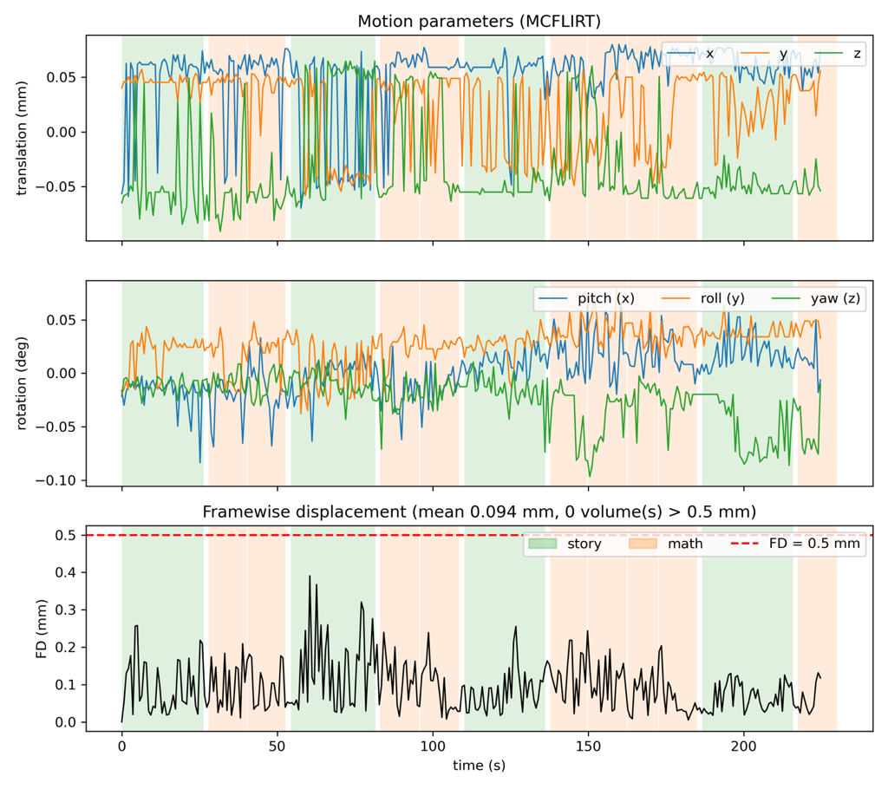
Motion correction: non-stationary volumes were removed (first 3 volumes), as their higher contrast would bias the reference volume (the mean volume) of the realignment. Then, motion correction (MCFLIRT) is applied before smoothing. We then applied motion correction (MCFLIRT) so that each voxel follows the same brain location over time; its 6 parameters are used as nuisance regressors. The framewise displacement (FD; Fig. 4) shows very little head motion: no volume exceeds the 0.5 mm threshold, so no censoring was needed, and motion is not visibly linked to the story/math blocks. With a stricter threshold, the frames around 60 s would probably need to be scrub
Figure 4 Middle volume of fMRI time series before and after gaussian smoothing with FWHM = 6mm.
Figure 5 Framewise displacement between subsequent volumes. The 0.5mm FD threshold is displayed as a red dotted line, and the math/story blocks are displayed as shaded areas.
Smoothing. A 3D Gaussian of 6 mm FWHM (three times the 2 mm voxel size) was applied inside the brain mask. This increases the signal-to-noise ratio, since noise is mostly independent between voxels while activations span several voxels, and brings the data closer to the assumptions of voxel-wise statistics (Gaussian random fields). The cost is spatial specificity: small activations are diluted and grey-matter signal spreads into WM and CSF. 6 mm is a compromise for a single subject (8 mm is usual in group studies).
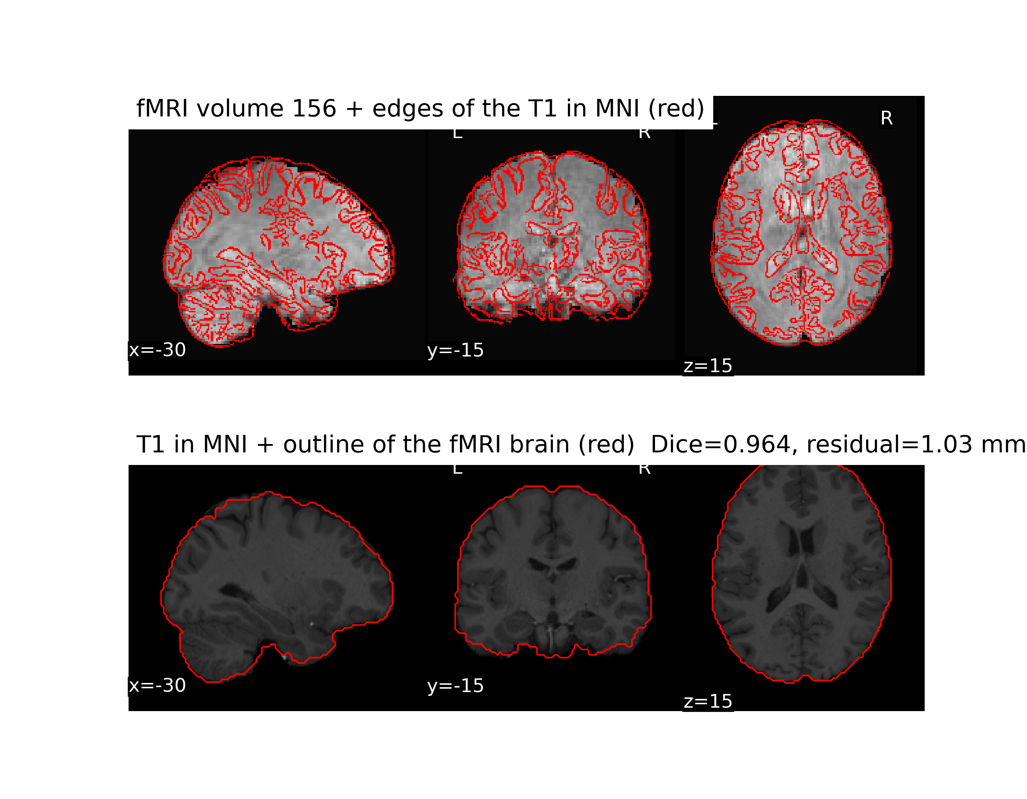
Anatomical–functional alignment. Fig. 6 shows the MNI-registered T1w overlaid on a functional volume. The T1 edges follow the ventricles, the insula and most of the cortical folding. Minor discrepancies remain in the parietal cortex and at the base of the brain (inferior temporal lobes, cerebellum), where EPI signal is lost near the sinuses and ear canals; the permissive BET threshold, which keeps some CSF, also contributes. As a test, we let FLIRT register the mean fMRI to the T1 (rigid, starting from the current position): the residual displacement is about half a voxel, close to the accuracy of an EPI-to-T1 registration itself. Therefore, the coregistration of the fMRI to the T1 and its normalisation to MNI can be skipped: the HCP fMRI is already non-linearly normalised, on the MNI 2 mm grid, and its internal structures line up with the SyN-registered T1.
Figure 6 Anatomical MNI-registered T1w (one slice) overlaid on fMRI volume for alignment assessment.

1.3 GLM

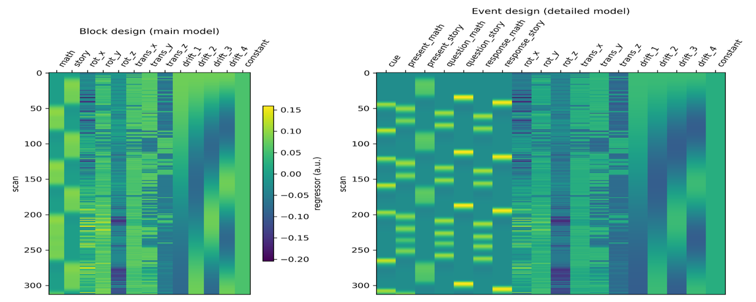
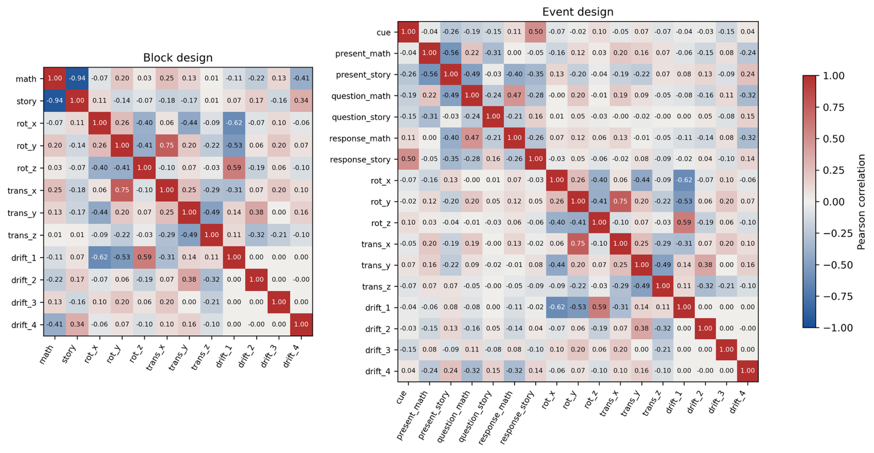
Design matrix. The event file describes two levels: the blocks story and math (~12–30 s each, alternating without rest), and the sub-events inside them (present, question, response, and a short auditory cue before each block). Our main model is a block design (story vs. math), which answers the project question with the most power and is the design used by Binder et al. (2011)[1]. It has two boxcar regressors (story, math) convolved with the canonical double-gamma HRF, plus nuisance regressors: the 6 motion parameters, 4 cosine drift terms (high-pass 0.01 Hz) and a constant (13 columns, Fig. 7). Story and math are strongly anti-correlated (r = −0.94): blocks alternate without rest and cover 94.5% of the run (213 of 225.4 s), so story + math ≈ constant, and both are almost collinear with the intercept. Their individual betas are poorly estimated (variance inflated ~10×) and mean "versus the ~12 s of cues/gaps", not "versus rest". They mostly capture what is common to both tasks (auditory input, attention, button press). The story−math contrast, however, lies along the direction of greatest variation of the design (the alternation itself) and is well estimated. This is why the task was designed with matched block durations.
Figure 7 Design matrix for Block design experiment.
Figure 8 Correlation matrix of the regressors. Red values indicate a positive correlation, while blue values indicate a negative correlation. Grey, pale boxes indicate little to no correlation.
The fourth drift term (period ~113 s) correlates moderately with the task (r = 0.34 with story, −0.41 with math), because the four consecutive math blocks (138–187 s) add low-frequency content. A lower cut-off (e.g., 1/128 Hz) would reduce this, at the cost of less drift removal. Motion parameters are weakly correlated with the task (|r| ≤ 0.25), so they remove little task signal. They correlate more with the slow drifts (|r| up to 0.62) and, among themselves, rot_y and trans_x (r = 0.75).
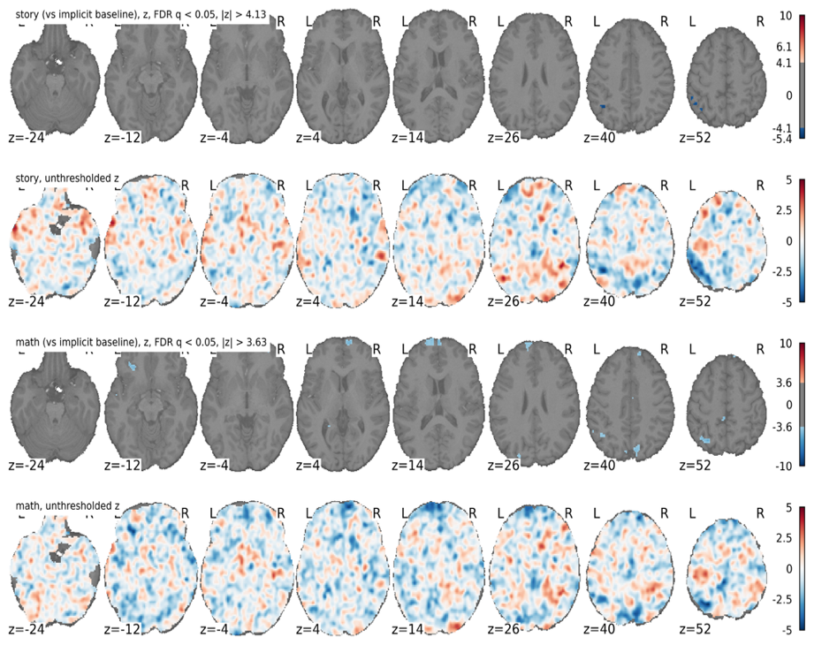
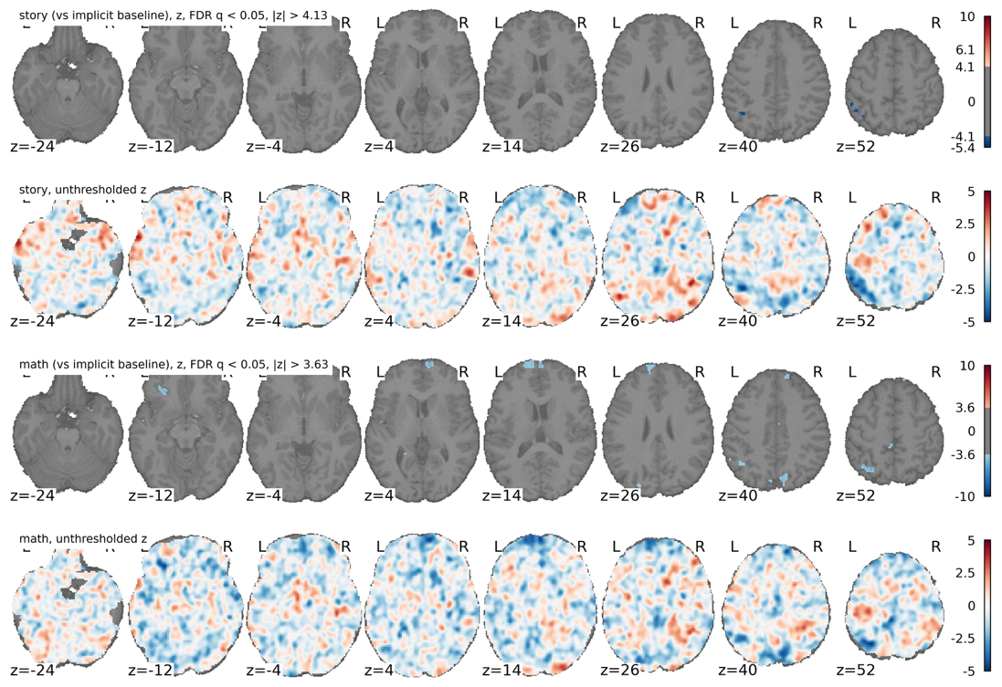
GLM and single-regressor maps. With one subject and one run, only a first-level analysis is possible. The GLM was fitted voxel by voxel on the preprocessed data. Maps are two-sided z-scores, FDR-corrected (q < 0.05), keeping clusters of at least 10 voxels. Each regressor is tested against the implicit baseline, i.e. the 12 s of the run that are covered by no block. As expected from the collinearity, the story and math maps are almost empty (145 and 1137 voxels, all negative) and the unthresholded maps look like smooth noise; they are not interpretable alone (Figure 9).
Figure 9 Activation maps for 'story' and 'math' against baseline (both FDR-adjusted).
Story (vs implicit baseline), FDR q < 0.05, |z| > 4.13
Math (vs implicit baseline), FDR q < 0.05, |z| > 3.63

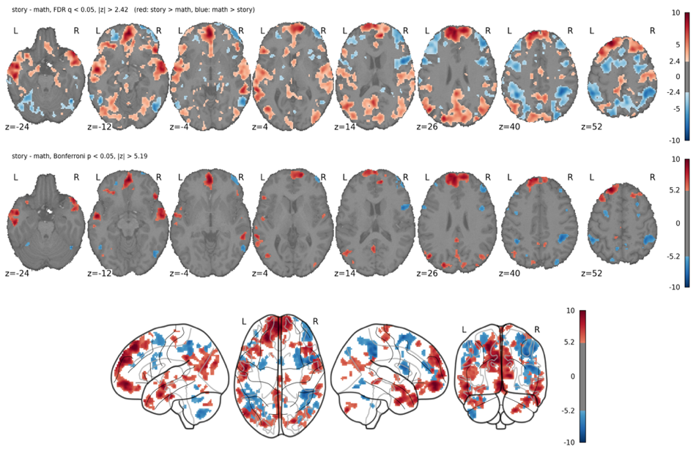
Story vs. math contrast. Contrast vector (order of the design matrix: math, story, 6 motion, 4 drift, constant): c = [−1, +1, 0, 0, 0, 0, 0, 0, 0, 0, 0, 0, 0], red is story > math and blue is math > story. Unlike the single-regressor maps, this contrast is very strong (peak |z| ≈ 10; Figure 10). About 72 000 voxels (one third of the mask) are significant, so the FDR threshold drops to |z| > 2.42 and the map is extended. The Bonferroni map (|z| > 5.19, ~12 000 voxels) controls the family-wise error rate and keeps only the core of each region, which makes regions easier to name.
Figure 10: story − math maps, FDR (top) and Bonferroni (bottom), axial slices. Red: story > math, blue: math > story
Story - Math, FDR q < 0.05, |z| > 2.42
Story - Math, Bonferroni p < 0.05, |z| > 5.19
Regions and networks. Region names were read off the maps using the Harvard-Oxford atlas (FSL).
- Story > math: medial prefrontal cortex and left superior frontal gyrus, bilateral anterior temporal lobes / superior temporal sulcus, angular gyrus, posterior cingulate / precuneus, right posterior cerebellum.
- Math > story: bilateral intraparietal sulcus, right precentral / middle frontal gyrus, right lateral prefrontal cortex, inferior temporal / occipito-temporal cortex.
In terms of the resting-state networks of Yeo et al. (2011) [2], the story > math regions correspond to the semantic / default-mode network. The default-mode network is typically engaged by internally directed, integrative processing such as understanding a narrative, retrieving semantic knowledge and following a situation over time, which is what the story blocks require. The math > story regions correspond to the fronto-parietal network of numerical processing, attention and working memory, which is required for math problems (keeping operands in mind, computing). The coverage map we obtained can be found in the appendix (Annex 2).
The regions expected from the literature for the story > math contrast are the lateral anterior temporal lobe (ATL), posterior middle temporal gyrus (MTG), left angular gyrus, left inferior frontal gyrus (IFG), medial prefrontal cortex (mPFC), and posterior cingulate. Most are left-dominant (expected for language processing), but the ATL activation is strongly bilateral. The exception is the ventral ATL: only 12–34% of its voxels pass the threshold, against > 70% for the lateral ATL, with lower peak (z = 4.1–6.6). This could be explained by the fact the contrast removes shared attributes between the blocks, and that math problems are also spoken sentences that must be understood and answered. The subtraction thus cancels shared auditory, phonological and syntactic processing, and part of the semantic processing (number words have meaning), so regions engaged by both tasks are weakened even if they are semantic. Other contributing factors are the low power of a single subject and a single 3.8 min run and the 6 mm smoothing (which mixes the thin ventral ATL cortex with neighboring low-signal voxels).

1.4 Theoretical questions
T1a) Use an F-test on the two task regressors, with contrast matrix [1 0; 0 1] (one row per regressor). It tests whether at least one beta differs from zero. A [1 1] t-contrast would also work if both effects were positive but could miss voxels where one task activates and the other deactivates. The F-test carries no sign or task information, so the single-regressor t-maps (story > baseline, math > baseline) are needed to see which task drives each region and in which direction.
T1b) Model the question-and-answer phases as separate regressors in each task (story-question, story-answer, math-question, math-answer). The contrast question-answer is [1 −1 1 −1]. Positive values (question > answer) mark regions more engaged during the question or problem presentation (mostly auditory and comprehension processing); negative values (answer > question) mark regions more engaged during the response (decision, motor areas).
T1c) Add a regressor for the preparation period (just before the task stimulus) next to the task regressor. The contrast task−preparation is [1 −1]. Positive values mark areas more involved in performing the task, negative values areas more involved in preparing for it. The two regressors must not be strongly correlated, otherwise their betas cannot be separated, so the correlation matrix should be checked.
T2) Use an F-test comparing models of varying complexity: the full model against a reduced model without the story regressor. The F-statistic compares the extra variance explained by the full model with the residual variance. A significant F means that story adds explanatory power beyond the other regressors. The test must also be corrected for multiple comparisons across voxels (FDR or Bonferroni).
T3) H0: the story−math effect averaged over both runs is zero (c·β = 0 with c = [−1, +1, 0, …]). H1: it differs from zero. The second run should be preprocessed exactly like the first. Runs should then either be concatenated into a single GLM, with separate drift terms, motion confounds and baselines, but shared story and math regressors, and tested on the same contrast; or each run should be fit separately and the contrast estimates averaged, weighted by their variance (fixed effects).

2. Part 2 – K-means

2.1 Method and choice of the number of components/clusters
- One timepoint = one sample; data matrix shape (timepoints × voxels).
- Number of components/clusters chosen and justification (e.g., explained variance / scree plot, stability, silhouette or elbow).
- [INSERT FIGURE: justification plot].

2.2 Spatial maps
- [INSERT FIGURE: each selected component/cluster map, axial view only; overlay on anatomical for K-means]. If it is too large, show the key ones in the main text and the rest in the appendix.

2.3 Correlation with GLM regressors
- First 10 components (temporal scores / timecourses / binary cluster timecourses) vs. GLM regressors.
- [INSERT FIGURE: correlation matrix] + comment, linking to the spatial maps and to the Part 1 GLM regions.

2.4 Theoretical questions (Part 2)
- Voxel as the sample: change in dimensionality and interpretation of the components (spatial vs. temporal roles swap).
- GLM vs. MVPA comparison: is the comparison appropriate? Common points, differences (model-driven vs. data-driven, assumptions, interpretability) and when to use each.

3. Contributions of each group member
- Marbach Valentin: GLM
- Schaffhauser Kilian: Functional preprocessing
- Martignoni Matteo: Structural preprocessing, writing the report

4. AI use statement
We used a generative AI assistant (Claude, Anthropic) during this project, limited to help with coding syntax (for example: recalling function signatures and library usage) and plotting of results. The analysis, the interpretation of the results, and the written report and video are our own work. The AI-assisted code was fully reread, tested and refactored by all group members, and we ran and checked the outputs ourselves to confirm they behave as intended.

References
- Binder, J. R., et al. (2011). Mapping anterior temporal lobe language areas with fMRI: a multicenter normative study. NeuroImage, 54(2), 1465–1475.
- Yeo, B. T. T., et al. (2011). The organization of the human cerebral cortex estimated by intrinsic functional connectivity. Journal of Neurophysiology.
Appendix
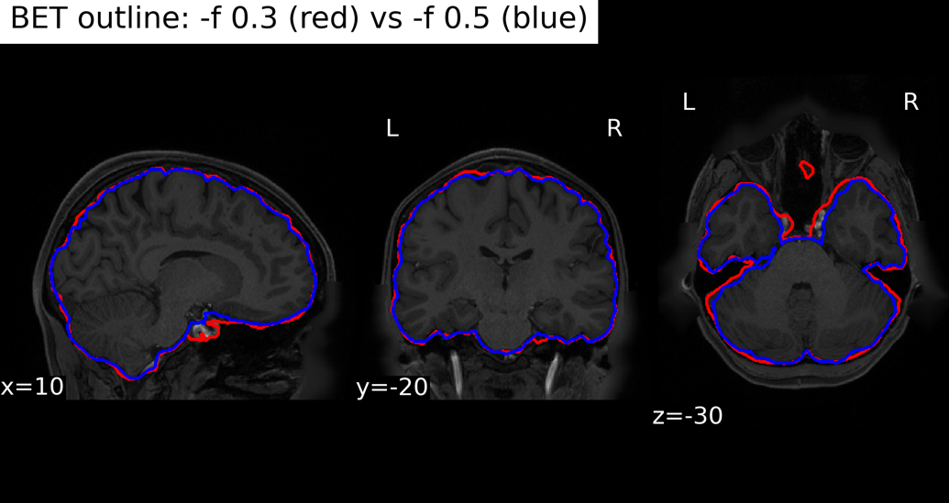
BET threshold variants: The 0.5-thresholded BET follows the cortex without visibly cutting the temporal poles or the cerebellum and removes ~59 mL from original brain, mostly at the base; FAST labels most of it as CSF/meninges (~47 mL), but also ~11 mL grey matter. It also removes ventral areas, e.g. in the ventral/hypothalamic sella area (visible on the sagittal slice). On the other hand, 0.3 keeps small non-brain islands, e.g. orbit/sinus region on axial slice, but was chosen as it keeps all the brain regions that may be of interest.
Annex 1 Comparison of 0.3 and 0.5 threshold for Brain Extraction Tool.
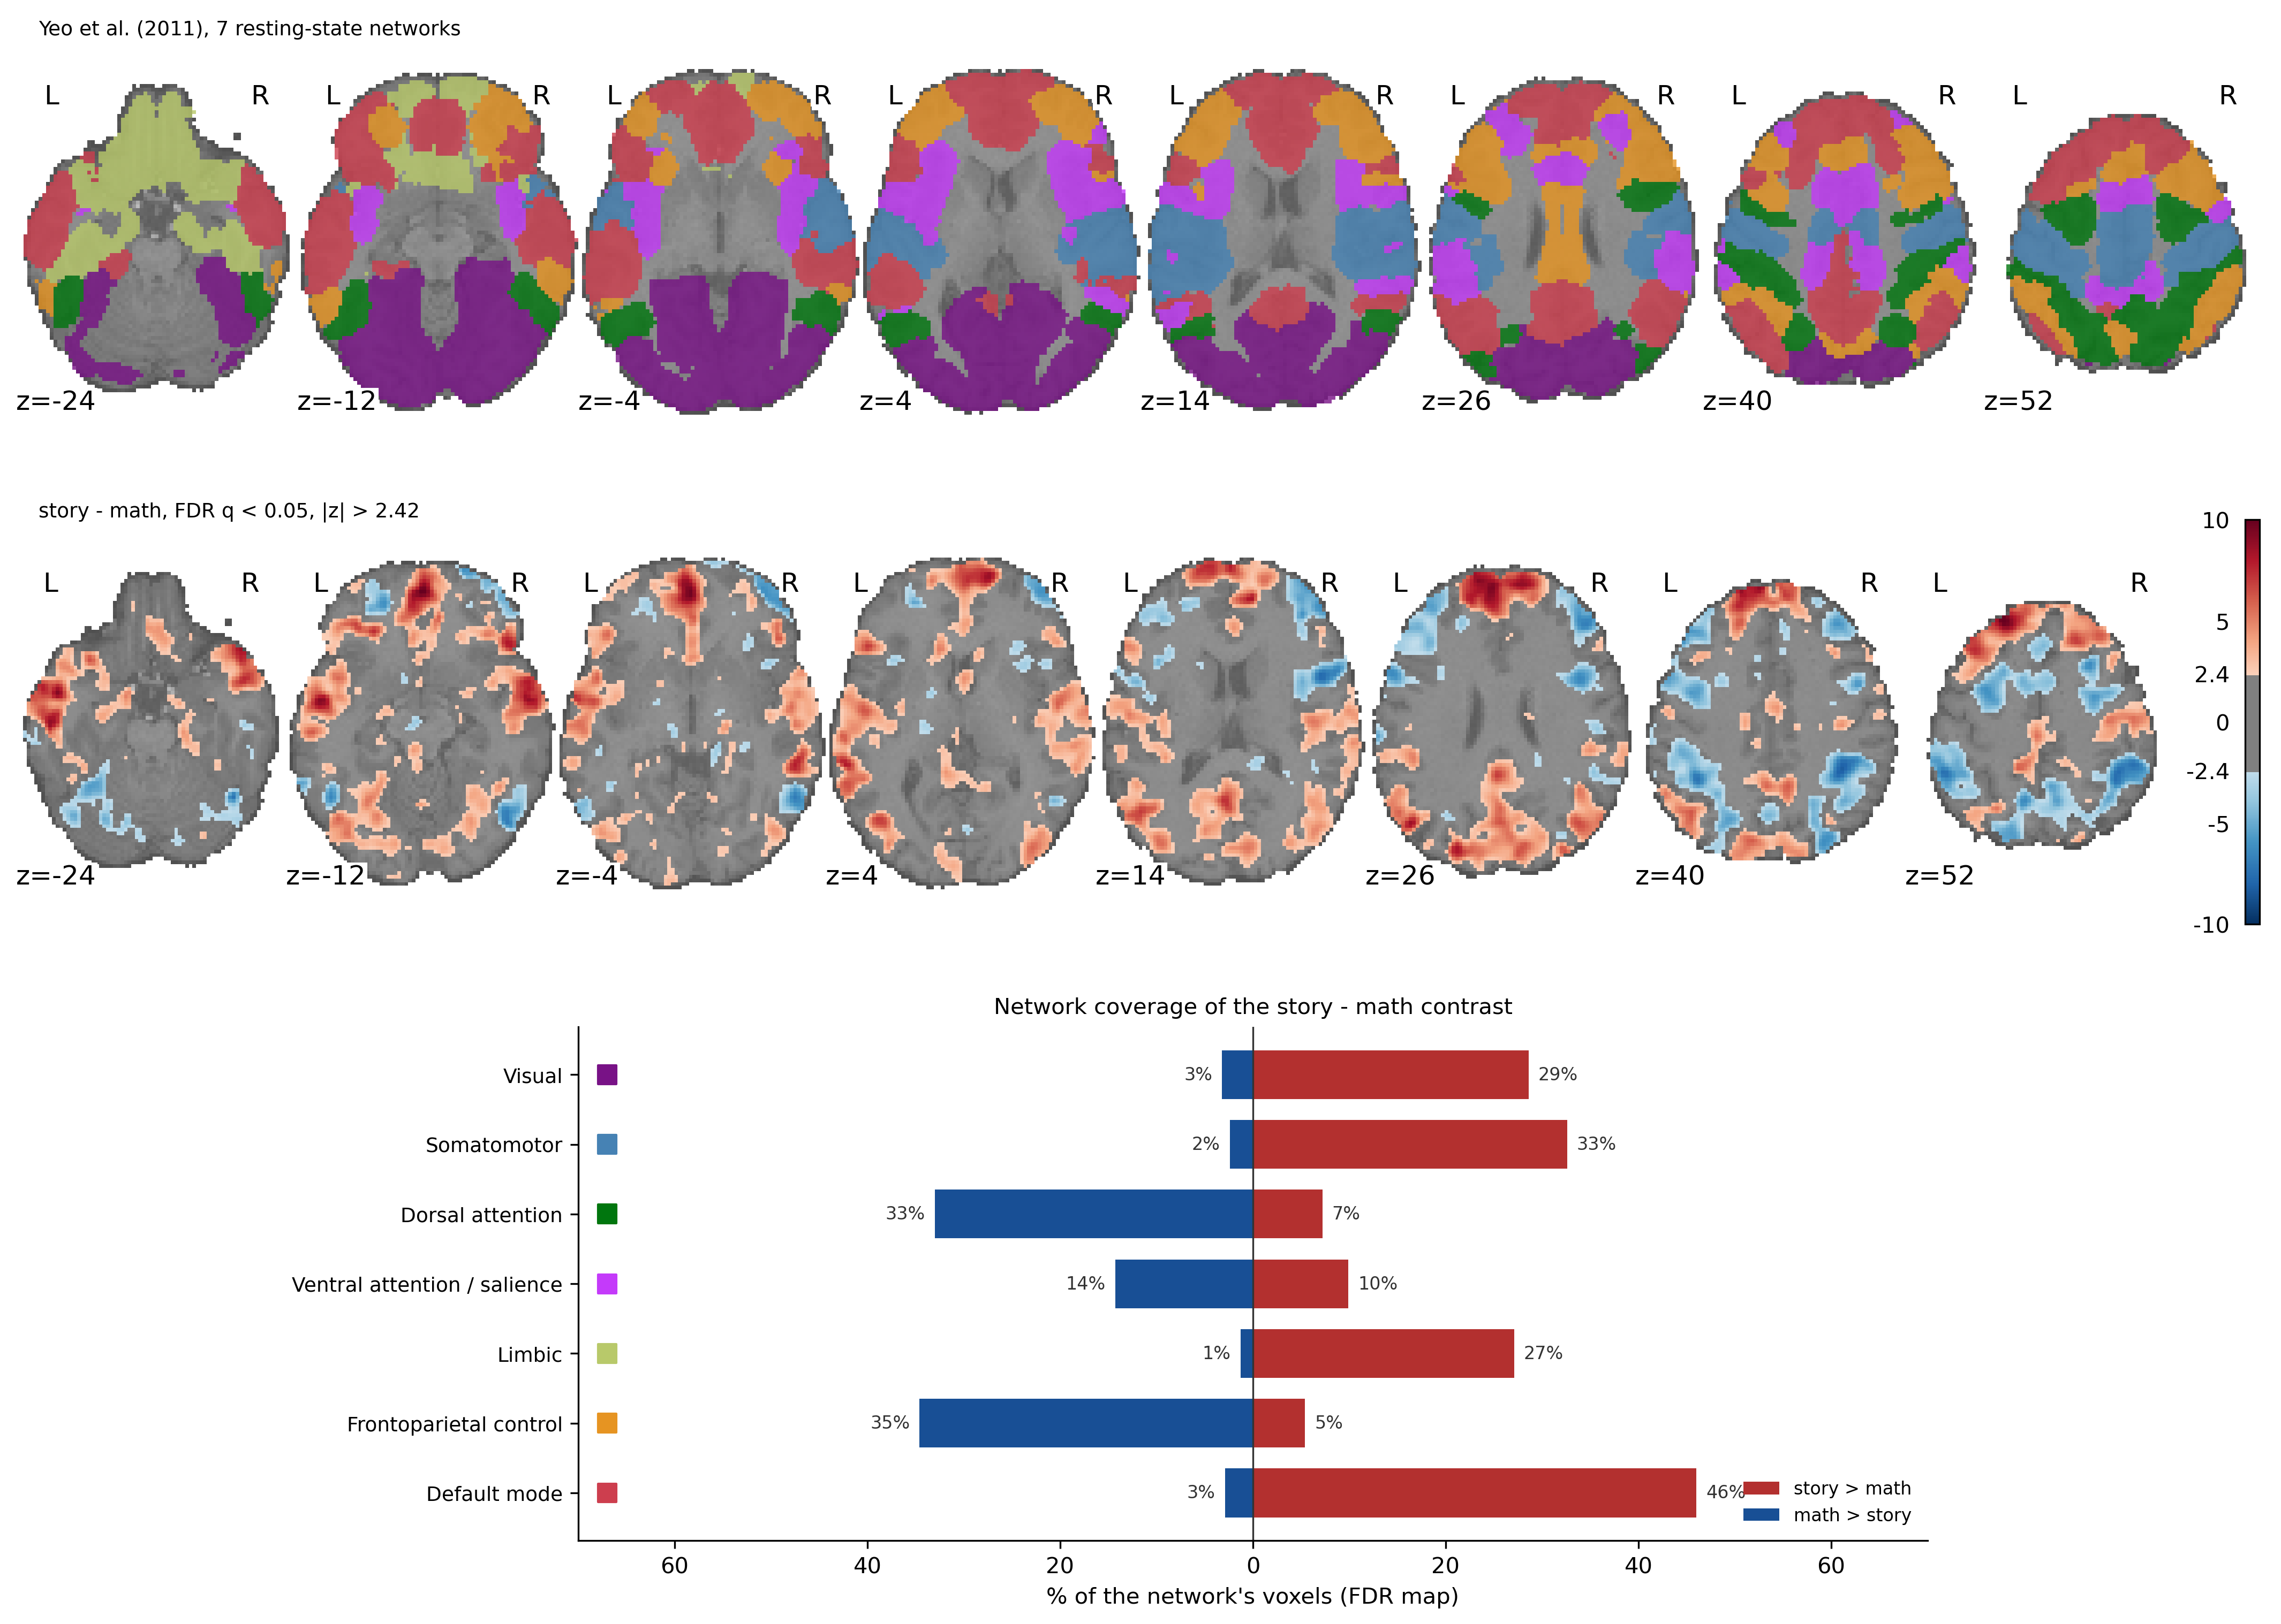
Annex 2 Resting-state networks from Yeo et al (2011) [2] with the story-math contrast activation map and the overlap between the activations and the network map.

