“ACME Network Implementation”

Authors: Jack Long, John Anstead-Jaacks, Matthew Jackson, Mario Lao

Deliverable 3: Our team had a hard time knowing where to go with our thinking and ideas, and what in particular to focus on when designing this network for ACME. We knew that for the scope of this project, it would be best to focus our efforts on more specific things, even if it came at a cost. For this network, we wanted one that focused on usability and security rather than cost. If more money is invested into subsets and servers to distribute the workload, it can help the entire system run smoother from the executives office all the way to retail. ACME is launching a new groundbreaking product soon after this network would be implemented, and to have a network that can’t support the traffic and work needed for that product, would be a disaster and a waste of a lot of money. We also tried to focus on adhering to the guidelines ACME specified for this project, such as separate subnets dedicated to the 20 support and sales staff, the 24 person training classroom, as well as a retail subnet to handle credit card transactions if needed. Everything but the public servers run through the firewall, which should guard all of the private and sensitive servers, ensuring that, alongside the increased number of subnets, the company's information is well guarded.

Deliverable 4: Our team researched a lot into what products ACME should buy to set up this network, as we knew we would be adding a lot to this network design, and knowing which system/product to use we felt was important. If we chose a main switch that is years old or not capable of supporting our network, it would not hold up for very long, especially if ACME is launching a groundbreaking product in the coming months. We also researched basic network designs and how to build a network, not as a wireframe but just as guidelines. This helped us understand some basic fundamentals of what we’d have to do for this project, and what considerations to keep in mind while developing it, such as support for each department, VPNS for the telecommuting teams, connectivity for the training and classrooms, etc. All in all our solution to the problem of creating a safe, affordable and secure network was to focus on what products to use for longevity, the pricing of those products, and keeping sensitive information secure

Deliverable 5: ACME listed out various needs that they had for the network we are trying to implement, focusing on an efficient flow of work and a safe environment to conduct sensitive work and store that information. We wanted to ensure everything was protected, with a firewall up in front of all the servers apart from the public server used to host their website with downloadables and other forms of media. Each room (R&D, Sales, Call Center) is equipped with high end computers they can use to access the information needed, as well as phones equipped with VoIP to securely and quickly communicate with each other. Our various subnets will also help distribute workload, which (in theory) will help prevent some slow loading times for the people in the office. The network is equipped to last as well, as we focused on hardware that would be able to support a growing network, even at a cost of costing money.

Deliverable 6:
Strengths: Our team's strength in our approach comes from the high end equipment we used to ensure sustainability, especially as ACME expands in the coming months and years, as well as our focus on security (as much as we could). While ACME is doing well as a company in this scenario, they still aren’t very big, and we tried to use that as a strength in our decision making. We wanted equipment that would be secure and hold up for a while, such as having their own servers to host their websites instead of offloading elsewhere; it helps with long term sustainability, and addresses and issues ACME specified.

Weaknesses: The weakness in the aforementioned approach comes with cost. It will cost money to sustain these servers, actively patch them, and make sure they are always operational. People will have to be employed to care for the servers and ensure the security is always updated and patched to prevent cyber attacks, and ensure the system runs smoothly as the company expands

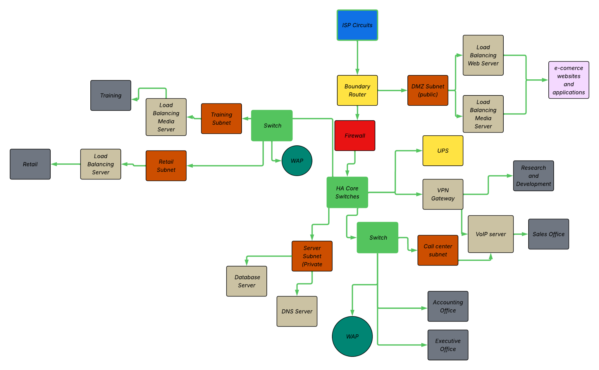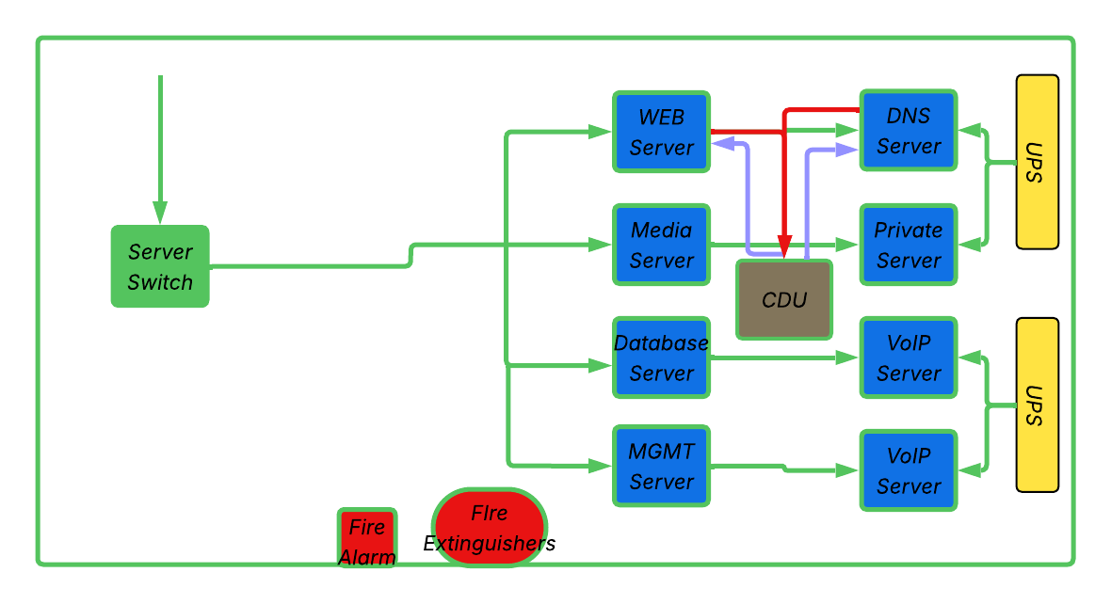
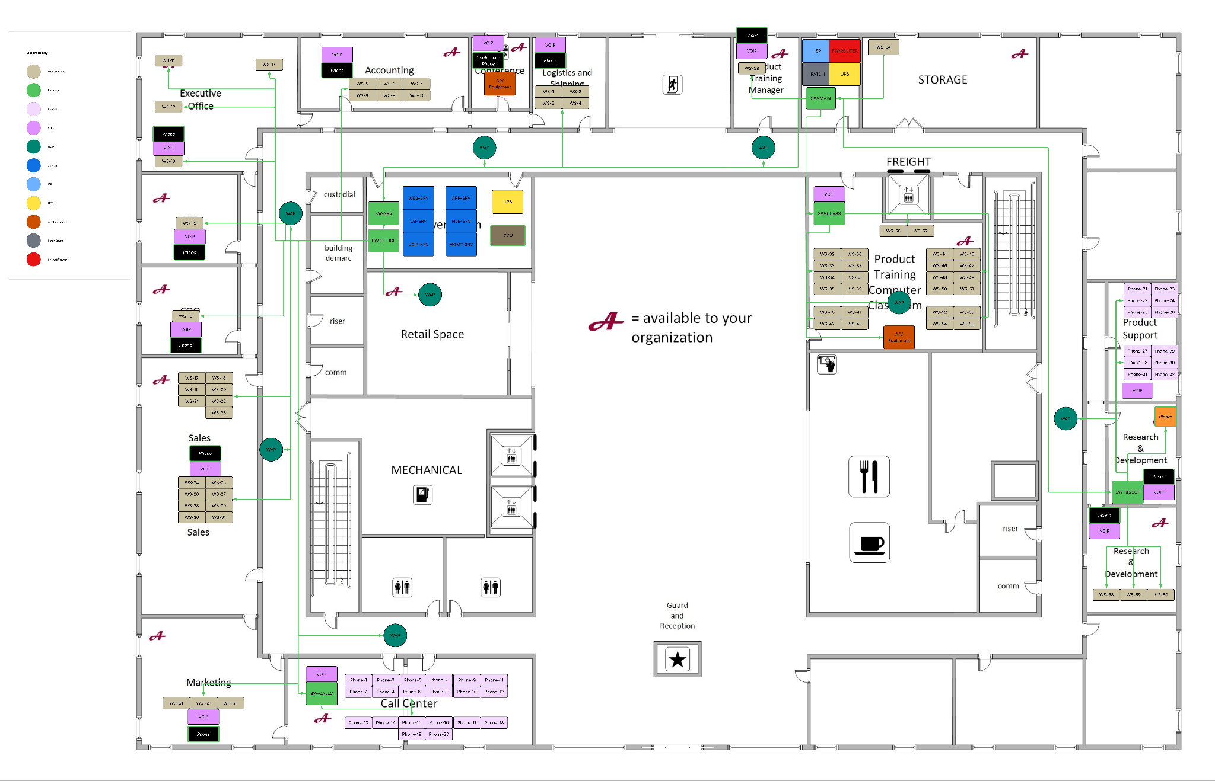

Works Cited
“colosolutions.com.” Optimizing Server Room Design for Efficiency and Growth, Colo Solutions, 27 February 2025, https://www.colosolutions.com/blog/server-room-design/.
N-Able. “N-Able.” How to Design a Network for a Small Business, https://www.n-able.com/features/small-network-design.
Petryshuck, Steve. “Auvik.com.” Network Design and Best Practices, Auvik, 16 September 2024, https://www.auvik.com/franklyit/blog/network-design-best-practices/.
Rob Riker's Tech Channel. Understanding Basic Network Design. 14 January 2016, https://www.youtube.com/watch?v=xh0bWHkT8-E.

