First remove caliper from car. Clamp of the break line, open bleed nipple, use proper tool and wind the piston in a bit. Remove retaining clip on handbrake cable, lever it down and remove it from the caliper. Unscrew the bolts to the carrier. Two wrenches needed 13 and 15mm if I remember correctly.  
Unscrew brake line and remove caliper. (Optional, remove carriers as well for a little cleaning love, a stell brush or deemed where the pads rest is the least you should do to ensure smooth operation.  
Caliper is now if and should be cleaned with brake cleaner and elbow grease;

[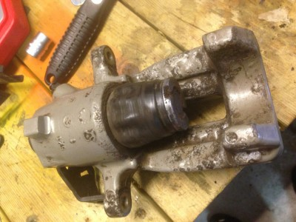](http://www.ttforum.co.uk/forum/download/file.php?id=24401&mode=view)

TBC  
In the pic above I've played with the handbrake lever to extend the piston and cleaned the caliper a bit. Remove and inspect piston for rust and pitting, toss the piston rubber seal.   
Refurb kit with piston;  
Zoom in (real dimensions: 768 x 1024)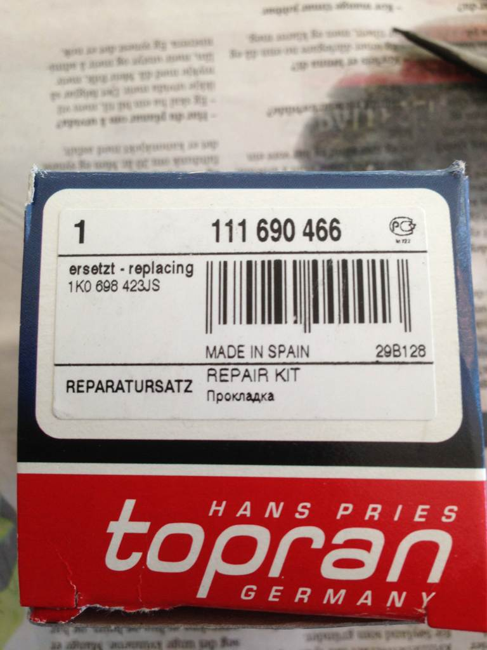  
Included parts:  
Zoom in (real dimensions: 1024 x 768)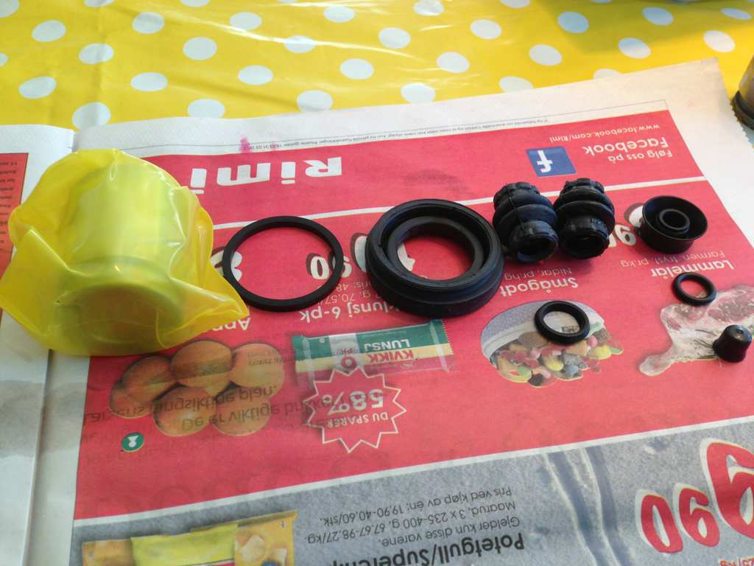  
  
Remove the spring and handbrake lever, spring is easy, lever is pressed on the shaft of the internals and has a seal underneath that most likely will be torn in the removal process. No worry, new one included in kit:  
Zoom in (real dimensions: 640 x 480)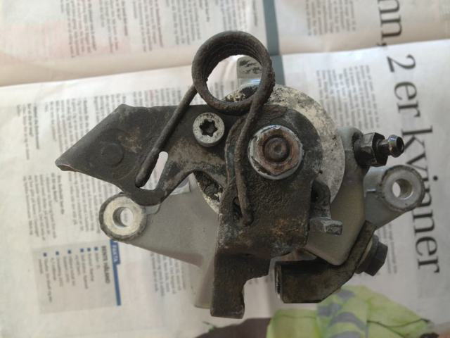  
Parts removed, also shaft is out on this pic( Next step)  
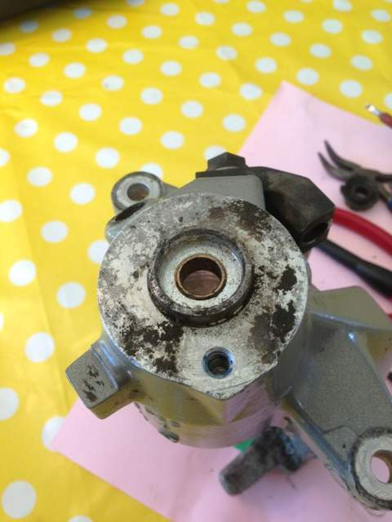  
No the real fun begins, you have cleaned up the brake fluid mess on the kitchen top and bought the wife some flowers, life should be good. How wrong you are, look into the caliper, you will see a circlip/ retaining ring holding the internal gibbons in place. Remove this;)   
Ideally you will have a pair of long reach, slender master cylinder internal circlip pliers. Alternatives include, but not limited to: Regular long reach circlip pliers and a grind them down to fit( my solution) And old plier, a drill and concrete nails to make a tool, and lastly give up and order a replacement caliper;  
Zoom in (real dimensions: 640 x 480)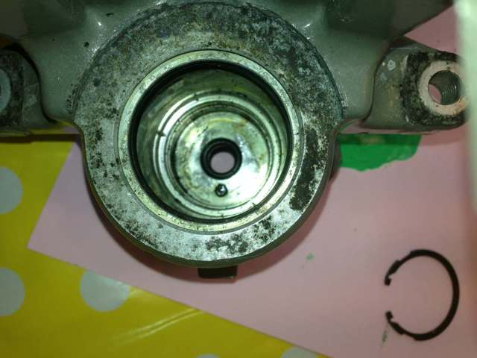Parts out, a moment to celebrate, circlip pictured. For me there was no need to rig a press down on the spring retainer. WD40 on the circlip to ensure it is not rusted to the cylinder wall was enough. ( and an hours worth if fiddling with my sup par pliers).  
Cleaning time again: Brake cleaner and brushes, no water allowed, it's a hydrolic system after all. Internal self adjusting handbrake mech:   
Zoom in (real dimensions: 640 x 480)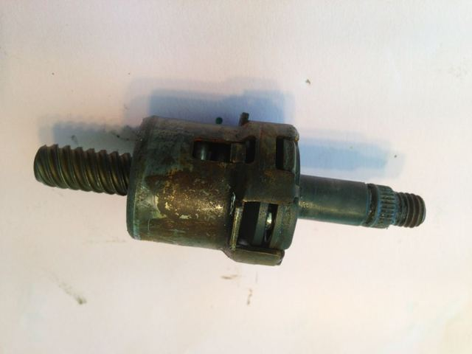Clean with brake cleaner, pay attention to the shaft, if pitted smooth it out so it won't eat the new seals. If severly pitted you are back to start and need a new caliper. Or sand it down and hope for the best. Check for leaks often after reinstall.  
  
Disassemble the piston and clean parts, replace Oring and grease it up with suitable grease, there is an circlip holding the internals together, should be an easy match for you by now:) 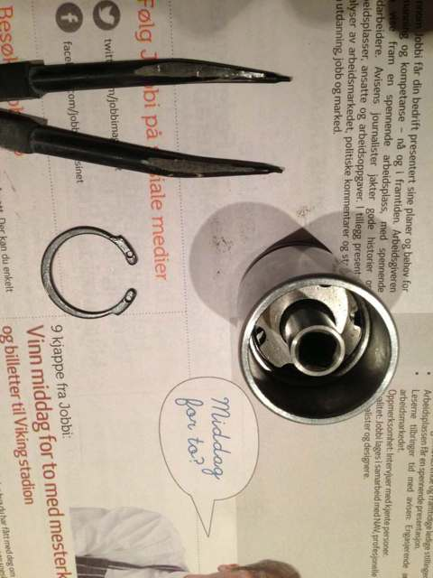  
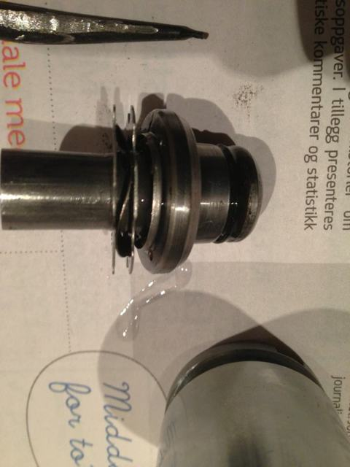Take note how the parts are mounted during strip down.  
  
Finish cleaning the caliper, remove rust and flaking paint. Repaint in your fav colour.  
Zoom in (real dimensions: 640 x 480)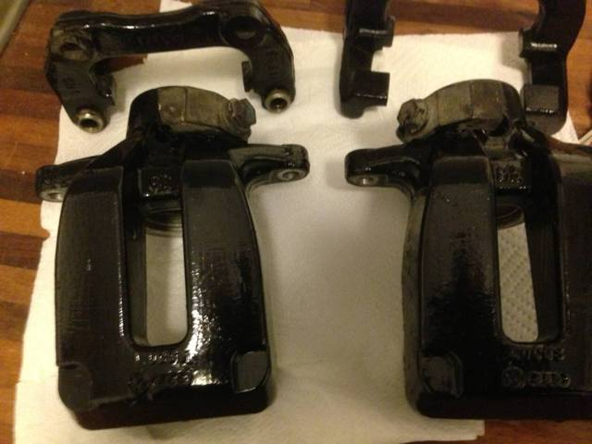  
  
Reassembly is a reversal of the steps, good luck with the circlip ;)