Source: https://www.freecodecamp.org/news/brief-history-of-open-source/

What is Open source?
At its core, open source is an idea. It’s a concept that revolves around access. You can access someone else’s source code (or even a company’s). This way, you can customize it for your use case, find bugs, and fix them too.
Better still, you can share your “version” of the source code with others in addition to the original.
The person who writes the inceptive source code gives this access, which is an invitation to contribute, based on existing licenses. Different licenses will have certain limitations or obligations.
Open source can also be seen as a movement. Yes, initially, open source was a “rebellion” against closed source (proprietary software whose source code is “owned” by a certain company or organization and therefore is not accessible).
Developers did not want to keep paying for software that did not meet their use cases, had bugs that they could not always fix, and had security issues. They also didn't want to have to wait for the next big update to have even the smallest bug fixes. Let’s not even get started with vendor lock-in.
Richard Stallman, who is hailed as the father of open source, seems to prefer to use “free software” instead. He believes that open source and free software have come to stand for very different philosophies over time.
Who Owns Open Source Software?
So, is there any particular person or group of people who own a particular piece of OSS?
Ideally, the authors of the software are its owners. This is, however, a tricky way to look at it because, in some cases, there are thousands of authors.
A better way to look at “ownership” would be in terms of rights, intellectual property, or copyright.
Software Licenses
This is where licenses come into play. There are licenses that do not allow for the sale of the original software or its versions, while others require you to “update” the initial code base with the changes you make.
The terms of “ownership” are therefore defined by the licenses the code is distributed under. Since you are likely to have several libraries and frameworks within your open-source code base, you need to adhere to those other licenses, too.
There can be different "levels of ownership" for open source projects, from contributors to maintainers to committers.
All these levels have different types of access to the code base. The “higher tiers” get to approve changes that will be included in the core code base for official releases.
Committees and organizations like the Apache Software Foundation (ASF) are in charge of bigger open source projects. There is an Apache Project Management Committee (PMC) that helps manage the code bases.
It is important to note that open source is a concept that is applicable to other fields beyond technology.

How Did Open Source Software Come About?
The roots of OSS go deep, wide, and far back into the past, as early as the 1950s.
The 1950s – the A-2 system
In 1953, the A-2 system (an equivalent of today’s compilers) was released together with its source code, and customers were asked to send any improvements to UNIVAC (the Universal Automatic Computer).
UNIVAC was a division under Remington Rand, Inc., an early American business machine manufacturer. Remington Rand had acquired UNIVAC patents as well as its creators, J. Presper Eckert, Jr., and John Mauchly.
There were a few decades of OSS “silence” after the 1950s. Creating software was an expensive and exceedingly complex process. Giving it away for free was thus out of the question.
The 1980s – GNU
In 1983, however, Richard Stallman started to work on the GNU project, which was made up of rewrites of closed software he frequently used.
GNU stands for "GNU’s Not Unix" and is pronounced as one syllable with a hard g.
In 1984, Stallman spearheaded the creation of the GNU, a free operating system that was made to counter closed systems.
In 1985, he wrote the GNU Manifesto, asking for support in the development of the GNU operating system.
He also founded the Free Software Foundation (FSF), a nonprofit that was aimed at promoting freedom in computer use.
By 1987, most of the essential components of the GNU operating system were complete. There was an assembler, editor, and various Unix utilities like grep and ls. A C compiler was almost finalized.
In the 1980s, Stallman also created the GNU General Public License (GPL). All the components of the GNU operating system were released under this license.
Today, the GPL allows for the freedom to share and change all program versions, ensuring that they remain accessible to all users.
The 1990s
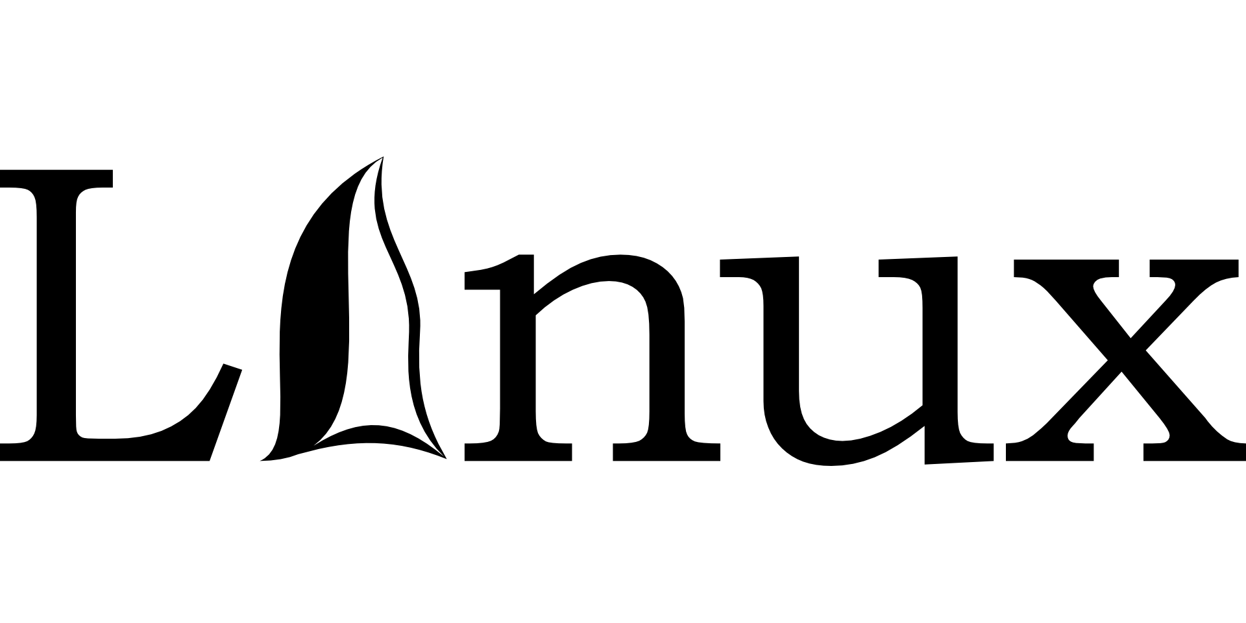The Linux Operating System | Image by Clker-Free-Vector-Images from Pixabay
In the 1990s, Linus Torvalds pushed OSS even further by creating the Linux kernel. He then released it to the public in 1991, along with its source code.
It became the kernel for the GNU operating system.
Other salient events in the 1990s that significantly shaped OSS include:
- The publication of the Python interpreter source code (1991)
- The launch of the Apache HTTP Server (1995)
- The coining of the term “open source” (1998)
- The release of the Netscape browser’s source code (1998)
- The release of Open Office’s source code, the free software counterpart to Microsoft Office (2000)
The 20th century laid a sturdy foundation for OSS. We’ll explore more recent open source developments a bit later on.

