**Sinehan Sa Recto**

A Case Study Project

Presented to the Faculty of the

College of Engineering

Computer Engineering Department

Adamson University

Manila

In Partial Fulfillment

of the Requirements for the subject

**ONLINE TECHNOLOGY**

Submitted By:

**CUELLO, DARWIN JOLO**

**DENDIEGO, JACOB**

**IMPERIAL, JOMAR JONAS**

**VASQUEZ, MATTHEW**

**BALUYOT, RAFFAELLO MANALAYSAY**

Instructor

**March 12, 2018**

**I. INTRODUCTION**

Nowadays, whenever people wants something they want to get it without hassle and in a fast way. This application is very useful so that they don’t need to go to the actual store and buy what they want. They can use this application whenever they want and wherever they are.

**II. BACKGROUND OF THE PROJECT**

*Sinehan sa Recto* is an application where users can buy movie tickets and reserve tickets online. This application will let the users view all movies that is now showing in the cinemas. It will also let the users have their own cart, this is where they can put all the items that they want to buy. If users change their mind, they can view and sort the cart if they want to remove some item. Also, in this application the mode of payment is via credit card.

**III. OBJECTIVES OF THE PROJECT**

**General objective:**

To develop a movie reservation application applying all learnings in Online Technology exemplified by Python language, html. CSS and Java Scipt.

**Specific objectives:**

* To create UML class diagram of the developed game application.
* To code the game application using Python language, CSS, html, Java Script and Pycharm Environment.
* To dockerize the project and upload it to git.

**IV. SCOPE AND DELIMITATION OF THE PROJECT**

The developed movie reservation application has the following features. First, it allows the users to create their own account and access it whenever they want. Second, it allows the user to select a movie and select quantity of ticket they want to reserve and put it in their cart. Third, users have their own cart that they can access whenever they want. They can view, delete and edit items they have there. Lastly, they can pay the tickets through credit card.

However, the movie ticket reservation application will not let users to delete their account once they already created it. The cart will not save upon exiting or logging out the program. The purchasing method is not secured and valid because the program will not validate the credit number inputted. There will be no Admin page for editing movie details.

**V. UNIFIED MODELLING LANGUAGE**

**Case Diagram**



Fig. 2 Title

**Activity Diagram:**

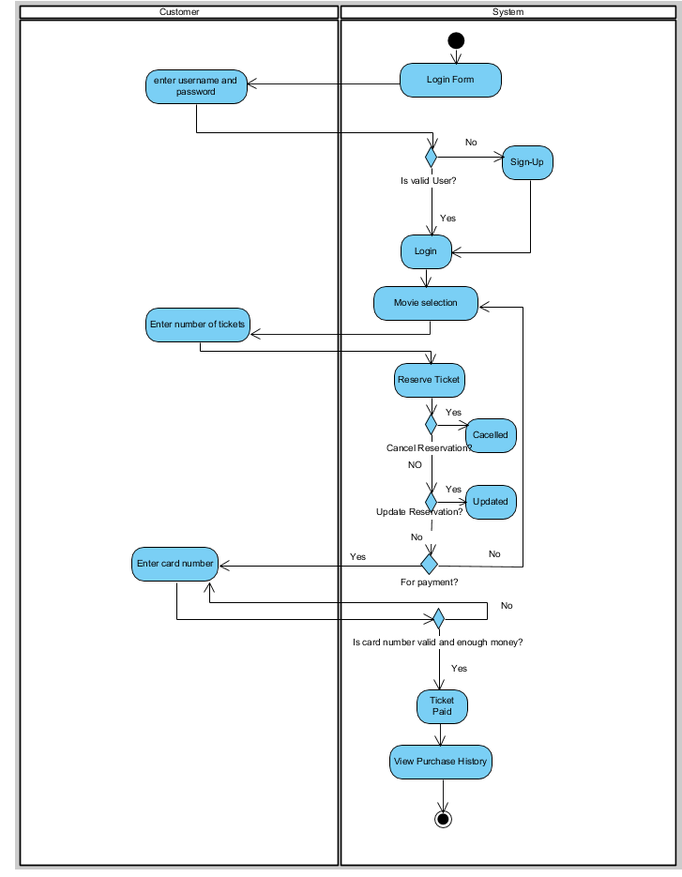

**Conceptual Class Diagram**

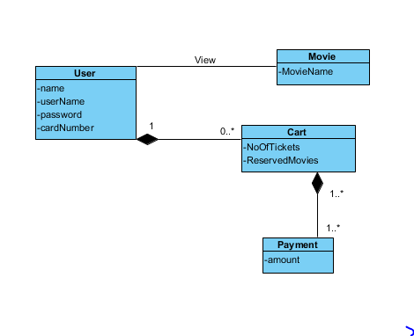

**Detailed Class Diagram**

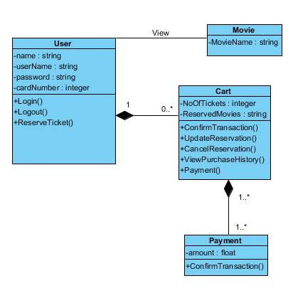

**VI. PRESENTATION OF THE DEVELOPED SYSTEM**

.

*Discuss your figure…*

Fig. 3 Title

*Discuss your figure…*

Fig. 4 Titll