Matthew Mendoza

CSC 174 - Advanced Database Management Systems

Dr. Yin Jin

March 3, 2023

Assignment 3

Table of Contents

Create Table Statements 2

Student Table 2

TA Table 2

Course Table 2

Enrolled Table 3

Instructor Table 3

Classroom Table 3

OnlineCourse Table 3

InPersonCourse Table 4

Populate Database - Insert Statements 4

Create Data Entries for Table Students 4

Create Data Entries for Table TAs 5

Create Data Entries for Table Courses 6

Create Data Entries for Table Enrolled 7

Create Data Entries for Table Instructors 9

Create Data Entries for Table Classrooms 10

Create Data Entries for Table OnlineCourses 10

Create Data Entries for Table InPersonCourses 11

CREATE VIEWS 12

TAView 12

OnlineView 12

InPersonCourseView 13

Drop View and Table 14

Initial Setup – self reference for future assignments 14

# Create Table Statements

## Student Table

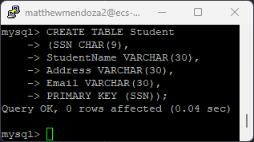

## TA Table

## Course Table

## Enrolled Table

## Instructor Table

## Classroom Table

## OnlineCourse Table

## InPersonCourse Table

# Populate Database - Insert Statements

## Create Data Entries for Table Students

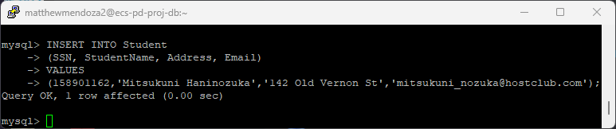

## Create Data Entries for Table TAs

## Create Data Entries for Table Courses

## Create Data Entries for Table Enrolled

## Create Data Entries for Table Instructors

## Create Data Entries for Table Classrooms

## Create Data Entries for Table OnlineCourses

## Create Data Entries for Table InPersonCourses

# CREATE VIEWS

## TAView

## OnlineView

## InPersonCourseView

# Drop View and Table

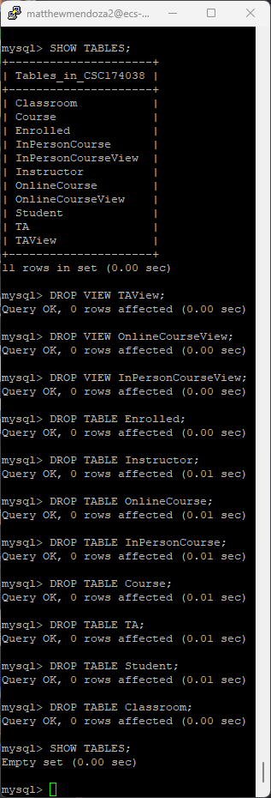

# Initial Setup – self reference for future assignments

1. VPN, GlobalProtect, to the campus network using your SacLink account.
2. Use SSH to connect to the server. Type “**ecs-pd-proj-db.ecs.csus.edu**” as the host name.
   1. **If using MacOS:** ssh saclinkUserName@ ecs-pd-proj-db.ecs.csus.edu
3. Enter your SacLink user name and password
4. Then type the following command: mysql -h ecs-pd-proj-db.ecs.csus.edu -u dbUserName -p
   1. Use your professor assigned dbUserName; for example,  
      mysql -h ecs-pd-proj-db.ecs.csus.edu -u CSC123456 -p
5. Enter your professor assigned password
   1. **For example**: Csc134_123456789
6. Enter: use [provided dbUserName]
   1. **For example**  
      mysql> use CSC123456  
      Database changed  
      Text

      Description automatically generated