|  |  |
| --- | --- |
| **ML Model** | **Accuracy on Test Set in Percent** |
| Naive Bayes | 78 |
| KNN | 80 |
| SVM | 80 |
| DT | 84 |
| Logit | 80 |

See “assignment03_part_3_Classification_Models_ian_schultz.ipynb” to see how the above percentages were computed.

Some graphs:

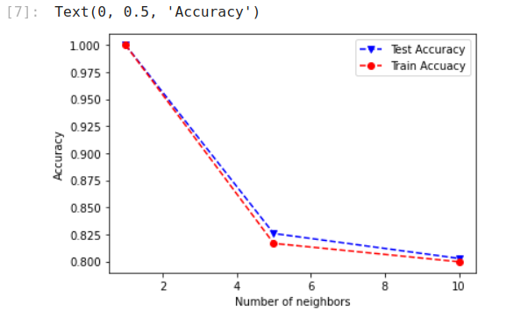How accuracy changes based on number of neighbors:

Interpretation:   
The accuracy is high with 1 neighbor because of the small sample size. Basically, these two graphs being similar shows that the test/train split was not egregious. The split did not adversely affect the training.  
----

The decision tree:

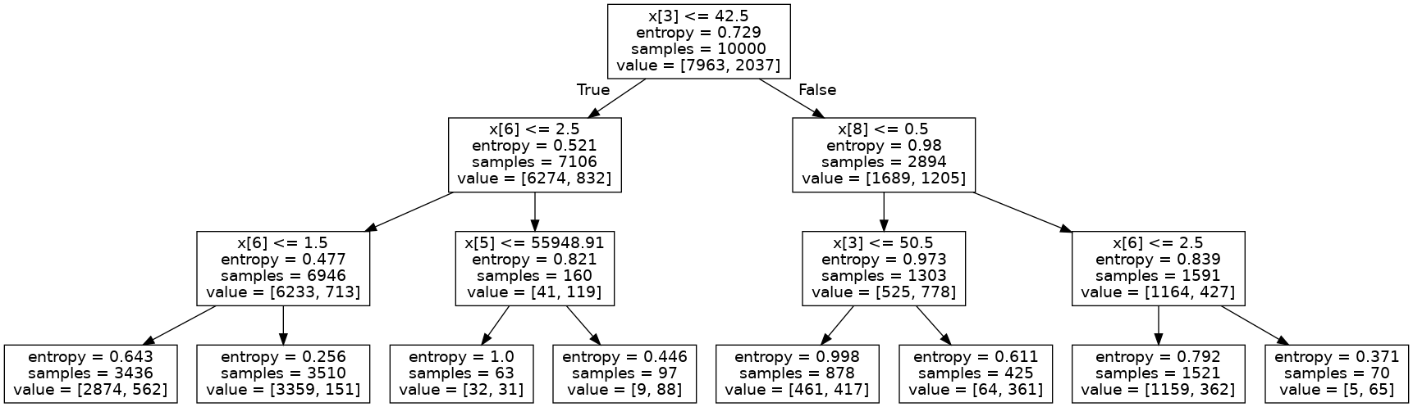

Based on our accuracy analysis, following this tree leads to the right categorization around 80% of the time, depending on the model.

The below graph (notice the y axis) shows that the test and train accuracy differences were not significant. This implies that the dataset was not split in a way that decreases the effectiveness of training.

