CSUS
COLLEGE OF ENGINEERING AND COMPUTER SCIENCE
Department of Computer Science

CSc/CpE 138 Computer Networks and Internets

Chapter #1 (Intro to Computer Networks)
Do the following problems in Chapter 1 of Kurose and Ross Text

Q1 (R4) List six access technologies. Classify each one as home access, enterprise
Access, or wide-area wireless access

Q2 (R12) what advantage does a circuit-switched network have over a packet-switched network?

Q3 (R23). List the 5 layers in the Internet protocol stack? What are the principal responsibilities of each of these layers?

Q4
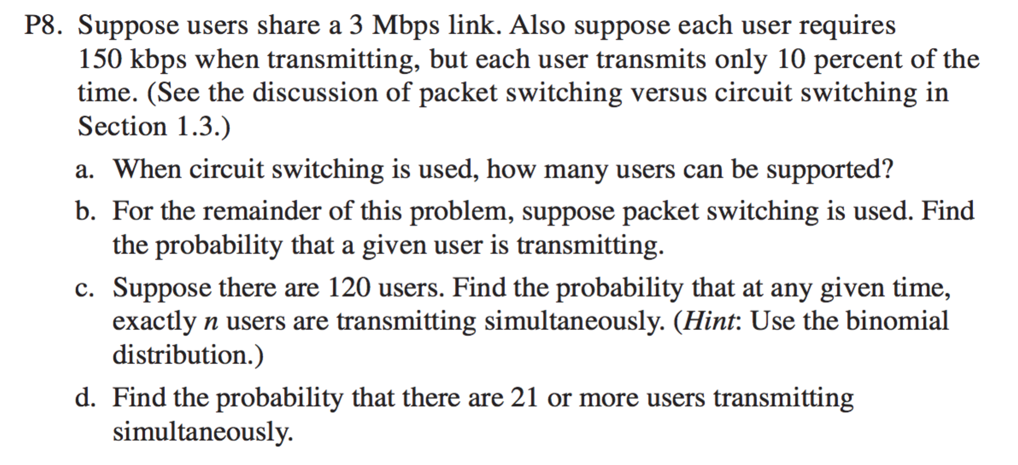

Q5
