Group_Subquery

1) Display the first name of all the candidates who are Democrats. (use subquery)
SELECT fname FROM mendoza_candidate
WHERE partyid = (SELECT partyid FROM mendoza_party WHERE partydesc = 'Democrat');

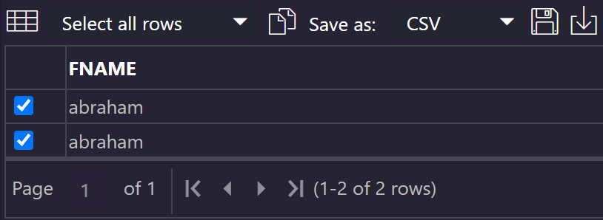
2) Display the party description of the all the candidates whose last name ends with ‘C’ regardless of case. (Use subquery)
SELECT partydesc FROM mendoza_party WHERE partyid IN
(SELECT partyid FROM mendoza_candidate WHERE LOWER(lname) like '%c');

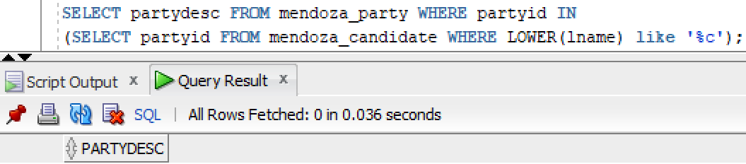

3) Display the first name of all the candidates who are either Democrats or Republicans regardless of case. (use subquery, use in clause)
SELECT fname FROM mendoza_candidate WHERE partyid IN
(SELECT partyid FROM mendoza_party WHERE partyid = '1' OR partyid = '2');

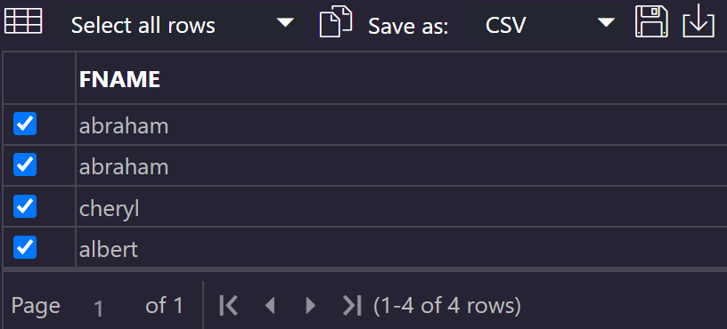
4) Create a second table called candidate2 that contains all the data from the candidate table using create table as… statement. The new table should contain only the first name, lastname and the salary, lowered by 10% for all the candidates who are Republicans
Create Table mendoza_candidate2 AS (SELECT fname, lname , salary- salary*0.1 AS salary
FROM mendoza_candidate INNER JOIN Party ON Party.partyid = mendoza_candidate.partyid
WHERE partyDesc = 'Republican');

