Contracts week 11 class 11/09/26

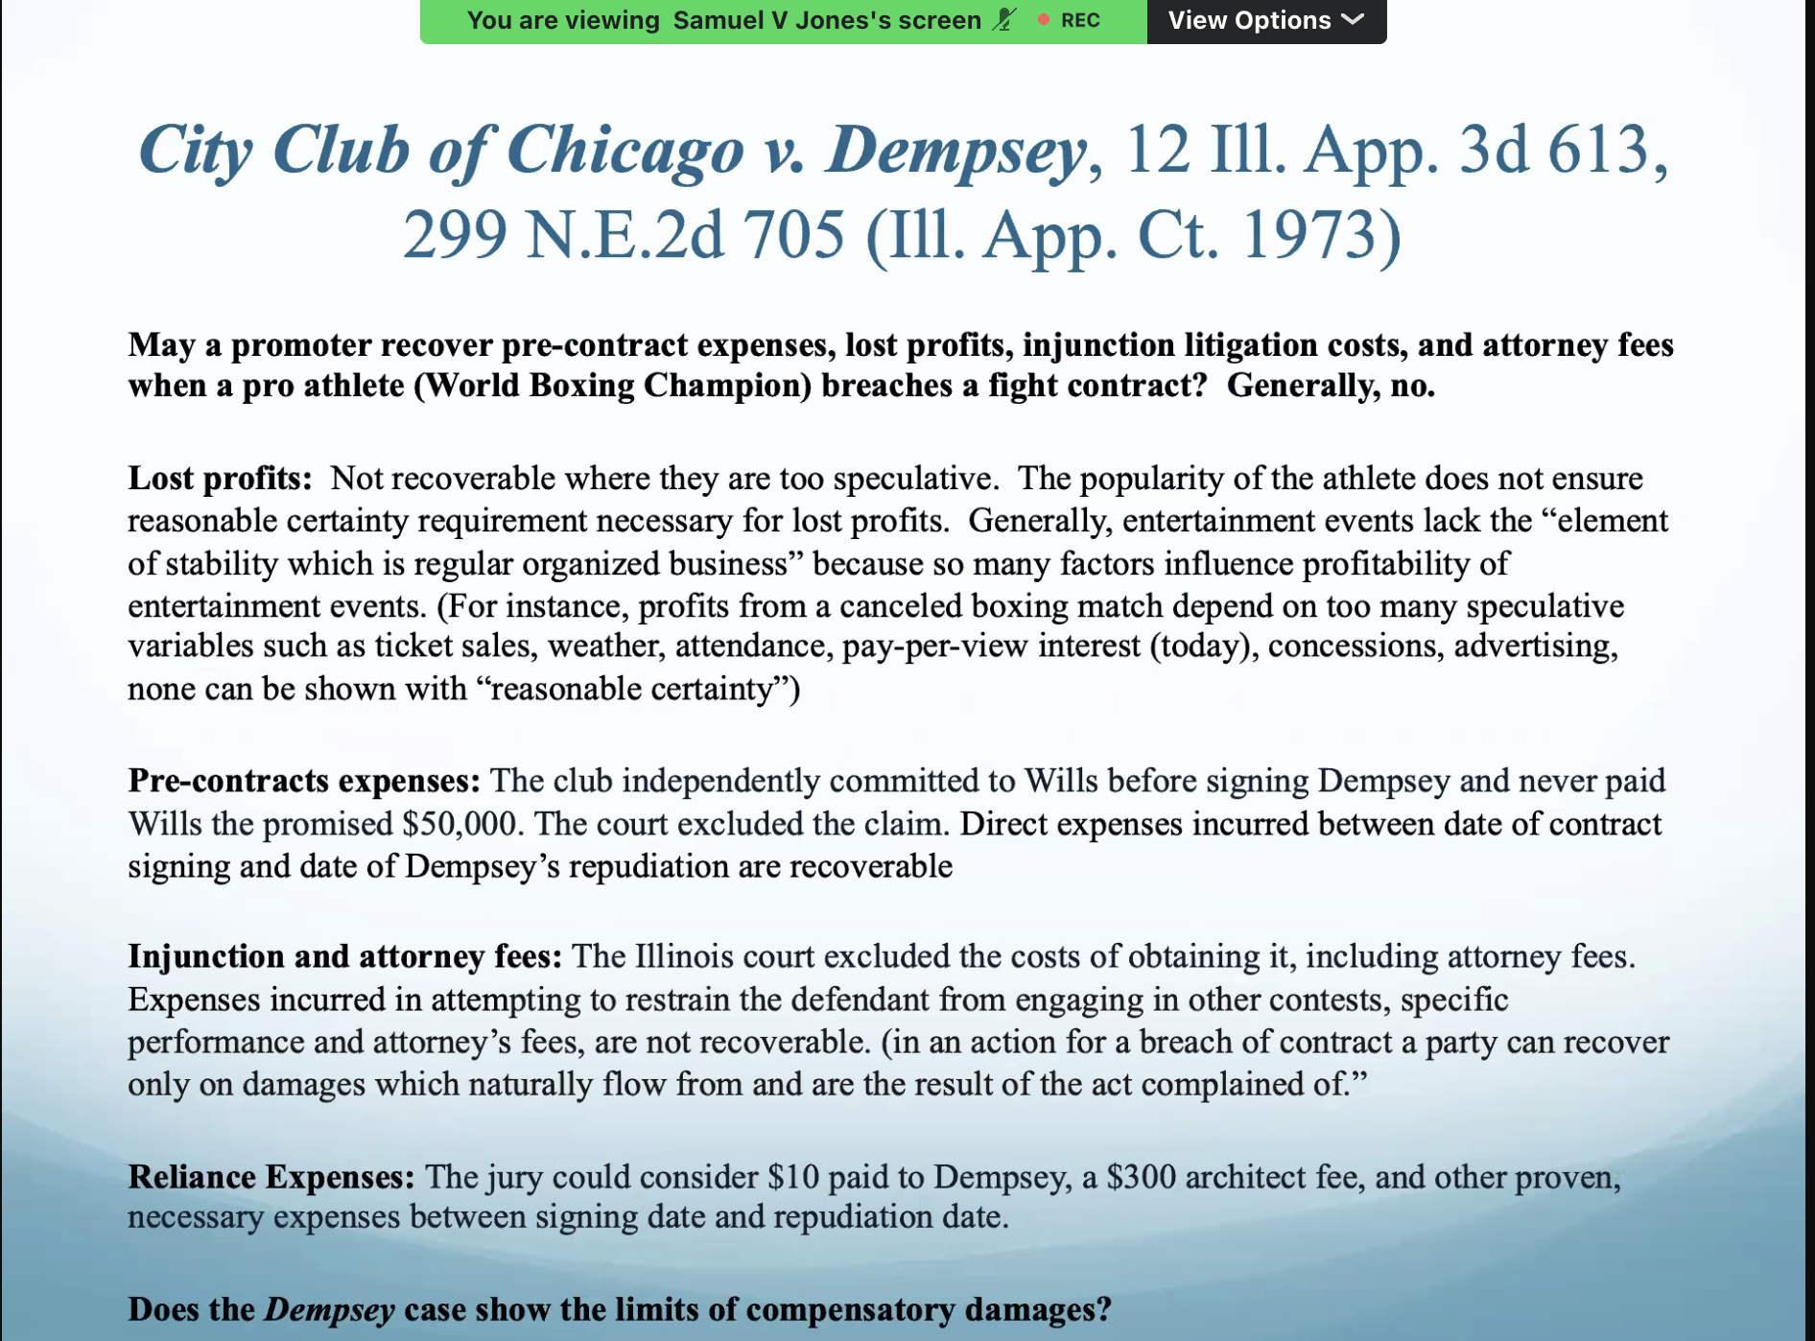
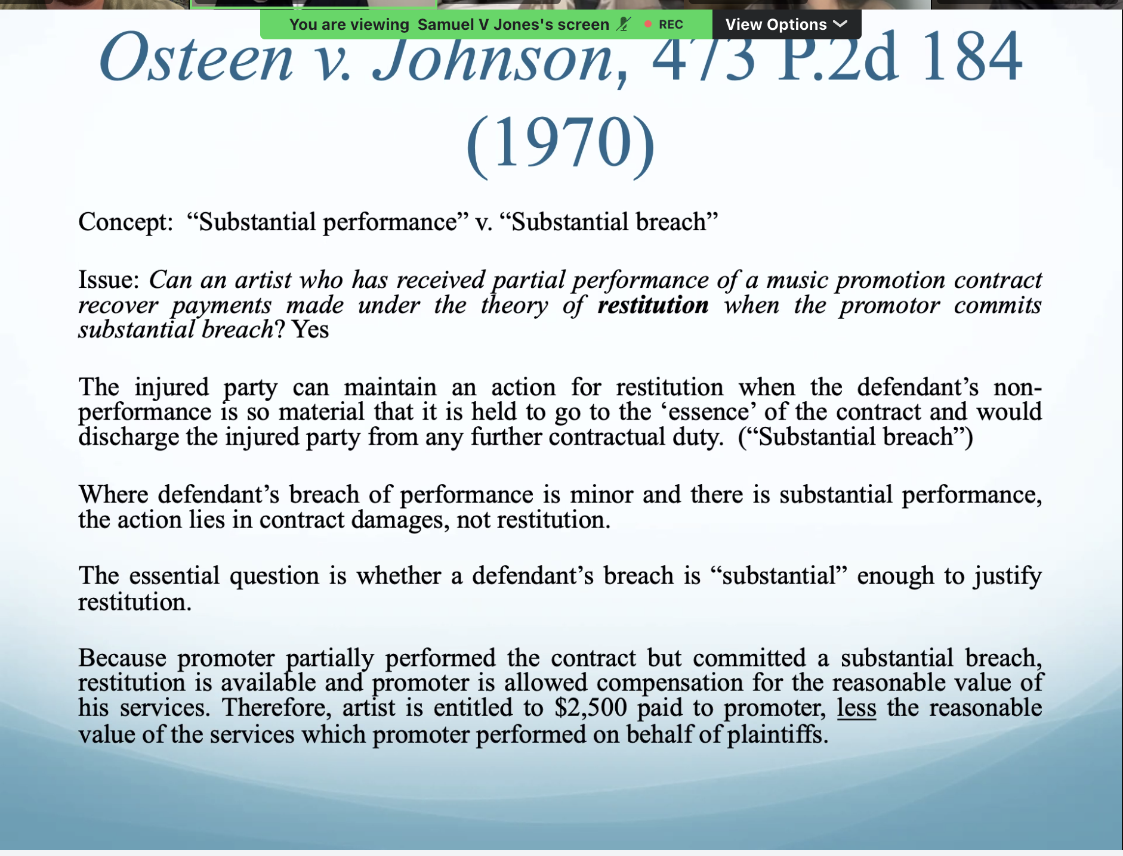
Substantial performance or substantial breach—because they had performed, there were benefits conferred on both sides. Heart of the contract, what the contract was intended to achieve. When the defendants non performance so material that it is held to go to the essence. Why purpose of contract went into effect. Rule of restitution.
Substantial performance v. substantial breach
You can’t recover restitution unless you have a total breach.
If there’s been substantial performance in can’t coexist with a total breach.
Substantial breach and minor breach-action in damages NOT RESTITUTION.
I give you a breach, and there’s been substantial performance, so not a total breach, but they’re not entitled to restitution. BRING THIS UP IN CLAUDE. Have them include this one.

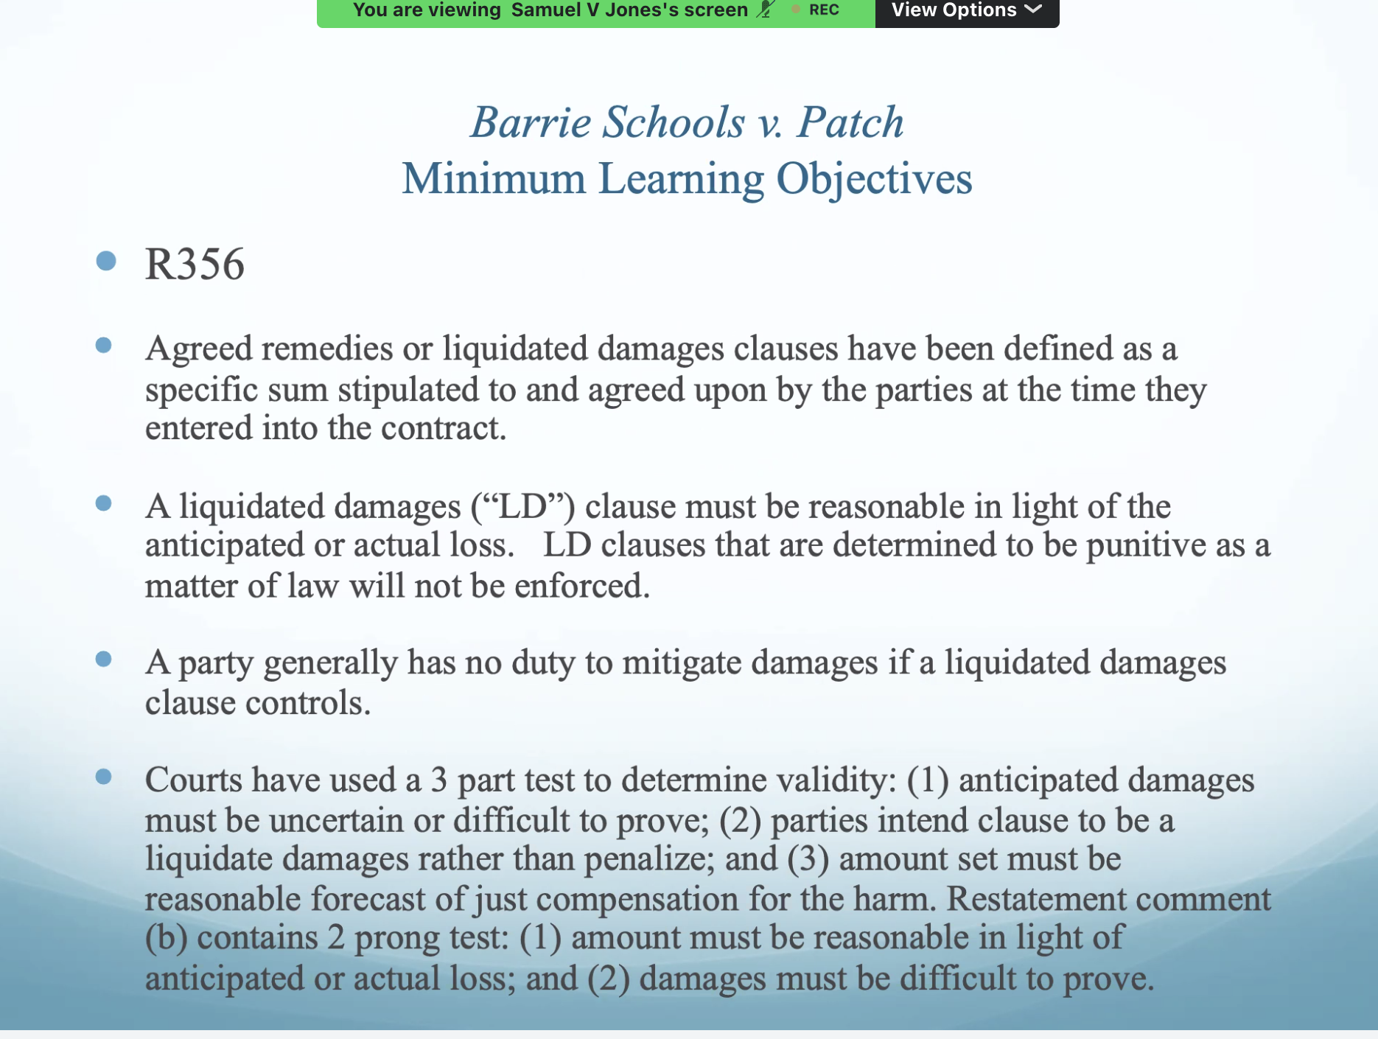
Enforceability of liquidated damages clause-court find damages are difficult to prove. Calculating damages for the court, would be difficult, and the liquidated damages clause and designed to compensate the injured party, rather than operate as a penalty. The clause is not punitive. Simply to compensate the injured party that is agreed upon by the injured party.

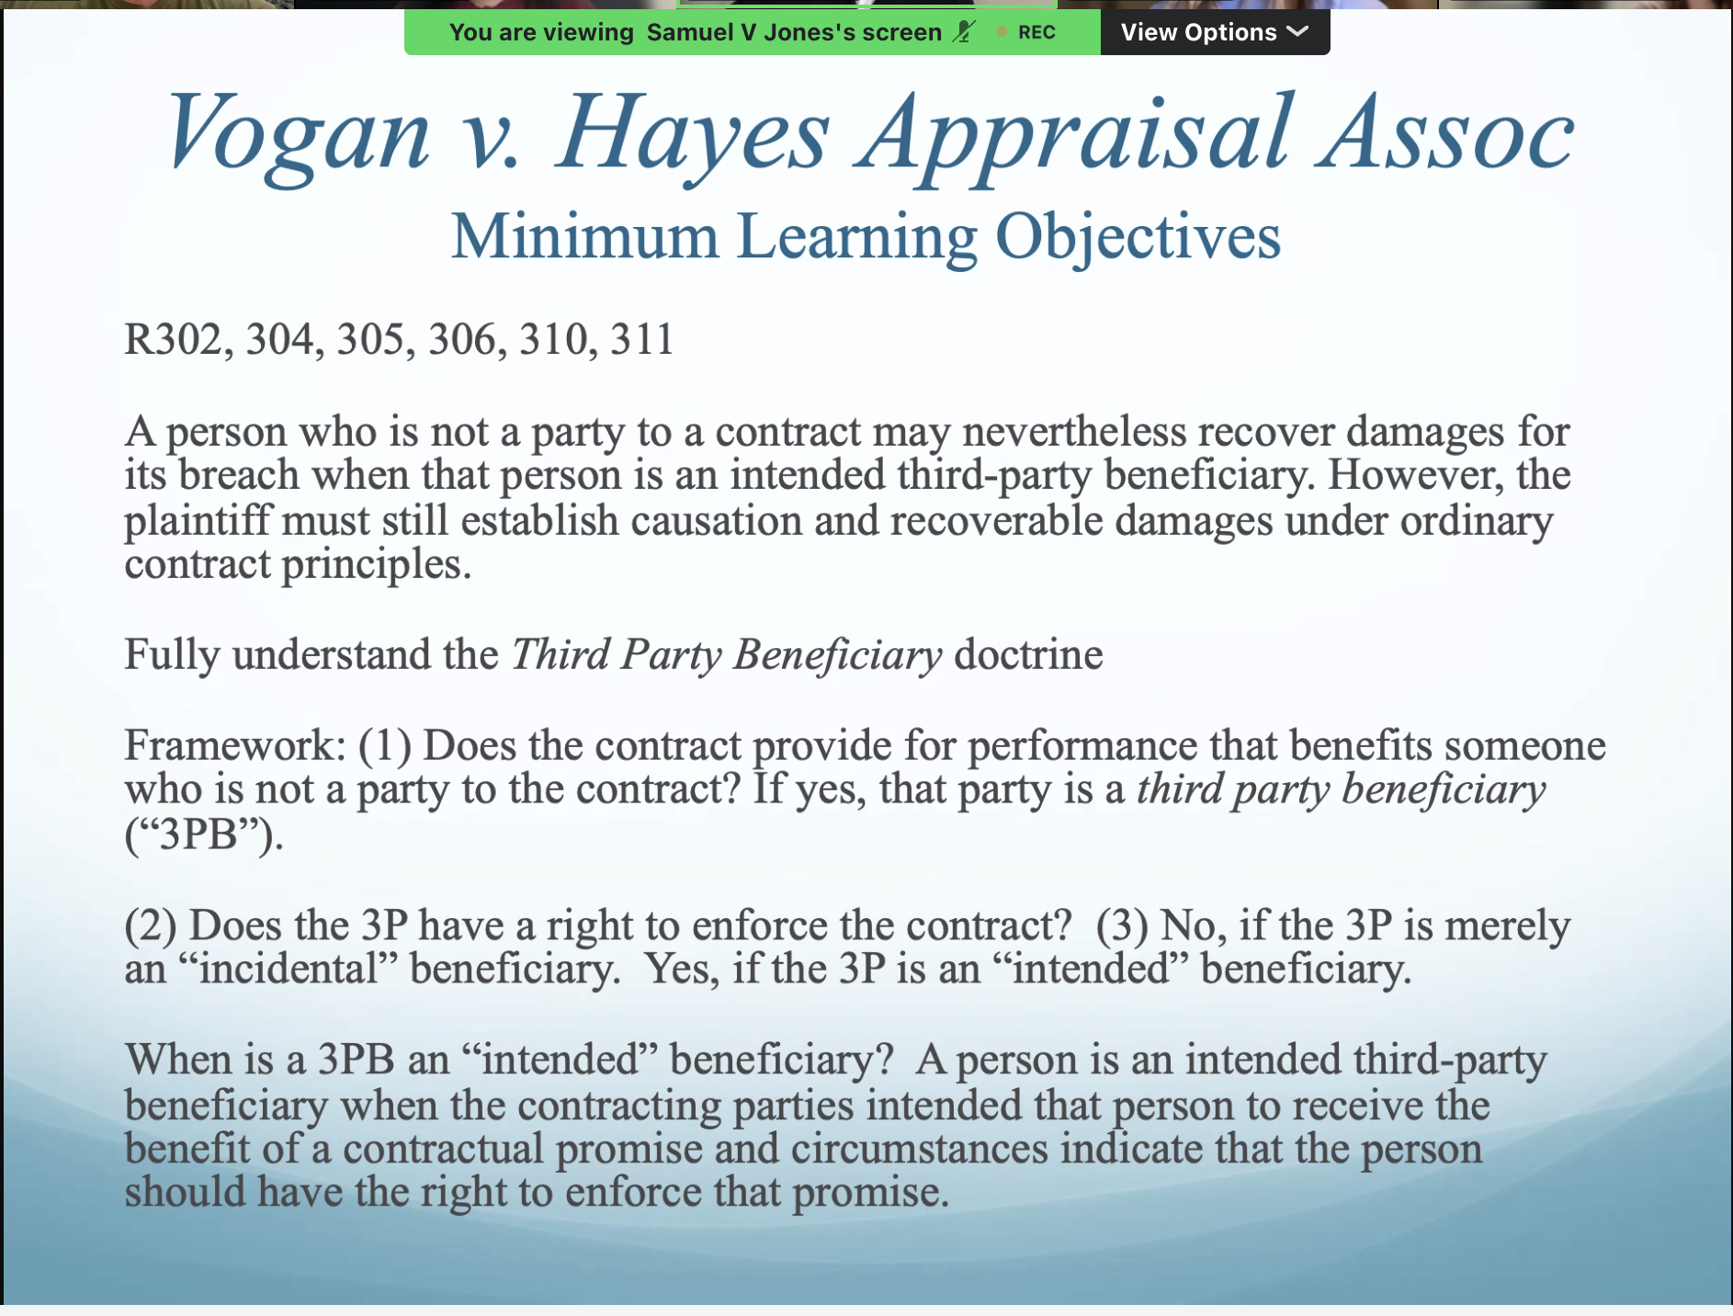
Established third party beneficiary-Vogans.
Inaccurate reports directly caused them to lose the money they did.
Damages which they are seeking are actually recoverable. No speculative lost profits involved.
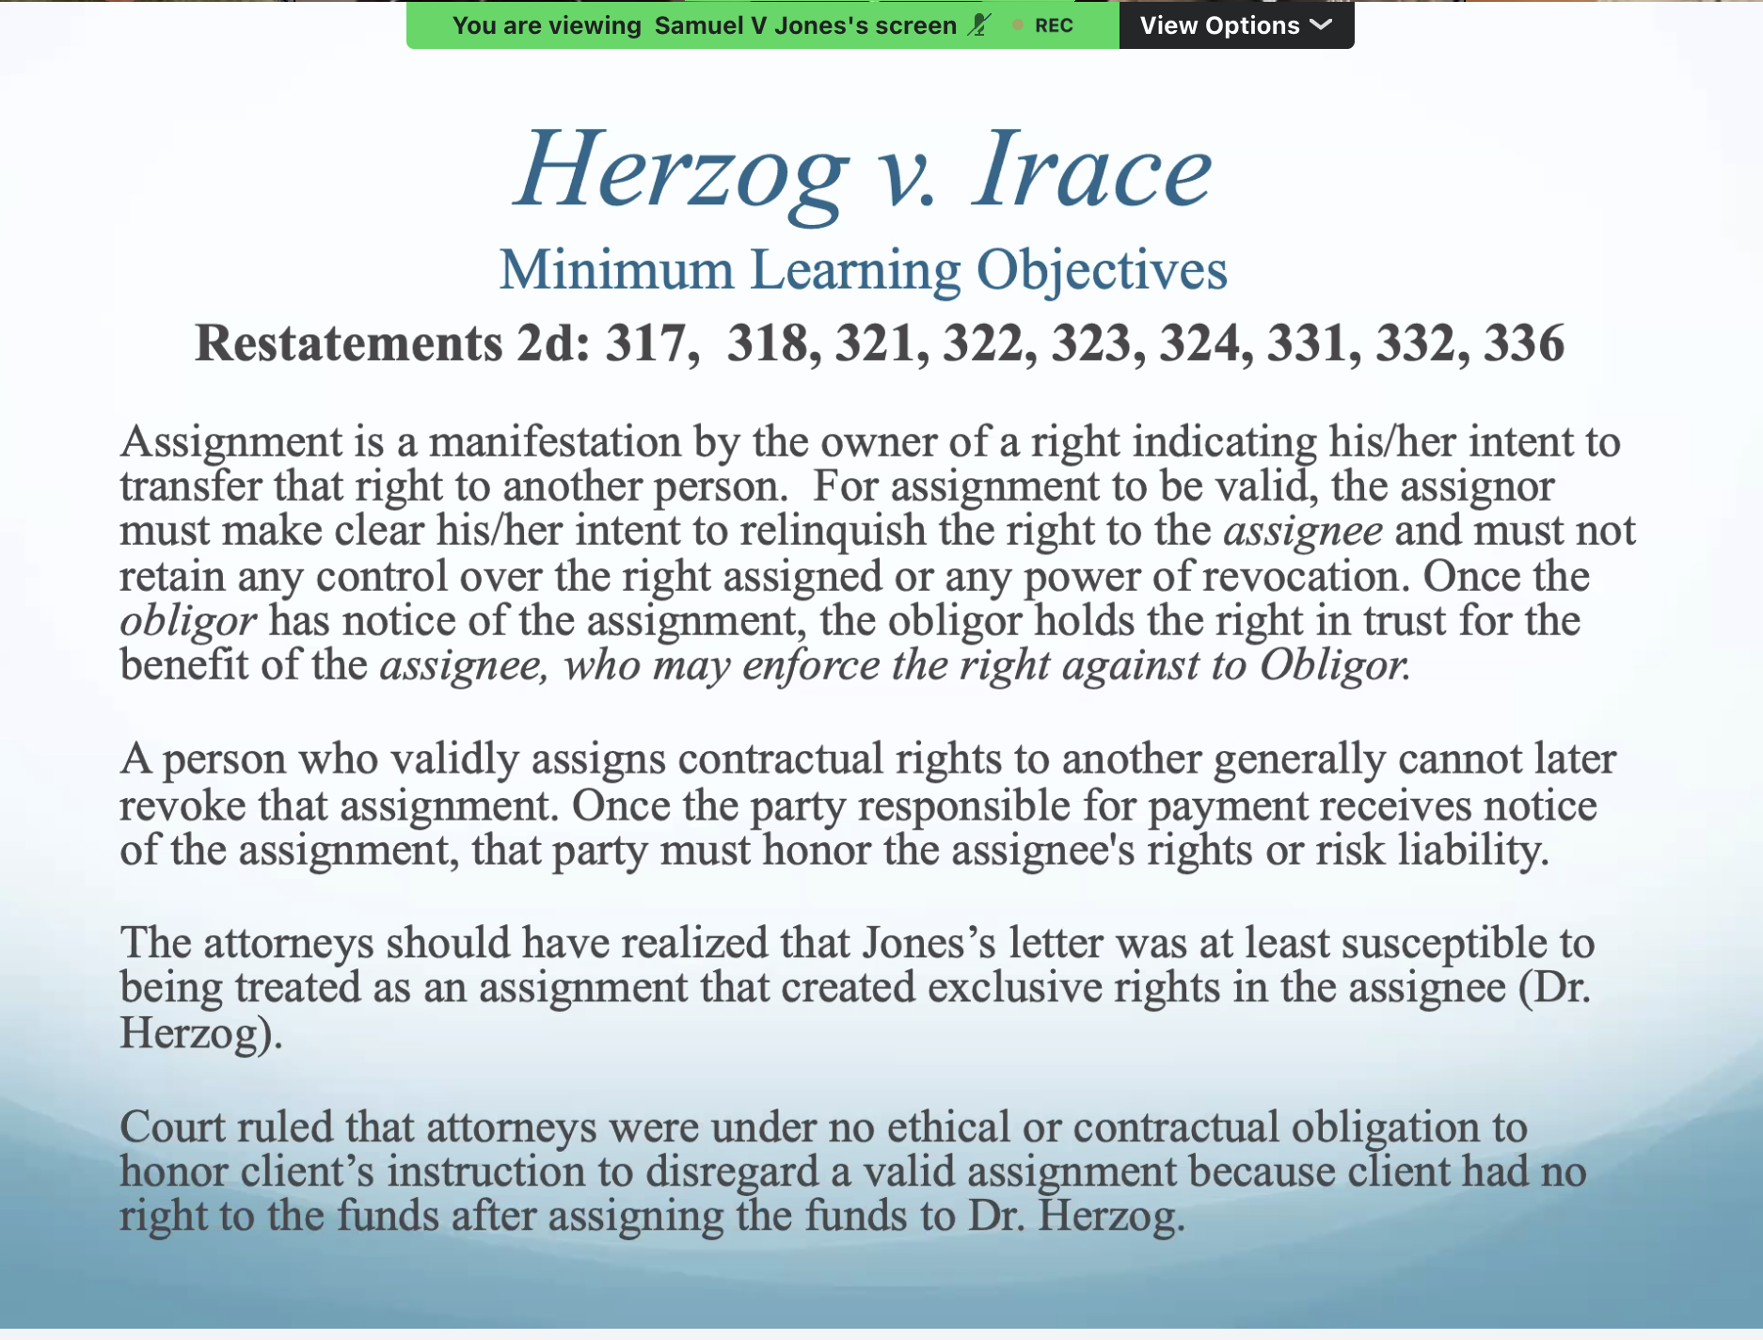
The letter was effective assignment, once the letter is sent, it’s an effective assignment and can’t be revoked.
Ethical obligation if it was enforceable- lawyer had to honor the terms of the assignment. In and of itself it was a legal obligation.
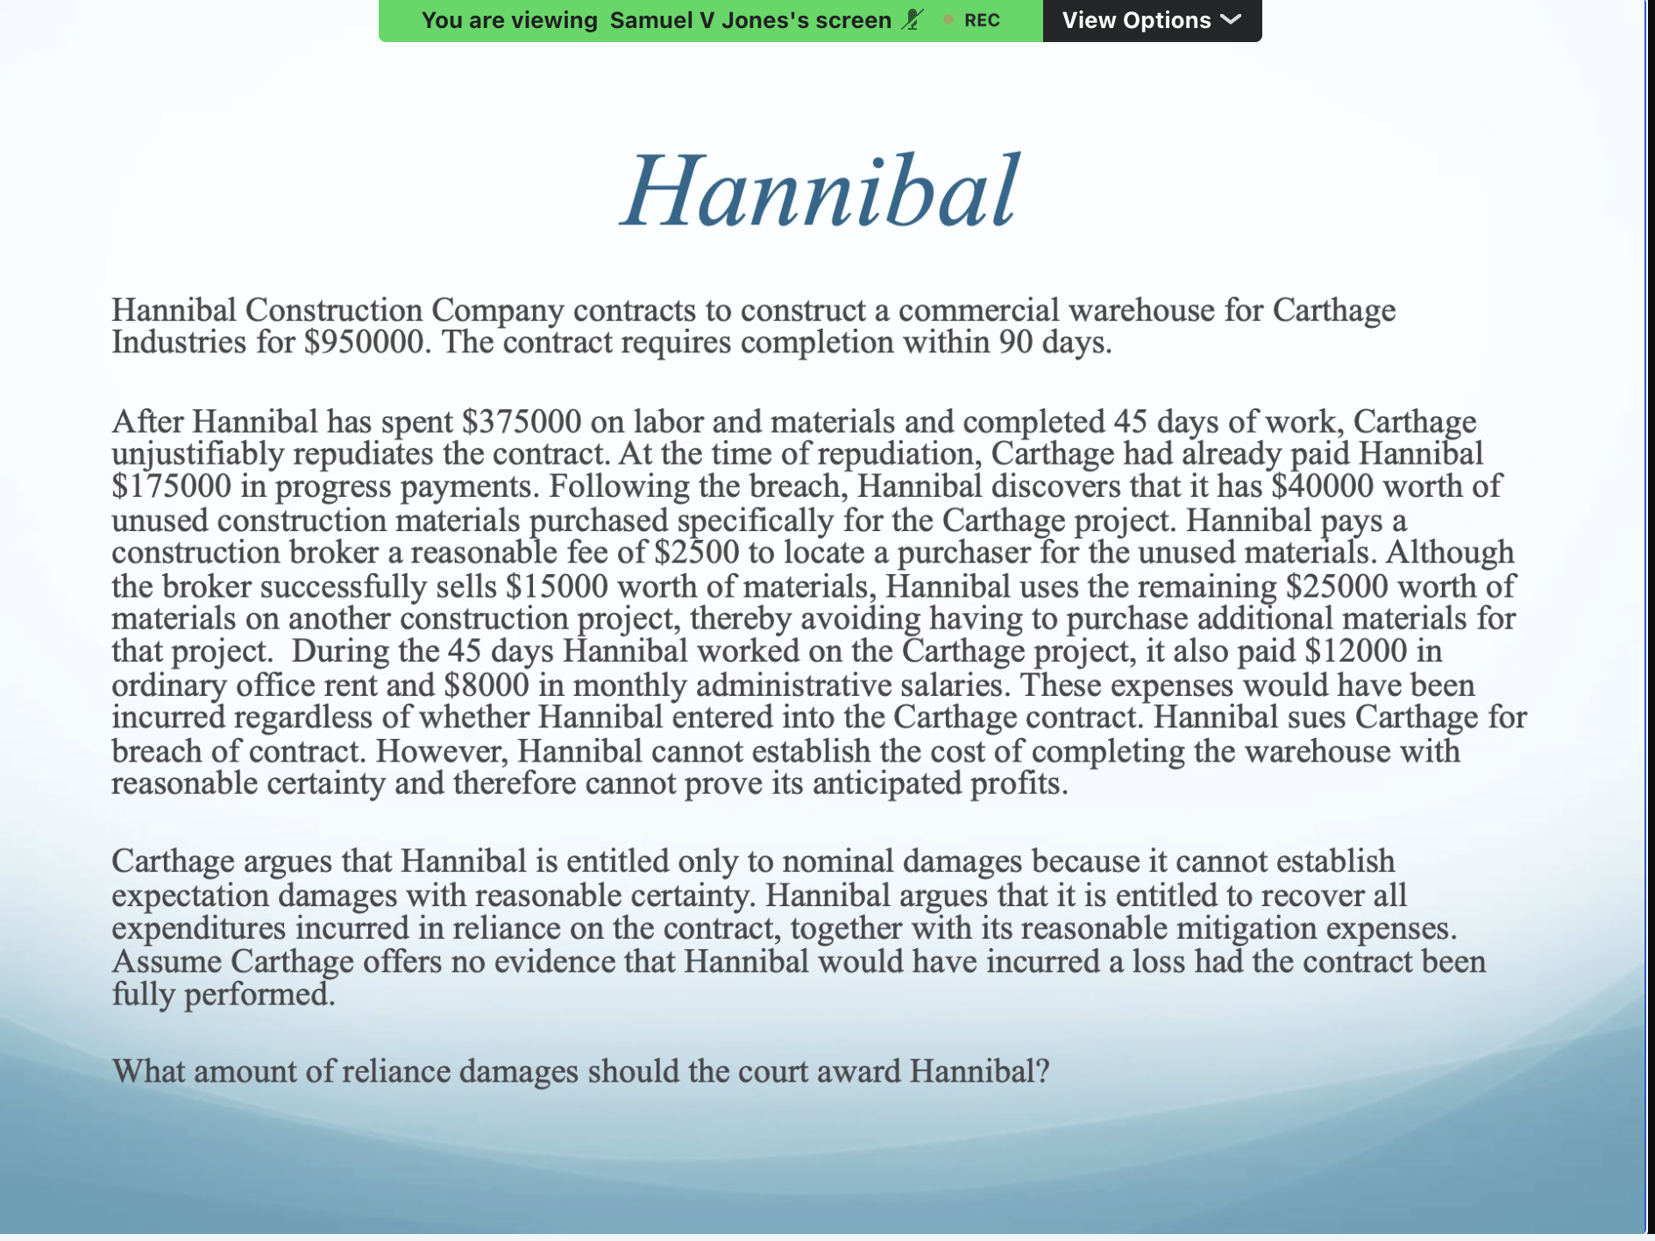
$162,500-reliance damages
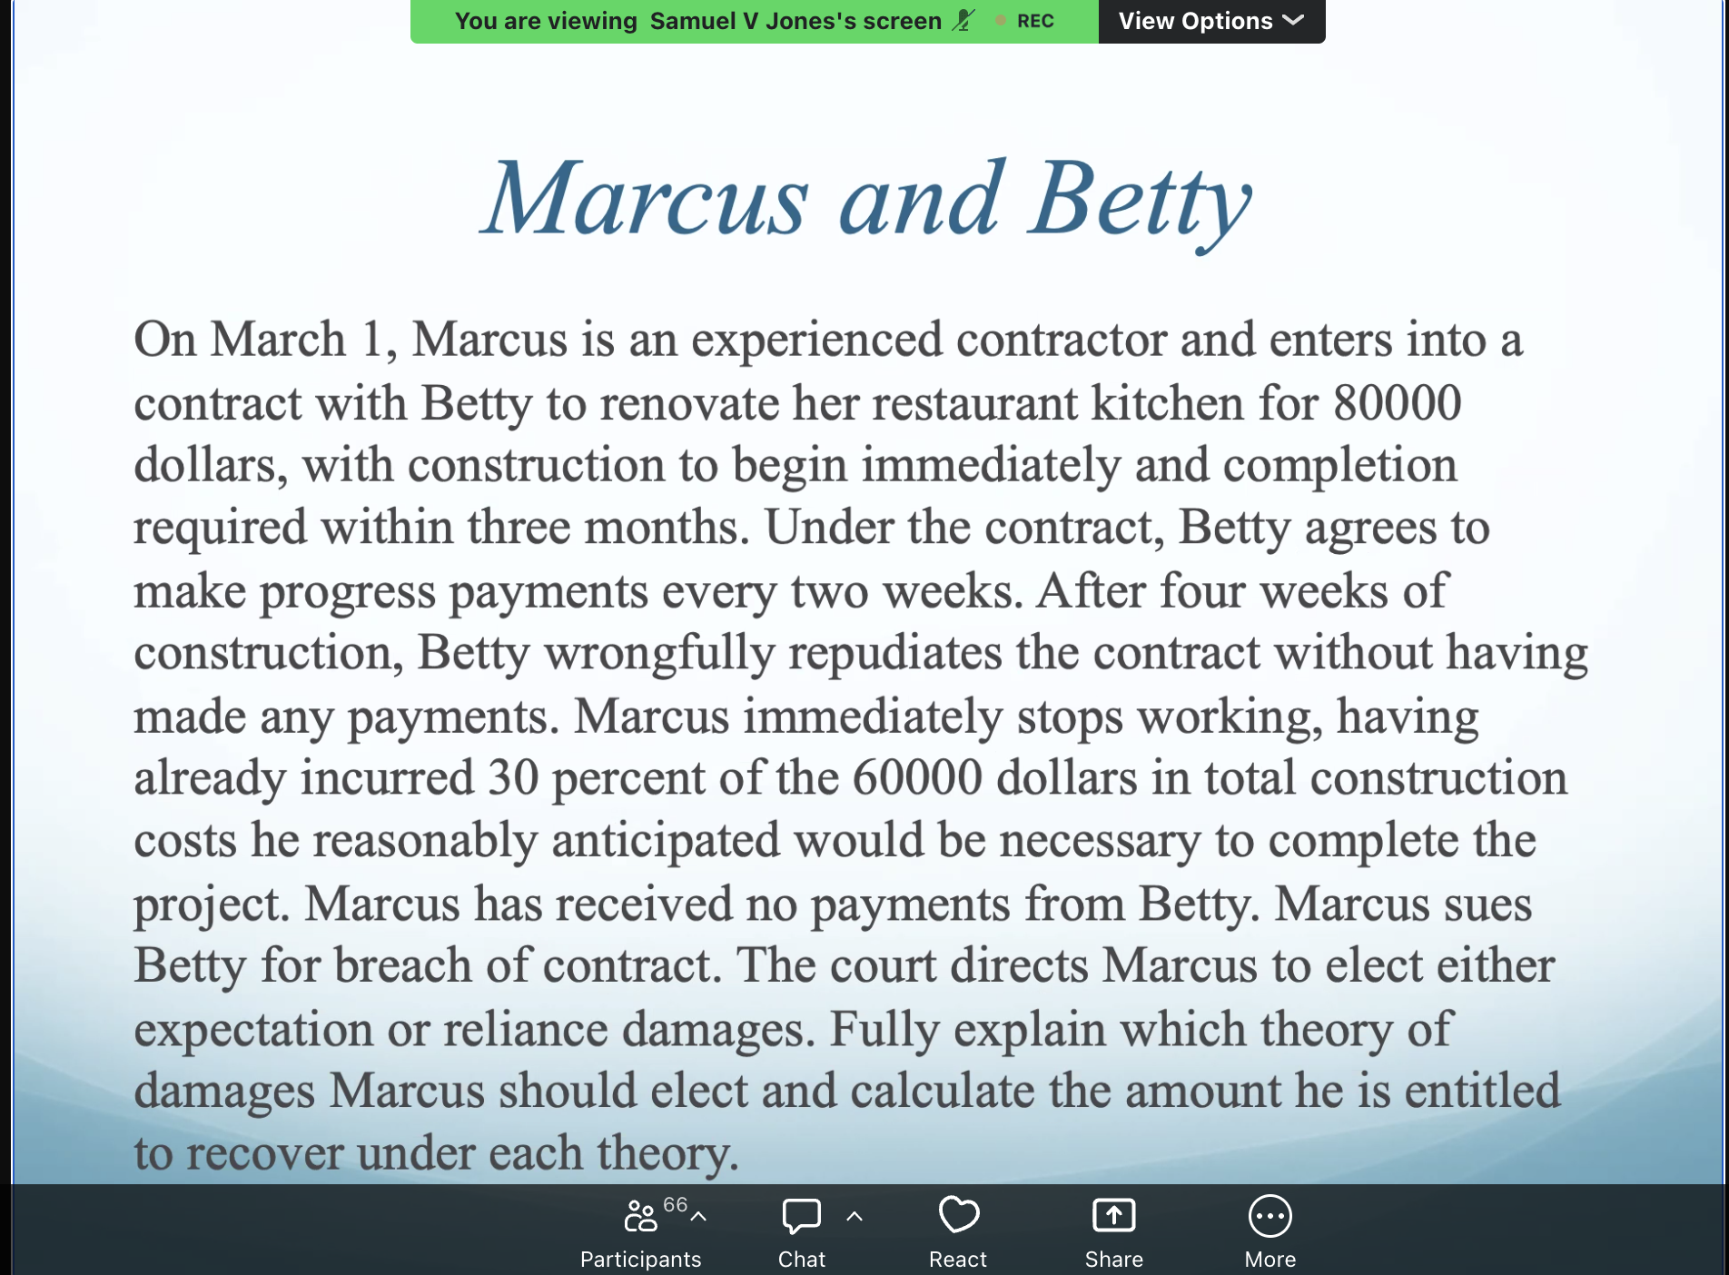
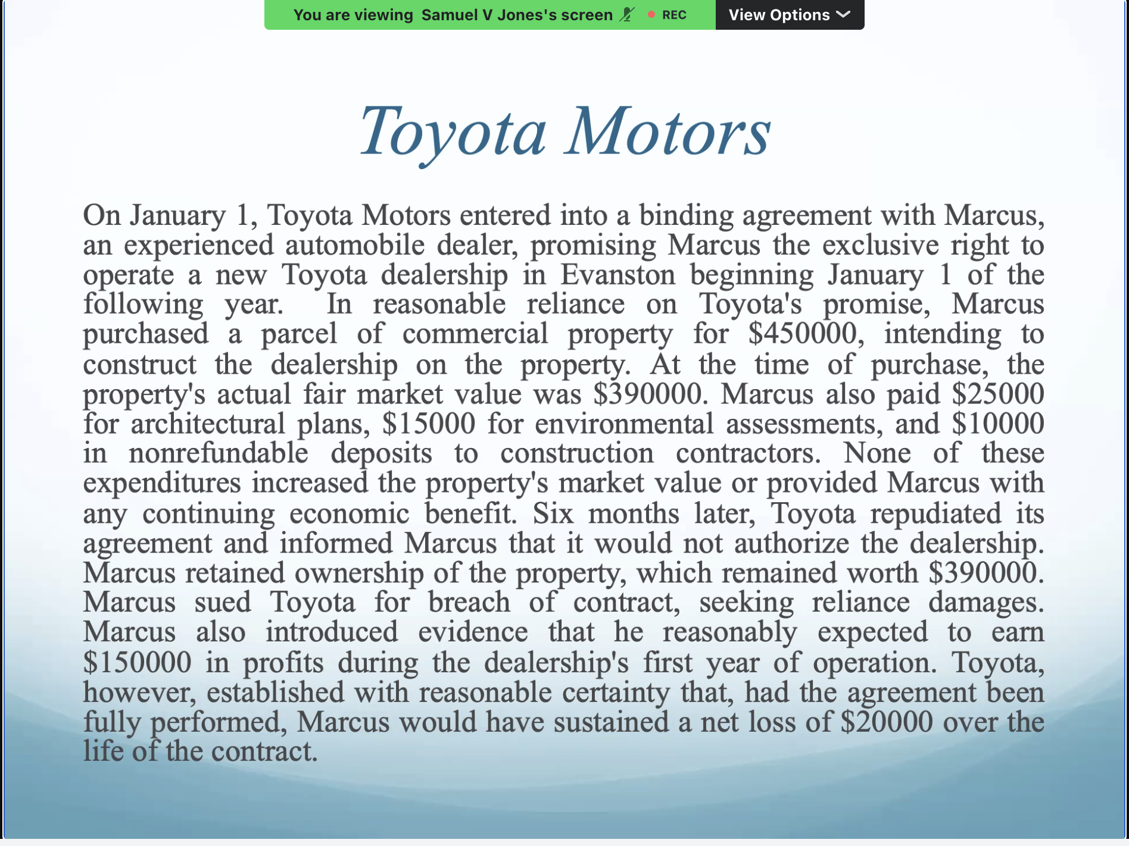
Total breach allows for restitution
Substantial performance doesn’t allow for restitution.
Predominantly damages question, 1 or two beneficiary assignment questions.
He’s not going to test liquidated damages and specific damages on midterm III
10 of the questions on expectation, reliance, restitution, 2-3 will be on assignment.
Specific performance will ONLY be on final.
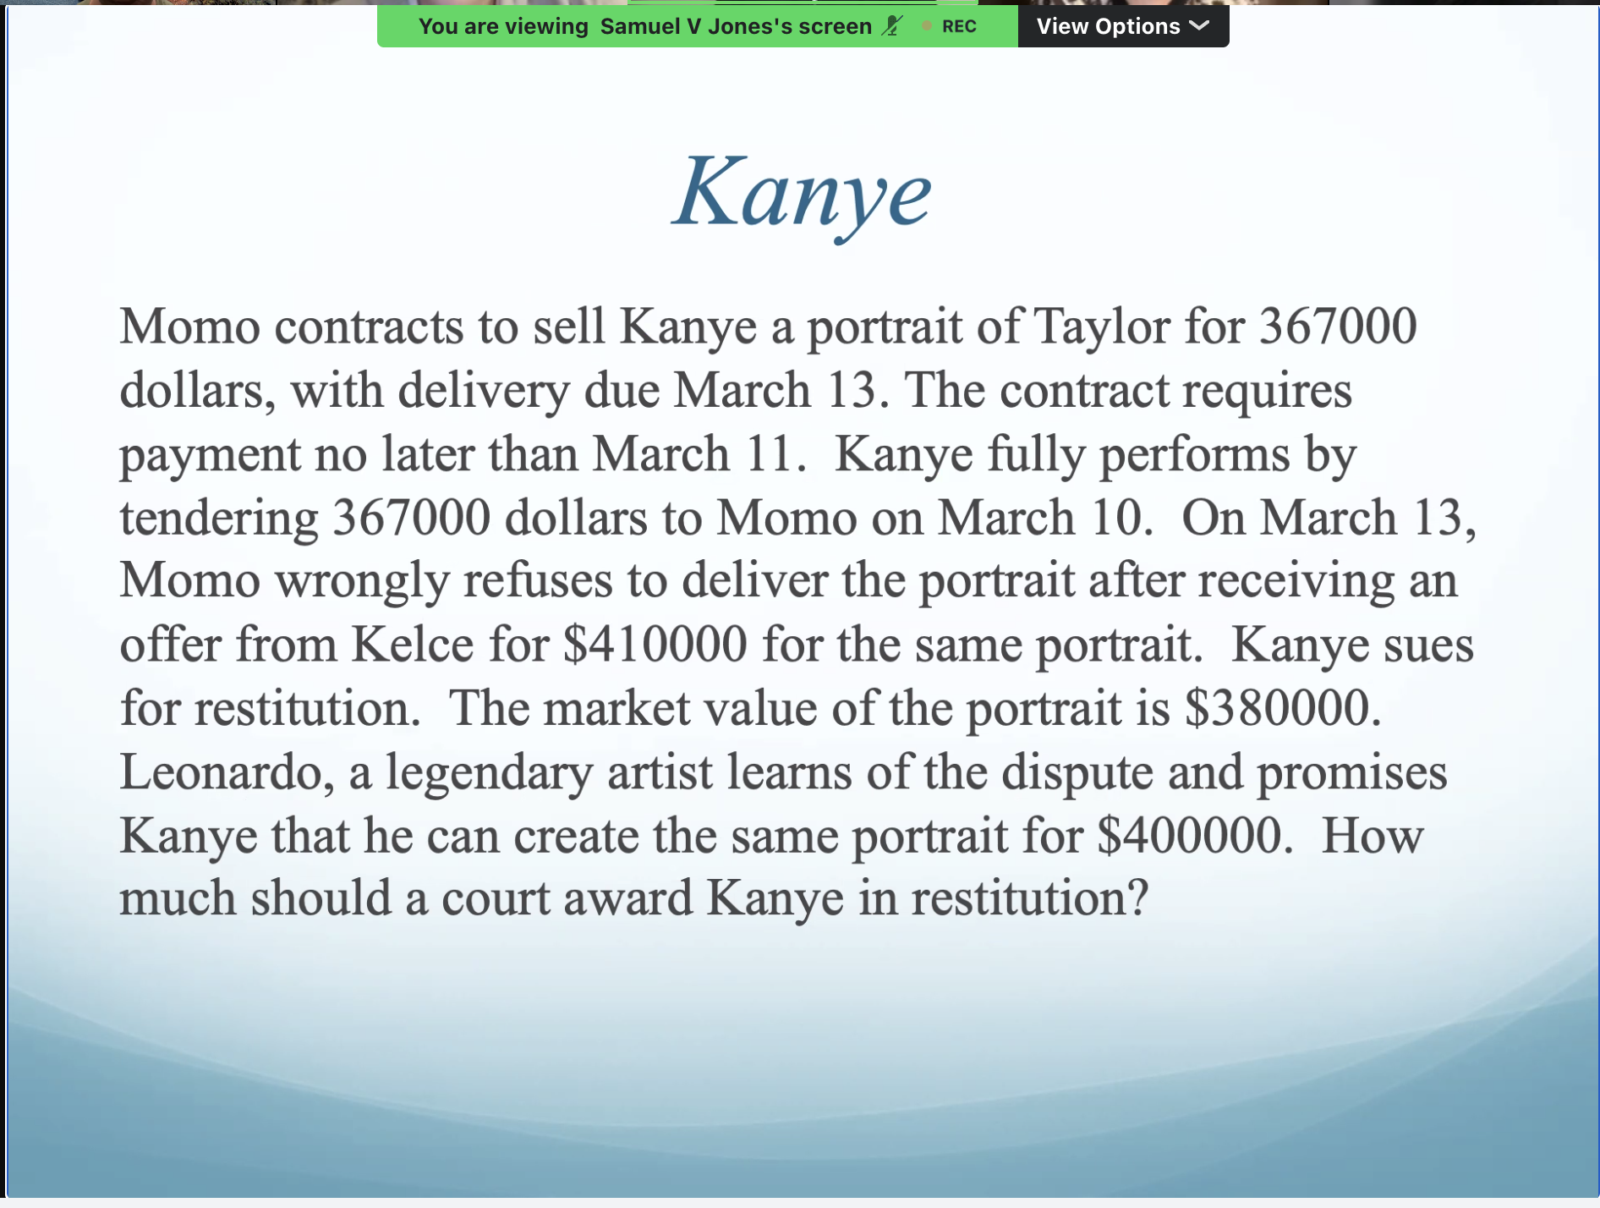
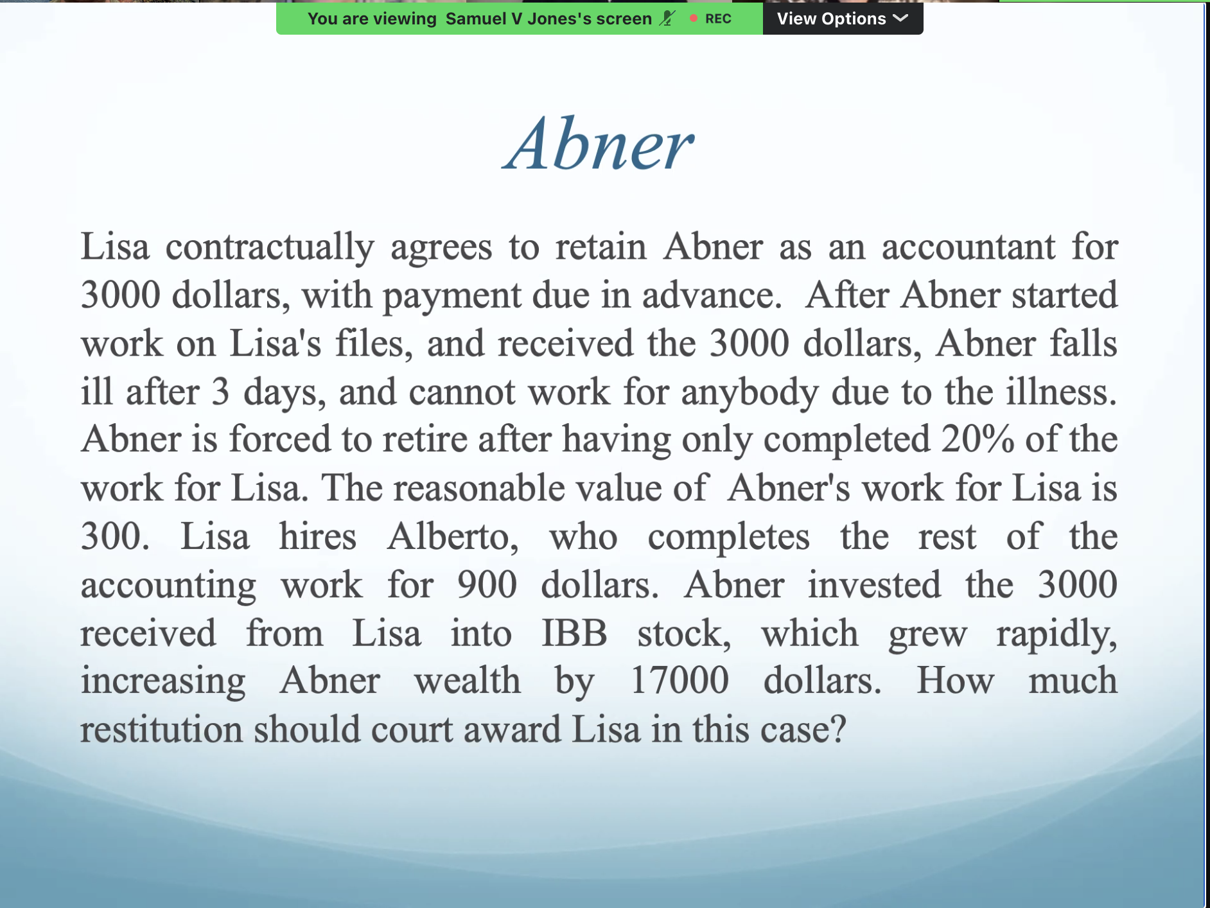
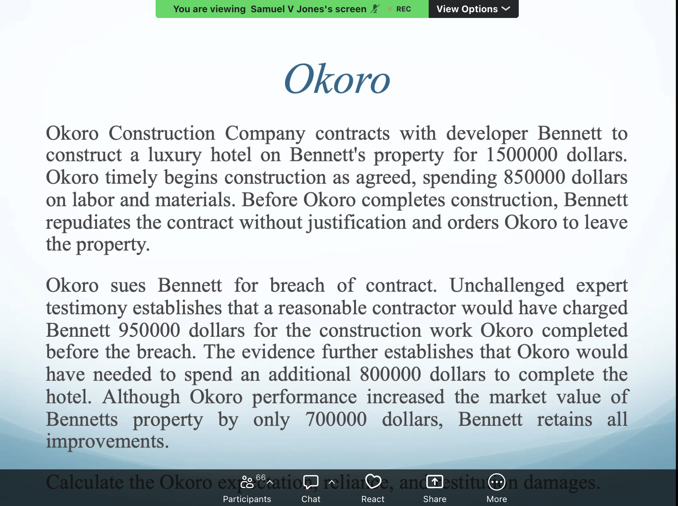

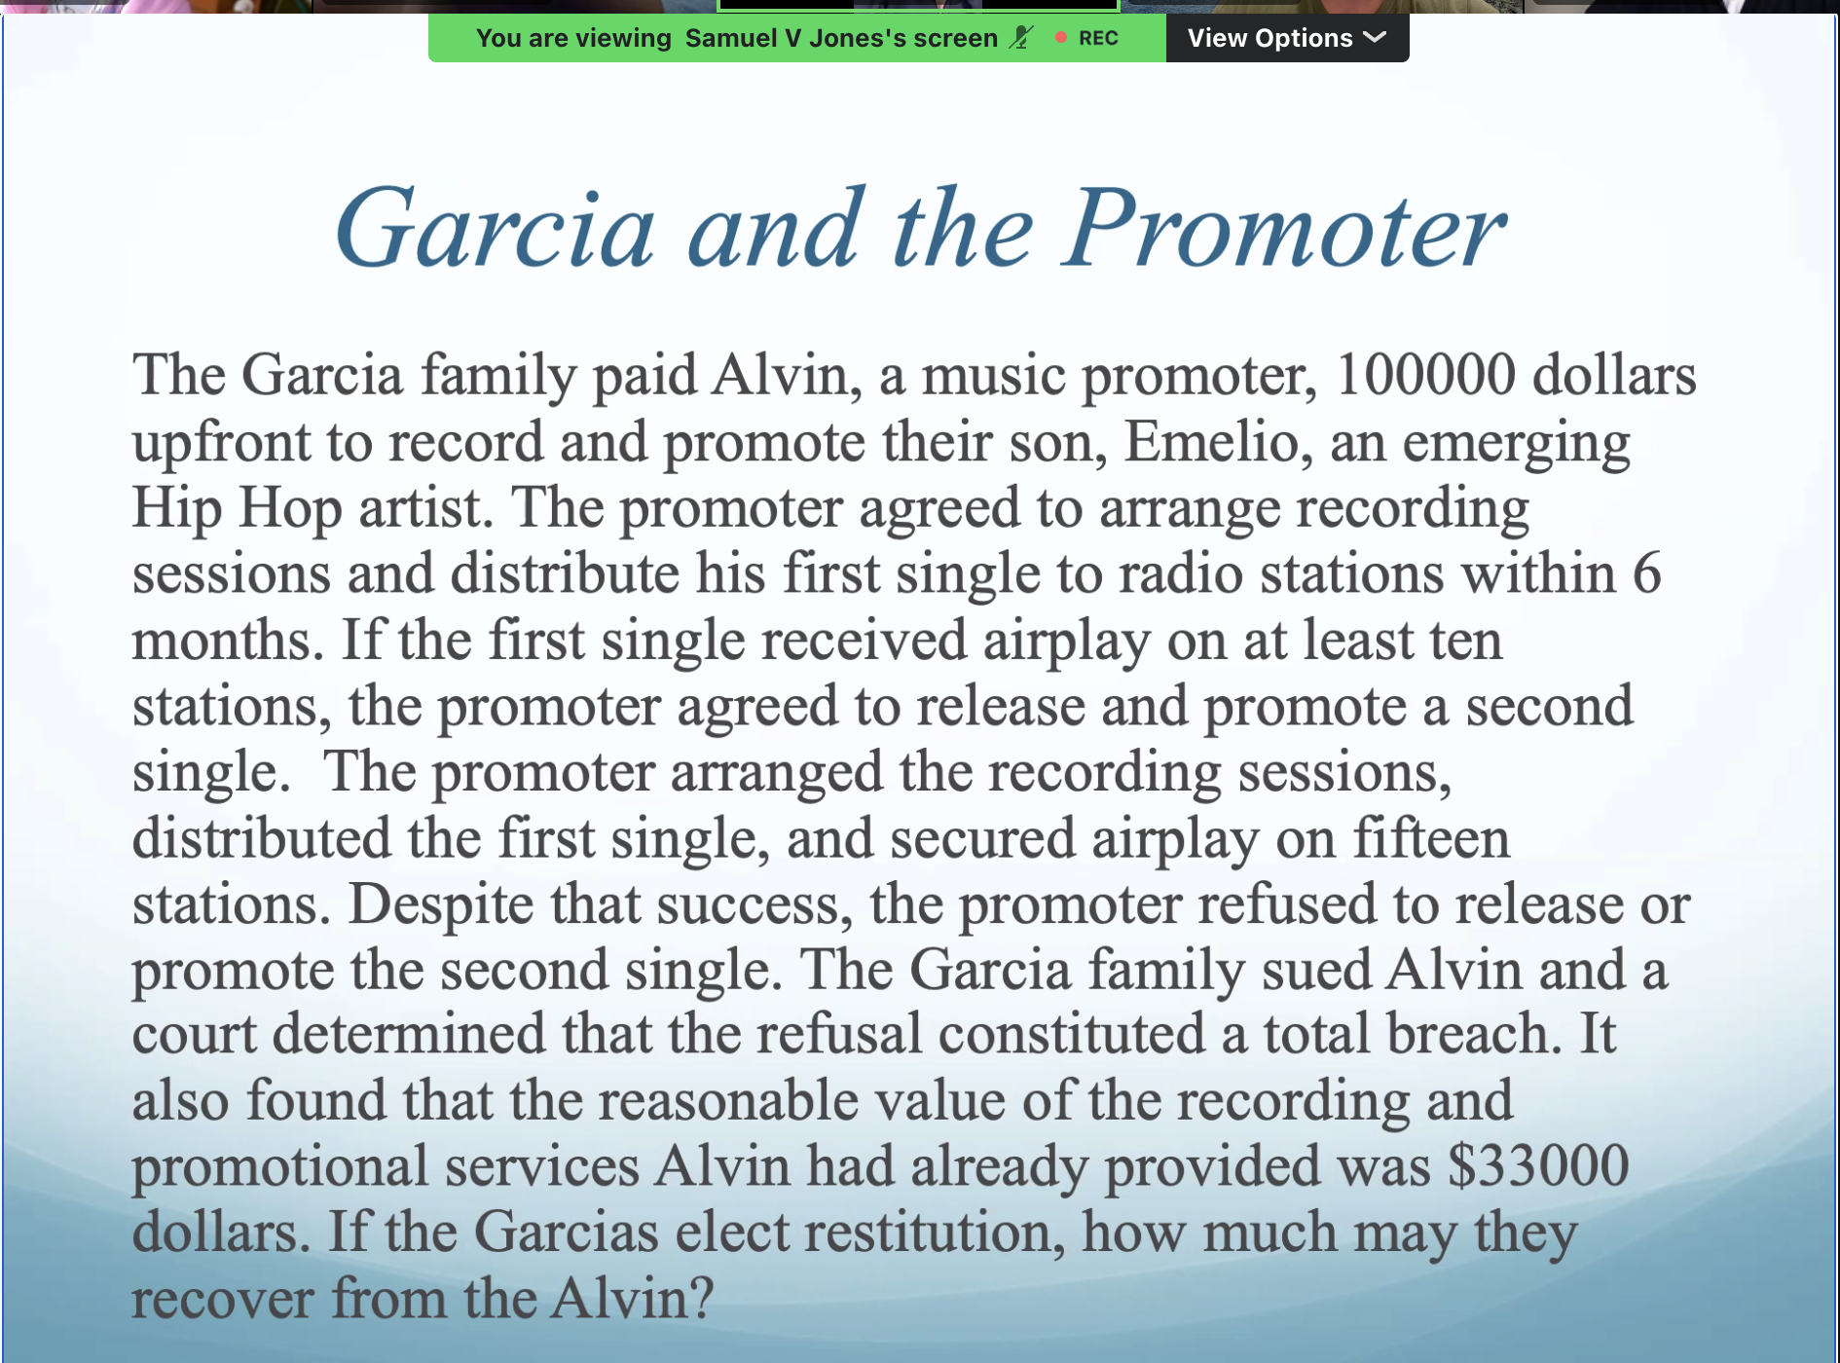
$67000

