Civ Pro Class Notes 11/11/26

Eerie Doctrine- It’s its own thing. Happens in Federal Court. Connected to the other stuff still.
Focus on two key things.
Why doctrine is important.
3 tests commonly used for analysis they have to do under Eerie doctrine.
Substantive and procedural
She’s not going to ask us to apply the test.
Why is Eeris is important? Could be tested this way on exam.
What test would help plaintiff argue this? Could be tested this way on exam.
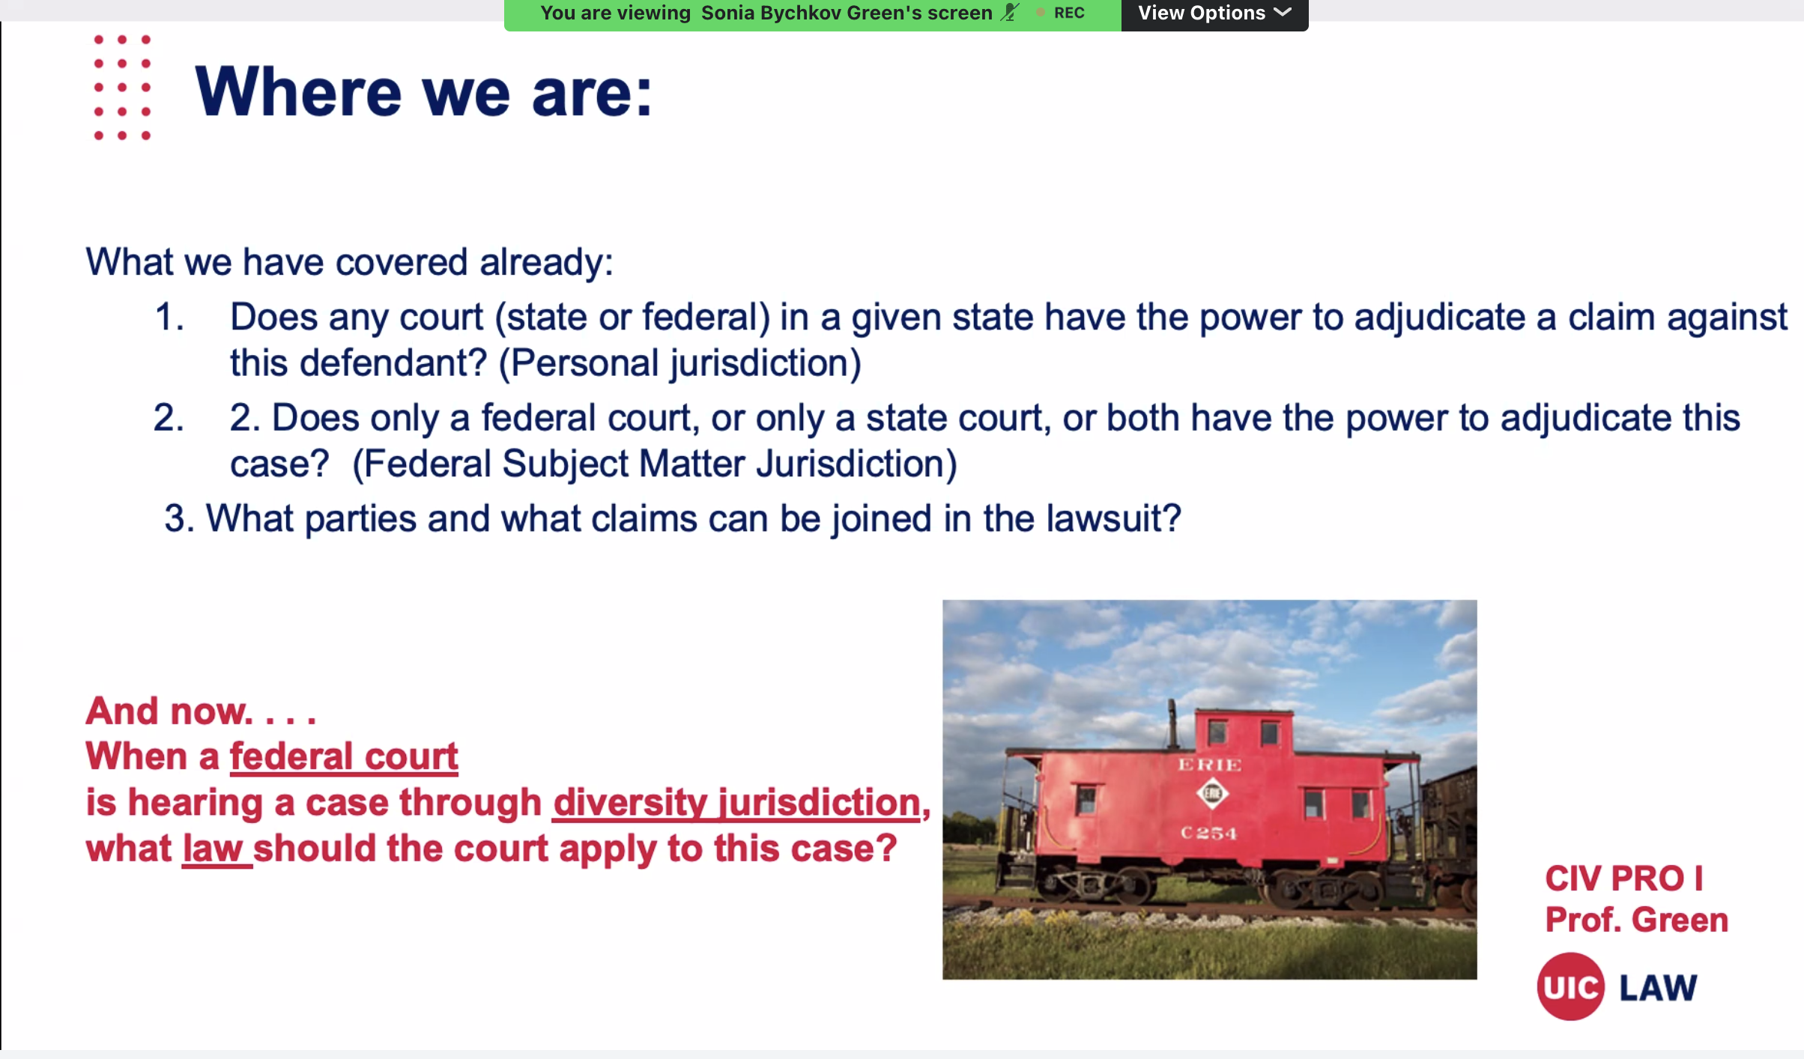
If just asking Subject matter jurisdiction.. Focus ONLY on that.
A defendant is a corporation and being sued in state in which they’re incorporated. Always personal jurisdiction over that corporation.
You need both personal and subject matter jurisdiction.
If suit is brought in state court, state court will have proper subject matter jurisdiction over 99% of cases
Only if pursuant to federal law, lawsuits for this law can only be brought in federal court. Otherwise, state courts can hear pretty much anything.
If she’s asking about subject matter it will always be set in fed jurisdiction. Fed question and diversity are the ways a case can get removed to fed court.
If joinder then you can analyze subject matter jurisdiction.
Always going to be in federal court for Eerie doctrine. Only comes up if fed court can hear it due to diversity.
Question that’s asked is what law should apply.
Fed court for diversity- suing for violation of state common law.
Not binding on state courts.
If fed question- did it raise a question of federal law. Has to come in in the complaint.
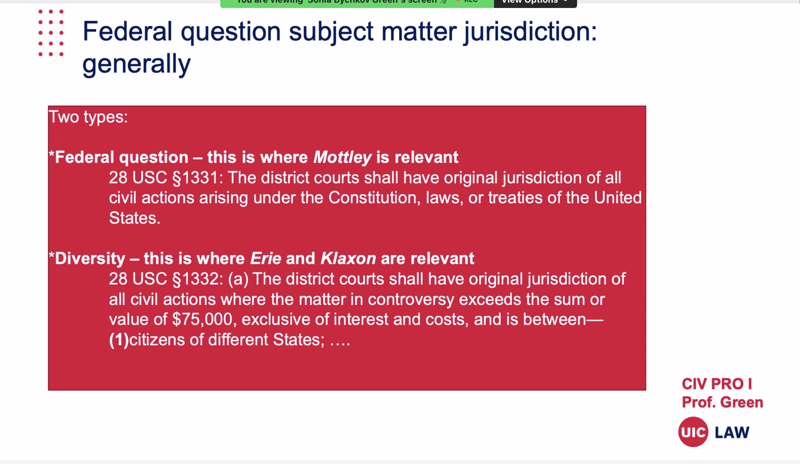

Fed court will use law in state in which it sits when it’s in fed court for diversity.
No longer a difference between how the case is adjudicated between fed and state court. Using the same law. Both going to be using state law.
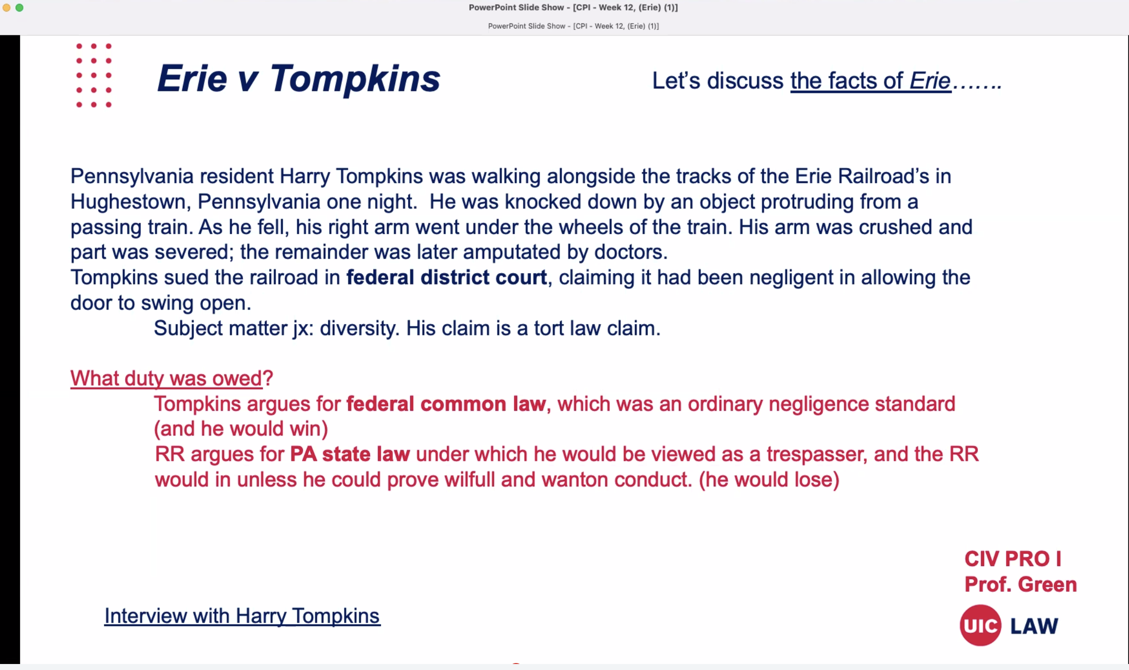

Encourages forum shopping.
Eerie gets rid of general federal law or federal common law.
Eerie uses state law in the state in which it sits because of diversity.
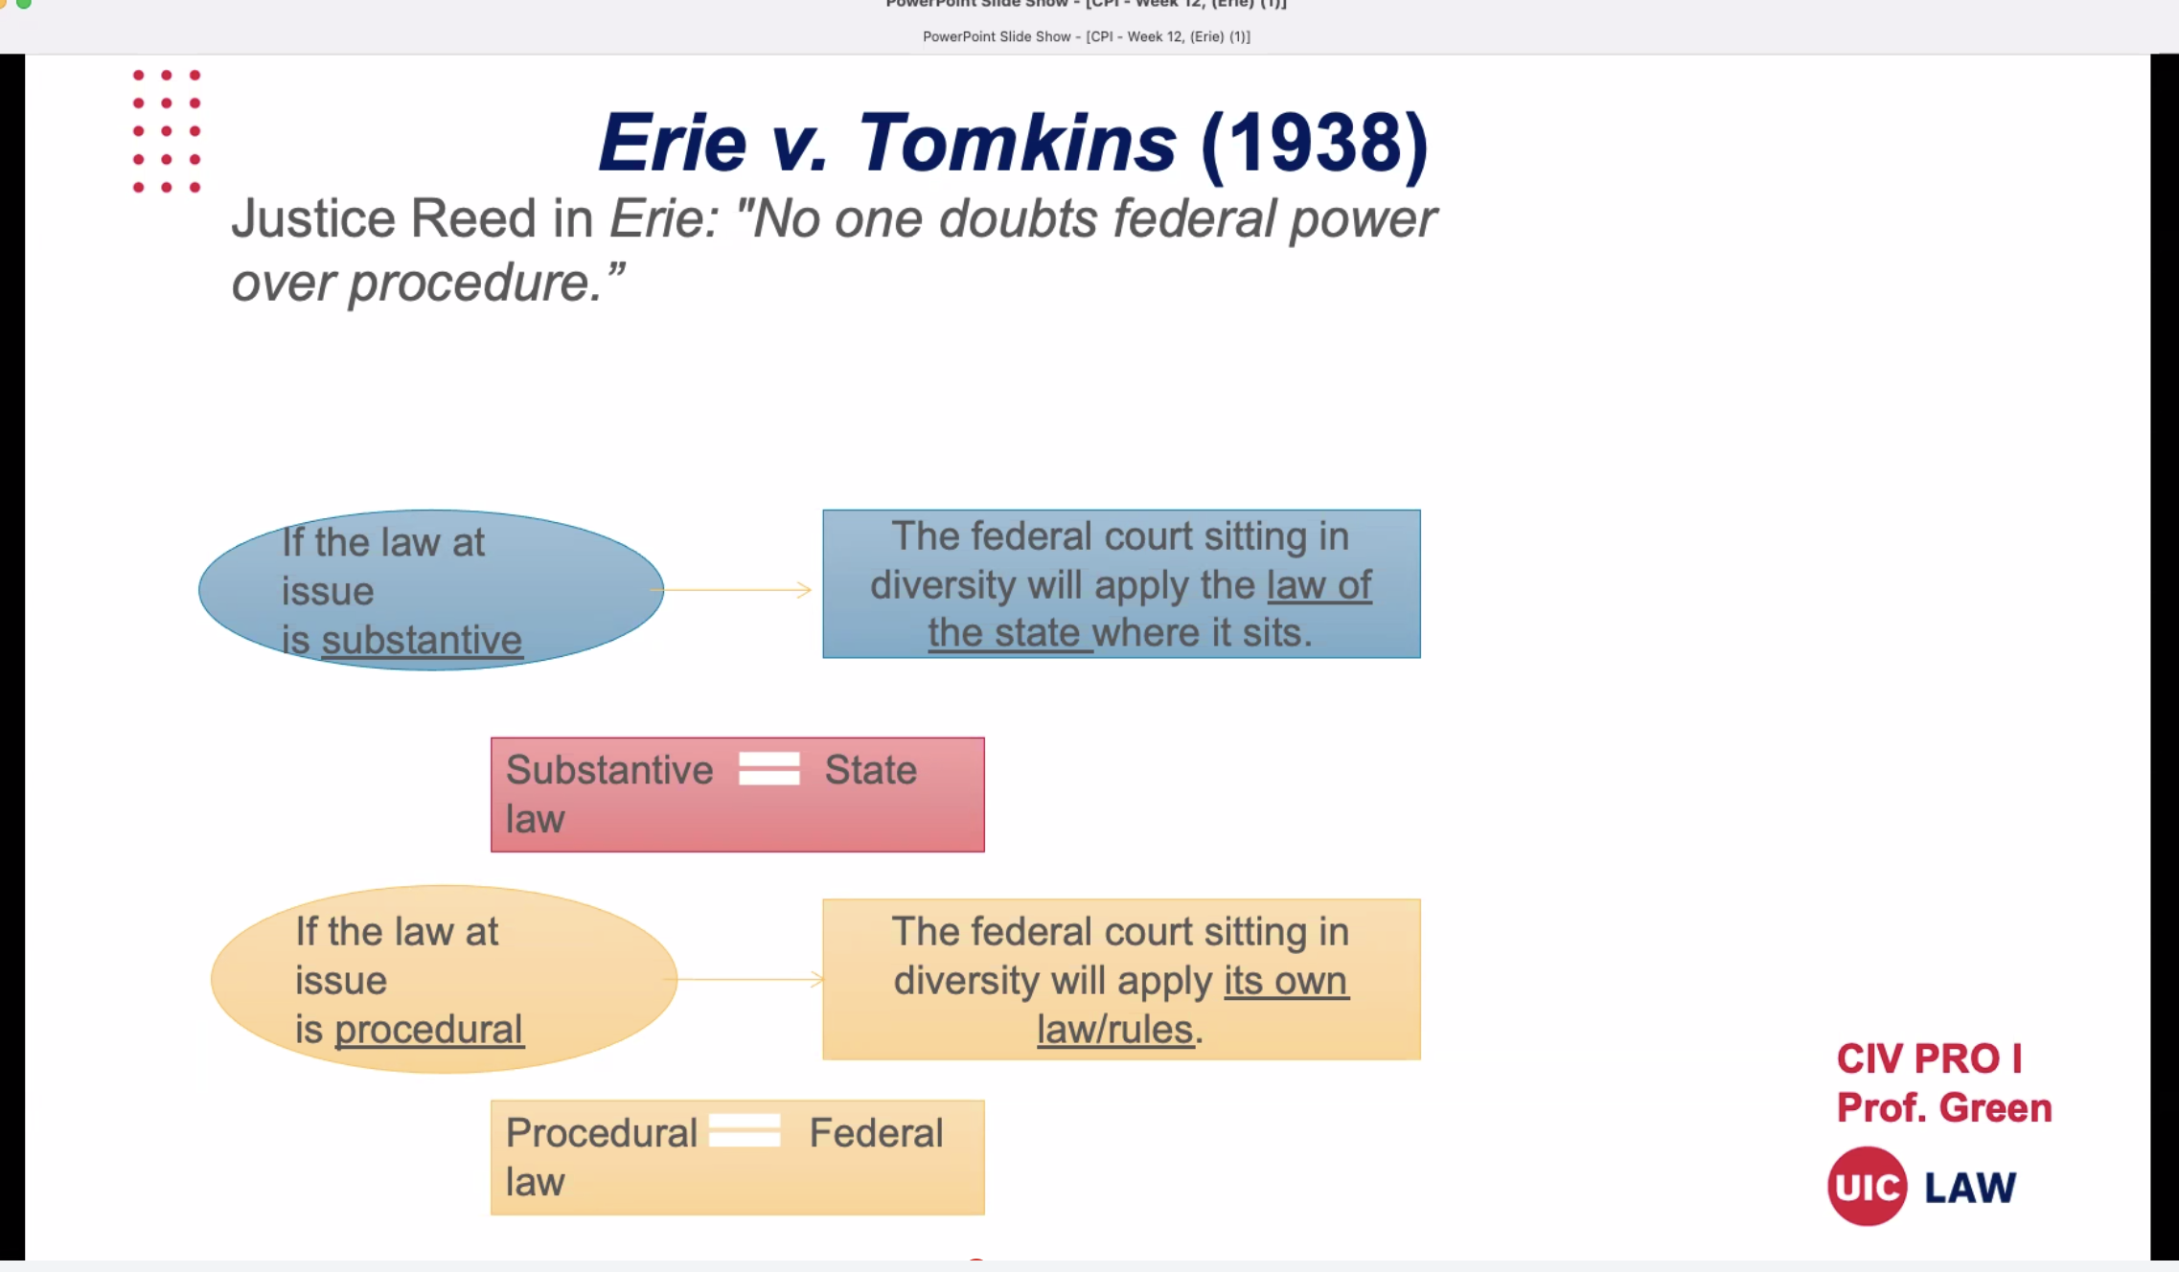
If procedural federal procedural rules apply
Substantive state law where the court sits.
Procedure-federal procedural rules
Fed court is sitting in diversity- court finds it’s substantive. It’ll be state law. Not federal law.
If it’s procedural-than fed law is going to apply. These are possible test questions.
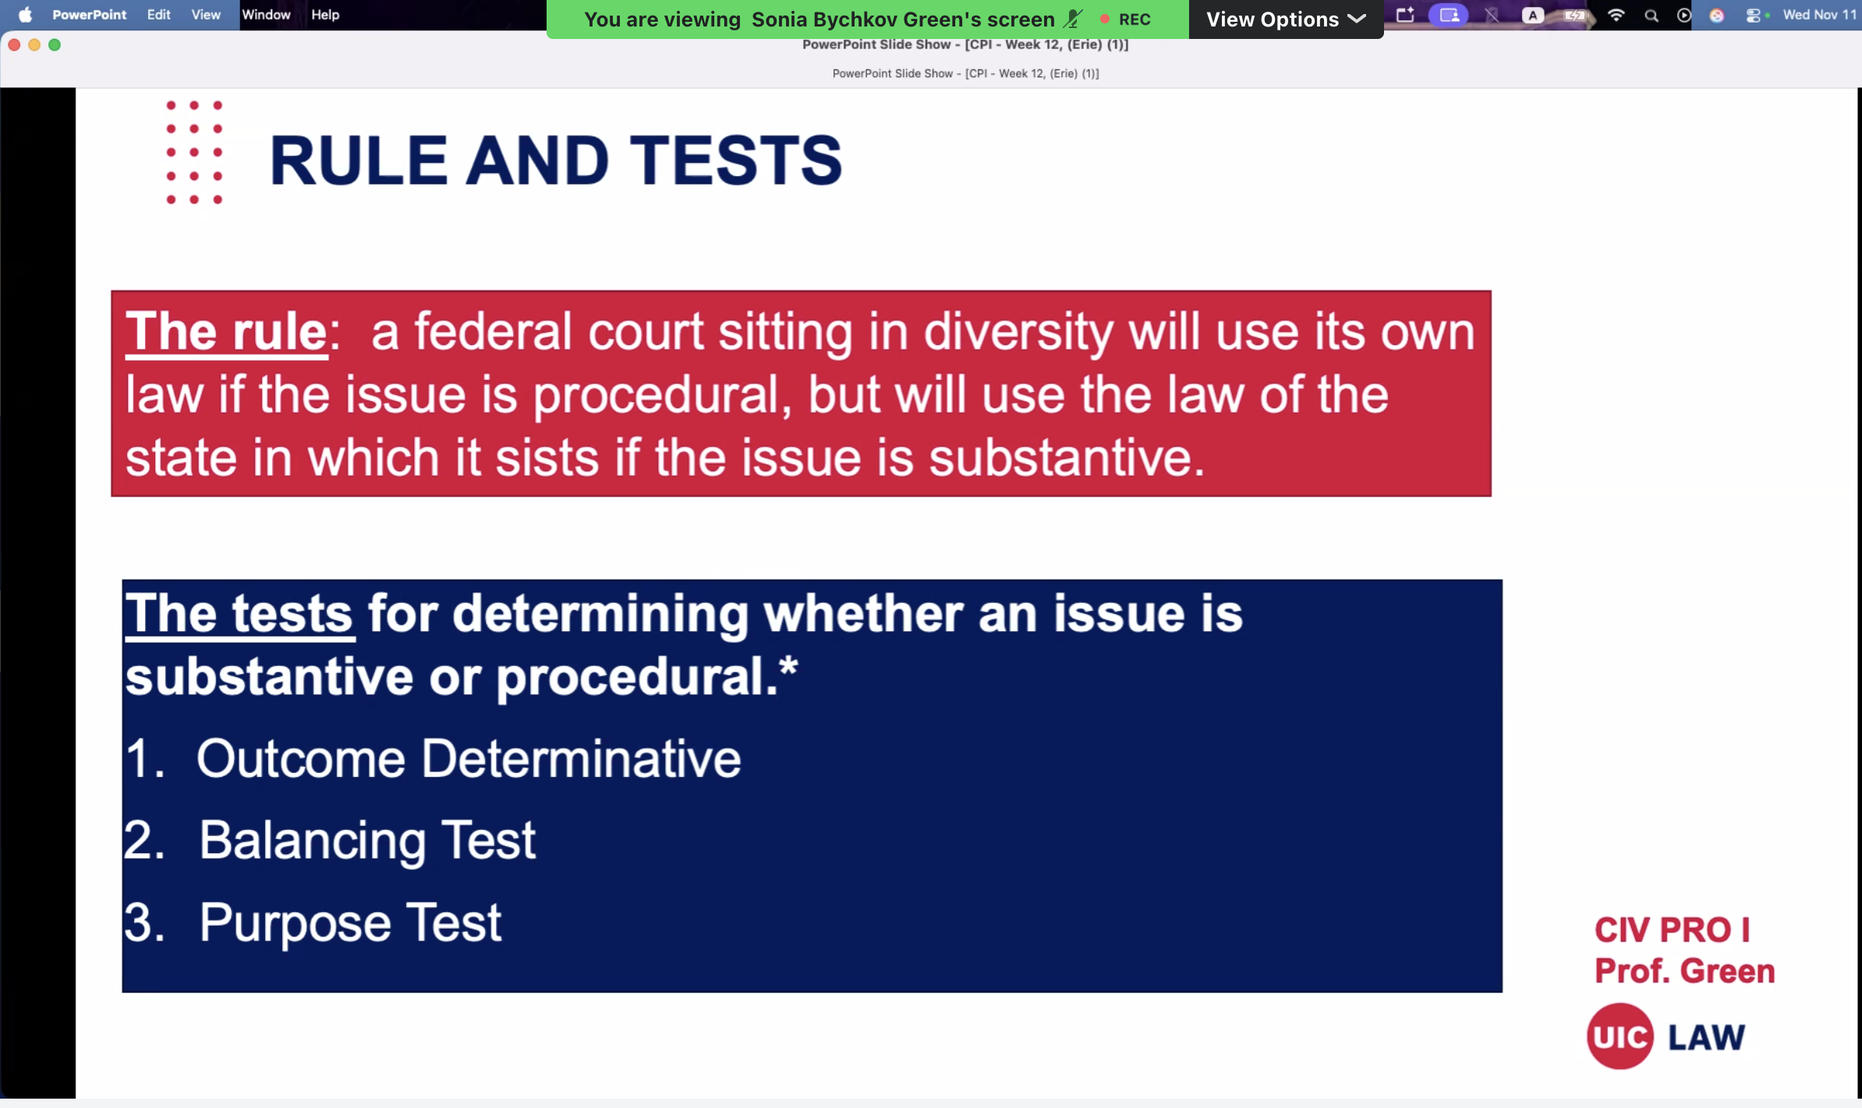
Outcome determinative test- question we’re asking is the resolution of this issue going to determine whole case. If yes= substantive, no=procedural
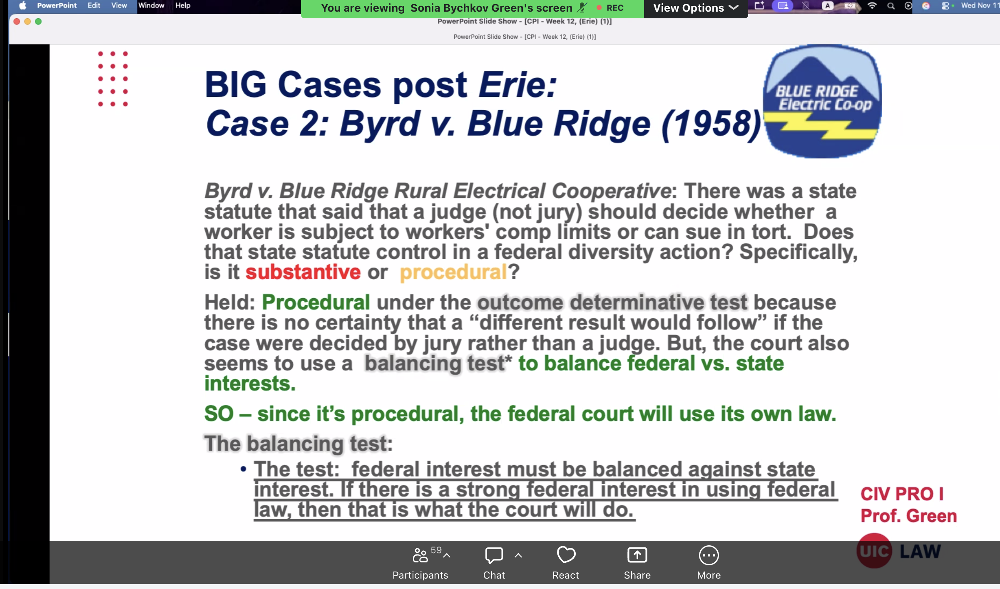
If there’s

