CPU designed following the Ross McGowan "Design a CPU" Course

<https://www.udemy.com/course/design-a-cpu>

<https://www.buthowdoitknow.com/cpu_simulator.html>

CPU_MEM_1

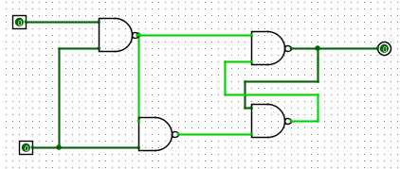

CPU_MEM_8

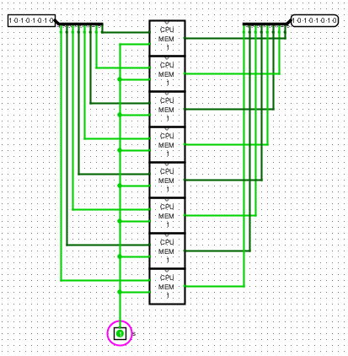

CPU_ENABLE

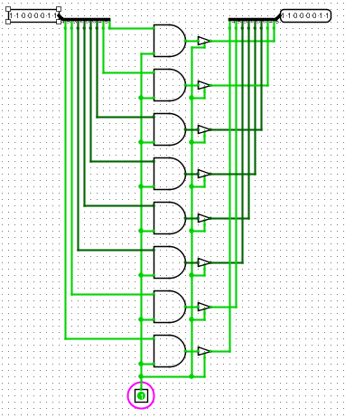

CPU_REG_8

