Lab 8:
Part 1)
CREATE DATABASE websyslab8 CHARACTER SET utf8 COLLATE utf8_unicode_ci;

CREATE TABLE courses (
crn INT(11) PRIMARY KEY,
prefix VARCHAR(4) NOT NULL,
number SMALLINT(4) NOT NULL,
title VARCHAR(255) NOT NULL
) COLLATE=utf8_unicode_ci;

CREATE TABLE students (
rin INT(9) PRIMARY KEY,
rcsID CHAR(7),
firstname VARCHAR(100) NOT NULL,
lastname VARCHAR(100) NOT NULL,
alias VARCHAR(100) NOT NULL,
phone INT(10)
) COLLATE=utf8_unicode_ci;

Part 2)

ALTER TABLE students
ADD street VARCHAR(255),
ADD city VARCHAR(100),
ADD state CHAR(2),
ADD zip INT(5);

ALTER TABLE courses
ADD section VARCHAR(10),
ADD year INT(4);

CREATE TABLE grades (
id INT PRIMARY KEY AUTO_INCREMENT,
crn INT,
rin INT,
grade INT(3) NOT NULL,
FOREIGN KEY (crn) REFERENCES courses(crn),
FOREIGN KEY (rin) REFERENCES students(rin)
);

INSERT INTO courses (crn, prefix, number, title, section, year)
VALUES
(35257, 'CSCI', 1200, 'Data Structures', '01', 2025),
(73048, 'ITWS', 2110, 'Web Systems Development', '01', 2025),
(38402, 'CSCI', 2800, 'Computer Architecture & OS', '01', 2025),
(35955, 'CSCI', 2200, 'Foundations of Computer Science', '01', 2025);

INSERT INTO students (rin, rcsID, firstname, lastname, alias, phone, street, city, state, zip)
VALUES
(662081897, 'lifrim', 'Matthew', 'Lifrieri', 'Matt', 1234567890, '83 S Main St', 'New City', 'NY', 10956),
(662045813, 'durdet', 'Tyler', 'Durden', 'Narrator', 1112223333, '12 6th Ave', 'Troy', 'NY', 12180),
(662082634, 'doej', 'John', 'Doe', 'JD', 1002003000, '99 College Dr', 'Troy', 'NY', 12180),
(662091359, 'harves', 'Steve', 'Harvey', 'KB', 2147483647, '4110 Paces Ferry Rd', 'Atlanta', 'GA', 30327);

INSERT INTO grades (crn, rin, grade) VALUES
(35257, 662045813, 95),
(35257, 662081897, 88),
(35257, 662082634, 92),
(35955, 662081897, 85),
(35955, 662091359, 91),
(38402, 662082634, 89),
(38402, 662045813, 93),
(73048, 662091359, 87),
(73048, 662081897, 90),
(73048, 662045813, 94);

- a) by RIN: SELECT * FROM students ORDER BY rin;
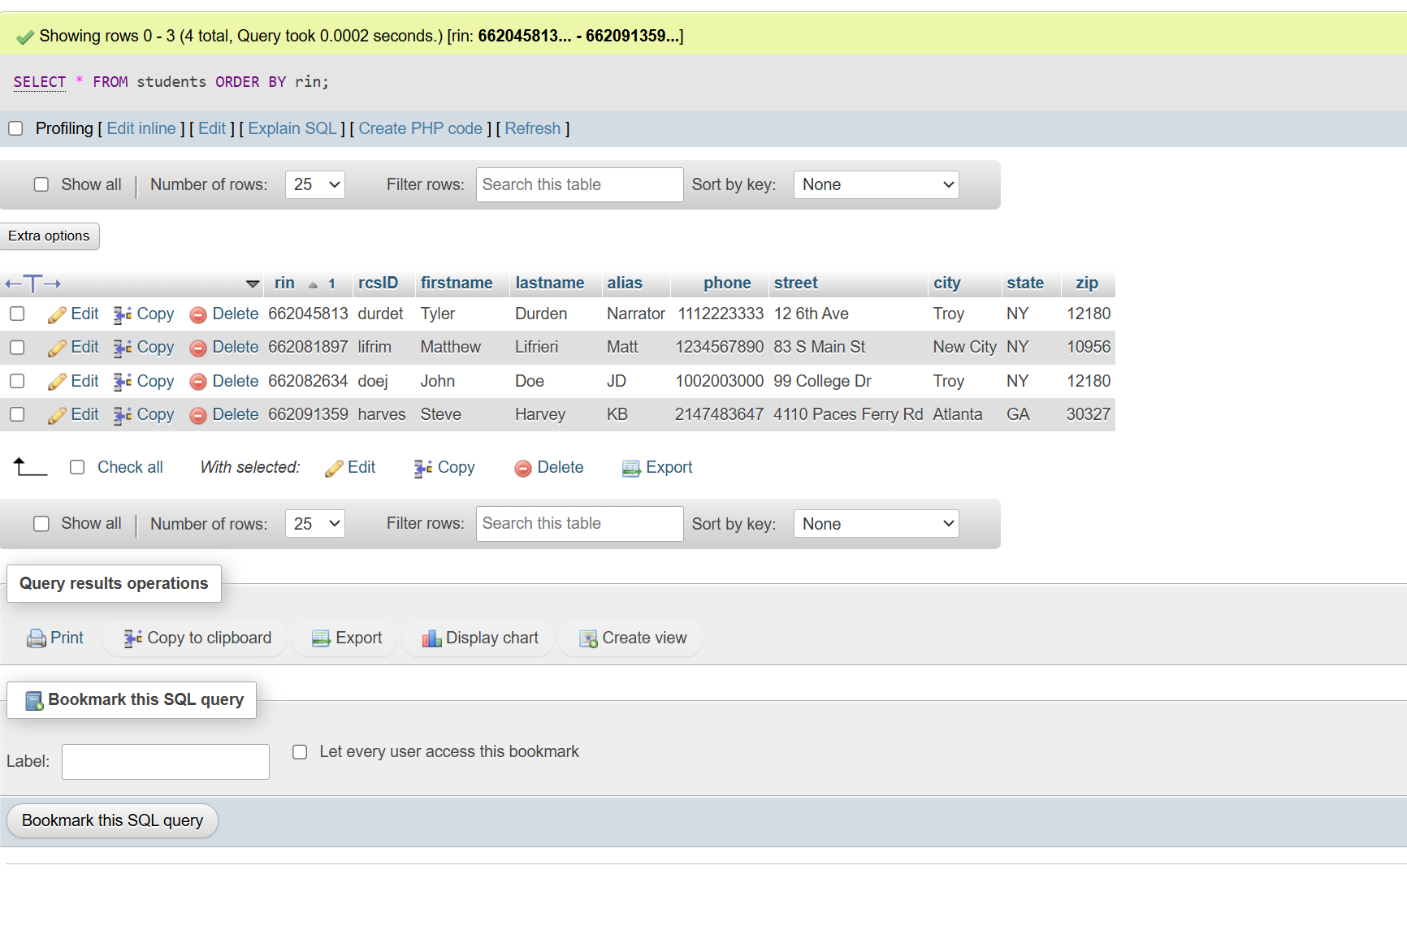
b) by lastname: SELECT * FROM students ORDER BY lastname;
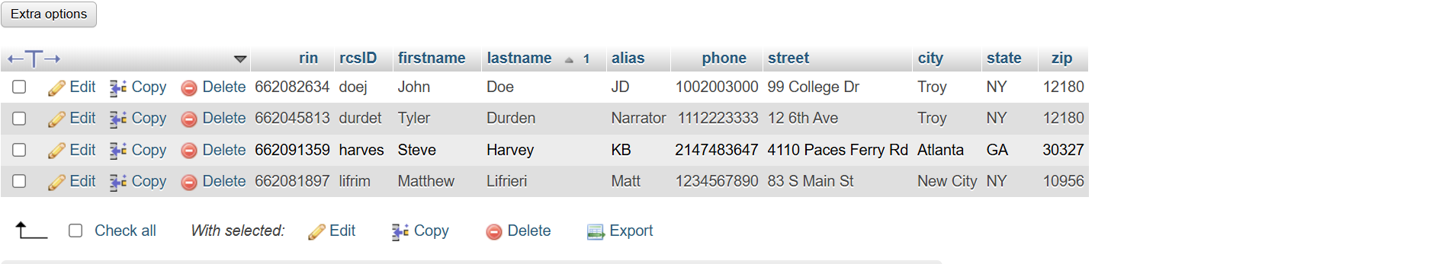
c) by rcsid: SELECT * FROM students ORDER BY rcsID;
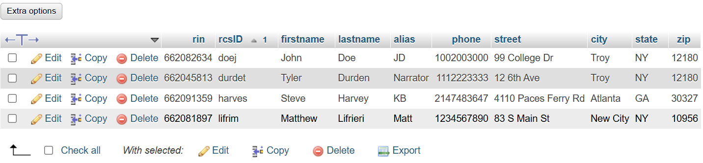
d) by firstname: SELECT * FROM students ORDER BY firstname;
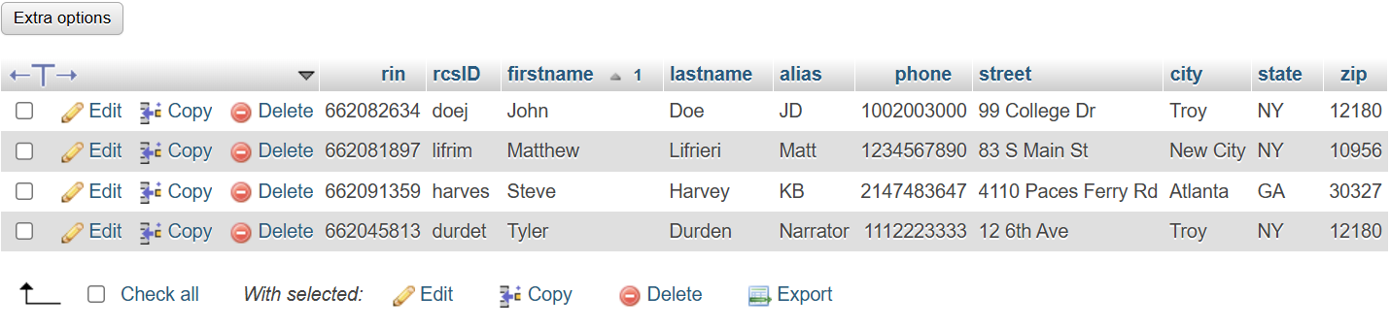

SELECT s.rin,
s.firstname,
s.lastname,
s.street,
s.city,
s.state,
s.zip,
g.grade
FROM students s
JOIN grades g ON s.rin = g.rin
WHERE g.grade > 90;
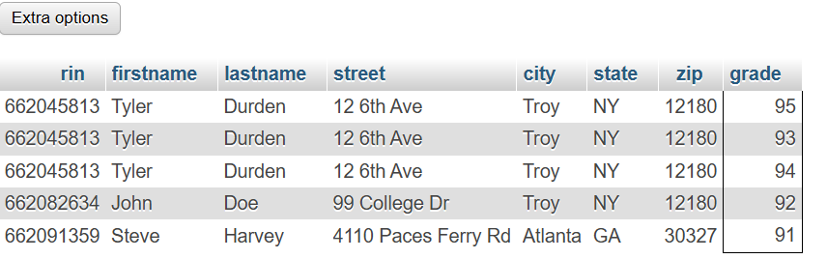

SELECT c.crn, c.title, AVG(g.grade) AS avg_grade
FROM courses c
JOIN grades g ON c.crn = g.crn
GROUP BY c.crn;
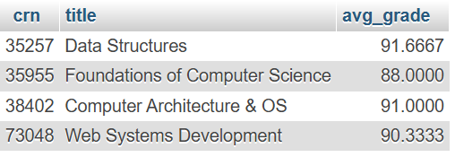

SELECT c.crn, c.title, COUNT(g.rin) AS student_count
FROM courses c
LEFT JOIN grades g ON c.crn = g.crn
GROUP BY c.crn;
