**Patient-centered Hypertension Decision Support: a user-centered study to build a patient-facing decision support tool.**

High blood pressure (hypertension) is a common condition amongst adults; ongoing, uncontrolled hypertension increases the risk of heart disease and stroke, the most common cause of mortality of older adults. Like many common conditions, however, there are myriad choices made from diagnosis to treatment; these choices involve health care providers but are largely dependent on the needs, preferences, values, goals, and choices of patients. Behavioral and lifestyle factors like diet and activity can substantially affect treatment and outcomes. Adverse events from treatment are challenging to capture but important in quality of life, treatment adherence and avoiding morbidity. Like many conditions with these issues, our ability to support the informed decision-making of people with the illness and health care professionals is limited.

**Our main goal of the grant is to understand how best to support patients as they address hypertension, focusing on their goals, experiences, motivation, and engagement with the health care system, and to build a FHIR-based application that embodies those best practices while facilitating adherence to guidelines.**

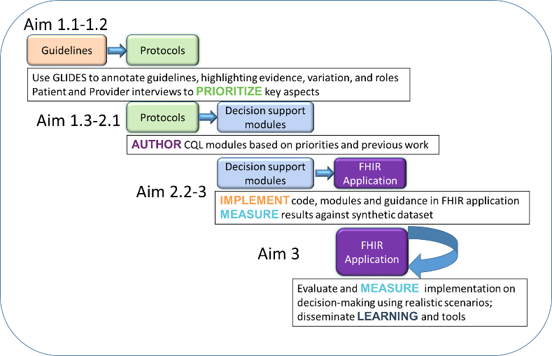**Specific Aims**

SA1. With the help of patients and an interdisciplinary research team, translate multiple hypertension guidelines and protocols into Clinical Quality Language (CQL) query modules that are flexible and evidence- based;

SA2. Leveraging previous work, build Clinical Decision Support (CDS) artifacts using the CDS Connect

Authoring tool and build a FHIR application that can elicit inputs and provide guidance to both patients and health care teams, validating against a database of patients with hypertension; and

SA3. Evaluate this application with appropriate patients and health care teams to learn its potential impact in assisting tailored decision making, refining the CDS artifacts and disseminating.

**How can you get involved?**

We will start by gathering active hypertension guidelines and protocols.

We also will review the literature and gather examples of current HTN CDS tools. If you have examples of these, please send them to [dautremo@ohsu.edu](mailto:dautremo@ohsu.edu). We will be recruiting additional experts for guidance and review of initial results; if you are interested in participating or just have comments or thoughts, please contact PI Dr. David Dorr at [dorrd@ohsu.edu](mailto:dorrd@ohsu.edu).

The figure below demonstrates one potential vision of a patient-facing tool that could help decision making and care planning for optimal health.

