# MPD Coursework Submission Document

Matthew Bori Alston [malsto200@caledonian.ac.uk](mailto:malsto200@caledonian.ac.uk) S1824614

## Video Link

<https://github.com/mattahu1992/MPDCourseworkMA/blob/master/Alston_Matthew_Bori_S1824614.mp4>

## Android Project Link

<https://github.com/mattahu1992/MPDCourseworkMA/tree/master/src>

## Project .apk File Link

<https://github.com/mattahu1992/MPDCourseworkMA/tree/master/apk/debug>

## Documented Testing

Images of the tests undertaken in the table below are viewable underneath the Test Table

|  |  |  |  |  |  |
| --- | --- | --- | --- | --- | --- |
| Test ID | Test Scenario | Expected Outcome | Actual Outcome | Comments | Visual Link |
| 1 | Clicking on Current Incidents button on main activity | User will be taken from Main Activity to Incidents Activity | User was taken from Main Activity to Incidents Activity | Test successful | Link.id.1 |
| 2 | Clicking on Roadworks button on main activity | User will be taken from Main Activity to Roadworks Activity | User was taken from Main Activity to Roadworks Activity | Test successful | Link.id.2 |
| 3 | Main Activity changed from Portrait mode to Landscape mode when flipped on emulator and vice versa | Main Activity will load view on the corresponding layout resource file | Main Activity loaded view on the corresponding layout resource file | Test successful | Link.id.3 |
| 4 | Toolbar will load view when called on in opened activity | Toolbar will show on top of  Activity | Toolbar shown on top of activity. | Test successful | Link.id.4 |
| 5 | Toolbar will show dynamic search widget Roadworks Activity is opened. | In Roadworks activity a search icon will appear on the top right of the screen. Once clicked a keyboard will appear at the bottom of the screen. On type the text will appear in search bar | Search icon appears on the top right of the screen. Once clicked a keyboard will appear at the bottom of the screen. On type the text appears in search bar | Test Successful | Link.id.5 |
| 6 | Once Roadworks or Incident button parse Data from RSS feed into app. Log tags are used to show the RSS data and its assigned value are passed to the app. Viewable in Logcat | On click of a button within the main activity the RSS data will be parsed to the app. Works for both Roadworks and Incidents | The RSS data was parsed after Button click | Test Successful | Link.id.6 |
| 7 | Once data is parsed it fills the card view which is displayed in recycler view | On click of a button in the Main Activity  the data will be parsed and then displayed on the selected Activity Screen. Both for Roadworks and incidents | Data parsed is displayed in recycler view for both roadworks and Incident Activity | Test Successful | Link.id.7 |
| 8 | At the search widget type in text to search for within the Roadworks Activity (m8 in this case) | All roadworks with M8 in the title will be displayed and the others hidden on the recycler view. | No change in the recycler view searched items do not show and those without the search criteria remain | Test Unsuccessful.  Error code viewable at Link.id.8  Changes to the code were implemented from online suggestions but none could solve the problem. | Link.id.8 |
| 9. | Application Landscape and portrait view. On every the application must respond when the emulator is turned form portrait to landscape. Layout views must change and show the content appropriately | When Screen orientation is changed the resource layout file of the application will change to match the new orientation | Screen orientation matches layout orientation | Test Successful | Link.id.9 |

## Test Results Images

Notes: Yellow circle represents mouse click. Roadworks RSS feed was used for incidents as there was no incidents at time of tests.

### Link.id.1

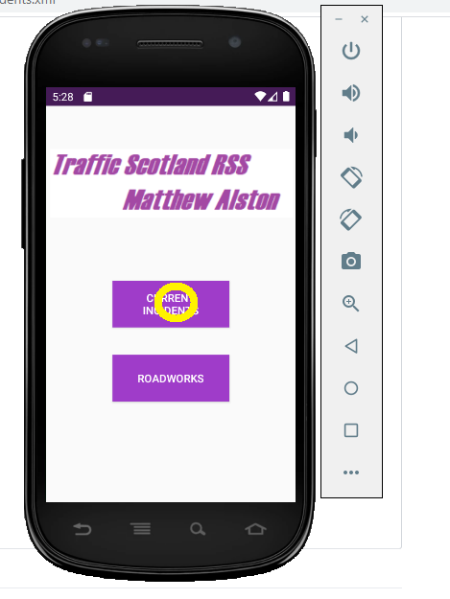 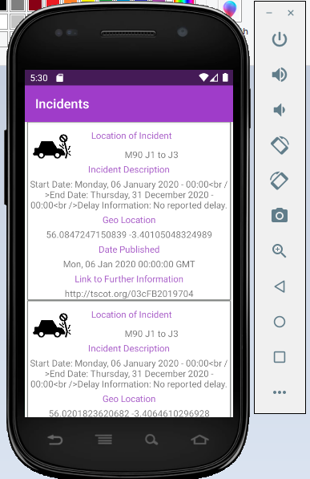

Resulting Final Outcome

Start point and initial action

### Link.id.2

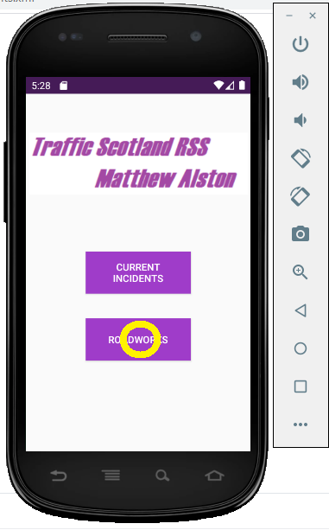 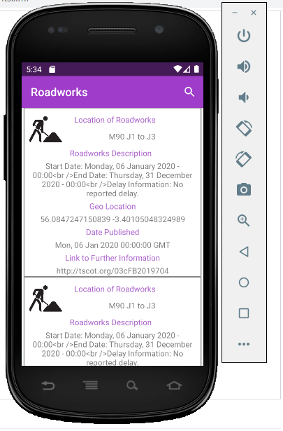

Resulting Final Outcome

Start point and initial action

### Link.id.3

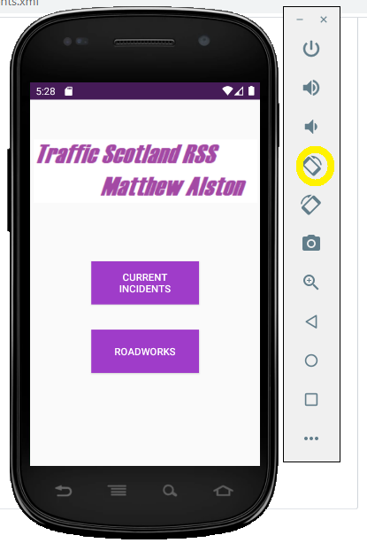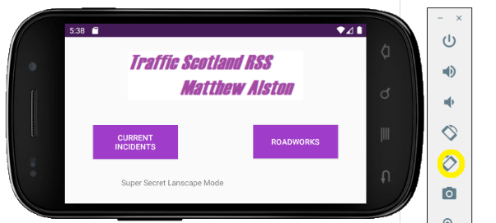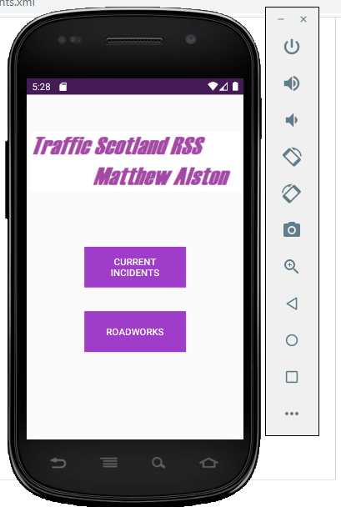

Resulting final outcome

Resulting Outcome and second action

Start point and initial action

### Link.id.4



Toolbar Viewable at top of screen

### Link.id.5

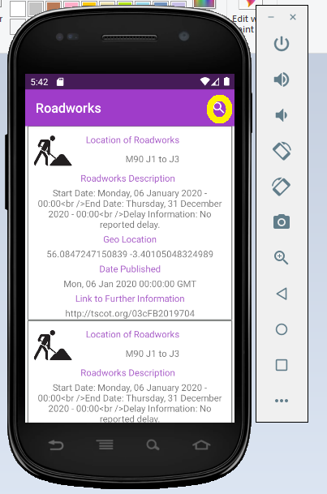 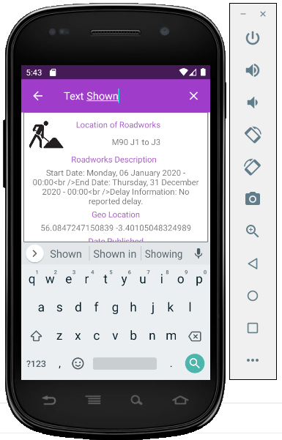

Resulting final outcome

Start point and initial action

### Link.id.6

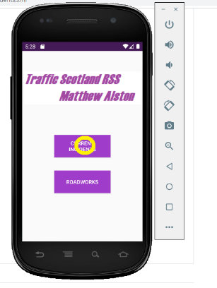 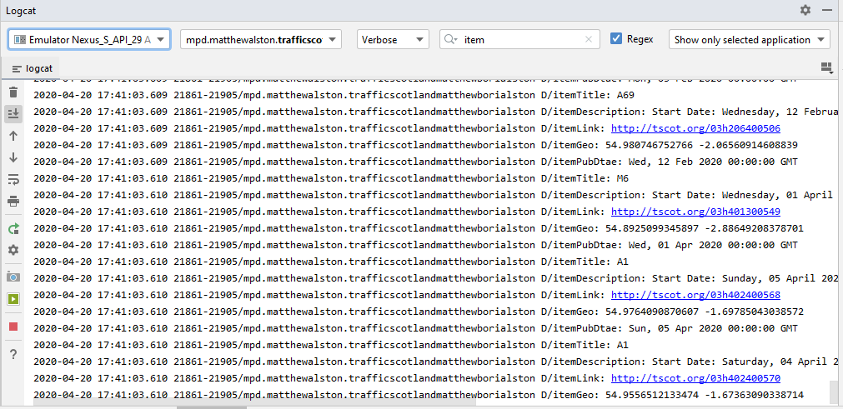

Logcat display from item search

Start point and initial action for current incidents

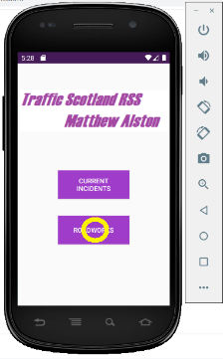 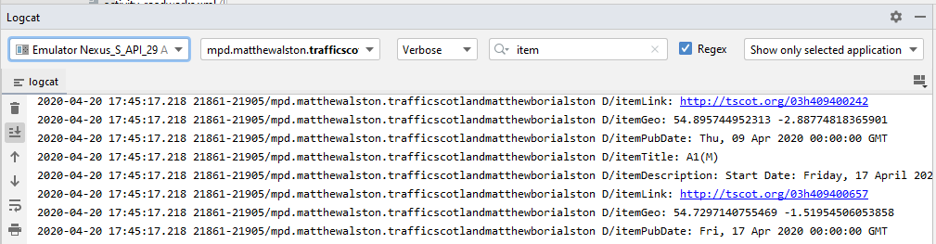

Start point and initial action for current roadworks

Logcat display from item search

### Link.id.7

 

Resulting Final Outcome for current roadworks

Start point and initial action for current roadworks

 

Resulting Final Outcome for current incidents

Start point and initial action for current incidents

### Link.id.8

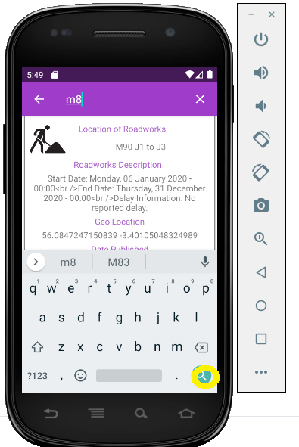 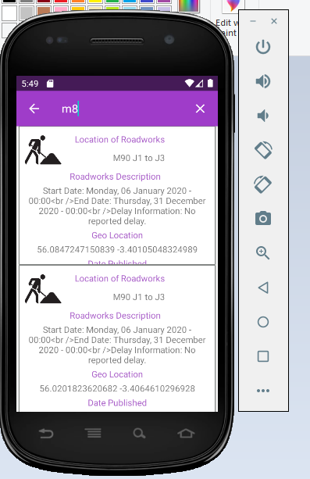

Resulting final outcome

Start point and initial action

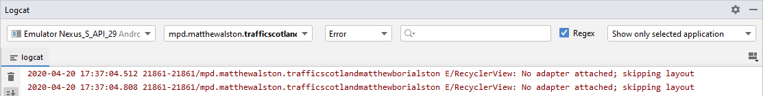

Logcat error message received

### Link.id.9

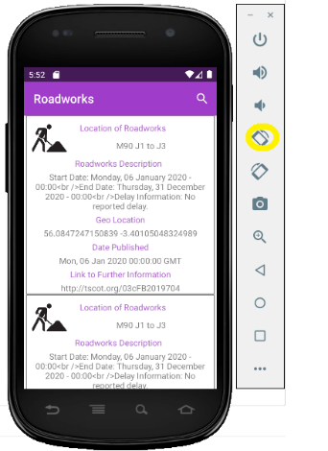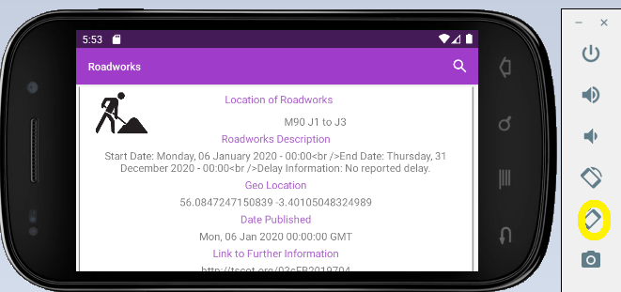 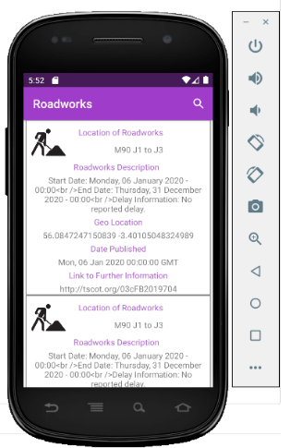

Resulting Outcome and second action for Roadworks

Resulting final outcome for Roadworks

Start point and initial action for Roadworks

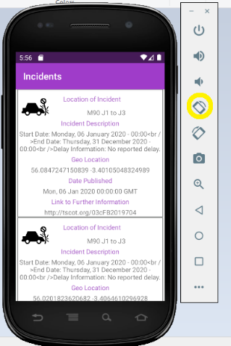 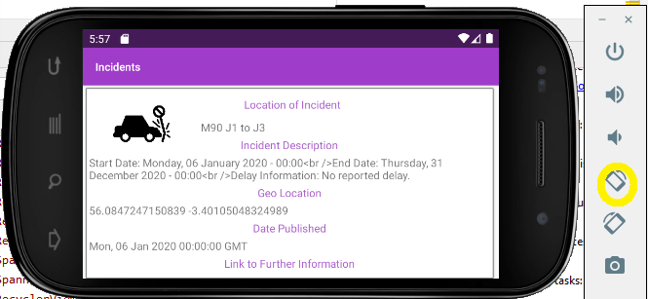 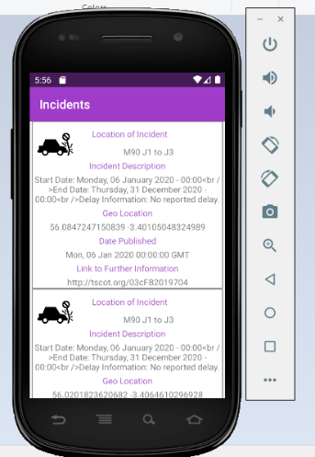

Resulting Outcome and second action for Incidents

Resulting final outcome for Incidents

Start point and initial action for Incidents