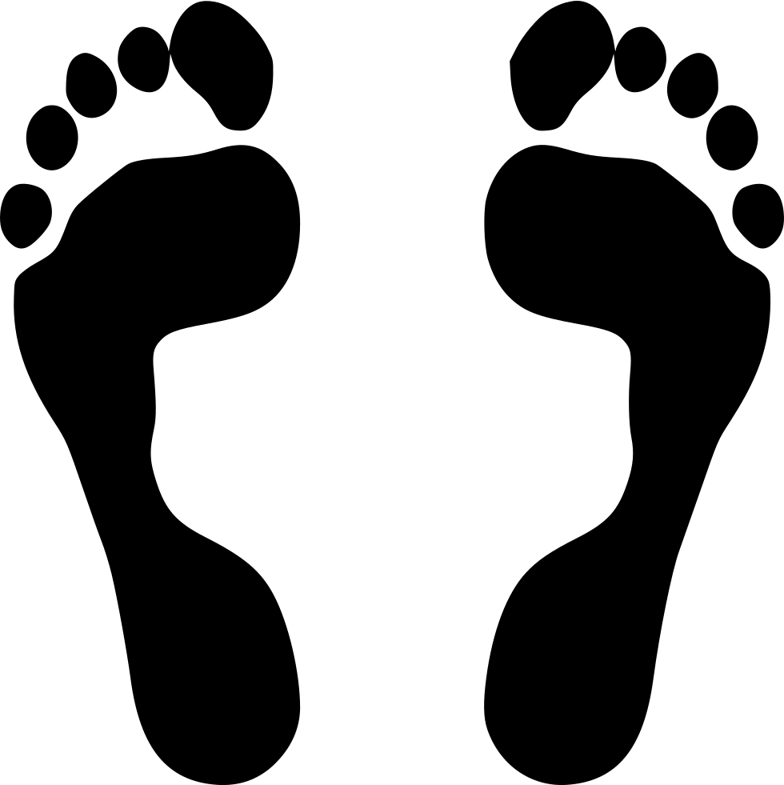
Foot-Print

Premise:

As a receptionist using footfall, the process seems unnecessarily complicated. With loading screen and buffers between clicks. The main issue being the constant interruptions from the phone ringing or other more pressing tasks, the stop start approach makes it take much longer than it should.
Sometimes the right way is the most simple, even when it can feel like a step backwards.
Concept:
Foot-Prints is a program which logs into footfall and acts as a receptionist. It can reply to, compile and process the information pts have sent to us. It’s purpose is to organise and deal with this information in the most efficient way possible, helping receptionists manage their workloads.
For the time being, Foot-prints will tackle prescriptions only. However, as I’m sure you can imagine, it’s potential is much greater. For example, I believe the next step would be to create an automated process that reads through all footfall requests, hunting for key-words and using machine learning to pick up on high risk/ urgent queries so that it can make the reception team aware.

Task 1) Prescriptions:

So far I have only done research into the application of printing prescriptions. This is the most common task and even though the time per script may be low compared to other tasks, the demand is tenfold that of any other task. My findings were encouraging.
After averaging time taken from paper prescriptions, I arrived at 29s per request (from 200 prescriptions).
Footfall, however, averaged to around 1min29s which is more than 4 times longer than its paper counterpart! (from 20 prescriptions).

