Matthew Morrisey
CS101
09/19/08

Chapter 1 Review Problems

1)
a. 0 b. 0 c. 0

2)
a. (1,0) (0,1) b. (1,1) c. (1,0)

3)
a. AND b. OR c. XOR

4)
If the upper input were temporarily changed to 0 the output would be 1. If the lower input were temporarily changed to 0 the output would become 0.
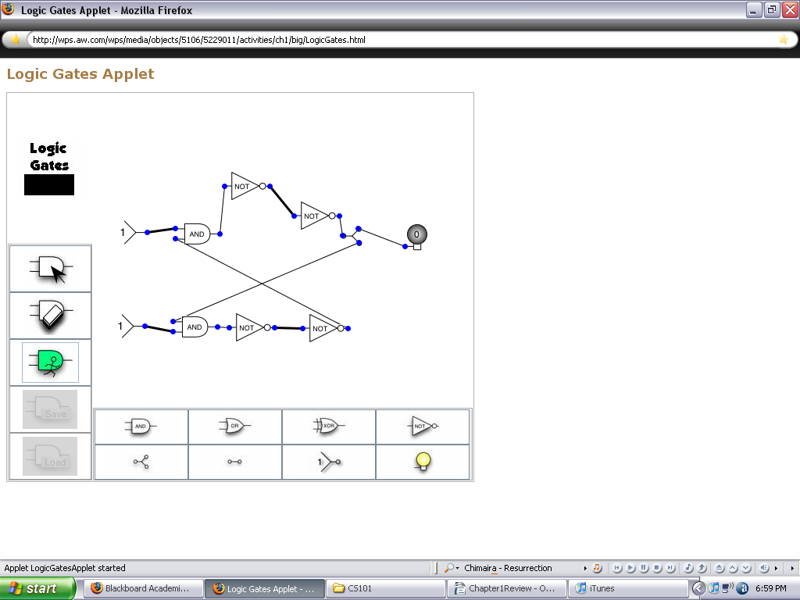
With the NAND configuration the output would remain 0 regardless of what you did to the inputs.

5)
ADDRESS | CONTENTS
00 | 02
01 | 53
02 | 01
03 | 53

10)
You could store 81 pictures.
17)
The seek time would be 60.01 seconds

25)
Any value which is 2^{X}
0001, 0010, 0100, 1000, 00010000, 00100000

