Computer Science: An Overview
Ninth Edition Activities
Chapter 1, Data Storage
Lab 1: Digital Gates
Part A – Basic circuits

Lab Report Date: 09/18/08

Name: Matthew Morrissey Section: CS101

Procedure
Start the LogicGates applet and carry out the instructions below.

Stage 1. Warm-up
In this stage you will start only a single input switch and a single output light to insure you are familiar with the applet. Create Circuit 1 below and run it to see if you can switch the output value from 0 to 1. If you are having problems doing this, check with your instructor to be sure you understand the lab and that your computer has a web browser and version of Java compatible with the applet.
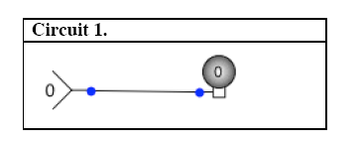
Try going back from Run to Edit and see if you can move the circuit elements around. The position of circuit elements on the screen does not change their operation so you may move them around for clarity. When you are done initial the blank below.

Stage 1 completed MM

Stage 2. Running a gate

In this stage you will test a single gate to establish its basic Boolean table. The gate will be XOR. Construct Circuit 2 below:

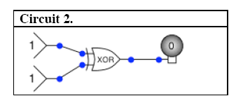

Now run the circuit and verify that you get the results that you should. (We’ll use the convention that Input 1 and Input 2 read top to bottom in the diagram.) Fill out the Actual Output column by changing the input values on your circuit and recording the result. In the final column put a check mark if the predicted and actual output agree (as they should). In all the tables in this lab columns that you fill out are labeled in Bold font.

Input 1 | Input 2 | Predicted output | Actual output | Ok?
0 | 0 | 0 | 0 | OK
0 | 1 | 1 | 1 | OK
1 | 0 | 1 | 1 | OK
1 | 1 | 0 | 0 | OK

Stage 3. Running a two gate circuit
In this stage you will test a circuit with two gates. Build the circuit below with an OR and NOT gate and then fill out the table

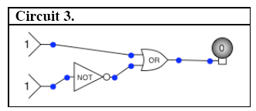

Input 1 | Input 2 | Output
0 | 0 | 1
0 | 1 | 0
1 | 0 | 1
1 | 1 | 1

Stage 4. Running a two gate circuit – second version
In this stage you will again test a circuit with two gates. Build the circuit below with an XOR and NOT gate and then fill out the table

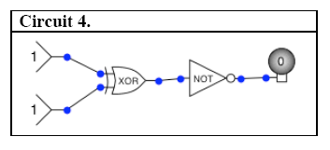

Input 1 | Input 2 | Output
0 | 0 | 1
0 | 1 | 0
1 | 0 | 0
1 | 1 | 1

Stage 5. Creating a circuit for a table
In this stage you reverse the process, building a circuit from a Boolean table. Here is the table:

Input 1 | Input 2 | Required Output | Actual Output
0 | 0 | 1
0 | 1 | 1
1 | 0 | 1
1 | 1 | 0

Figure out a circuit that will create this table with the Required Outputs and then draw it below. Test the circuit to insure it performs correctly and fill out the Actual Output column. NOTE: You can explain in words how the circuit is built. You can also build the circuit and capture the screen and paste it (USE Control + prtSc)

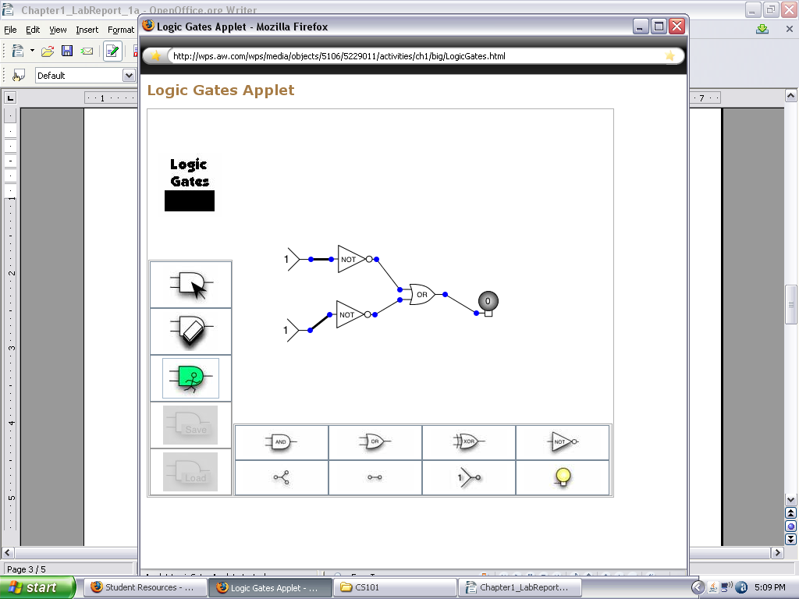
Stage 6. A three input circuit
In this final stage we will build a three input circuit. Build the circuit below with an OR and NOT gate and then fill out the table

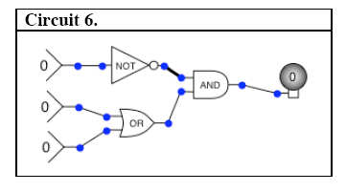

Input 1 | Input 2 | Input 3 | Output
0 | 0 | 0 | 0
0 | 0 | 1 | 1
0 | 1 | 0 | 1
0 | 1 | 1 | 1
1 | 0 | 0 | 0
1 | 0 | 1 | 0
1 | 1 | 0 | 0
1 | 1 | 1 | 0

