Computer Science: An Overview
Ninth Edition Activities
Chapter 1, Data Storage
Lab 1: Digital Gates
Part B – Flip-flops
Lab Report Date: 9/18/08
Name: Matthew Morrissey Section: CS101

Procedure
Start the LogicGates applet and carry out the instructions below. This lab will cover the flip-flop circuits from Chapter 1 that store single bits.
A flip flop is memory circuit that stores one bit. These circuits can be set to 0 or 1 and retain their values despite some changes to their input.

Stage 1. A non-erasable circuit
In this stage we will start with a circuit that is not a flip-flop, but illustrates a circuit that remembers if it has ever been set to an output of 1. It has an output of 0 until its single input is 1 – then, after that, its output remains 1 even if the input is changed back to 0. This is a non-erasable circuit – you can write a 1 value into it once, but having done so, you can’t change it. Note that in this circuit one connector goes over the OR gate, which is OK.

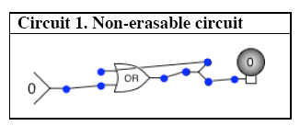

Build this circuit and then run it, setting the input to 1. What happens? Then reset the input back to 0 and try it. What happens now? Describe what happens and explain why the circuit remains at 1 despite changes to its input.

Once you change the single input to 1 the OR gate will return a 1, and since the output is continuously cycled back to the input it will always remain 1. Changing the input from 0 to 1 and back will make no difference since it is an OR gate and does not care if both inputs are 1, it will return 1 as long as at least one of the inputs is 1.
Stage 2. An OR/AND/NOT flip-flop
In this stage you will test the flip-flop circuit from Figure 1.4 on page 23. Build this
circuit.
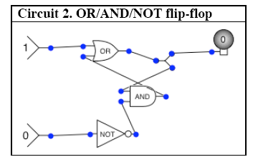
A. Set the lower input to 1 and then change the upper input back and forth between 0 and 1. What happens to the output?
The output changes from 0 to 1.

B. First set the lower input to 1 and the upper input to 0. The output light should be 0.
Now set the lower input to 0 so you should have upper as 0, lower as 0.

1. What is the value of the output? 0

2. What happens when you switch the upper input from 0 to 1?
The light bulb turns on.

3. What happens when you switch the upper input back from 1 to 0?
The light bulb stays on.

4. What is the similarity between this flip-flop and the Non-erasable circuit in Stage 1?
Once you set the upper input to 1 the output changes to 1 and stays 1.

Stage 2. An OR/AND flip-flop
In this stage you will test the flip-flop circuit from Figure 1.5 on page 24. Build the circuit below.
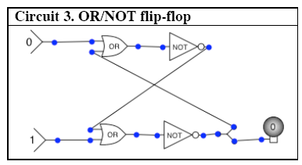

Now investigate this circuit to figure out how it works.
What happens when you hold the lower input to 0 and change the upper input?
Instead of flickering on and off the light bulb remains on.

What happens when you hold the lower input to 1 and change the upper input?
The light bulb goes off and remains off.

How does this flip-flop work? Does it work exactly the same as the OR/AND/NOT flipflop?

No, once the output is changed to 0 in this flip flop it can't be changed back.

