Data Architecture Comparison – Benchmark Report
Generated: 2026-02-07 11:24:37

Scope
This report summarizes a single-run benchmark across four sandbox architectures (typed TypeScript, DBT/SQL, Drizzle ORM, and Cube semantic layer) for seven models. Each model was run once across all sandboxes with three tasks: ARPU, churn rate, and LTV.

Method
For each sandbox, the model must read context files and write the required function/model/measure. Validation executes the model output against the same JSON-backed data. Pass/fail is determined by a numeric tolerance for each metric.
Fairness adjustments in the harness include: DBT validation accepts common filename variants; Cube validation no longer injects default filters; Drizzle runs against a rebuilt better-sqlite3 binary.

Results Summary
Each cell shows pass count out of 3 tasks for the model and sandbox.
Model | typed | dbt | drizzle | cube
google/gemini-3-flash-preview | 0/3 | 1/3 | 0/3 | 0/3
moonshotai/kimi-k2.5 | 2/3 | 0/3 | 3/3 | 3/3
z-ai/glm-4.7 | 3/3 | 2/3 | 0/3 | 1/3
minimax/minimax-m2.1 | 0/3 | 0/3 | 0/3 | 0/3
x-ai/grok-code-fast-1 | 3/3 | 1/3 | 3/3 | 1/3
arcee-ai/trinity-large-preview:free | 3/3 | 0/3 | 0/3 | 0/3
qwen/qwen3-coder-next | 3/3 | 0/3 | 1/3 | 1/3

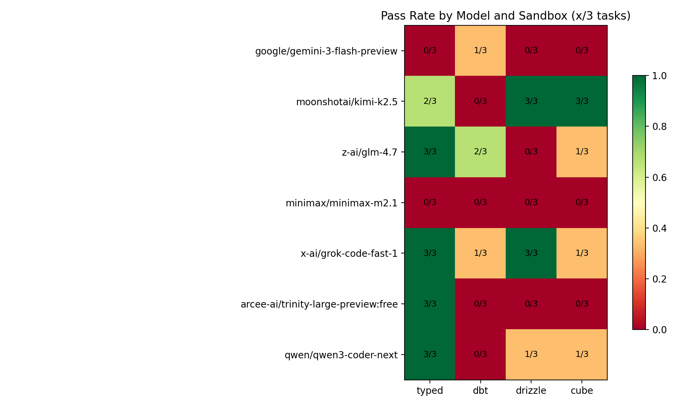

Key Observations
- Tool-use compliance varies by model: some models repeatedly returned no tool calls, leading to max-turn failures.
- DBT can pass (e.g., GLM 4.7 and Grok Code Fast), but some models stall or use invalid table names.
- Drizzle and Cube performance is model-dependent; Kimi performed strongly on both, while others struggled with syntax or measure definitions.
- Typed functions are generally reliable for stronger code-focused models (e.g., Grok, Qwen, GLM).

Limitations
This is a single-run snapshot per model; variance can be significant. For statistically robust conclusions, repeat runs per model are recommended.

