Data Architecture Comparison – Detailed Benchmark Write‑Up
Generated: 2026-02-07 11:46:30
Repository: this report assumes the codebase is accessible via GitHub, and references file paths within the repo so reviewers can inspect the implementation directly.

1. Purpose and Research Question
This benchmark asks whether the choice of data architecture (typed TypeScript, DBT/SQL, Drizzle ORM, or Cube semantic layer) affects a model’s ability to implement analytics tasks correctly. The goal is not to compare business logic choices, but to compare how effectively models can navigate and use different data contexts.

2. Repository Layout (Key Paths)
Core harness and sandbox definitions:
• scripts/modular-benchmark.ts – orchestrates runs, tool use, validation, and summary output
• sandboxes/typed/sandbox.config.ts – typed TypeScript sandbox config & validator
• sandboxes/dbt/sandbox.config.ts – DBT/SQL sandbox config & validator
• sandboxes/drizzle/sandbox.config.ts – Drizzle ORM sandbox config & validator
• sandboxes/cube/sandbox.config.ts – Cube semantic layer sandbox config & validator
Data for all sandboxes: data/*.json

3. Tasks and Expected Outputs
Three metrics are evaluated across all sandboxes:
• ARPU (Average Revenue Per User): total paid invoice amount / unique paying customers
• Churn Rate: active subscriptions with cancel_at_period_end=true / total active subscriptions
• LTV (Average Customer LTV): average of per‑customer paid revenue totals
Expected values are computed directly from data/*.json within scripts/modular-benchmark.ts and used for validation.

4. Model Interaction Protocol
Each sandbox provides a system prompt and task prompt, and the model must use a constrained tool interface: read_file, write_file, list_files, done. The harness enforces tool use and re-prompts when the model fails to use tools. If the model never completes within max turns (default 20), the task is marked as failed.

5. Validation Mechanics (Per Sandbox)
Typed (TypeScript):
• Model writes a function in src/analytics/queries.ts
• Validator imports the function and executes it against JSON data
• Pass if numeric result within tolerance
DBT (SQL):
• Model writes a SQL file in models/staging/
• Validator runs SQL in DuckDB with JSON tables
• Pass if numeric result within tolerance
• Filename matching is relaxed to accept common variants (e.g., stg_arpu.sql, stg_stripe_arpu.sql, etc.)
Drizzle (ORM):
• Model writes async function in src/queries.ts
• Validator loads SQLite in‑memory DB populated from JSON and executes function
Cube (Semantic Layer):
• Model adds a measure in src/cubes.ts
• Validator extracts SQL from measure definition and executes in DuckDB
• Note: Validator does not inject default filters; measures are evaluated as written

6. Fairness Adjustments and Known Fixes
To reduce architecture bias caused by test harness issues, the following adjustments were made:
• Cube validator removed auto‑filter injection (status=paid/active), so measures are not silently corrected.
• DBT validator relaxed file name matching to accept common variants.
• Drizzle better-sqlite3 native module rebuilt for current Node version.

7. Results Summary (Single Run per Model)
Each cell shows pass count out of 3 tasks for a model and sandbox.
Model | typed | dbt | drizzle | cube
google/gemini-3-flash-preview | 0/3 | 1/3 | 0/3 | 0/3
moonshotai/kimi-k2.5 | 2/3 | 0/3 | 3/3 | 3/3
z-ai/glm-4.7 | 3/3 | 2/3 | 0/3 | 1/3
minimax/minimax-m2.1 | 0/3 | 0/3 | 0/3 | 0/3
x-ai/grok-code-fast-1 | 3/3 | 1/3 | 3/3 | 1/3
arcee-ai/trinity-large-preview:free | 3/3 | 0/3 | 0/3 | 0/3
qwen/qwen3-coder-next | 3/3 | 0/3 | 1/3 | 1/3

8. Charts
Matrix heatmap of pass rates (x/3 tasks):
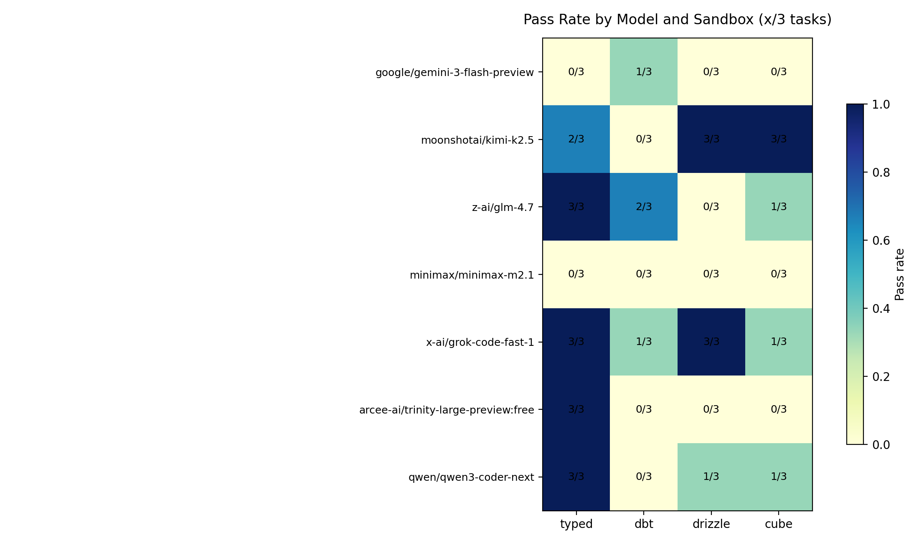
Total passes per model (out of 12 tasks):
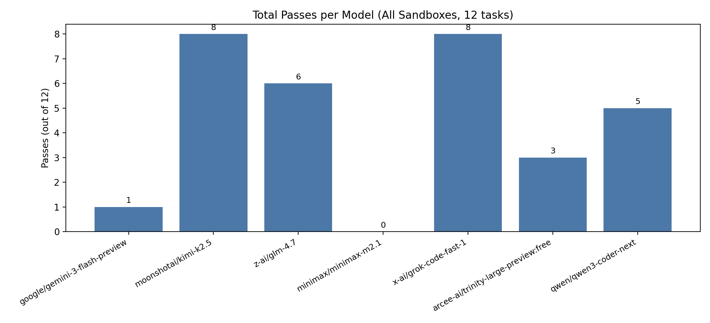
Total passes per sandbox (across 7 models, out of 21 tasks):
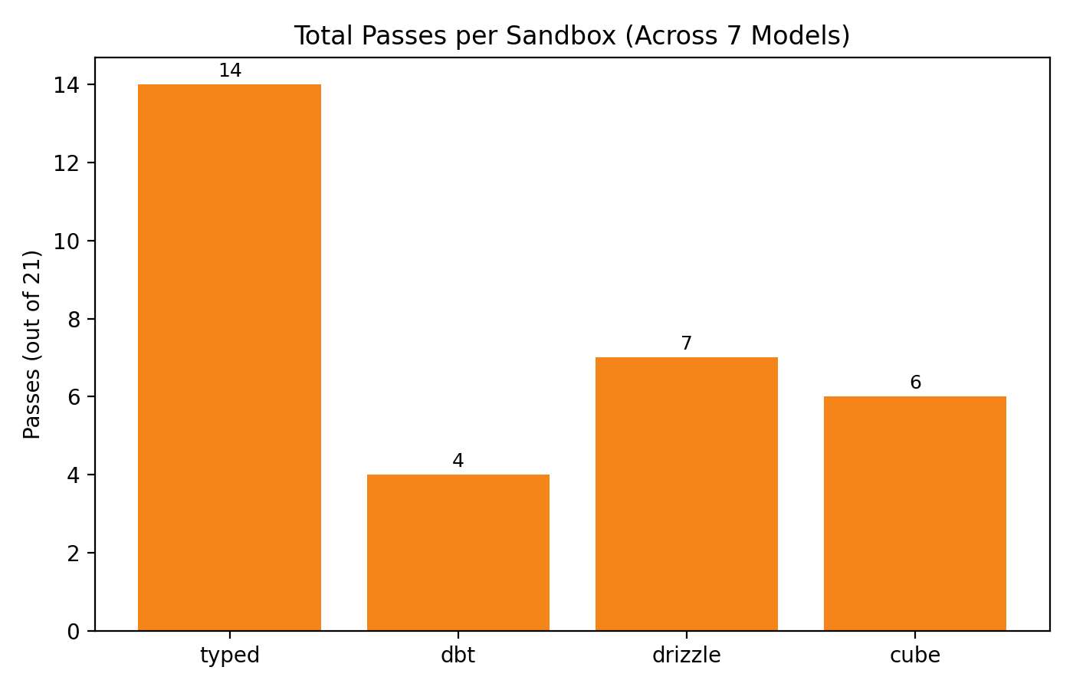
Pass breakdown per model by sandbox:
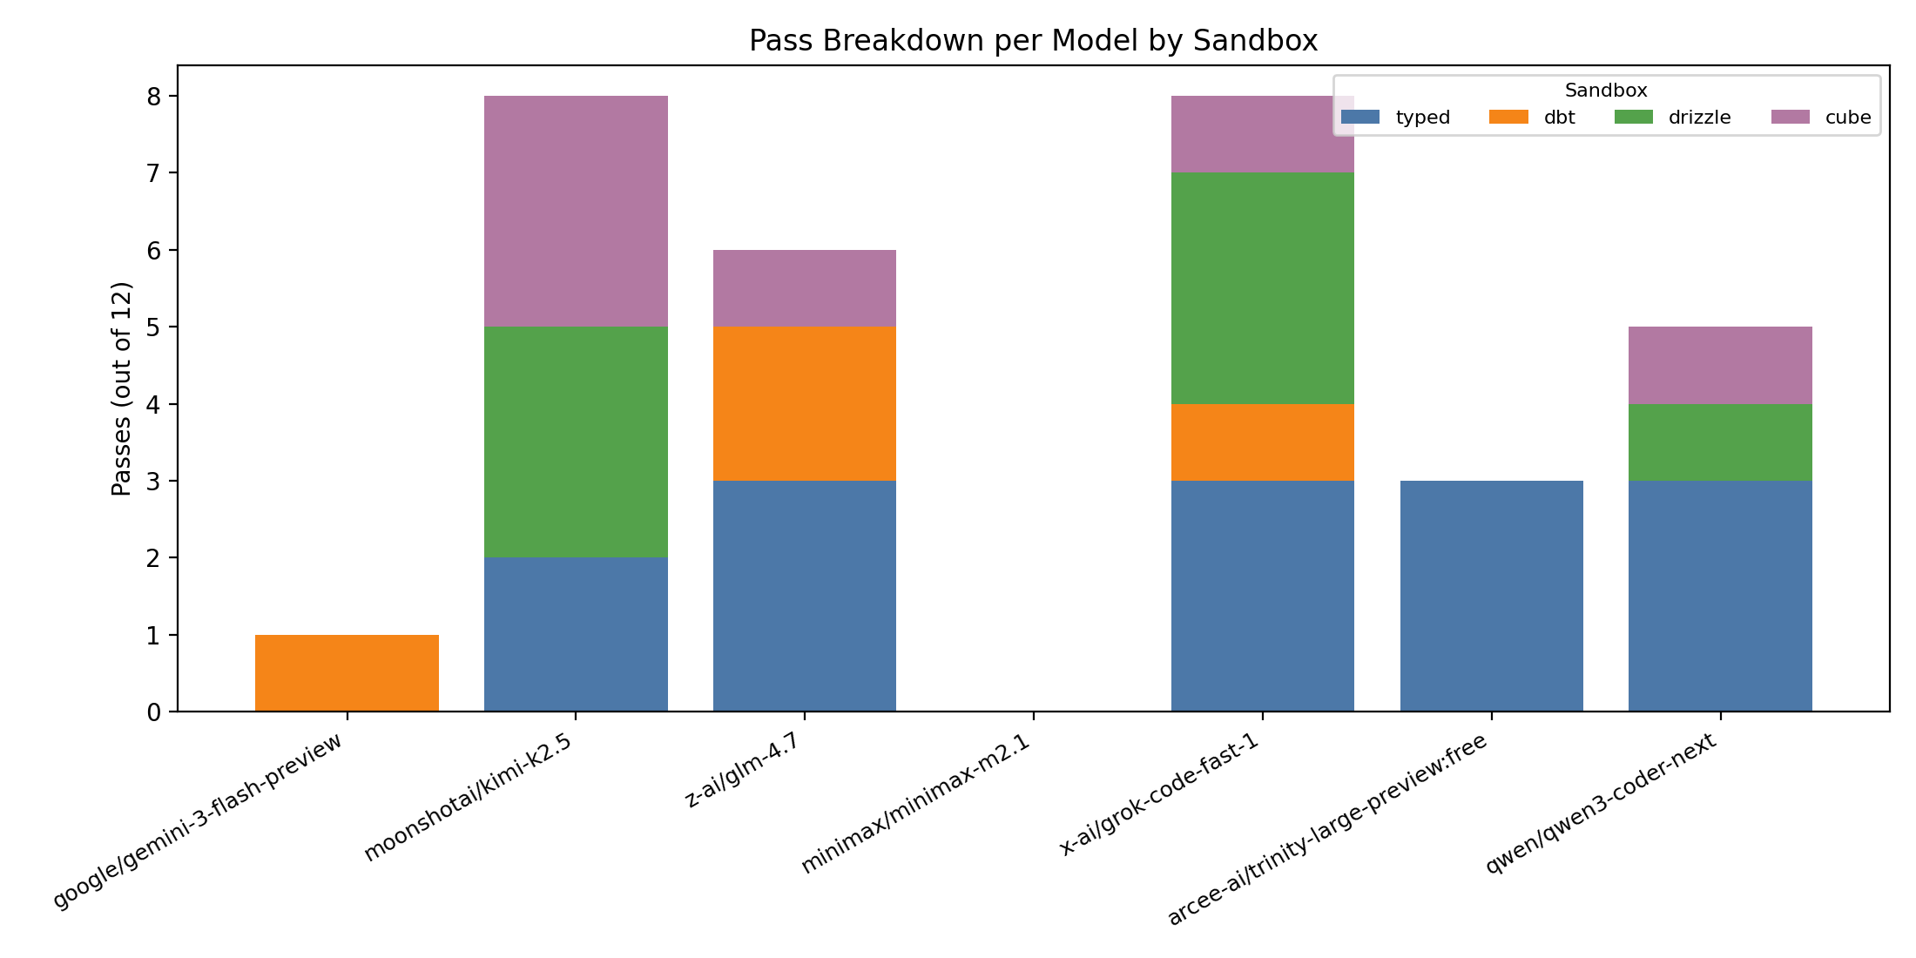

9. Key Observations (Qualitative)
• Tool compliance varies widely. Some models repeatedly output no tool calls, leading to max‑turn failures.
• DBT performance is sensitive to table naming and schema‑prefix assumptions (e.g., raw_stripe.* or stripe_invoices).
• Drizzle and Cube are more sensitive to syntax/DSL correctness than plain SQL or JS.
• Typed TypeScript tends to be robust for code‑centric models but can still miss filters or grouping logic.

10. How to Reproduce
From repo root:
• node --experimental-strip-types scripts/modular-benchmark.ts --sandbox=all --model=<MODEL_ID>
• Requires OPENROUTER_API_KEY or ANTHROPIC_API_KEY depending on model provider.
• Each run writes artifacts to sandbox-runs/. Clear it between runs to avoid disk exhaustion.

11. Limitations and Critique Points
• Single‑run snapshots are high variance; multi‑run averages are needed for robust comparisons.
• Some models do not follow tool‑use constraints; this conflates model capability with tool‑use compliance.
• Cube validation extracts SQL via heuristics; non‑standard measure definitions can lead to false negatives.
• DBT validation executes SQL directly in DuckDB rather than compiling a DBT project; this omits dbt-specific context.
• Typed validation runs TS via type‑stripping; it does not enforce compile‑time type correctness.

12. Recommendations for Future Iterations
• Run N≥5 repetitions per model to reduce variance and compute confidence intervals.
• Track a separate “tool compliance” metric to isolate tool‑use failures from logic failures.
• Add automated error categorization to the main harness output for easier analysis.
• Consider adding a “strict mode” for Cube to require explicit SQL or standardized measure templates.

