MEMORANDUM
Kanawana Wiki Project · Research Memorandum KWP-2026-09-24-LOOKOUT
TO Matt Aronson, Kanawana Wiki Project
FROM Kanawana Wiki research pipeline
DATE 24 September 2026
SUBJECT The Lookout (also "Charlton Lodge," also the "Seniors’ Log Club-House"): what is documented, what is tradition, and where to look next
STATUS Preliminary. Sixteen sources. No construction date established.

1. In brief
The Lookout is a log building on the slope above the swimming beach at Camp Kanawana, fifteen to twenty metres up from the water and just above the lower road, in what is today the Pathfinders section for senior girls. It is held at camp to be the oldest building on the property, and camp tradition makes it the farmhouse in which the search committee sheltered from a snowstorm in the winter of 1910 and from which, the next morning, they first saw the lake that became Lake Kanawana.
A photograph supplied to this project on 24 September 2026 gives the building two names it carries in no other source held here: "Charlton Lodge" and "Seniors’ Log Club-House." Both names are traceable, and both point at the same man. R. L. Charlton chaired the committee that found the site, proposed the name Kanawana, and in 1923 was reported in the camp’s own paper to be arranging a Senior Log Cabin.
Two findings and one failure come out of the work summarised here. First, the name "the Lookout" is documented continuously from 1932 to the present, in nine sources, four of them earlier than the 1962 map that had been thought to be the first use. Second, the same building can be identified in the same position on five camp maps drawn across ninety-seven years, from 1928 to 2025. Third, and this is the failure, nothing in the corpus dates the building. Two readings of the evidence survive every document the project holds, and they disagree about whether the Lookout is older than the camp or younger than it by a decade and a half.

2. What a reader needs to know first
Camp Kanawana is the oldest residential summer camp in Quebec. The YMCA of Montreal founded it in 1894 as Camp Jubilee at Lake Saint-Joseph, moved it to a property at Saint-Sauveur-des-Monts in 1910, and has run it there ever since. The camp today belongs to the YMCAs of Québec. Almost nothing physical survives from the beginning. The dining hall on the site dates to 1920, the Lodge to 1927, and the first sleeping cabins, the Bantams, to 1936. A building that predates any of those is therefore unusual, and a building that predates the camp’s arrival on the land would be unique.
Three buildings are easy to confuse and are kept apart throughout this memo. The Lodge is a separate structure in the middle of camp, built in 1927 to house the library, museum, basketry room and leaders’ room. The Longhouse is the later name of what the 1951 history calls "the lower pavilion on the lake front built early," and it stood on the waterfront, not on the slope. The Lookout is the subject of this memo: up the hill from the beach, at the eastern end of camp, away from the central cluster.
One more piece of housekeeping. The YMCA of Montreal closed its books on 30 April through 1950, so an annual report titled for a given year is describing the summer before it. Dates from annual reports in this memo have been adjusted accordingly where the season matters.

3. The photograph
The print is sepia on a card mount, captioned in white ink along the lower edge in two places: "CHARLTON LODGE" — KAMP KANAWANA at left, and "SENIORS’ LOG CLUB-HOUSE" at right. It is undated. The card mount, the ink captioning and the clothing put it in the 1920s on style alone, which is an estimate and not a date.
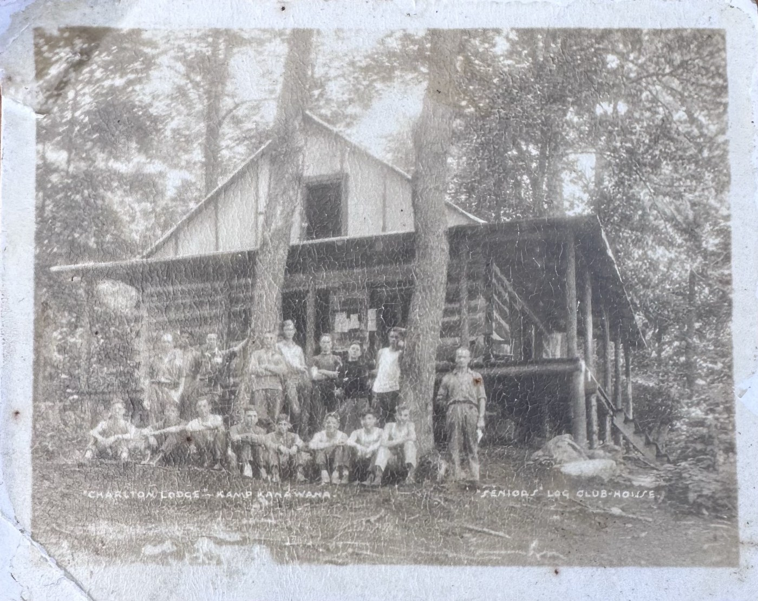
Figure 1. The building later called the Lookout, photographed as "Charlton Lodge," the Seniors’ Log Club-House. Note the deep verandah under the overhanging roof, the steps climbing to it at the right, and the notices pinned to the wall behind the rail. Undated, probably 1920s.
The photograph shows a two-storey log building on a slope, gable end toward the camera, with a deep verandah running the length of one side beneath an overhanging roof and a flight of steps climbing to it at the right. Roughly twenty people are arranged in front, standing and seated on the ground: young men in shirtsleeves, several women or girls, and one figure at the right in breeches and high boots. Notices are pinned to the wall behind the verandah rail, which is what a section noticeboard looks like before anybody calls it that. Mature trees rise through the frame on either side.
Figure 2. The caption strip, enlarged. Two names, one photograph, and the only surviving instance of "Charlton Lodge" anywhere in this project’s 1,020 source texts.
Three details in the image match three separate documents. The verandah matches the "veranda rail of the Lookout at Senior Camp" described in 1940. The log construction matches the "Senior Log Cabin" Charlton was arranging in 1923. And the word "Seniors’" in the caption matches the building’s position inside the area the 1928 camp map labels Senior Camp. The photograph is the hinge that joins those three records into one building.

4. R. L. Charlton, and why a building would carry his name
R. L. Charlton was a Montreal marine surveyor. He was elected founding Treasurer of the Canadian Board of Marine Underwriters in March 1917, and the record of that meeting describes him as "an ardent YMCA worker." He went to France with the YMCA during the First World War. His involvement with this camp was not incidental or late. He sat on the YMCA of Montreal’s Training Classes committee in 1892-93 alongside D. A. Budge and W. H. Ball; he chaired the Junior Department, which is to say boys’ work, in the year Camp Jubilee was founded in 1894; and he sat on the first Summer Camp committee that same year with John W. Ross and E. J. Coyle.
Three things then make him the obvious person for a building to be named after.

He found the site
The camp’s own 1951 history gives the account:
"Early in 1910 a Committee under the Chairmanship of Mr. R. L. Charlton was constituted to look for a new site for the boys’ camp… During the late winter months of 1910 Mr. Charlton and his Committee of Messrs. R. B. Ross Jr. and L. Cushing made a trip to the Laurentians to choose the camp site. After some searching the group arrived at St. Sauveur and commenced to walk at night over the hills to Lac Marois. Running into a rain and snow storm the Committee lost its way and stayed overnight at a farmhouse. The next day the country was explored and Lake St. Louis, the present site, was located."
That paragraph is the camp’s founding story in its earliest connected form, and it is the passage on which the whole question of this building turns. Note what it does not say. It does not say where the farmhouse was. It places the party walking over the hills toward Lac Marois when they lost their way, which is some distance from the eventual site, and it reports the discovery of the lake as the next day’s work rather than as a view from a window. The claim that the committee looked out of this particular farmhouse and saw the lake comes from camp tradition, not from this document.

He named the camp
The same source: "A great deal of thought was given to choosing a name for the camp. Mr. Charlton suggested Kanawana which was like the name of a Furness Steamer." Whether a Furness Line steamer of that name existed is a separate open question in this project and is not settled.

He got this building
The Gas-Bag Extra, Kamp Kanawana’s official paper, Volume 13 Number 1, 1923, under the heading SENIOR CABIN: "Mr. R. L. Charlton reports that he hopes to complete arrangements for a Senior Log Cabin. On rainy nights the Cabin, with a roaring fire throwing out its warmth and comfort, will be more than welcome." The word arrangements is doing a great deal of work in that sentence, and section 7 below returns to it.
Charlton was still writing about the camp when it was fifty years old. His manuscript "Notes re Early Days of YMCA Camps at Lake St. Joseph and Kanawana," dated 1943, survives in the Concordia archives and has never been read by this project.

5. The name, traced from 1932 to 2025
The building is called the Lookout in nine documents spanning ninety-three years. Four of them predate the first map to carry the name, which corrects an earlier working assumption in this project that the 1962 map was the first use.
Year | Source | What it says
1932 | The Green Triangle, 20 August | "After determining and getting the course from the Lookout, ten valiant braves wandered their way past the ball field"
1940 | The Green Triangle, 27 June | "the veranda rail of the Lookout at Senior Camp"; "armchairs on the Lookout veranda"; "the Senior Section invites the whole camp to the Lookout for fun, games and stuff… and the Lookout band"
1952 | YMCA of Montreal annual report | "Kamp Kanawana: …new roof on gallery and new steps at the Lookout"
1962 | Camp map | "LOOK OUT" lettered on a signboard beside a building
1974 | Camp orienteering map | "Lookout" among the numbered features
1976 | Director’s report | "repairing and replacing balconies on the chief’s cabin, lookout and grand portage"
1980–2001 | Site map | "LOOKOUT," above the Beach & Swimming Waterfront
2007–2010 | Dining hall plaques | "Lookout" as the senior girls’ section name; a 2008 board reads "To the women that filled the lookout with love and friendship"
2025 | Camp facilities list | F18, Lookout, marked restricted access
Sources in row order: 1932, 1940, 1952, 1962, 1974, 1976, 1980–2001, 2007–2010, 2025.
Two things in that table are worth drawing out. The 1932 use is navigational. A hiking party gets its course from the Lookout, which is what you do from a vantage point and not from a clubhouse. The name is behaving in 1932 exactly as the origin story says it should, seventy-odd years before anyone wrote the story down for this project.
Three separate records across thirty-six years describe the same architectural feature. A veranda in 1940, a gallery in 1952, balconies in 1976. All three are the porch in Figure 1, called by three different words by three different writers, and their survival across that span means the building kept its defining feature through at least two rounds of repair.

Two names, and a pattern this camp repeats
"Charlton Lodge" appears once, on a formal photographic caption. "The Lookout" appears in the campers’ own newspaper, in the association’s maintenance ledger, on the maps, and on the plaques. That split is familiar at Kanawana. The dining hall was formally renamed Salle Julien Tassé after the camp’s caretaker of some thirty years died in the early 1990s, and the name never entered ordinary use; everyone went on calling it the dining hall. A dedication name and a use name can live side by side for decades, and the dedication name is usually the one that disappears. Charlton Lodge went the same way, with one difference: it went so completely that until September 2026 this project had never heard it.

6. Where it stands, read across five maps
The Kanawana maps are pictorial rather than surveyed, so they support no measurement. What they do support is topology. Anchoring on two features that appear in the same relation on every sheet, Snowshoe Lake off the northeast corner and the northeast shore of the lake itself, puts the same structure in the same place on all of them.
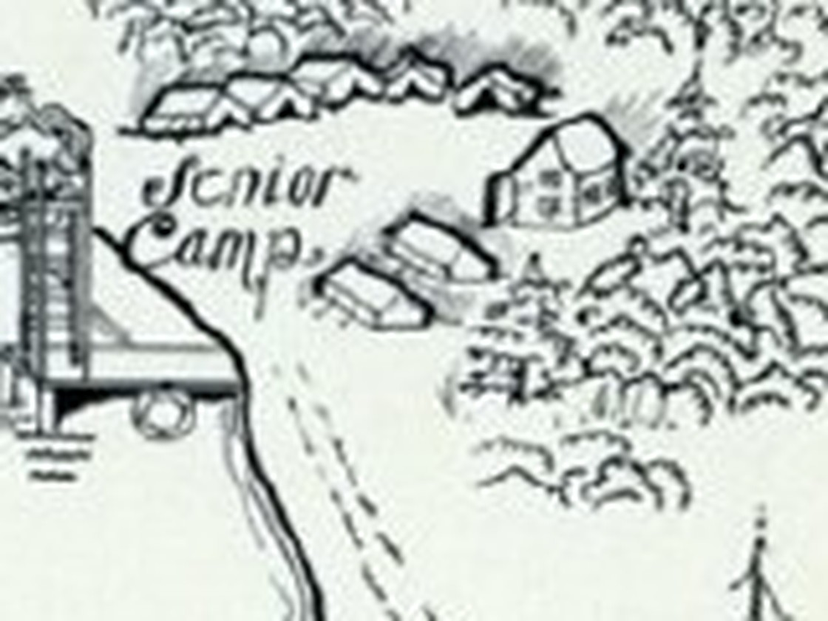
Figure 3. The 1928 Kamp Kanawana map, enlarged eight times on the east end of the Senior Camp cluster. A substantial gabled building with windows drawn on two faces stands above the waterfront, east of the senior tent row, with open ground running east toward Snowshoe Lake. It is the easternmost structure of the camp proper and the only building in that cluster drawn as architecture rather than as a tent. It carries no name.
The omission on the 1928 sheet is meaningful, because that map names buildings when it wants to. "Craftshop" is lettered beside its icon a few hundred feet west. The 1941 map is the same plate reissued, so it adds nothing and subtracts nothing.
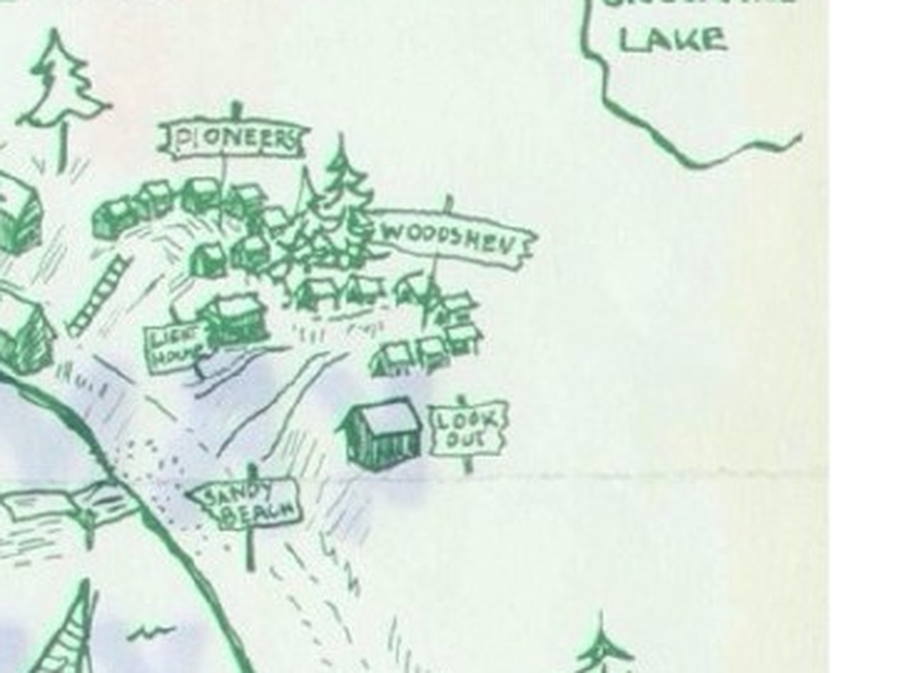
Figure 4. The 1962 map, enlarged four times. The "LOOK OUT" signboard stands beside a building in exactly the 1928 position: east of the Woodsmen cluster, above Sandy Beach, the same open ground to the east.
The 1962 map does something else worth noticing. It carries a numbered legend of nine buildings: 1 Craftshop, 2 Lodge, 3 Long House, 4 Dining Hall, 5 Business Office, 6 Chief’s Cabin, 7 Pump House, 8 Windward Ho!, 9 Sanctam. The Look Out is not among them. It is signposted instead, in the style the map reserves for Farewell Rock, Parliament Rock, Frog Bay, Lost Cabin and Sandy Beach. The cartographer treated it as a place rather than as an item on the building list, which is either a reflection of how campers spoke about it or a hint that whoever drew the map did not think of it as one of the camp’s buildings.

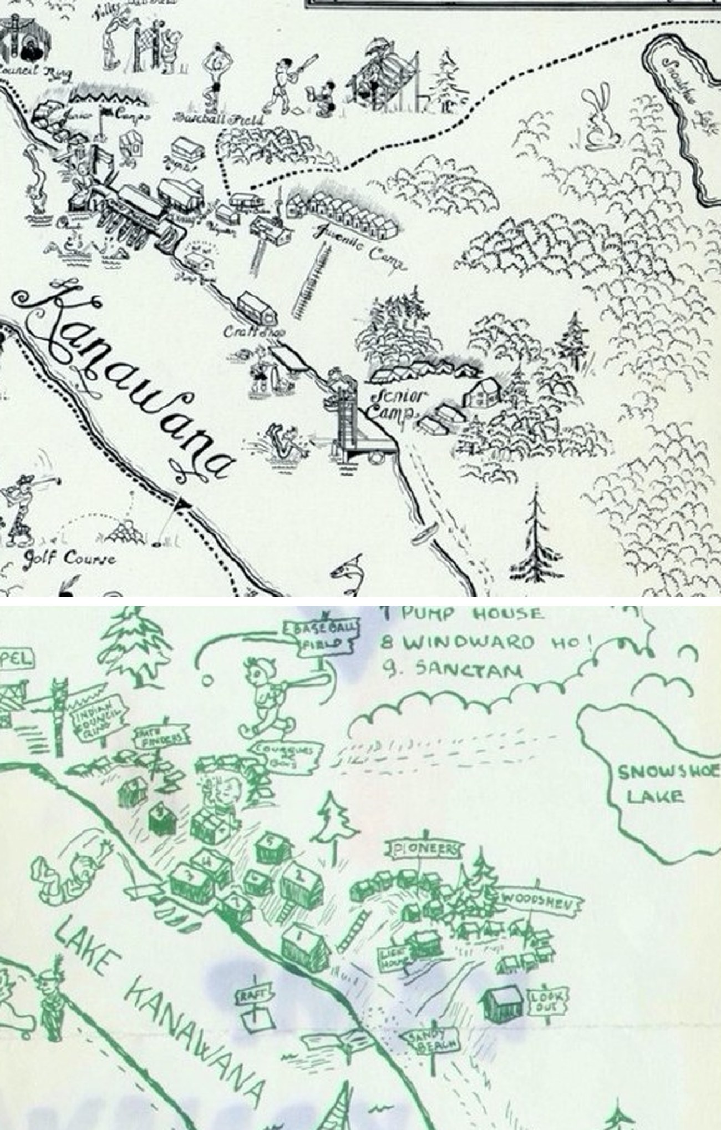
Figure 5. The 1928 map above, the 1962 map below, the same stretch of the northeast shore. The two sheets are at different scales and are aligned here on Snowshoe Lake, visible at the right of both. The gabled building at the east end of Senior Camp in the upper frame and the signboarded building above Sandy Beach in the lower frame occupy the same position relative to the shoreline, the tent or cabin rows to the west, and the open ground to the east.
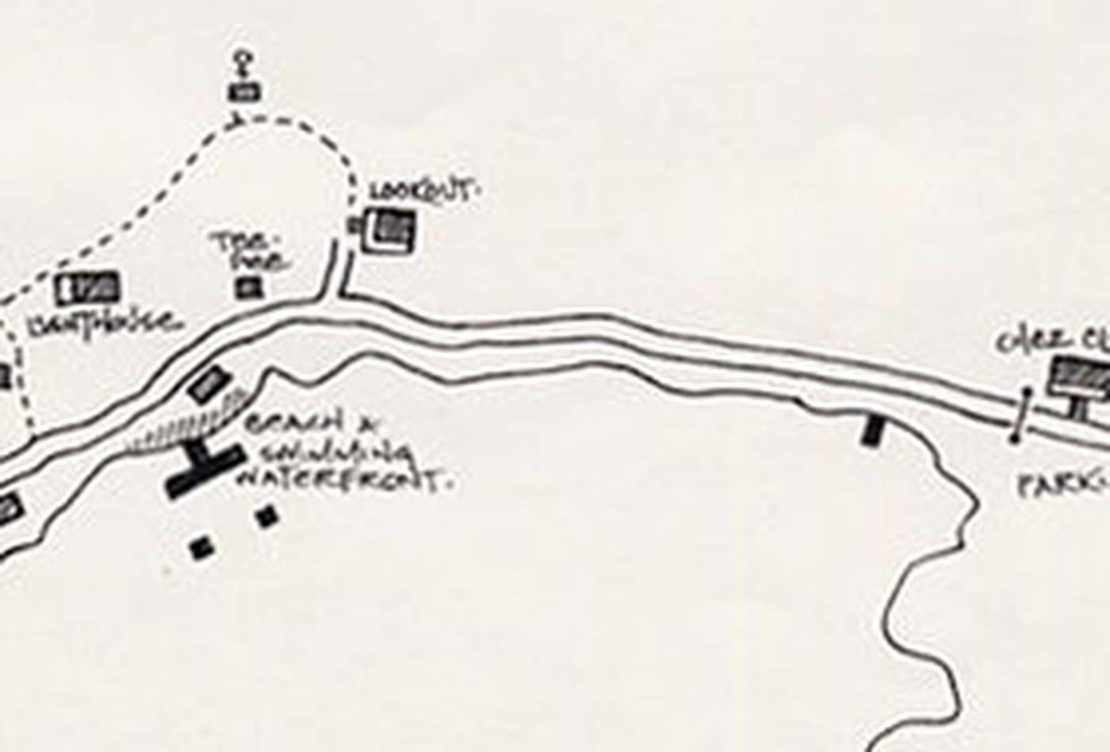
Figure 6. The site map in use from about 1980 to 2001. The Lookout is labelled directly up the slope from the Beach & Swimming Waterfront, with the Lighthouse and Tee Pee to its west and the road running between it and the shore.
On the 2025 map the same building is F18, at the east end between zone 6 (Pathfinders) and zone 7 (Leaders in Training), above the shore road, drawn with the restricted-area symbol. Ninety-seven years of maps put one building in one place, under no name, then a signboard, then a label, then an inventory number.

7. How old is it? Two readings, and why the record cannot choose
Nothing read so far dates the building. What the record gives is a frame, and the frame is worth setting out in order.
1913. The association describes its new Saint-Sauveur property: "A dining room, kitchen, with tents, boats, etc., is now provided, and the Committee is endeavoring to secure a pavilion for use as club and boat house." No club house at Kanawana, and one wanted.
1921–1923. The camp brochures describe two pavilions, one for dining and one for recreation in wet weather. No senior club house.
1923. The Pictorial Review, in the same issue of the Gas-Bag Extra as the Senior Cabin notice, captions a photograph "Senior Tent-site": white wall tents pitched among trees.
1923. Charlton "hopes to complete arrangements" for a Senior Log Cabin.
1928. A substantial building stands at the east end of Senior Camp.
1932. "The Lookout" is a named place, used for navigation.

Reading one: built or converted between 1923 and 1928
The 1913 committee wanted a club house and did not have one. The 1922 and 1923 brochures list two pavilions and no senior club. The 1923 pictorial review shows the seniors under canvas. Charlton arranges something in 1923, and by 1928 a building is standing where no building is otherwise attested. On this reading the Lookout went up in the middle 1920s, it is not the oldest building at camp, and the tradition that it predates the camp is simply mistaken, in the ordinary way that camp traditions drift.

Reading two: a Pagé farmhouse, standing since before 1910, converted in the 1920s
The YMCA bought the Saint-Sauveur property from the Pagé family around 1910. A farmhouse already standing on that land would appear in none of the documents listed above, because each of them is a list of what the camp provided or built. An annual report accounts for expenditure and for new plant. A brochure sells the season’s facilities to parents. Neither has any reason to mention an old farm building sitting unused at the far end of the property. And Charlton’s word in 1923 is arrangements, which is the right word for securing and fitting out an existing structure and the wrong one for raising a new one. On this reading the tradition is right, and the building Charlton sheltered in during the storm of 1910 is the building the camp later named for him.

What separates them, which is nothing yet
Both readings are compatible with every document this project holds. No source read so far describes the building’s construction, its conversion, its cost, or its age. The 1962 cartographer’s decision to signpost it as a place rather than list it as a building is suggestive on the second reading and proves nothing.
One caution belongs with the second reading. The camp had its own term for a Pagé building, and it is not this one. The 1969 annual report refers to "the unfinished playing field out by the Pagé farmhouse," meaning the farm the camp bought in 1960 just outside the gate, which is most likely today’s Farmhouse at the east end. If the Lookout was also a Pagé house, then the camp acquired two of them fifty years apart and reserved the family name for the later one. That is possible, and it is the kind of thing that happens when the people who knew the first name have left. It is also exactly what you would expect if the first building was never a Pagé house at all.

8. Why the building matters either way
If the tradition is right, the Lookout is older than the camp’s presence on the land, and it is the only structure at Kanawana connected to the moment of the camp’s founding rather than to its subsequent growth. It would be the room in which the decision to buy this particular lake was effectively made, still standing, still in use.
If the tradition is wrong, the building is still named for the man who chaired the search that found the site and who proposed the name the camp has carried for more than a century. It is still among the oldest buildings on the property, older than every cabin. It served as the senior section’s gathering place from at least 1940, when it had a veranda, armchairs, an open invitation to the rest of camp, and a band of its own. It gave its name to a section, and that section’s campers put the name on a dining hall plaque in 2008.
The photograph adds a third thing, which is a lost name. A building at this camp was once formally called Charlton Lodge, and the project had no record of it until a print surfaced in a private collection. That is worth stating plainly as a caution about the rest of the corpus: the written record at Kanawana is thin enough that a single photograph can restore a name nobody had.

9. Where to look next
The following are in rough order of how likely they are to settle the construction question. The first two would settle it outright.
A. The 1915 hand-drawn property sketches
Where: Concordia University Records Management and Archives, YMCA of Montreal fonds P145/12B03, "Land, facilities, equipment, supplies." On site, Concordia Library, Montreal; consultation by appointment.
Why: Decisive. A building drawn on that knoll five years after the purchase means the farmhouse reading is right. Its absence from a sketch that shows the rest of the property means construction in the 1920s. Nothing else in the known record does this job. While in the same file, note the 1919 dining and kitchen pavilion blueprint with its covering letter, the 1928 boathouse construction records, the 1937 trail mapping, the ice-house blueprints of about 1929 in Box HA2313 with undated Lodge and boat-dock drawings, and the 1940, 1945 and 1952 building drawings in Box HA2694.
B. The Ross & Macdonald drawings
Where: Canadian Centre for Architecture, Ross & Macdonald fonds AP013, Montreal. AP013.S1.D37 (CCA object 48095), "YMCA Boy’s Camp buildings," 1913–1914, five working drawings. Consultation in the CCA Study Room by appointment.
Why: The association was commissioning architectural work at Saint-Sauveur within three years of the purchase. If the 1913–1914 set includes a club house, the 1913 annual report’s wish was acted on early and reading one gains a decade. If the five drawings are all dining hall, kitchen and service buildings, the senior club house was a later and separate problem. Also worth pulling in the same visit: AP013.S1.D46 (48710), the 1919 Dining and Kitchen Pavilion, six drawings, which would confirm the 1920 dining hall date; and AP013.S1.D67 (50576), the 1921 Doctor’s Cottage, three drawings.
C. Charlton’s own 1943 manuscript
Where: Concordia, P145/12A, Box HA1881: R. L. Charlton, "Notes re Early Days of YMCA Camps at Lake St. Joseph and Kanawana," 1943.
Why: The man who chaired the search, writing thirty-three years later, with no reason to leave out the night of the storm. If he describes the farmhouse, or describes what he arranged in 1923, this is the closest thing to a witness the project will ever get. Read alongside Ralph Dawson’s "History of Kamp Kanawana," 1933, in Box HA2307, and W. E. Cushing’s "Historical sketches," 1943, in P145/12L.
D. The Pagé land records
Where: Concordia P145/12B03, "KK land purchase — Pagé farm, 1960–1961," for the later purchase; and for the original, the Registry Office for the registration division of Terrebonne (Bureau de la publicité des droits), plus the Saint-Sauveur cadastral plans at Bibliothèque et Archives nationales du Québec, Vieux-Montréal.
Why: A deed of sale for the 1910 purchase would ordinarily describe what stood on the land. Cadastral plans of the period sometimes show structures. This is slower than the archive work above and does not depend on anyone having written a camp history.
E. Insurance valuations and fire schedules
Where: Concordia P145, association finance and property records; and the Goad and successor fire insurance plans at BAnQ and Library and Archives Canada for rural Terrebonne coverage.
Why: Insurance schedules list buildings individually with construction type and year. A YMCA property schedule from the 1920s or 1930s that lists the senior club house with a build year would settle the matter as cleanly as the 1915 sketches.
F. The Green Triangle and Gas-Bag runs, read forward from 1923
Where: Concordia P145, camp periodicals. The project holds scattered issues; the runs are longer than what has been cached.
Why: A camp newspaper reports its own construction. The issues between 1923 and 1932 are the likeliest place for a sentence describing the cabin going up, being fitted out, or being dedicated, and for the first use of "Charlton Lodge" in print. This is the highest-yield reading task that needs no travel beyond the reading room.
G. Dated photographs
Where: Concordia P145 photographic series; the camp’s own historical album; and alumni collections.
Why: The print in Figure 1 is undated. A dated print of the same building, or a dated print of the Senior Camp area showing the ground where it stands either occupied or empty, brackets the construction without any text at all. Photographs of the senior tent site after 1923 would be particularly useful.
H. The building itself
Where: Camp Kanawana, Saint-Sauveur. The 2025 facilities list marks F18 as restricted access, so this needs the camp’s permission.
Why: Log construction is datable. Corner joinery, sawn versus hewn timber, nail types, sill and foundation work, and any surviving milled lumber in the verandah frame would separate a farm building of the 1890s or 1900s from a YMCA project of the middle 1920s. Dendrochronology on a core sample would date the felling of the logs outright. This is the one line of inquiry that does not depend on the archives having kept anything.

Questions that remain open regardless
Was the farmhouse of the 1910 storm on the property at all? The 1951 history places the party walking over the hills toward Lac Marois when they lost their way and does not locate the farmhouse. When did "Charlton Lodge" fall out of use, and was it ever a formal dedication? No minute, plaque or programme naming it has been found. And what is the building used for now, and why is it marked restricted on the 2025 map?

10. Note on method and on corrections
This memo rests on sixteen sources, of which the photograph is new to the project as of 24 September 2026. Two facts that had been sitting in the knowledge base as orphans, cited by no article, carry most of the weight: the 1923 Senior Cabin notice and the 1951 account of the site search and the storm. Joining them required the photograph, which nobody had.
Three corrections were made in the course of the work and are recorded here because the reasoning was wrong and not only the conclusion. First, an earlier pass concluded from the 1913 and 1923 evidence that the "pre-existed the camp" tradition was probably wrong; the 1910 storm and Pagé details, and the 1951 history’s own storm account, put both readings back in play. Second, this project reported that no source used "Lookout" as a building name before the 1962 map. That was false, and the table in section 5 is the correction. Third, the 1928 map’s Senior Camp building was called unnamed only after cropping and magnifying it; an earlier pass at contact scale had missed the windows that mark it as architecture rather than a tent.
Searches run with null results are listed in the notes rather than left unrecorded, so that a later pass can tell the difference between a source that says nothing and ground that was never covered.
Prepared for the Kanawana Wiki Project. Wiki article: wiki/site/the-lookout.md.

Oral history, the operator, 24 September 2026 (project source records src_oral_aronson_lookout_2026 and src_oral_aronson, facts f_1198 and f_1201). Covers the building’s location above the swimming beach in the Pathfinders section, its standing at camp as the oldest building on the property, the tradition of the 1910 storm and the view of the lake the next morning, and the distinction between the Lookout, the Lodge and the Longhouse.
Photograph, "CHARLTON LODGE — KAMP KANAWANA / SENIORS’ LOG CLUB-HOUSE," undated sepia print on card mount, captioned in white ink. Private collection of the operator, supplied to this project 24 September 2026. Digital copy filed at assets/images/historical/charlton-lodge-seniors-log-club-house.jpg; project source record src_photo_charlton_lodge_nd. The only attestation of the name "Charlton Lodge" in the 1,020 source texts held by this project.
The Gas-Bag Extra, Kamp Kanawana’s official paper, Vol. 13 No. 1 (1923), the SENIOR CABIN notice and the Pictorial Review plate captioned "Senior Tent-site." Concordia University Records Management and Archives, YMCA of Montreal fonds P145, camp publications (P145/12B04). Project copy cached at sources/cache/ymca-montreal-fonds/the-gas-bag-extra-vol-13-no-1.txt (src_ymf_the_gas_bag_extra_vol_13_no_1); fact f_2167.
The Green Triangle, 20 August 1932 (src_ymf_the_green_triangle_1932_08_20). Concordia P145, camp periodicals.
Oral history, the operator, 24 September 2026 (src_oral_aronson_lookout_2026).
"Kamp Kanawana History," typescript presented at a camp training course, 6 June 1951 (src_ia_kanawana_history_1951; fact f_2373). Digitised copy via Internet Archive; the paper original belongs with the Kanawana historical material in Concordia P145/12A. This is the earliest connected narrative of the 1910 site search the project holds.
The 1951 history dates "the lodge and museum" to 1927; the YMCA of Montreal annual report for 1928 describes the new building as built "to take care of our library, museum, basketry room, and leaders’ room." Concordia P145, annual reports series.
"Kamp Kanawana History," 6 June 1951 typescript (src_ia_kanawana_history_1951).
YMCA of Montreal, annual report for the fiscal year ending 30 April 1913, Summer Vacation Camps section (src_ymf_sgw_ymca_annual_report_1913). Concordia P145, annual reports series. Note that the association’s year end was 30 April through 1950, so a report titled for a given year describes the previous summer.
Photograph, "Charlton Lodge / Seniors’ Log Club-House," n.d., private collection of the operator (src_photo_charlton_lodge_nd).
Photograph, "Charlton Lodge / Seniors’ Log Club-House," n.d., private collection of the operator (src_photo_charlton_lodge_nd).
Searches run against all 1,020 cached source texts with null results: "Charlton Lodge" (no instance outside the photograph caption); "Pathfinder" within sixty characters of cabin, lodge, house or club (no matches); "Log Club House" (two matches, both the 1898 building at Lake St. Joseph, a different camp); and the McMorris thesis for lookout, Charlton or farmhouse (no matches).
The Green Triangle, 27 June 1940 (src_ymf_the_green_triangle_1940_06_27), three separate mentions in a single issue. Concordia P145, camp periodicals.
The Gas-Bag Extra, Vol. 13 No. 1 (1923). Concordia P145/12B04.
Kamp Kanawana map, 1928 (src_ymf_1928_kamp_kanawana_map), with the plate as reproduced in D. McMorris’s thesis on the camp (src_mcmorris_thesis); fact f_1811. Concordia P145/12B07, "Maps of Kanawana n.d." The 1941 map is the same plate reissued: same artist, same border, same inset.
For Charlton’s career: Canadian Board of Marine Underwriters founding records, March 1917, which name him Treasurer and describe him as "an ardent YMCA worker"; and YMCA of Montreal annual reports for 1891-92 and 1893-94 for the Training Classes committee, the Junior Department chairmanship and the first Summer Camp committee. Set out in full in the project article on R. L. Charlton.
Canadian Board of Marine Underwriters records, 1917; YMCA of Montreal annual reports 1891-92 and 1893-94.
"Kamp Kanawana History," 6 June 1951 typescript (src_ia_kanawana_history_1951).
Oral history, the operator, 24 September 2026 (src_oral_aronson_lookout_2026).
"Kamp Kanawana History," 6 June 1951 typescript (src_ia_kanawana_history_1951).
The Gas-Bag Extra, Vol. 13 No. 1 (1923). Concordia P145/12B04.
R. L. Charlton, "Notes re Early Days of YMCA Camps at Lake St. Joseph and Kanawana," 1943. Concordia University Records Management and Archives, YMCA of Montreal fonds, P145/12A, Box HA1881. Not read by this project.
The Green Triangle, 20 August 1932.
The Green Triangle, 27 June 1940.
YMCA of Montreal, annual report 1952, capital works list for Kamp Kanawana (src_ymf_sgw_ymca_annual_report_1952). Concordia P145, annual reports series.
Kamp Kanawana map, 1962, reproduced as Figure 2.6 in McMorris (src_mcmorris_thesis); fact f_1812. Concordia P145/12B07.
Kamp Kanawana orienteering map, 1974 (src_ymf_kanawana_orienteering_map_1974). Concordia P145, Kanawana programme material.
Kamp Kanawana Director’s Report 1976, maintenance section (src_ia_kanawana_directors_report_1976).
Kamp Kanawana site map, in use c. 1980 to 2001, from the Concordia historical album (src_flickr_kanawana_concordia_historical_album); facts f_1573 and f_1791.
Dining hall section plaques, 2007 to 2010, photographed at camp and recorded in this project. A 2008 board reads "To the women that filled the lookout with love and friendship."
Camp Kanawana site map and facilities list, 2025 preparation guide (src_kk_prep_guide_2025); fact f_1801.
On the dining hall and Salle Julien Tassé, see the project article on places and locations at Camp Kanawana. Tassé was the camp’s caretaker for roughly thirty years and died in the early 1990s.
Map correlation method: the Kanawana pictorial maps are not surveys and support no metric comparison. Correlation here is topological, anchored on two features that appear in the same relation on every sheet: Snowshoe Lake off the northeast corner, and the northeast shore of Lake Kanawana. Buildings are then read by their position relative to those anchors and to each other.
Kamp Kanawana map, 1928. Concordia P145/12B07.
Kamp Kanawana map, 1928. Concordia P145/12B07.
Kamp Kanawana map, 1962. Concordia P145/12B07.
Kamp Kanawana map, 1962. Concordia P145/12B07.
Correlation is topological, anchored on Snowshoe Lake and the northeast shore of Lake Kanawana; see note on method above.
Kamp Kanawana site map, c. 1980–2001.
Camp Kanawana site map and facilities list, 2025.
YMCA of Montreal annual report, year ending 30 April 1913. Concordia P145, annual reports.
Kamp Kanawana camp brochures, 1922 and 1923 (src_brochure_1922, src_brochure_1923), describing two pavilions, one for dining and one for recreation in wet weather.
The Gas-Bag Extra, Vol. 13 No. 1 (1923). Concordia P145/12B04.
The Gas-Bag Extra, Vol. 13 No. 1 (1923). Concordia P145/12B04.
Kamp Kanawana map, 1928. Concordia P145/12B07.
The Green Triangle, 20 August 1932.
Oral history, the operator, 24 September 2026 (src_oral_aronson_lookout_2026).
Kamp Kanawana Annual Report 1969 (src_ia_kanawana_report_1969), recommending work on "the unfinished playing field out by the Pagé farmhouse."
The Green Triangle, 27 June 1940.
Dining hall section plaques, 2007–2010.
Concordia University Records Management and Archives, YMCA of Montreal fonds, P145/12B03, "Land, facilities, equipment, supplies" (src_concordia_12B03); facts f_1787 and f_1813. Contents noted in the finding aid include 1915 hand-drawn property sketches; a 1919 dining and kitchen pavilion blueprint with covering letter; 1928 boathouse construction records; 1937 trail mapping; ice-house blueprints c. 1929 with undated Lodge and boat-dock drawings (Box HA2313); a 1940 sleeping-cabins drawing, a 1945 eight-boy cabin blueprint and a 1952 proposed craft shop (Box HA2694); and "KK land purchase — Pagé farm, 1960–1961." Not examined page by page.
Canadian Centre for Architecture, Ross & Macdonald fonds AP013 (src_cca_ross_macdonald); facts f_1530 and f_0573. AP013.S1.D37 (CCA object 48095), "YMCA Boy’s Camp buildings," 1913–1914, five working drawings; AP013.S1.D46 (48710), Dining and Kitchen Pavilion, 1919, six drawings; AP013.S1.D67 (50576), Doctor’s Cottage, 1921, three drawings. Fourteen drawings in all, client YMCA, location Saint-Sauveur-des-Monts. None examined.
Ralph Dawson, "History of Kamp Kanawana," 1933, Concordia P145/12A, Box HA2307; and W. E. Cushing, "Historical sketches — Lake St. Joseph," 1943, Concordia P145/12L (src_concordia_12L). Neither read by this project.
Concordia P145/12B03, "Land, facilities, equipment, supplies," Boxes HA2313 and HA2694 (src_concordia_12B03).
Concordia P145/12B03, "Land, facilities, equipment, supplies," Boxes HA2313 and HA2694 (src_concordia_12B03).
The Green Triangle, 20 August 1932.
Photograph, "Charlton Lodge / Seniors’ Log Club-House," n.d., private collection of the operator (src_photo_charlton_lodge_nd).
Camp Kanawana site map and facilities list, 2025.
"Kamp Kanawana History," 6 June 1951 typescript (src_ia_kanawana_history_1951).
Null-result searches across the 1,020 cached source texts; see the note on searches above.
Camp Kanawana site map and facilities list, 2025.
Null-result searches across the 1,020 cached source texts; see the note on searches above.

