

Test1: Grade Table Insertion
Submitted by:
Matthew Azada
Student ID: 23038219
Submitted to:
Professor: Nawaz Chowdhury
Subject: Web Development 2
Course code: CSD213

Honesty Statement: “I declare that this submission is my own work in compliance with Sault College Academic Policies.”

Due date: September 10, 2024

Table of Content

Assignment Steps 3
Assignment Step 1 3
Assignment Step 2 10

Assignment Steps

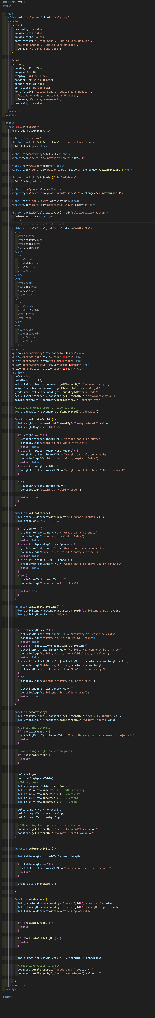
Assignment Step 1
This is the standard template for the Test 1 HTML

I’ve added error messages <p> elements for each of the inputs or actions (activity, weight, grade, activityNo, and delete)

I also set up global variables for them using document.getElementById()
AddActivity() has a built-in validation which is a simple if statement that checks if !activityInput. Aside from that, I call on ValidateWeight() and rely on the returned boolean for validation. If everything is okay, I count up the noActivity (for row count), add the activity, and reset the input fields.
AddGrade() is more or less the same thing as AddActivity with validation checks, and clearing of the input fields. DeleteActivity() gets the table.rows.length and checks if it’s <= 1. If it is, then an error displays to the user saying there’s no more rows to delete.

Assignment Step 2
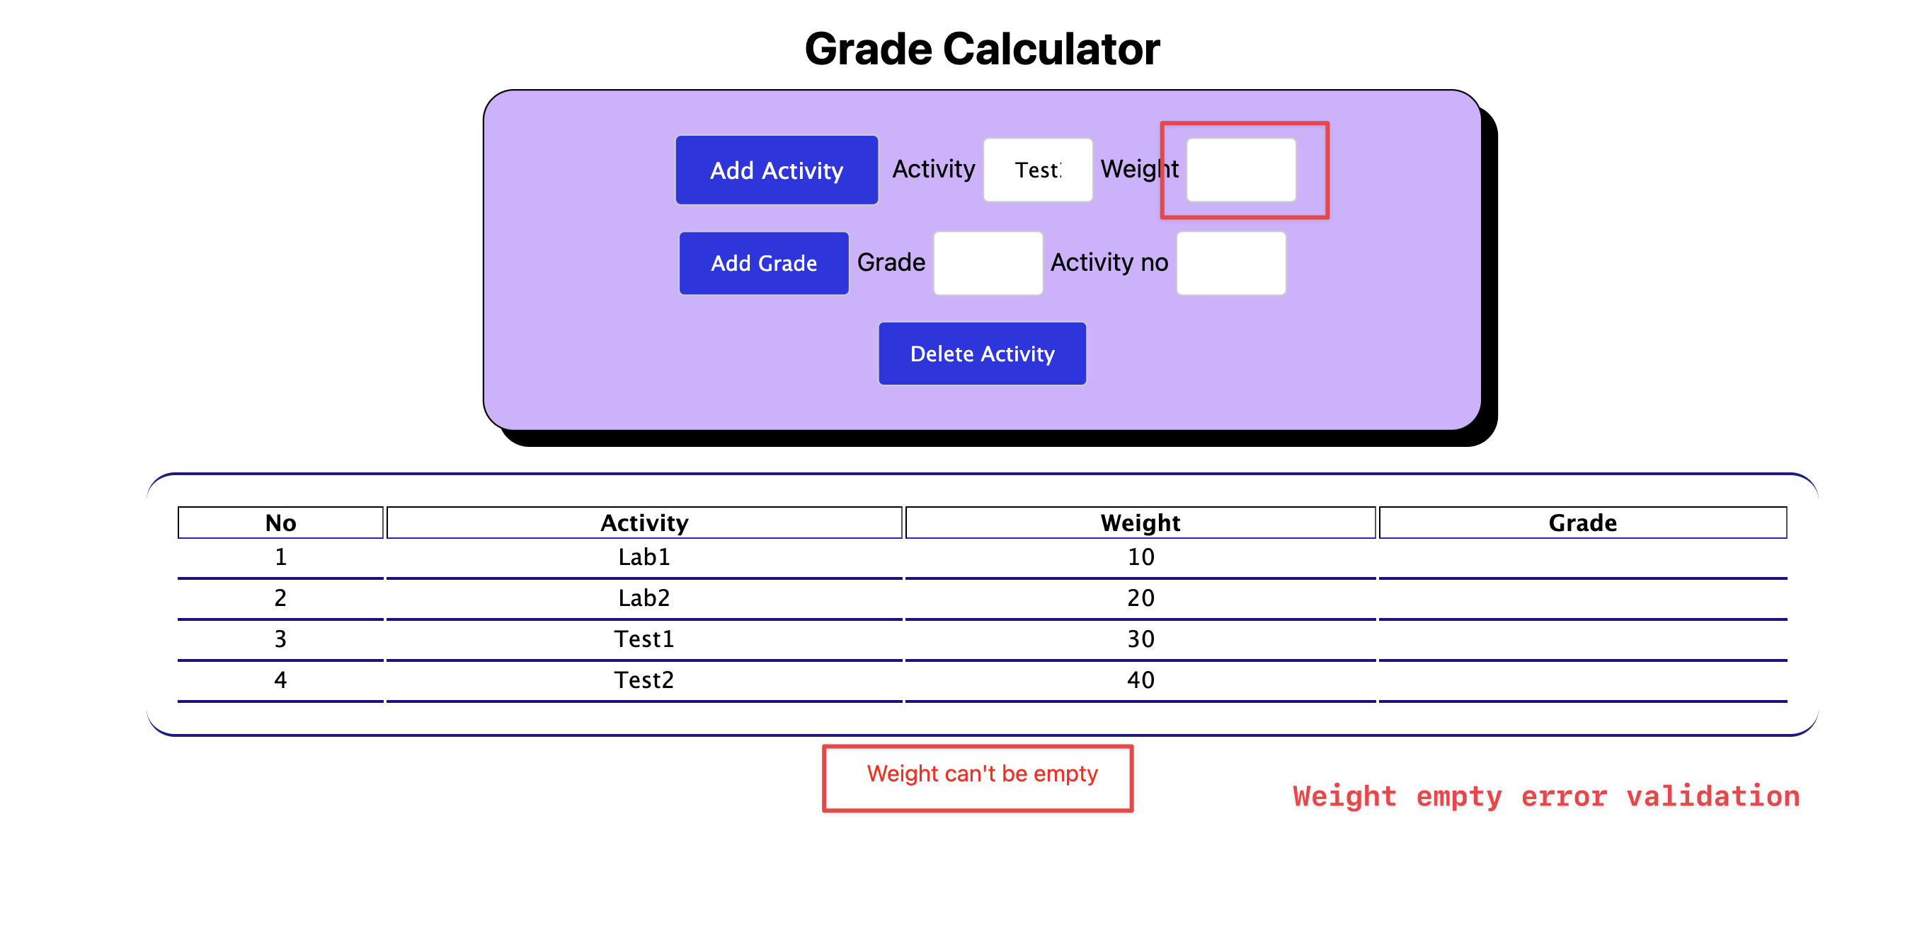
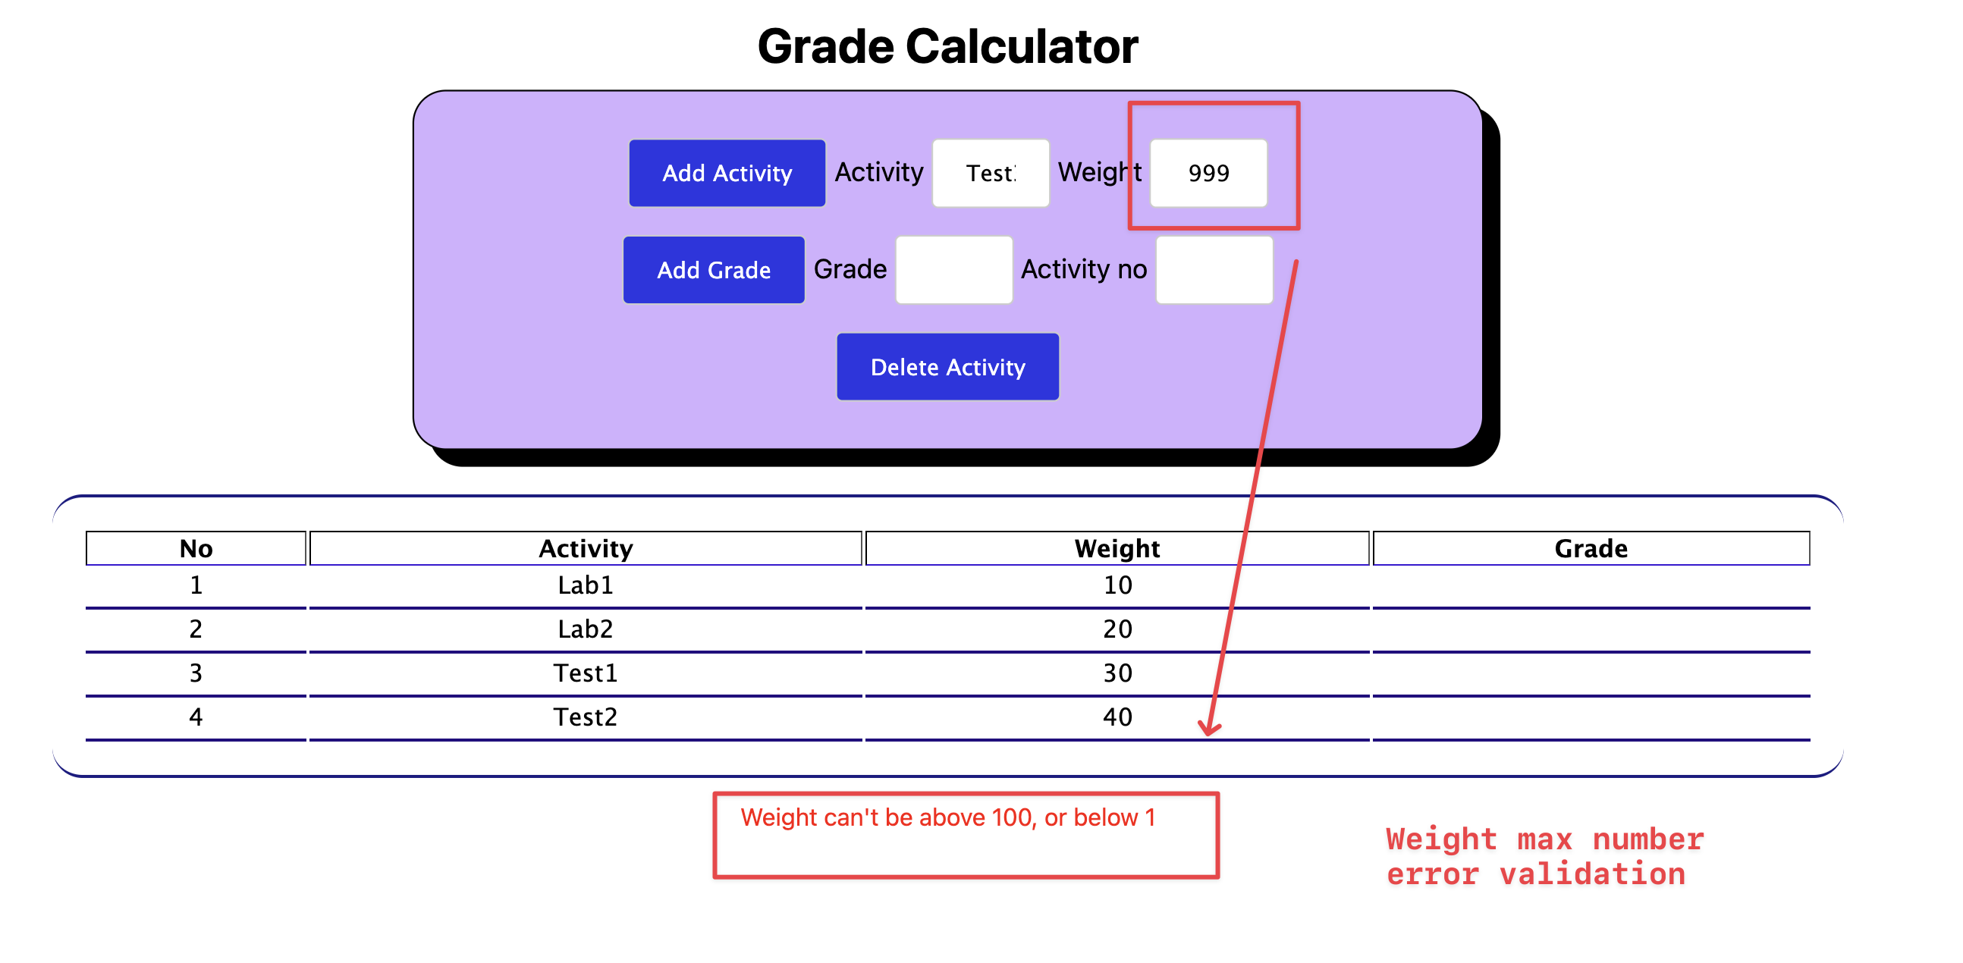
The output of my assignment as per the instruction are given below:
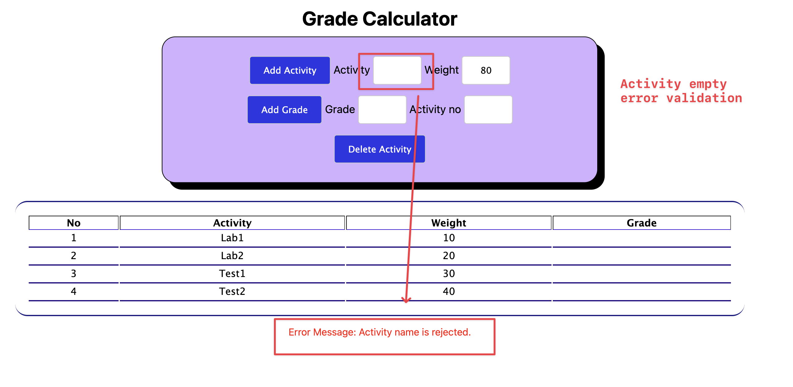
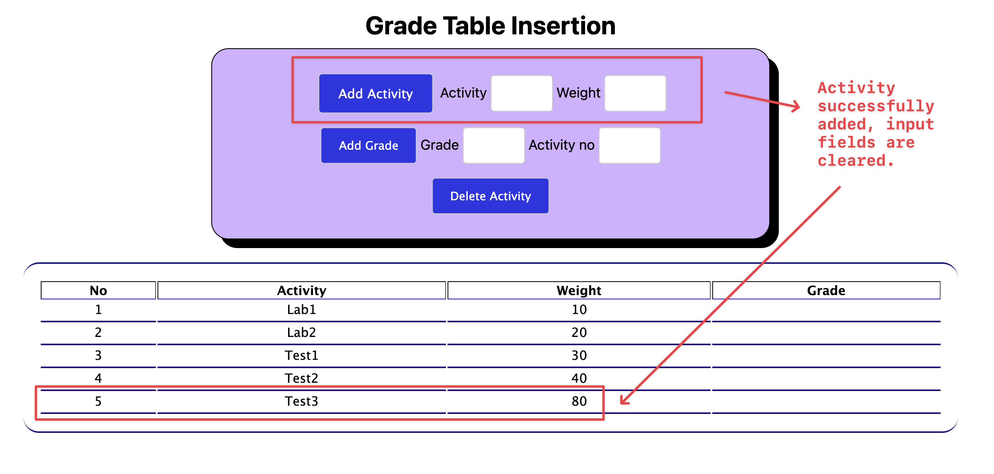

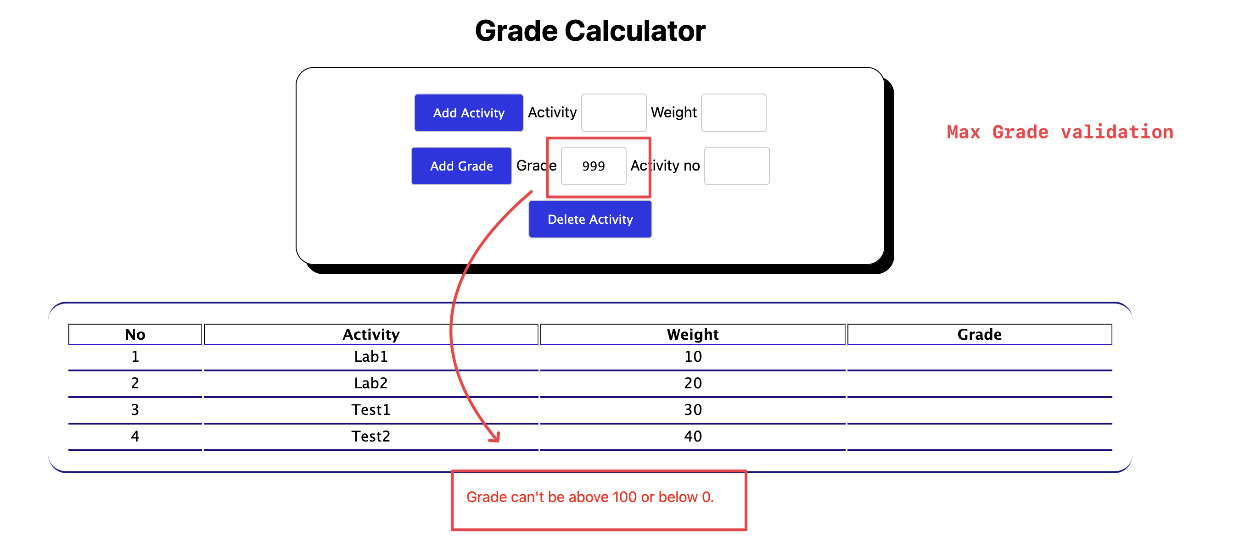
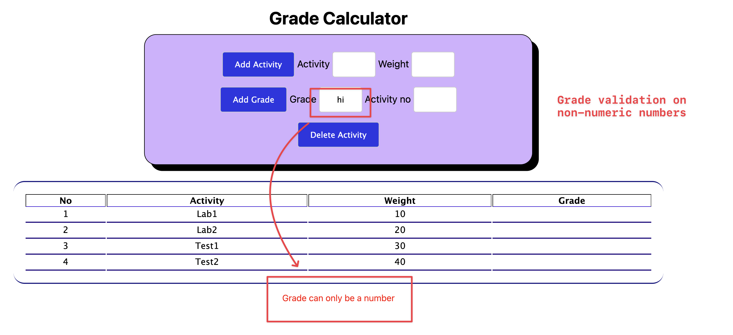

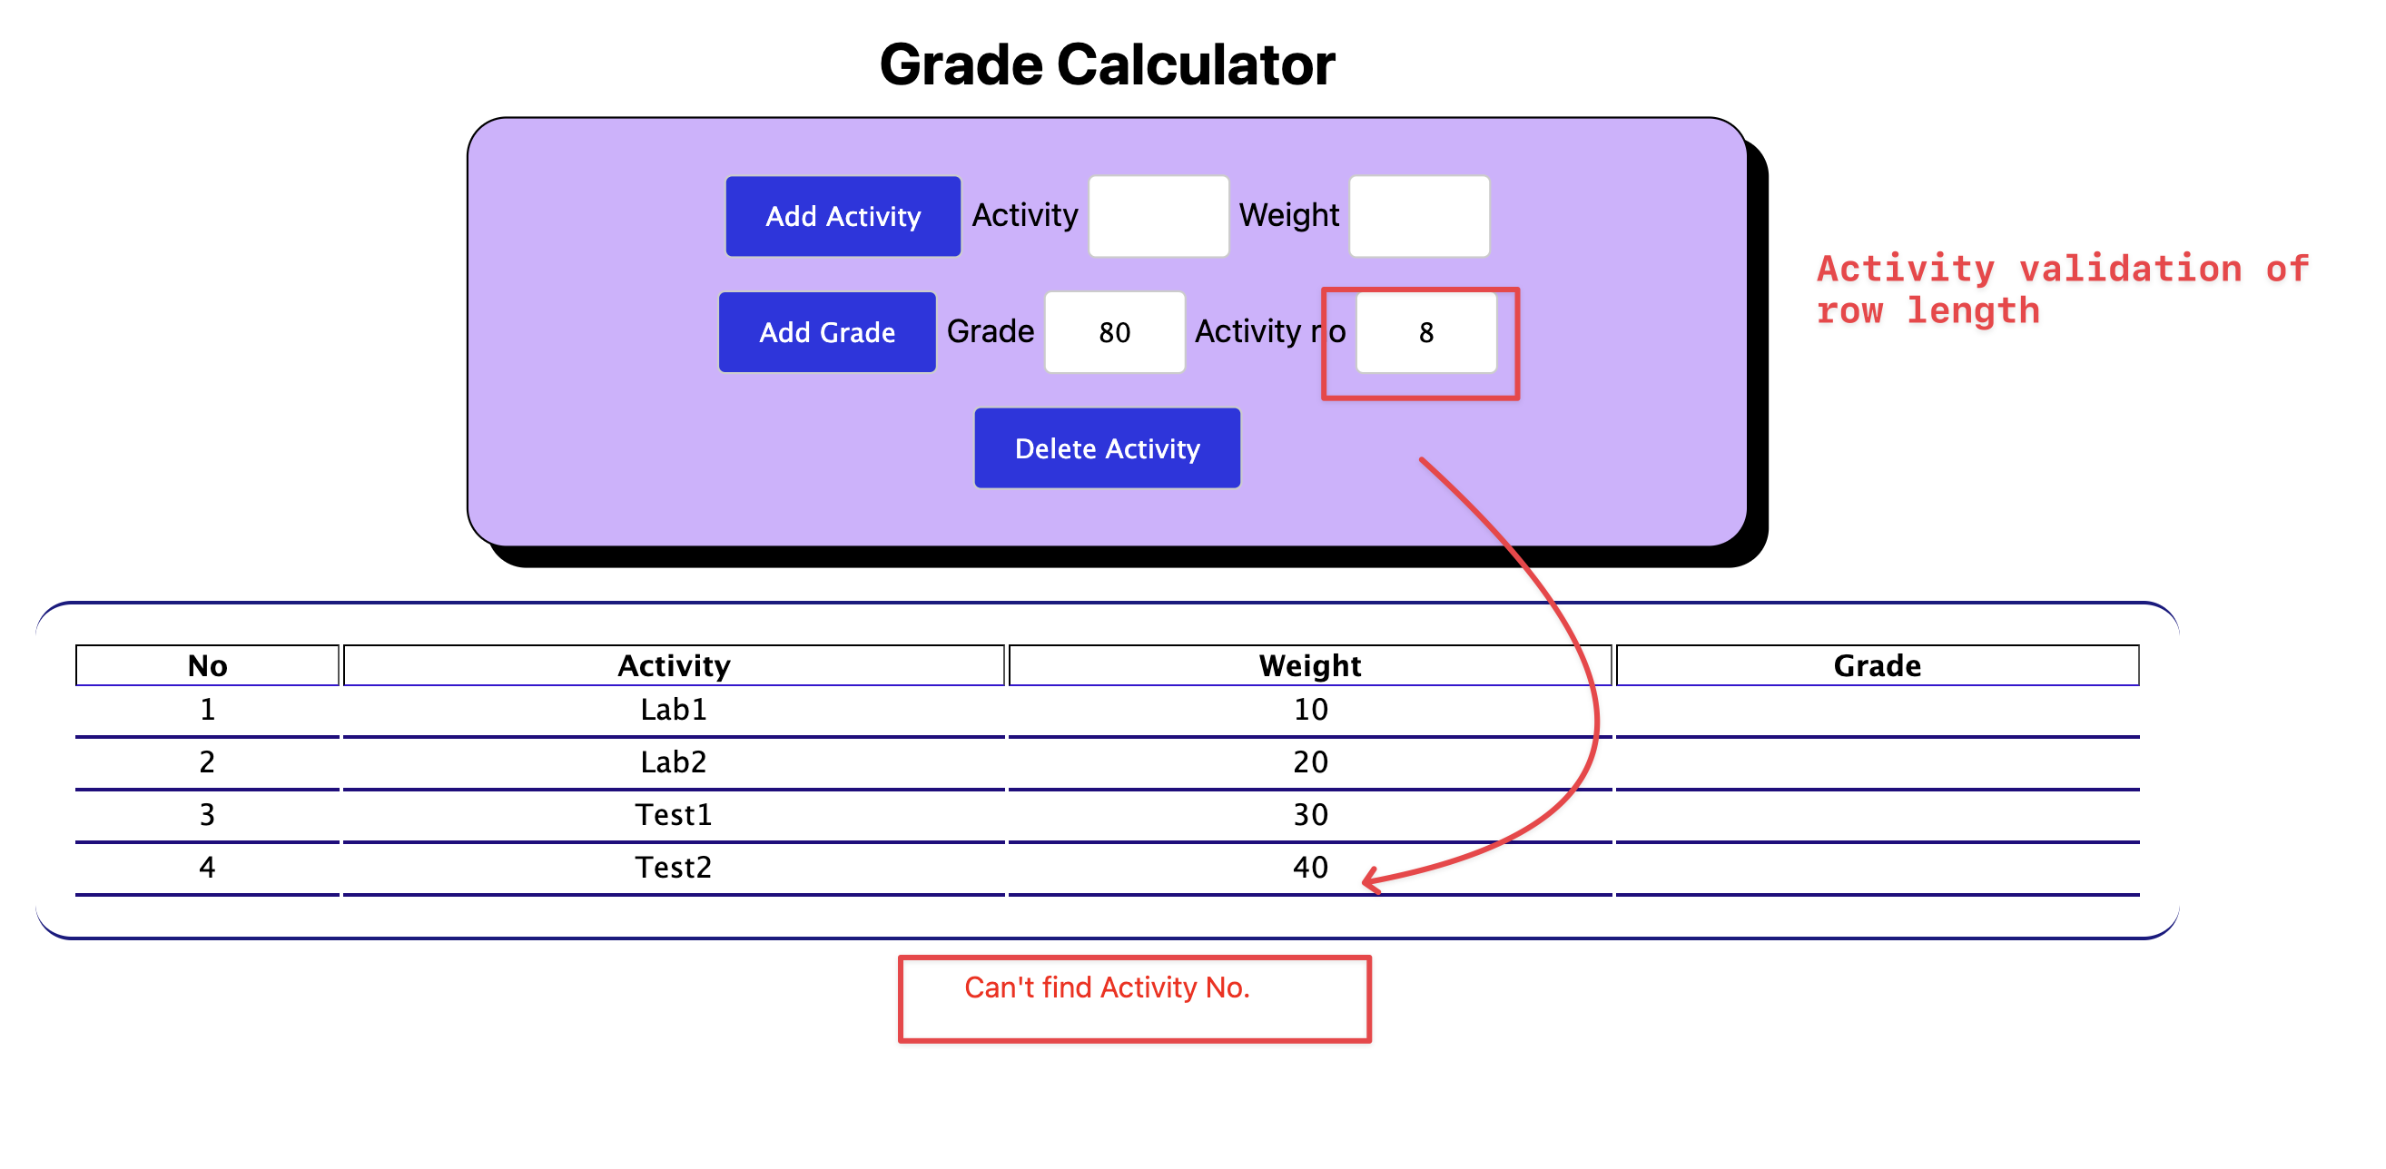
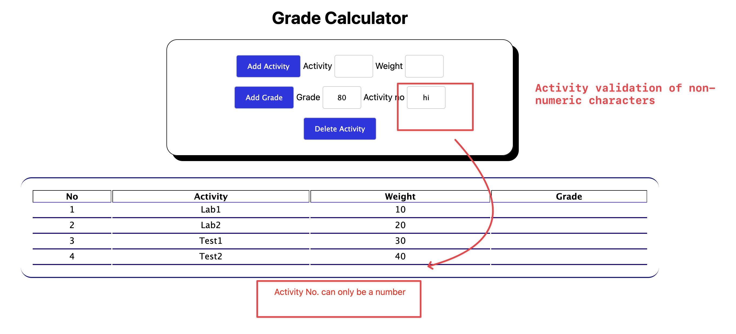

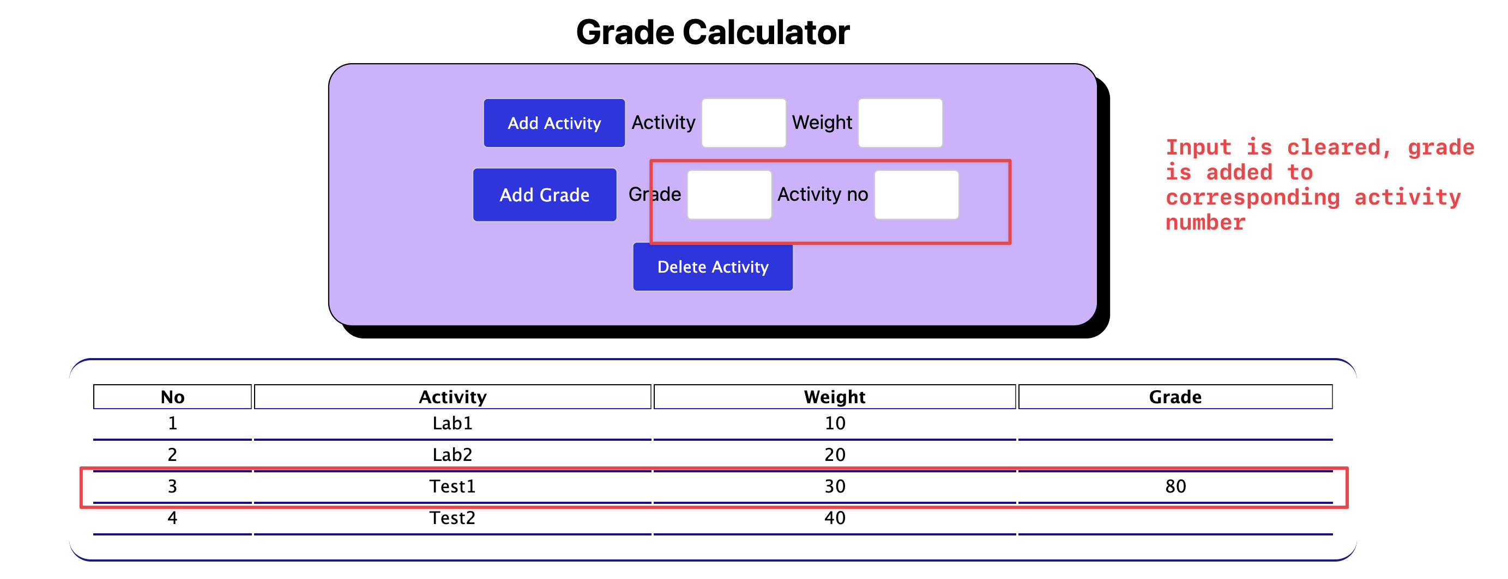

Thank you.

