**Assignment: Chuck Norris Jokes**

**Submitted by:**

**Matthew Azada**

**Student ID: 23038219**

**Submitted to:**

**Professor: Nawaz Chowdhury**

**Subject: Web Development 2**

**Course code: CSD213**

*Honesty Statement: “I declare that this submission is my own work in compliance with Sault College Academic Policies.”*

**Due date: September 11, 2024**

**Table of Content**

# 

Assignment Steps 3

Assignment Step 1 3

Assignment Step 2 6

# **Assignment Steps**

## **Assignment Step 1**

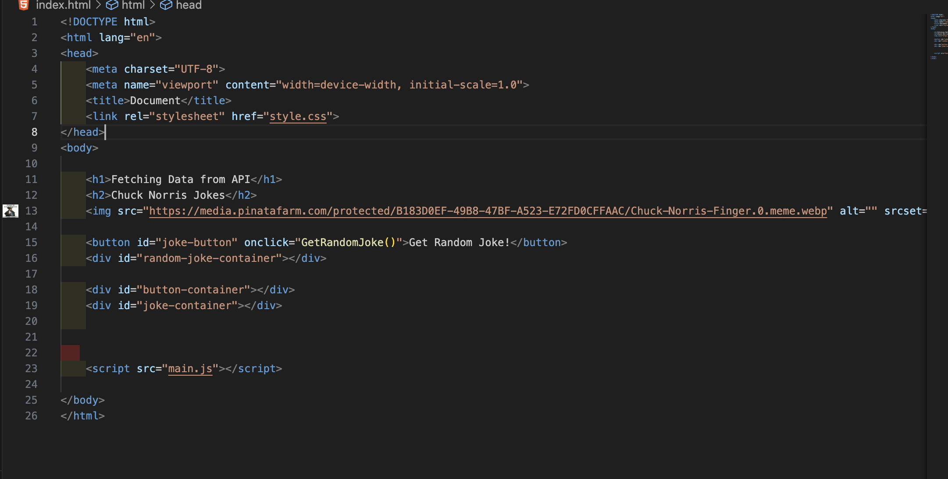

This is the html portion of my code. I put various divs with id’s that interact with my javascript code. I also put an img for design.

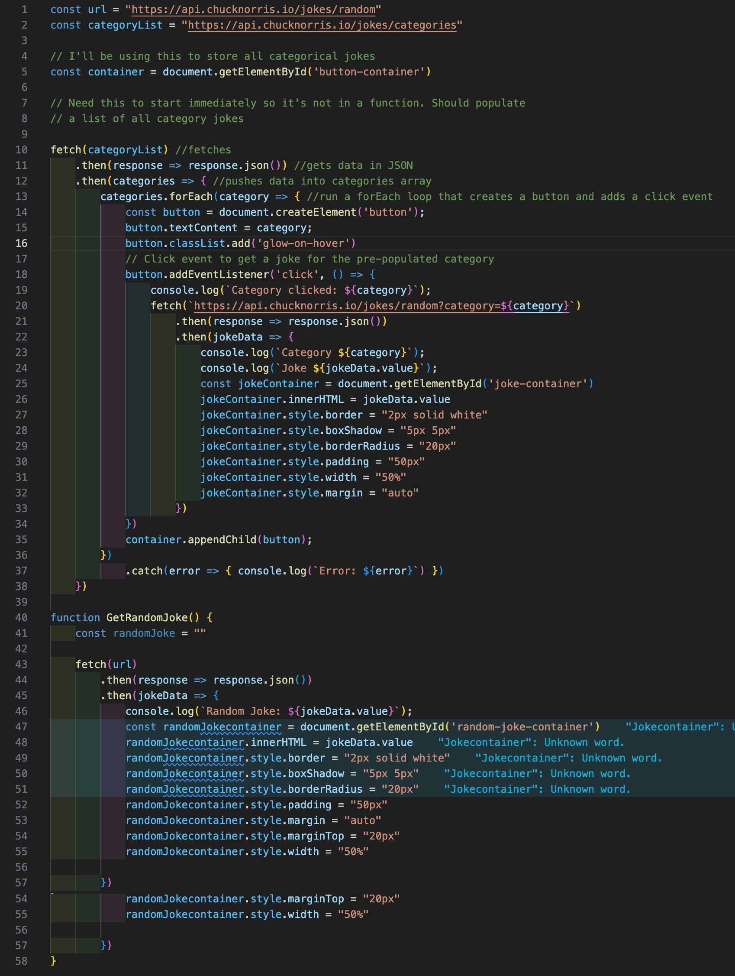

I use three API requests, one for the random jokes, one for getting the category list, and the the last one to get a categorical joke.

I use the API request to get the JSON data of all categories, and then run a forEach loop for each element in that array to create a button. Each button is assigned an EventListener that when clicked, will make another API request for a joke based on that category. A try / catch is used so that I can catch any error if ever there are any and then log the error for debugging.

The rest of the code is mostly styling the created elements before appending it as a child of the #joke-container div



This function gets a random joke when clicked. It’s similar to the other code where it requests a joke, then displays it in an assigned container.

## **Assignment Step 2**

The output of my assignment as per the instruction are given below:

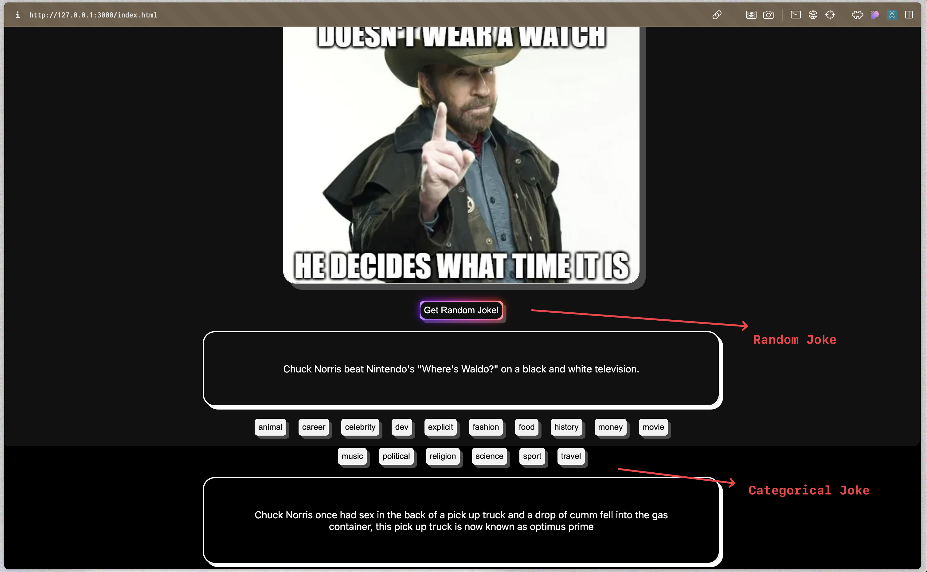

**Thank you.**