**Activity: Calculator**

**Submitted by:**

**Matthew Azada**

**Student ID: 23038219**

**Submitted to:**

**Professor: Nawaz Chowdhury**

**Subject: Web Development 2**

**Course code: CSD213**

*Honesty Statement: “I declare that this submission is my own work in compliance with Sault College Academic Policies.”*

**Due date: September 3, 2024**

**Table of Content**

# 

Assignment Steps 3

Assignment Step 1 3

Assignment Step 2 6

# **Assignment Steps**

## **Assignment Step 1**

Here’s the code for the calculator exercise sir. I have a lot of comments because I use that to review, evaluate, and remind myself of certain things similar what I did in Ma’am Shikha or Sir Sarmad’s class.

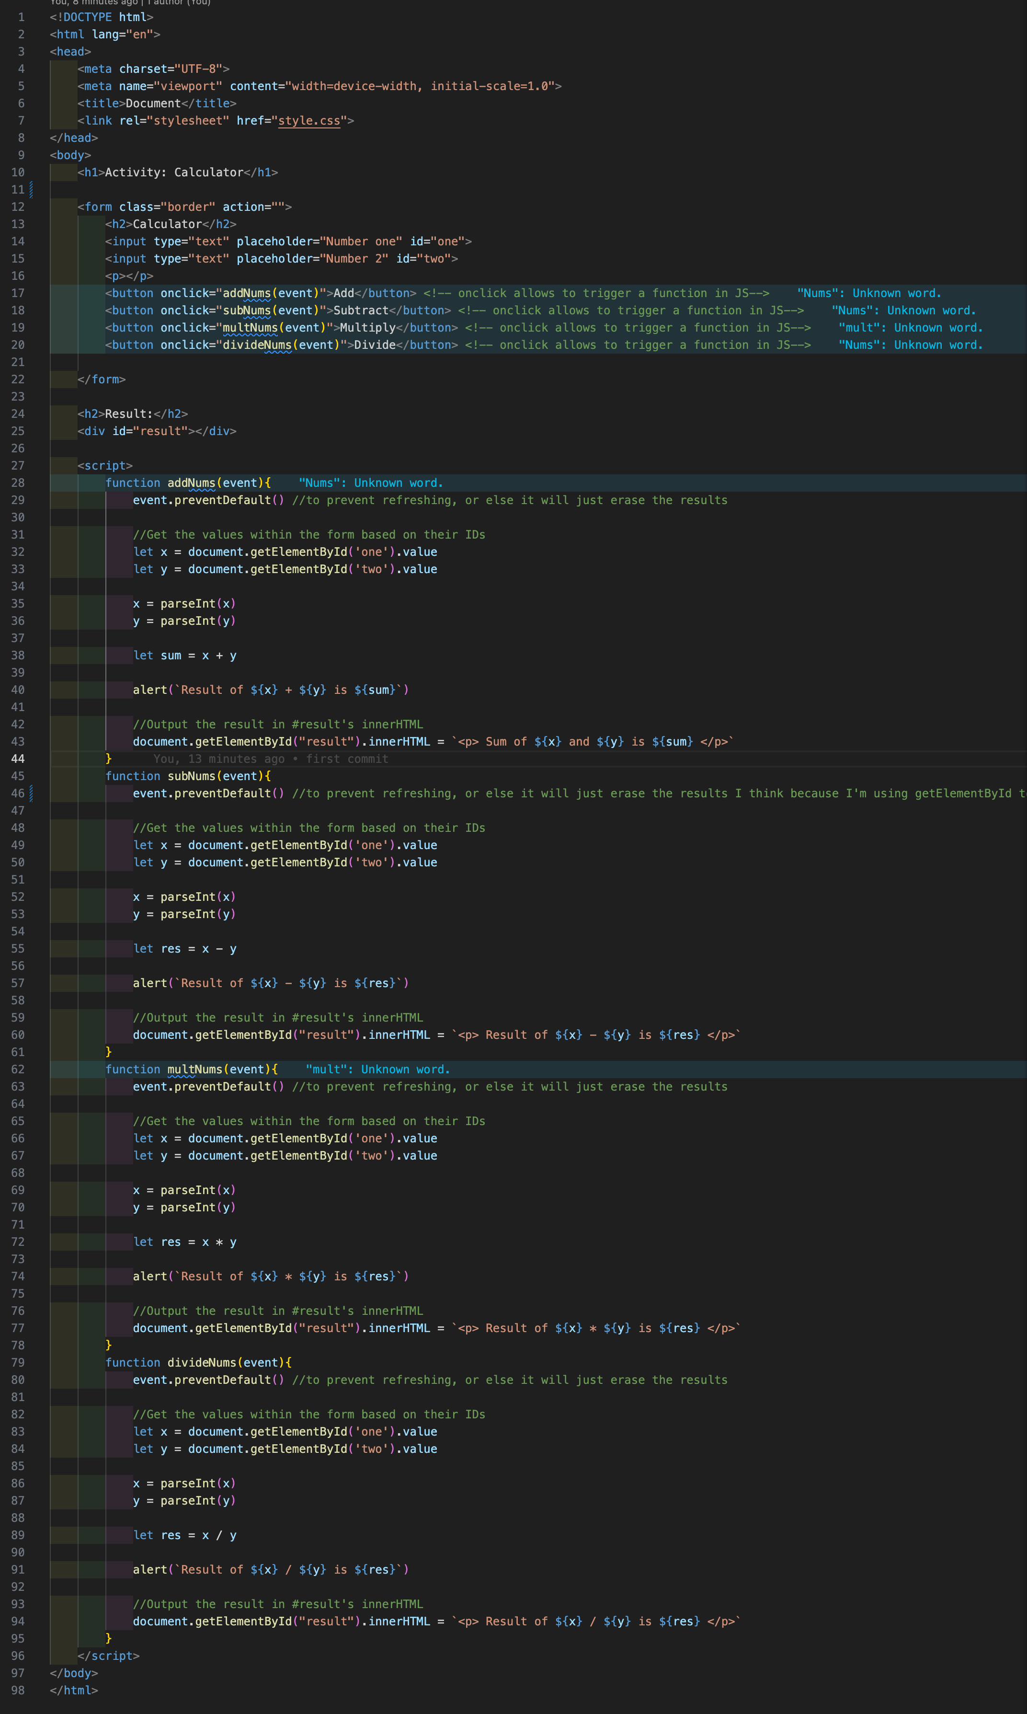

This is the first part of the code where I set up the form element with two inputs, and 4 buttons. The two inputs will accept two numbers of string format, and the 4 buttons are assigned to call different functions that will do mathematical operations to the numbers.



These are the first two functions (add and subtraction) which mostly have the same code except for a change in operations. I also use parseInt in order to convert that user input (string) into an Integer.

Aside from doing the alert pop-up, I also tried to add the result into the html page itself by making a <div id=“result”> blank element which will be replaced when the function is run.

.innerHTML is necessary in order to replace the inner HTML element of the “result”

I noticed that when I run the function, the browser refreshes so I had to research on how to solve this and came up with the event.preventDefault()



These show the remaining two functions which are multiply and divide.

## **Assignment Step 2**

The output of my assignment as per the instruction are given below:

Figure 1: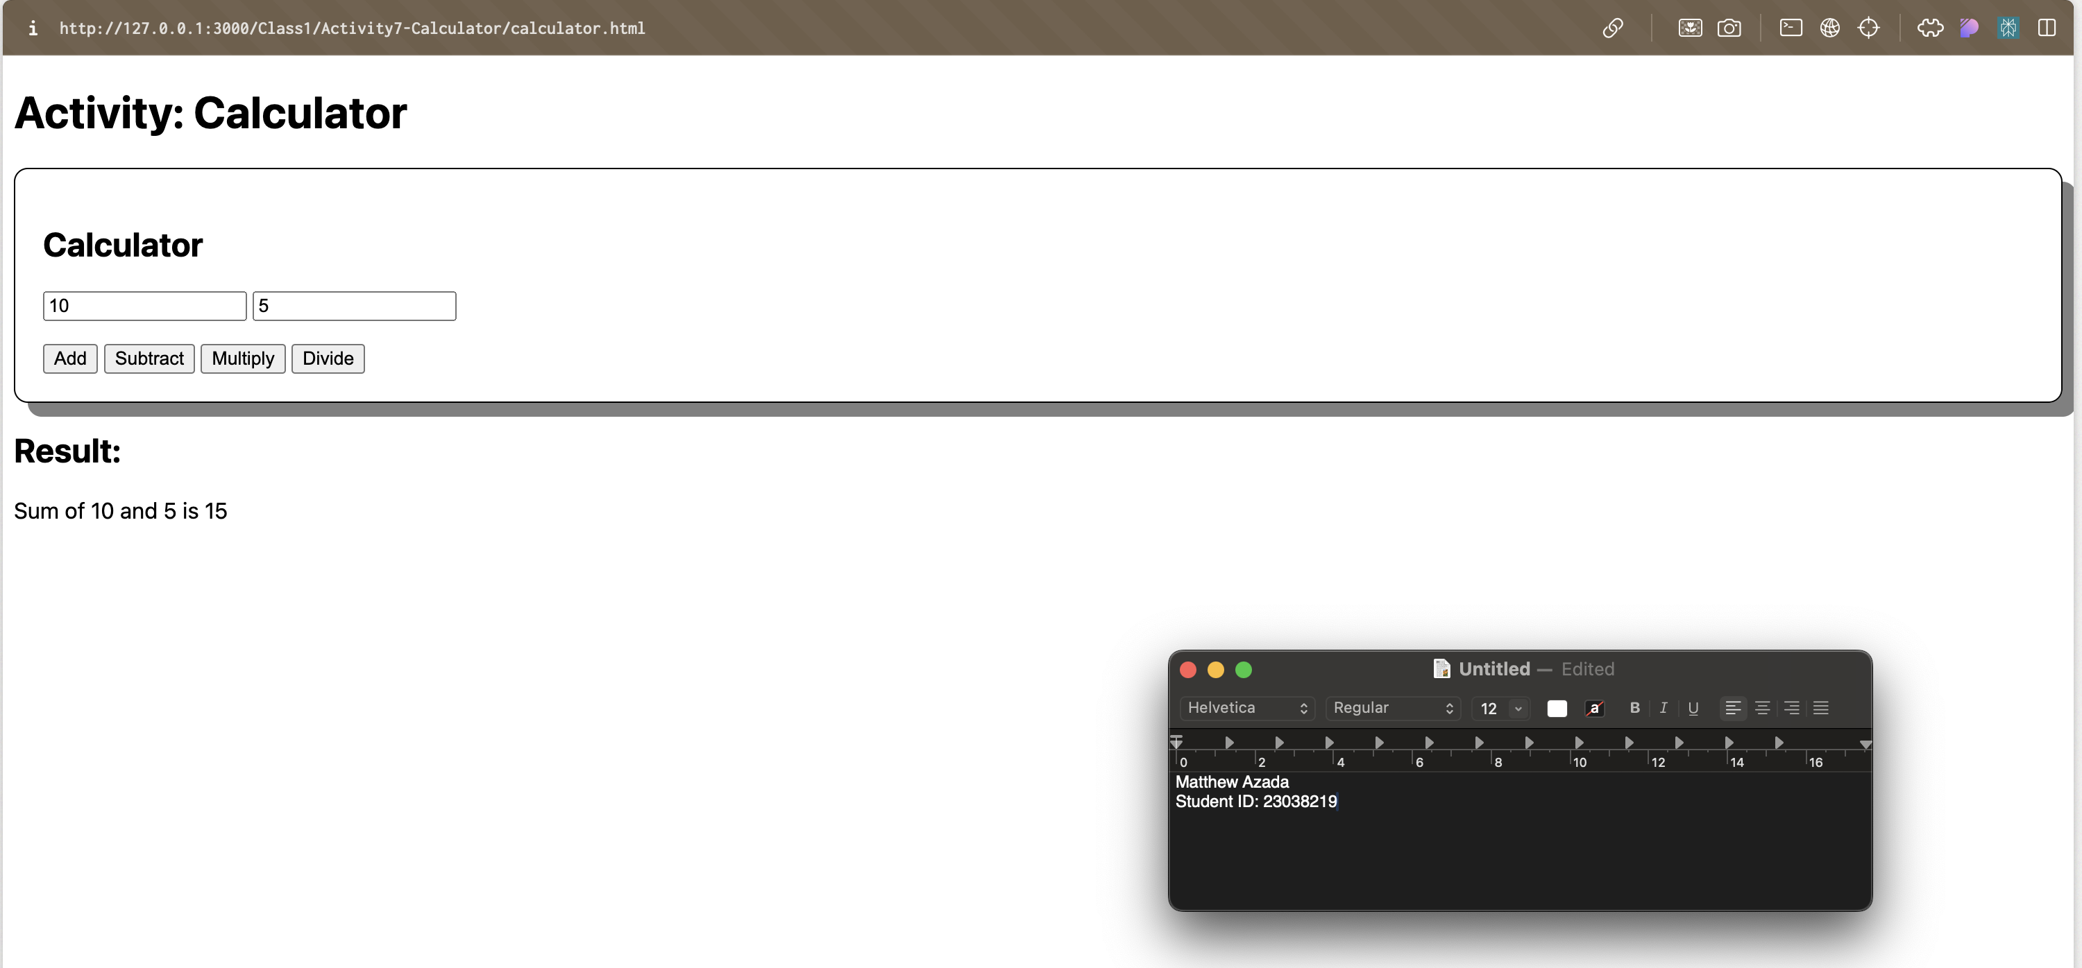

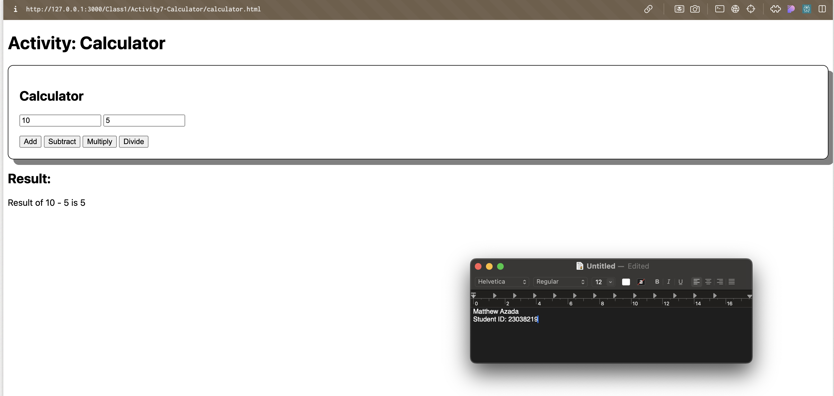

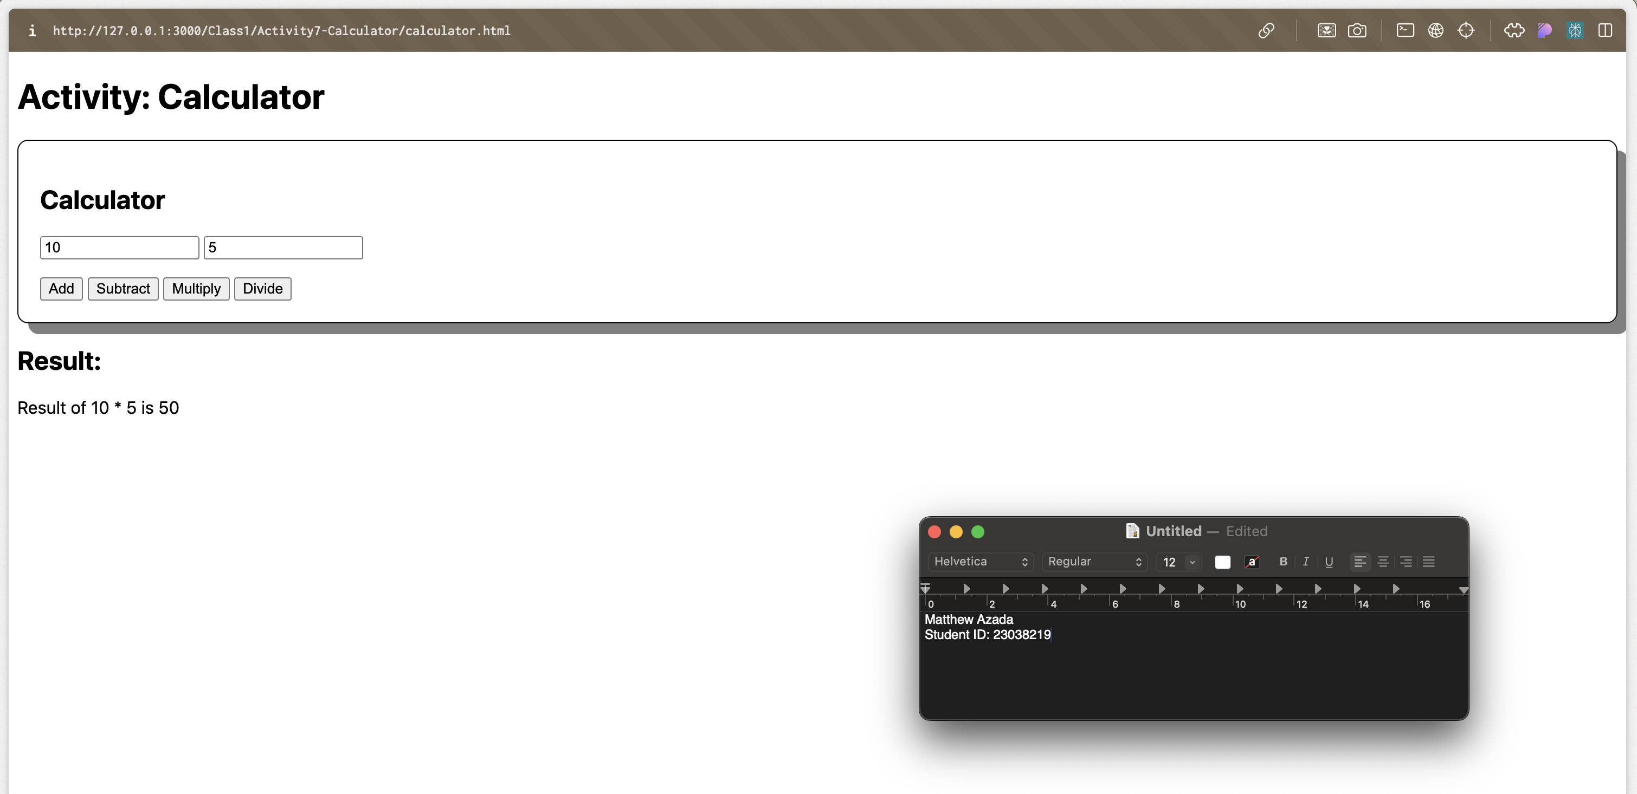

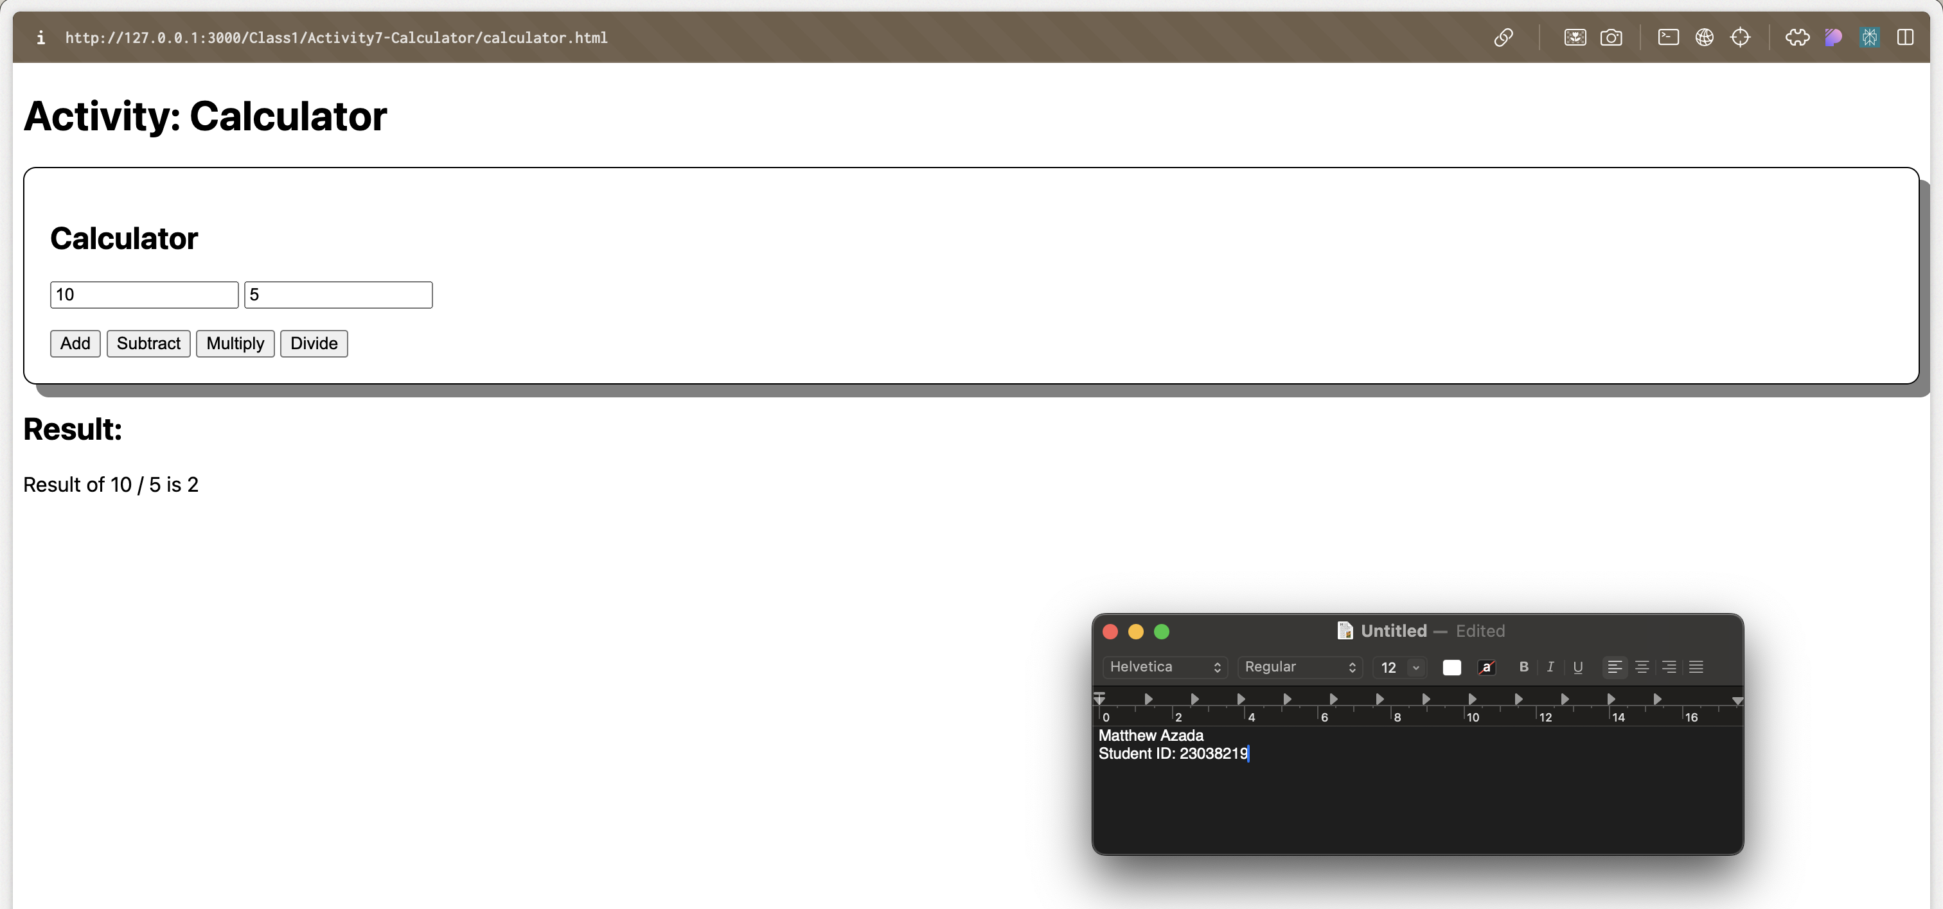

**Thank you.**