**Lab 1: JS Row Manipulation**

**Submitted by:**

**Matthew Azada**

**Student ID: 23038219**

**Submitted to:**

**Professor: Nawaz Chowdhury**

**Subject: Web Development 2**

**Course code: CSD213**

*Honesty Statement: “I declare that this submission is my own work in compliance with Sault College Academic Policies.”*

**Due date: September 6, 2024**

**Table of Content**

# 

Assignment Steps 3

Assignment Step 1 3

Assignment Step 2 5

# **Assignment Steps**

## **Assignment Step 1**

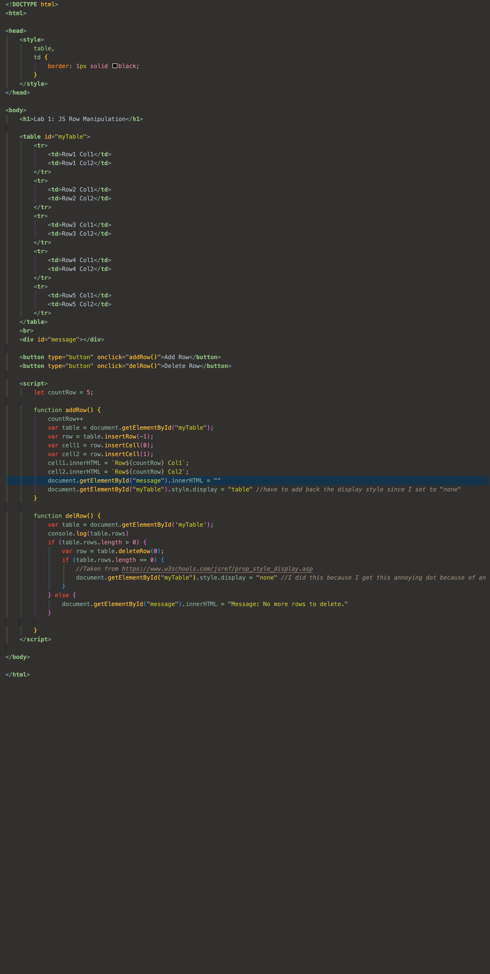

This is the template for the Lab work. I checked the html provided, and take note of the onclick functions that are provided in order to code the solution properly.



In the script, I set countRow as 5 (which is the starting number of rows) and put it outside of the addRow() function in order for it to not re-instantiate every time I click the addRow() function.

Whenever you click addRow, counRow increments y 1, and I change the insertRow index to “-1” in order for it to add at the bottom of the table instead of the top. I then use a template literal

${countrow} in order to dynamically change the numbers based on the current count of rows.

In the delRow() function, I put an if statement to check if the table.rows.length is > 0. If it is, then we continue to delete rows at index “0”. If it reaches table.rows.length == 0, I choose to hide the table since it shows a small dot due to the empty table.   
  
If table.rows.length is < 0, then I adjust the message to say “No more rows to delete”. Once the user adds a row again, I make sure to hide that message and add back the style.display = “table” for the table element.

## **Assignment Step 2**

The output of my assignment as per the instruction are given below:

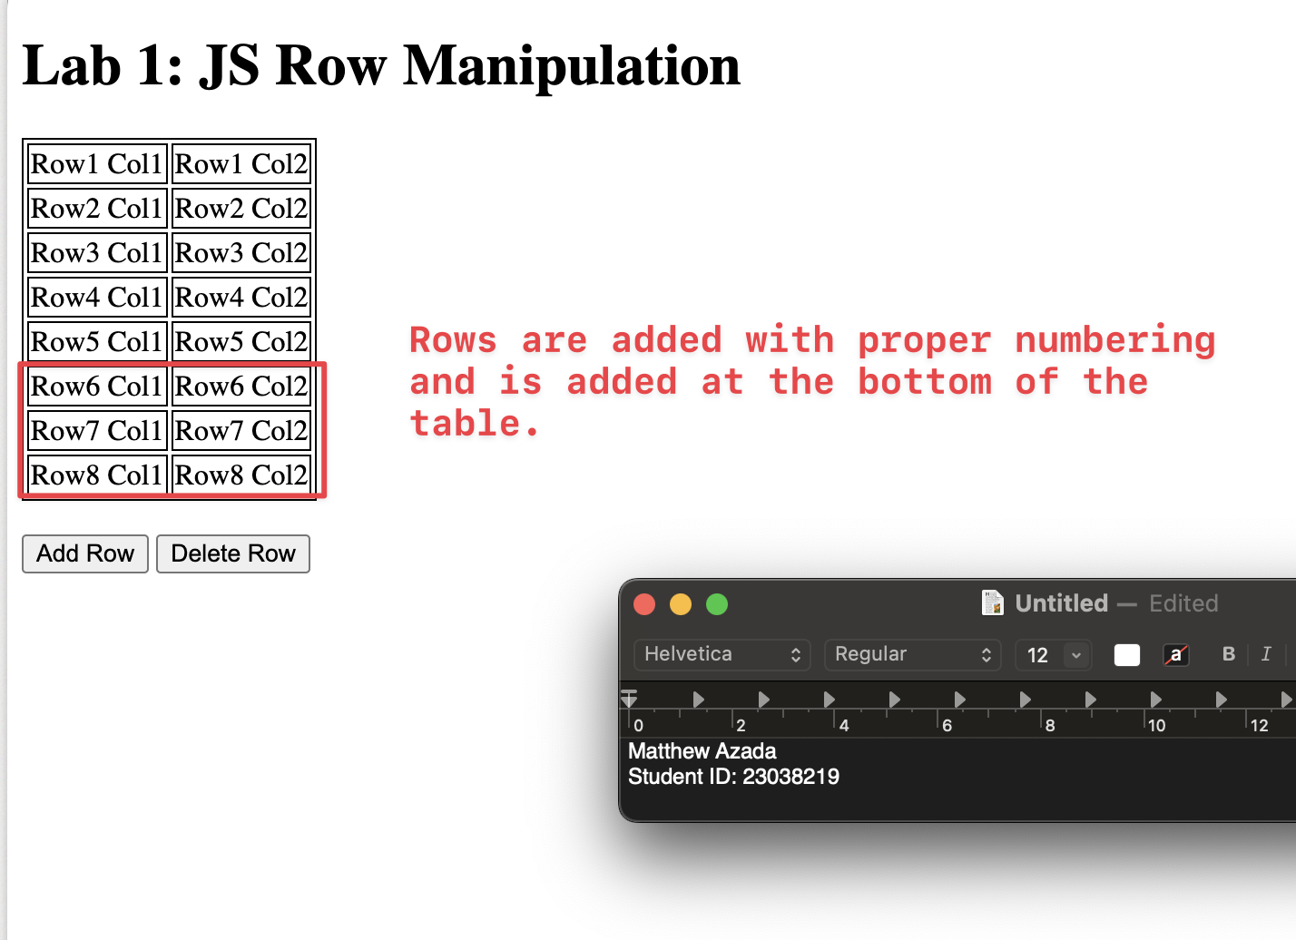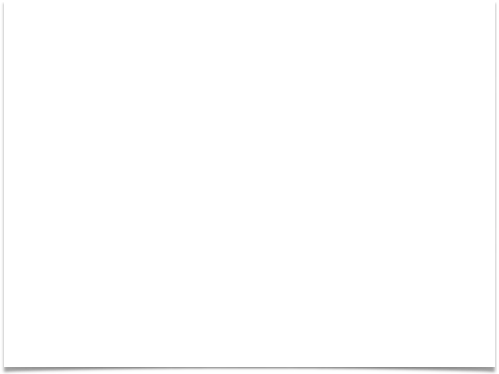

Row Addition

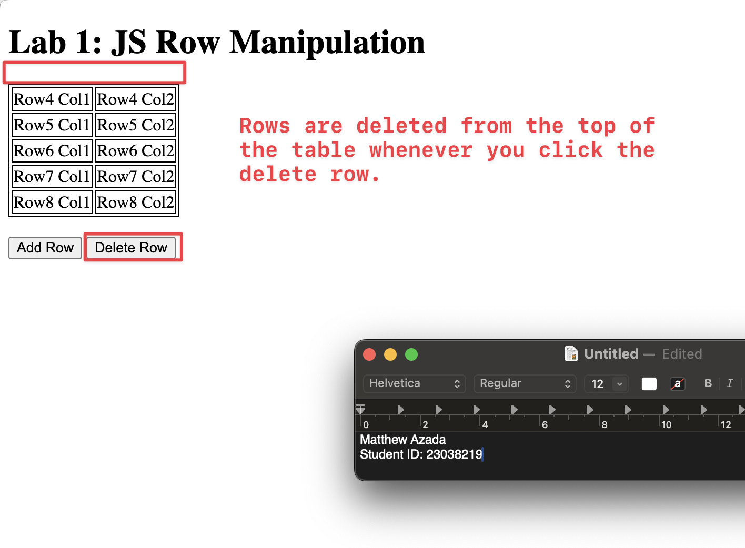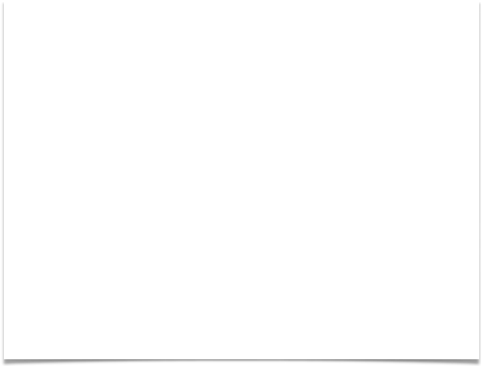

Row Deletion

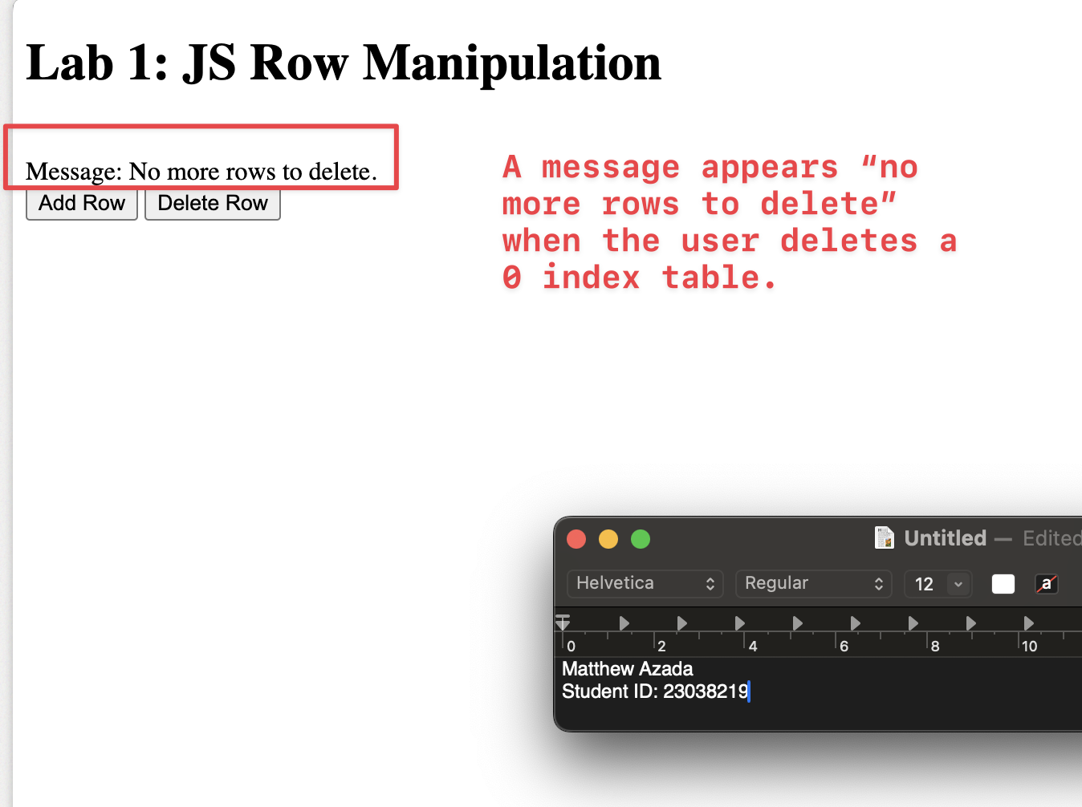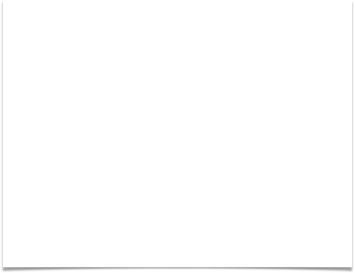

Message showing when deleting 0 rows

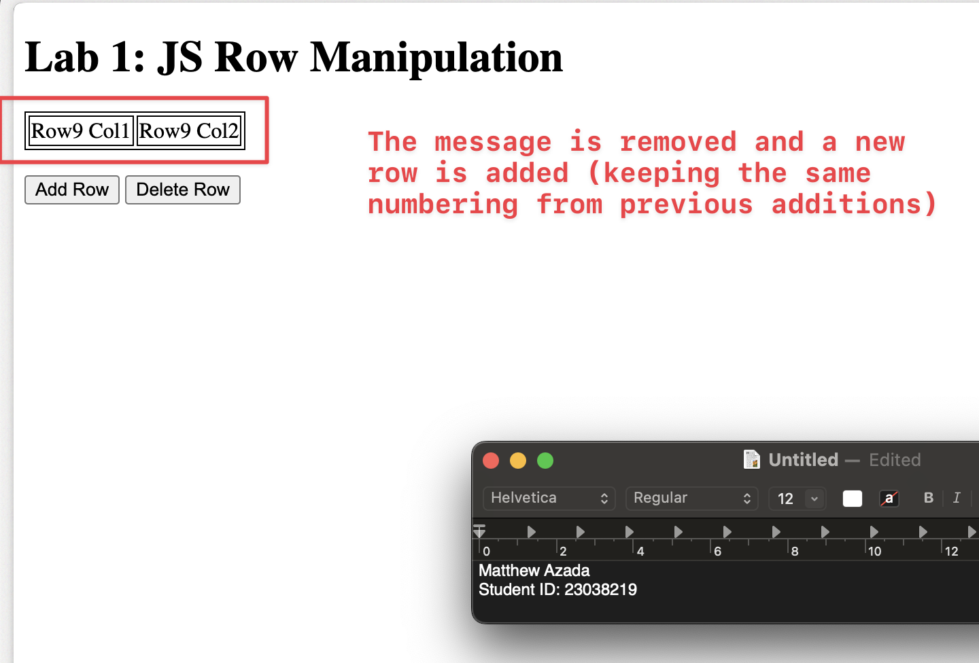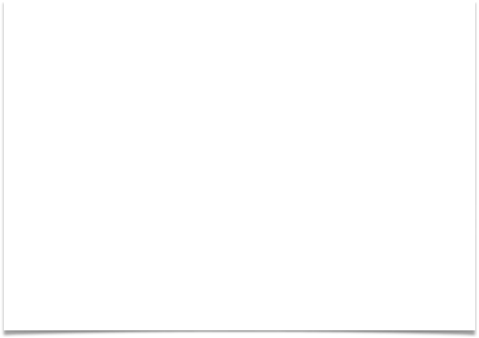

Add rows maintain numbering

**Thank you.**