Beyond niche news: Multilevel examination of audience overlap and social news cycle effects on ideological news consumption

*Working RQs*

RQ1: Based on a network projection, what are the potential patterns of niche news consumption?

RQ2a: How does the ideology of the audience within one’s news niche related to ideological news consumption?

RQ2b: How does the ideology of the organizations within one’s news niche related to ideological news consumption?

RQ3a: How are individual’s various uses of social media related to ideological news consumption?

RQ3b: How is audience engagement with the news on social media during a news cycle related to ideological news consumption?

RQ3b: How is the sentiment of the news on social media during a news cycle related to ideological news consumption?

**Literature Notes**

This study engages broad questions about the ideological news audience. As media choice accelerates alongside rise of social and mobile platforms for news, media markets have increasingly segmented into ever-smaller audience niches designed to serve special interests, from entertainment to news and hyper-partisan content (XX). Accordingly, scholars have extensively examined the nature of partisan selective exposure at the individual level (e.g., Stroud, 2008; Others). These studies typically show that while people do seek attitude-consistent information, they rarely avoid counter-attitudinal news altogether (XX). A second line of work in this area has looked to the macro, audience-level characteristics of channel overlap (XX). Employing network analysis, these studies find evidence of significant duplication across media outlets, suggesting that audiences are not as fragmented as everyday intuition would suggest (XX; XX). Yet another trend looks at social media uses and effects on ideological news use (XX). These findings paint a nuanced picture, where exposure to political information is dependent upon a variety of context-dependent variables, like social endorsements and other group-consensus informing attributes (XX).

Recently, scholars have turned to the role of major platforms in the filtering and selection of news (XX). These studies raise important questions about individual agency, as it becomes an open question to what extent one’s public affairs and political information exposure is a product of algorithmic filtering (XX), inattentive/incidental habits of attention (XX), or the ideological valence of the media system itself (XX). Taken together, the past decade of audience research has only partially answered the question of ideological news use and audience fragmentation. This research project has important implications for normative democratic theory, as audience fragmentation has been connected to contentious politics (XX), a lack of consensus on issue agendas and policy solutions, as well as the growing problems of declining institutional trust (XX) and a rejection of the progressive-era values of fact and objectivity (XX).

To forward scholarship in this area, we propose a multilevel theoretical framework for examining the individual, audience, and organizational attributes that influence ideological news use. We argue that existing approaches to the study of niche news and ideological news have yet to embrace advances in measurement, and in doing so, we are able to account for the various group and system-level context of news consumption. Drawing of theories of social integration () audience overlap (), and niche news (), we combine individual-level survey data (N=1965; 17 Waves) with publicly available posts from the top 25 news organizations on Facebook (N = 84,000). The resulting linkage study investigates attention to ideological news as the individual, network, and organizational levels.

**Ideological news**

**Niche News**

**Overlap and fragmentation**

**Social Media and Niche News**

**Multilevel Model**

**Methods**

**Sample**

The research design employs a linkage study based on two samples. First, respondent-level observations are derived from a 17-wave, nationally representative rolling cross-sectional online survey administered in the United States (N=1965) by Qualtircs. Respondents were contacted between September 3 and November 1, 2020 (Incidence Rate = 100%; Cooperation Rate = 70%). The sample frames coincide with bi-weekly constructed news cycles, offering researchers the ability to link responses to media content. Each wave was balanced according to quotas for age, race, gender, and census region according to 2018 American Community Survey (Table A1). Second, social media news content was collected by constructing a list of the most popular news outlets circulating on Facebook at the time of data collection (27 outlets; News Whip, 2020) (Table A2). The authors then filtered and collected the most prominent posts (top 98th percentile) by salience, as determined by a weighted engagement metric of the averaged likes (weight = 1), shares (weight = 2) and comments (weight = 3) per post. Facebook posts were collected on the last day of each time frame using Crimson Hexagon (King et al., 2012).

**Analysis**

The study incorporated a multilevel design to capture the various units of analysis where individual, audience, organizational, and news cycle variables might influence ideological news consumption. First, to capture audience-level features, and following previous work on audience overlap studies (Muckerjee et al, XX; XX), we constructed a network projection of audience overlap. The network was then filtered to reduce non-systematic response bias (Barnidge et al., 2021). Next, the authors ran a series of clustering algorithms on the network projection that: a) best fit the theoretical assumptions for audience fragmentation, and b) produced the most consistent results. Louvian clustering met these criteria, producing three stable “news niches” (citation here) (Table 1). This approach produced 51 potential points of sample invariance (17 waves and 3 niches per wave). To estimate the within and between group variances, a series of ANOVA regressions were employed. Subsequent individual-level analysis is based on bi-nominal and Poisson regression modelling in the multilevel framework were appropriate. Finally, news-cycle content variables (sentiment and engagement) were created using automated content analysis (Soroka & Young, 2015) and the ideological valence of the organization was coded according to established criteria (XX).

**Dependent Variables**

**News ideology.** News ideology is measured at the organizational and individual level. Respondents were asked three times to “write the name of a news outlet (e.g., The New York Times or nytimes.com, Fox News or foxnews.com, WBRC Birmingham) that you used in the past week”. Open-ended responses are designed to stimulate recall, and they have been found to reduce response error relative to traditional measures (XX). The author(s) then coded and cleaned and coded responses and assigned a news ideology score (-2 = far right, 0 = neutral, 3 = far left) to each outlet according to previously established criteria (intercoder-reliability = XX; citation?). After cleaning the open-ended responses, a total of XX sources were mentioned and ideological valanced was applied to the organization (M = SD = ) and averaged for each individual (M = ; SD = ).

**News Niche.** News niche is derived from Louvian cluster analysis of network projection of audience overlap (results?). Results produced three niches: *right-leaning cable, left-leaning elite,* and *local-aggregators* (Table 1). Respondents where then assigned to a niche based on their responses to the open-ended news attention items, and according to the strength of group membership. This approach produced four groups (cable, n = XX; elite, n = xx, local, n = xx; no niche, n = xx). Mean news ideology metric were then applied to each nice (cable: M = SD = ; elite: M = SD = ; local M = SD = )

**Independent Variables**

**Attention to news on social media.** Follows; frequency; incidental, algorithmic

**Network attributes.** Size and diversity

**News cycle on social media.** Sentiment and engagement

**Demographics and political attitudes.** Age, gender, education, income, interest, ideology.

Figures and Tables

Figure 1. Network Projection from Cluster Analysis (Appendix)

|  |  |  |  |  |  |
| --- | --- | --- | --- | --- | --- |
| Table 1  *Organizational Niche Membership* | | | | | |
| **Niche 1** | | **Niche 2** | | **Niche 3** | |
| *Right-Leaning Cable & TV* | | *Left-Leaning Online Elite Press* | | *Local/Aggregators* | |
| ABC*  BBC*  Breitbart  CBS*  CNBC*  CNN*  Fox | LA Times*  MSNBC*  NBC*  Newsmax  NY Post  OAN  Right Sphere  Univision* | Huffington Post  NY Times  Washington Post  Politico  NPR*  Buzzfeed  International Media*  Wall Street Journal*  New Magazines*  PBS*  Left Sphere |  | Aggregators  Chicago Tribune  Local Paper  Local Radio  Local TV  Local Web  MSN  Neutral Sphere  Social Agg. | USA Today  Yahoo |
| *Note:* * Indicates deviations from theoretical expectations. | | | | | |

|  |  |  |  |  |
| --- | --- | --- | --- | --- |
| Table 2  *Means and Variances for News Ideology at the Organization and Individual Levels* | | | | |
| Statistic | Local/Aggregators | Elite | Cable | Full Sample |
| **Organizational Level** | | | | |
| Mean | -0.10 | -0.79 | 0.41 | -0.10 |
| Variance | 0.09 | 0.27 | 1.88 | 1.08 |
| *N* | 11 | 11 | 15 | 37 |
| Between-Group Variance | 4.57 | | | |
| Within-Group Variance | 0.88 | | | |
| Test Statistic | *F* (2) = 5.19, *p* = 0.011 | | | |
| **Individual Level** | | | | |
| Mean | -0.07 | -0.73 | 0.03 | -0.10 |
| Variance | 0.15 | 0.15 | 0.79 | 0.62 |
| *N* | 344 | 195 | 905 | 1,444 |
| Between-Group Variance | 41.29 | | | |
| Within-Group Variance | 0.51 | | | |
| Test Statistic | *F* (2) = 81.20, *p* < .001 | | | |
| *Note*: Response variable has theoretical range of 6 (Min. = -3 ‘far left’ and Max. = 3 ‘far right’) and an observed range of 5.0 (Min. = -2.0, Max. = 3.0). Data weighted by education and income. | | | | |

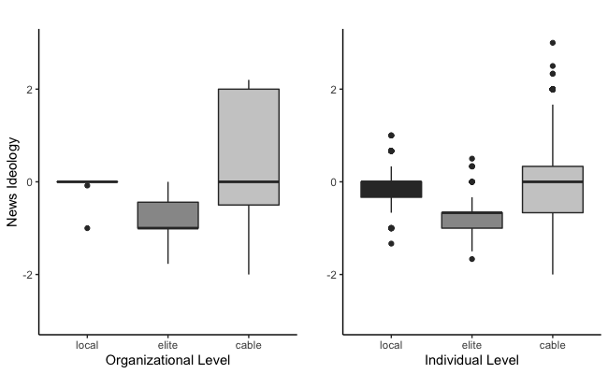

Figure 2. Boxplot of News Ideology at the Organizational and Individual Levels

|  |  |  |  |  |  |  |  |  |  |  |  |  |
| --- | --- | --- | --- | --- | --- | --- | --- | --- | --- | --- | --- | --- |
| Table 3  *The Predictors of News Ideology at the Individual, Audience, and Organizational Levels* | | | | | | | | | | | | |
|  | Model 1 | | | Model 2 | | | Model 3 | | Model 4 | | Model 5 | |
| **Fixed Effects** | *b* | | *SE* | *b* | *SE* | | *b* | *SE* | *b* | *SE* | *b* | *SE* |
| Intercept | -0.21*** | | 0.05 | -0.14*** | 0.03 | | 0.00 | 0.03 | -0.14*** | 0.03 | 0.00 | 0.03 |
| Age | -0.04*** | | 0.01 | -0.04*** | 0.01 | | -0.04*** | 0.01 | -0.04*** | 0.01 | -0.04*** | 0.01 |
| Gender (1 = Female) | 0.01 | | 0.04 | 0.00 | 0.04 | | 0.00 | 0.04 | 0.00 | 0.04 | 0.00 | 0.04 |
| Race (1 = Person of Color) | -0.15*** | | 0.04 | -0.15*** | 0.04 | | -0.16*** | 0.04 | -0.15*** | 0.04 | -0.15*** | 0.04 |
| Education | -0.01 | | 0.01 | -0.01 | 0.01 | | -0.01 | 0.01 | -0.01 | 0.01 | -0.01 | 0.01 |
| Income | 0.00 | | 0.01 | 0.00 | 0.01 | | 0.00 | 0.01 | 0.00 | 0.01 | 0.00 | 0.01 |
| Political Interest | -0.04* | | 0.02 | -0.04* | 0.02 | | -0.04* | 0.02 | -0.04* | 0.02 | -0.04* | 0.02 |
| Individual Ideology | 0.06*** | | 0.01 | 0.06*** | 0.01 | | 0.06*** | 0.01 | 0.06*** | 0.01 | 0.07*** | 0.01 |
| **Contextual Effects** | *b* | | *SE* | *b* | *SE* | | *b* | *SE* | *b* | *SE* | *b* | *SE* |
| Audience Ideology |  | |  | 0.43*** | 0.04 | |  |  | 0.44*** | 0.04 |  |  |
| Organization Ideology |  | |  |  |  | | 1.02*** | 0.09 |  |  | 1.03*** | 0.09 |
| **Interactions** | *b* | | *SE* | *b* | *SE* | | *b* | *SE* | *b* | *SE* | *b* | *SE* |
| Individual Ideology *  Audience Ideology |  | |  |  |  | |  |  | 0.02# | 0.01 |  |  |
| Individual Ideology * Organization Ideology |  | |  |  |  | |  |  |  |  | 0.08** | 0.03 |
| **Random Effects** | *Var*. | | | *Var.* | | | *Var.* | | *Var.* | | *Var.* | |
| Intercept Niche:Frame | 0.09 | | | 0.01 | | | 0.01 | | 0.01 | | 0.01 | |
| Individual Ideology | 0.00 | | | 0.00 | | | 0.00 | | 0.00 | | 0.00 | |
| Residual | 0.45 | | | 0.44 | | | 0.44 | | 0.44 | | 0.44 | |
| **Fit Statistics** |  |  | |  | |  |  |  |  | |  | |
| LR | -1,720.00 | | | -1,686.47 | | | -1,685.37 | | -1,688.34 | | -1,684.30 | |
| ICC | 0.17 | | | 0.02 | | | 0.02 | | 0.03 | | 0.02 | |
| *Notes*: Cell entries are parameter estimates from multilevel models (MLM) with random intercepts.  *N* = 1,444. Groups = 51 (3 niches by 17 frames). #*p* < .10,\**p* < .05, \*\**p* < .01, \*\*\**p* < .001. Data weighted by education and income. Variables are group-mean centered. | | | | | | | | | | | | |

|  |  |  |  |  |  |  |
| --- | --- | --- | --- | --- | --- | --- |
| Table 4  *Effects of Social Media Variables on News Ideology* | | | | | | |
|  | Model 6 |  | Model 7 |  | Model 8 |  |
| **Fixed Effects** | *b* | *SE* | *b* | *SE* | *b* | *SE* |
| Intercept | -0.51*** | 0.09 | -0.48*** | 0.09 | -0.46*** | 0.09 |
| Age | -0.05*** | 0.01 | -0.05*** | 0.01 | -0.05*** | 0.01 |
| Gender (1 = Female) | -0.01 | 0.04 | -0.01 | 0.04 | -0.01 | 0.04 |
| Race (1 = Person of Color) | -0.15*** | 0.04 | -0.14*** | 0.04 | -0.148** | 0.04 |
| Education | -0.01 | 0.01 | -0.01 | 0.01 | -0.01 | 0.01 |
| Income | 0.00 | 0.01 | 0.00 | 0.01 | 0.00 | 0.01 |
| Political Interest | -0.03 | 0.02 | -0.03 | 0.02 | -0.03 | 0.02 |
| Individual Ideology | 0.07*** | 0.01 | 0.04** | 0.01 | 0.03 | 0.02 |
| Frequency of Use | 0.02 | 0.01 | 0.01 | 0.01 | 0.02 | 0.01 |
| Network Size | -0.05* | 0.02 | -0.04 | 0.02 | -0.05* | 0.02 |
| Network Diversity | 0.07 | 0.09 | 0.07 | 0.09 | 0.07 | 0.09 |
| News Follows | -0.03 | 0.02 | -0.02 | 0.02 | -0.02 | 0.02 |
| Incidental News Exposure | 0.02 | 0.03 | 0.02 | 0.03 | 0.01 | 0.03 |
| Algorithmic Categorization  (1 = Interested) | -0.02 | 0.04 | -0.02 | 0.04 | -0.02 | 0.04 |
| **Contextual Effects** | *b* | *SE* | *b* | *SE* | *b* | *SE* |
| Audience Engagement | 0.80*** | 0.14 | 0.75*** | 0.15 | 0.78*** | 0.14 |
| Net Story Sentiment | 0.17 | 0.16 | 0.12 | 0.17 | 0.08 | 0.17 |
| **Interactions** | *b* | *SE* | *b* | *SE* | *b* | *SE* |
| Individual Ideology * Audience Engagement |  |  | 0.08*** | 0.02 |  |  |
| Individual Ideology *  Net Story Sentiment |  |  |  |  | 0.07* | 0.03 |
| **Random Effects** | *Var*. | | *Var.* | | *Var.* | |
| Intercept Niche:Frame | 0.03 | | 0.04 | | 0.03 | |
| Individual Ideology | 0.00 | | 0.00 | | 0.00 | |
| Residual | 0.45 | | 0.45 | | 0.45 | |
| **Fit Statistics** |  |  |  |  |  |  |
| LR | -1,715.61 | | -1,713.07 | | -1,715.70 | |
| ICC | .06 | | 0.08 | | 0.06 | |
| *Notes*: Cell entries are parameter estimates from multilevel models (MLM) with random intercepts.  *N* = 1,444. Groups = 51 (3 niches by 17 frames). #*p* < .10,\**p* < .05, \*\**p* < .01, \*\*\**p* < .001. Data weighted by education and income. Variables are group-mean centered. | | | | | | |

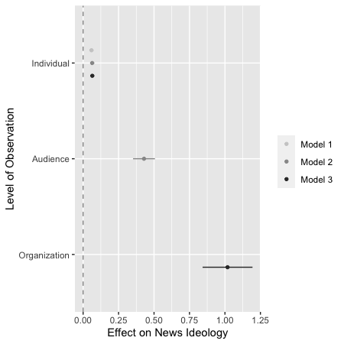

Figure 3. Dot-and-Whisker Plot Showing Effects on News Ideology at the Individual, Audience, and Organizational Levels

Figure 4. Conditional Effects of Individual Ideology at Various Levels of Audience and Organizational Ideology

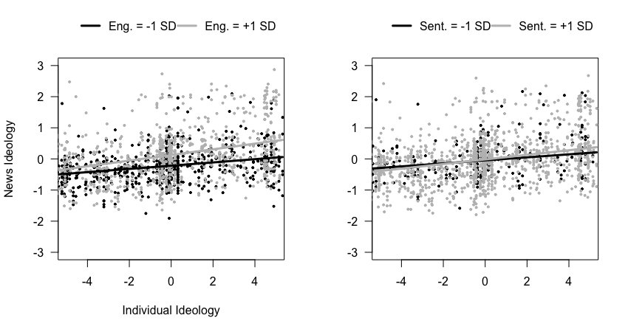

Figure 5. Conditional Effects of Individual Ideology at Various Levels of Audience Engagement and Net Story Sentiment